C.D.M.-3

Compact disc player MECHANISM
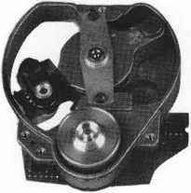
¿O 013 A12
Service

Service Manual
n compact

[fea
DIGITAL AUDIO
Veiligheidsbepalingen vereisen, dat het apparaat in zijn oorspronkelijke toestand wordt teruggebracht en dat onderdelen, identiek aan de gespecificeerde worden toegepast.
DocumentationTechnique Service Dokumentation Documentazione di Servizio Huolte-Ohje Manual de Servicio Manual de Servigio
Subject to modification
(£>
^ Published by
NL^) 4822 725 21062 Consumer Electronics
Printed in The Netherlands . __₀
^{c} Copyright reserved
INHOUD
- Inhoudsopgave en toelichting indeling
- Reparatiewenken
- Metingen en instellingen
- Exploded view C.D. mechanisme en stuklijst van de onderdelen
Principeschema’s, printplaatgegevens en stuklijsten van electrische onderdelen Service hulpmiddelen
1. TOELICHTING OP DE INDELING VAN DE DOKUMENTÄRE
De dokumentatie bestaat uit hoofdstukken.
Het nummer van het hoofdstuk wordt aangegeven door het eerste cljfer van het paginanummer.
Het tweede cijfer van het paginanummer is de volgordenummering.
Indien wijzigingen of aanvullingen nieuwe toevoegii.gs- of vervangingsbladen noodzakelijk maken wordt het paginanummer uitgebreid met een derde deel:
Een cijfer achter het paginanummer geeft aan dat het een toevoegingsblad is.
Een vervangingsblad wordt aangegeven door een letter achter het paginanummer.
Voorbeeld:
3-6 is pagina 6 van hoofdstuk 3
3-6-1 is een toevoegingsblad achter pagina 3-6
3-6-a is het vervangingsblad van pagina 3-6 (pagina
3-6 kan dus uit de dokumentatie worden verwijderd).
REPARATIEWENKEN
Om te voorkomen dat losse metalen voorwerpen in het CD mechanisme terecht komen moet ervoor gezorgd worden dat de plaats waarop gerepareerd wordt schoon is.
Het objectief kan met een blaaskwastje worden schoongemaakt.
Zorg ervoor dat bij reparatie en metingen aan het CD mechanisme de bladveren van de focusunit niet beschadigd worden.
DE FOTODIODES EN DE LASER ZUN VOOR ELEKTROSTATISCHE ONTLADINGEN GEVOELIGER DAN EEN MOS IC.
ONZORGVULDIG BEHANDELEN TIJDENS HET SERVICEN KAN DE LEVENSDUUR DRASTISCH VERMINDEREN. ZORG ER DAAROM VOOR DAT TIJDENS HET SERVICEN DE HULPMIDDELEN EN UZELF HETZELFDE POTENTIAAL HEBBEN ALS DE AFSCHERMING VAN HET APPARAAT.
In het apparaat zijn Chip componenten toegepast. Voor het demonteren en monieren van Chip componenten zie onderstaande figuur.
De plaat moet altijd goed aanliggen op de draaitafel. Wanneer voor reparatie het lademechansime moet worden uitgebouwd, gebruik dan een of meerdere losse aandrukkers. Het CD mechanisme kan dan normaal als in het apparaat functioneren.
- ESP
Alle IC’s en vele andere halfgeleiders zijn gevoelig voor electrostatische ontladingen (ESD).
Onzorgvuldig behandelen tijdens reparatie kan de levensduur drastisch doen verminderen.
Zorg ervoor dat u tijdens reparatie via een polsband met weerstand verbonden bent met hetzelfde potentiaal als de massa van het apparaat.
Houd componenten en hulpmiddelen ook op ditzelfde potentiaal.
Servicen van de RAFOC unit
De RAFOC-unit bestaat uit de posities 51, 53, 56 en 59.
- Maak de folieprint los door de klem pos. 52 uit het motorchassis te trekken.
- Draai de twee bouten M2,5X6 los en verwijder de lagerplaat pos. 54. Pos. 57 en pos. 58 zit in de plaat geklemd.
- Verwijder nu de defecte RAFOC-unit.
- Monteer nu in omgekeerde volgorde de nieuwe RAFOC-unit.
- Kontroleer of de arm vrijloopt en ook de hoekinstelling Zie voor de hoekinstelling het volgende hoofdstuk.
In het apparaat zijn chip componenten toegepast voor het demonteren en monieren van chip componenten, zie onderstaande Fig.
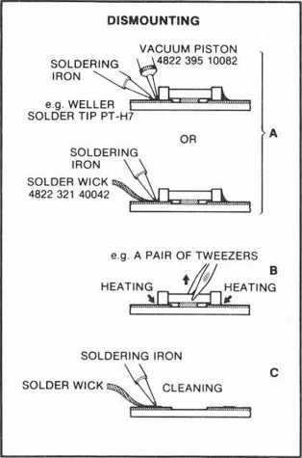
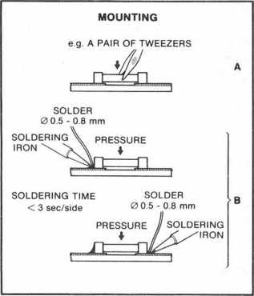
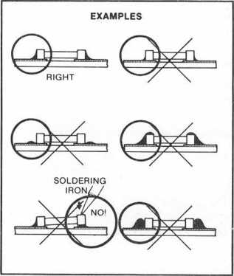
PRECAUTIONS
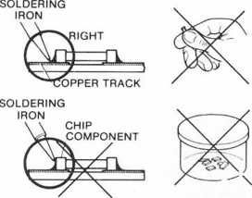
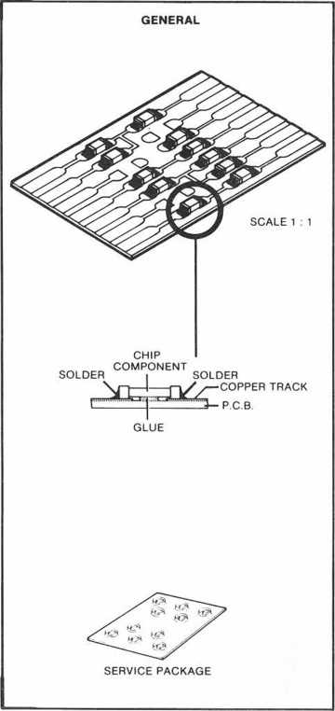

27 012C12
Testplaten
It is important that the test plates are treated with great care. The disturbances on the plates (black spots, fingerprints, etc.) are exclusive and are clearly positioned.
Damage can cause extra dropouts and the like, so that the wanted error on the plate is no longer exclusive. Testing e.g. the proper functioning of the track detector is then no longer possible.Metingen aan op-amps
- p-amps have been used extensively in the servo circuits.
These can be used inter alia as amplifiers, filters, inverters and buffers.
In those cases where feedback is applied in some way, the voltage difference at the differential inputs converges to zero. This applies to both DC and AC Signals.
The cause of this can be traced back to the properties of an ideal op-amp (Zj = oo, G = oo,
Z0 = 0).
When an input of an op-amp is directly connected to ground, it is virtually impossible to measure at the inverting and non-inverting inputs.
In such a case, only the output signal can be measured.
Therefore, in most cases the AC voltage will not be applied to the inputs.
The DC voltages at the inputs are the same.
Stimulate with "0" and "1"
During troubleshooting, certain points must sometimes be connected to earth or to supply voltage. As a result, certain circuits can be brought into a desired state, which shortens the diagnostic time. In a number of cases the points in question are outputs of op-amps. These outputs are short circuit proof, i.e. they may be brought to "0" or ground with impunity.
However, the output of an op-amp must never be applied directly to the power supply.
Measurements on microprocessors
Microcrocessor input and output must never be applied directly to the power supply. The inputs and outputs may only be set to "0" or ground when this is explicitly stated.
Measurements with an oscilloscope
When measuring with an oscilloscope, it is recommended to measure with a 1:10 measuring probe, since a 1:10 probe has a considerably smaller input capacity than a 1: 1 probe.
Choice of the earth potential
It is very important to choose an earth point that is as close as possible to the test point.
Conditions for injection
- Injecting levels or Signals from an external source may never happen if the circuit in question has no supply voltage.
- The injected levels or Signals must never be greater than the supply voltage of the circuit in question.
GENERAL CHECK POINTS
a. Make sure the plate and lens are clean (remove dust, fingerprints, etc.) and work with undamaged plates.
b. Check whether all supply voltages are present and have the correct value.
c. Check the proper functioning of the microprocessor by using. their built-in test program and service program.METINGEN AND SETTINGS.
Height adjustment of the turntable
For this setting, the device must be in the normal
state of use.
- Connect a D.C. voltmeter between the FOCUS + and the FOCUS- of the focus motor (for the connector connections, see the service manual of the device in which the CDM is installed).
- Play from test plate 5 (code no. 4822 397 30096), plate without defects track 1 at.
- Adjust with the bearing screw pos. 66 the turntable height such that the voltage across the focus motor is 0V + - 100mV.
- Secure the screw with a retaining varnish.
Check the angle setting
Use the glass plate code no.
4822 395 90204 and the push-button 4822 404 20725.
- Place the glass plate on the turntable with the pressure switch.
- Place the CDM under a light source, under which there is a straight line (e.g. TL with grid).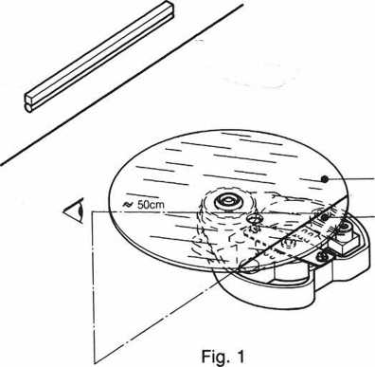
DISC
(TRANSPARENT)
OBJECTIVE
- Place the arm in the middle position. Turn the device so that the arm is parallel to the line under the light source (see Fig. 1).
Look in the direction and in line with the reflection of this on the glass plate and focus lens.
The reflection in the lens must fall within the surface of the focus lens. (The two reflections are then <4 mm apart).
Turn the CDM 90 degrees to the previous position (see Fig. 2).
Repeat the measurement.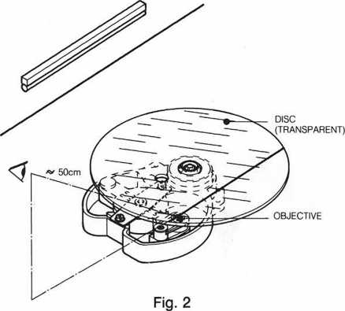
Adjust the angle setting
When adjusting the angle plate light path in the factory, a compromise was sought between a minimum angular deviation and minimal friction of the arm.
If, during measurement, it appears that the angle falls outside the given tolerance, the angle should NOT be adjusted to a minimum deviation, but rather within the tolerance. The new setting must lie between the old setting and the optimum setting.
After adjustment, the friction of the arm must be checked. This is done with the help of a spring-pressure meter which is installed at the counterweight. The friction of the arm, measured over the entire stroke, must not exceed 30 mN.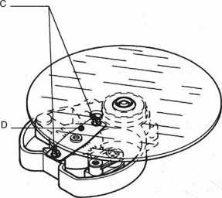
Fig. 3
f the friction proves to be too high, the setting must be returned to the old value. Or replace the arm with a new one and check the angle again.
MDA.00357
T28 / 633
Loosen screws C (see Fig. 3) until the bearing plate D can be moved. A hole has been made in the glass plate for the inner screw.
Correct the angle setting by moving the bearing plate in the direction indicated in fig. 4.
Tighten the screws C, taking care not to adjust.
Then check the two-way angle setting again.
After the angle has been set, the height setting of the turntable must be checked.ft

¹ r
!
t-zG
r 7T -►
i \
ot--0

EH EH
Fig. 4
\ i Li J
Check of the motor control (Hall control)
- Interrupt the Vc connection (for the connector connection, see the service manual of the device in which the CDM is installed).
- Connect channel A of a double-beam oscilloscope to pin 3 of 1C 6083 (a) and channel B to pin 1 of IC 6083 (b). Measuring against Vb + / 2.
Time base 10 ms / div.
1 Switch the player on.
2 Inject a voltage of -0.9 V to Vb + / 2 (!) +/- 0.1 V at point 04 of the motor circuit board.
The injection may only take place after the circuit has been connected to the supply voltage.
3 Sinusoidal Signals should now be visible on the oscilloscope which after approx. 2 sec. symmetrically around the O-axis and 90 degrees in phase with respect to each other (see Fig. 5).
The amplitudes of these Signals may have a maximum ratio of 1: 2.
V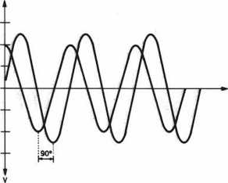
Fig. 5
4 With Vc = -0.9 V +/- 0.1 V, the speed must be 600 rpm.
The Signals then have a frequency of approximately 30 Hz.
- Switch the player off and connect channel A from the oscilloscope to pin 1 of IC 6081 (a) and channel B to pin 3 of IC6081 (b).
- Repeat points 1 to 4.
- Lower Vc now to -0.3 V.
At this voltage the motor must still run "properly".
- If all these conditions are present, it can be assumed that the motor and the PCB are in order.
If points 3 and 4 are not correct or if the motor no longer runs properly at -0.3 V, then the entire motor will be the pos. 61 to 67, must be replaced.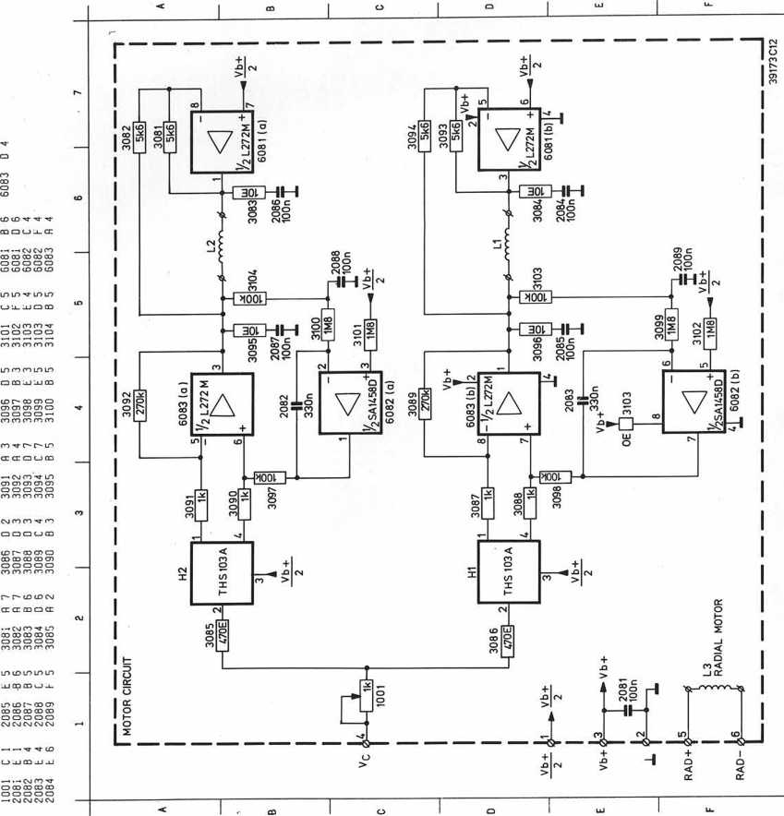

PRS.01570
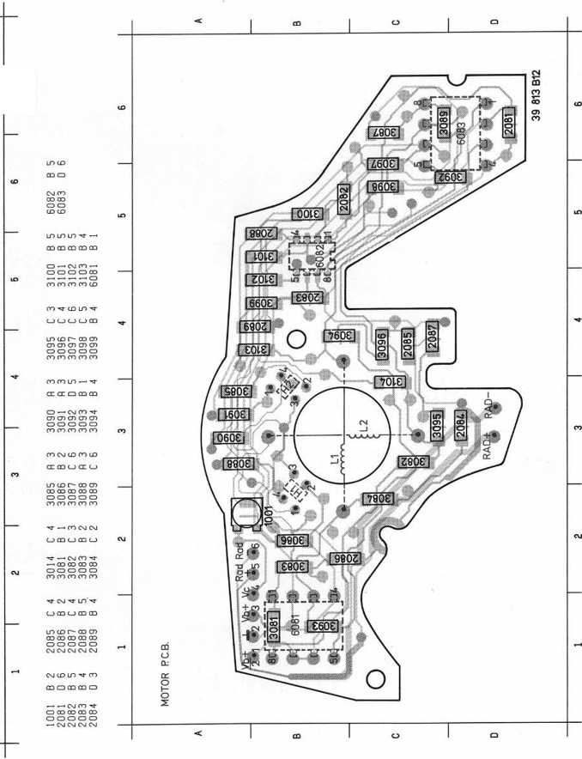
PRS.01569

EXPLODED VIEW
M2,5X6
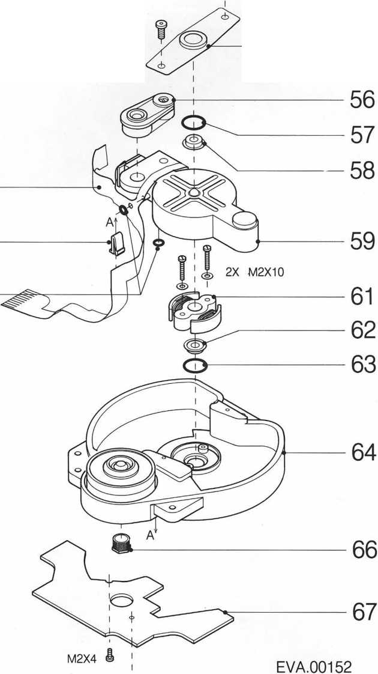
51
52
53
Pos. | Code number
51 | 4822 323 50116
52 | 4822 401 10948
53 | 4822 530 50876
54 | 4822 520 10601
56,59 | 4822 691 30179
57 | 4822 530 50864
58 | 4822 520 20429
61-5-67 | 4822 361 20678
66 | 4822 502 12529
T28/611
M2X4 CDM-3
ELECTRICAL PARTS
pnnnnnn
UUUUUUD
6081 | L272M | 4822 209 82374
6082 | SA1458D | 4822 209 11346
6083 | L272MB | 4822 209 70373

SERVICE TOOLS  Audio test plate 4822 397 30085  Plate without defects +  plate with DO errors, black  spots and fingerprints 4822 397 30096  Torx screwdrivers:  - set (straight) 4822 395 50145  - set (square) 4822 395 50132  Pressure switch 4822 404 20725  Glass plate 4822 395 90204 | SERVICE TOOLS  Audio test plate 4822 397 30085  Plate without defects +  plate with DO errors, black  spots and fingerprints 4822 397 30096  Torx screwdrivers:  - set (straight) 4822 395 50145  - set (square) 4822 395 50132  Pressure switch 4822 404 20725  Glass plate 4822 395 90204
SERVICE TOOLS  Audio test plate 4822 397 30085  Plate without defects +  plate with DO errors, black  spots and fingerprints 4822 397 30096  Torx screwdrivers:  - set (straight) 4822 395 50145  - set (square) 4822 395 50132  Pressure switch 4822 404 20725  Glass plate 4822 395 90204 | SERVICE TOOLS  Audio test plate 4822 397 30085  Plate without defects +  plate with DO errors, black  spots and fingerprints 4822 397 30096  Torx screwdrivers:  - set (straight) 4822 395 50145  - set (square) 4822 395 50132  Pressure switch 4822 404 20725  Glass plate 4822 395 90204
SERVICE TOOLS  Audio test plate 4822 397 30085  Plate without defects +  plate with DO errors, black  spots and fingerprints 4822 397 30096  Torx screwdrivers:  - set (straight) 4822 395 50145  - set (square) 4822 395 50132  Pressure switch 4822 404 20725  Glass plate 4822 395 90204 | SERVICE TOOLS  Audio test plate 4822 397 30085  Plate without defects +  plate with DO errors, black  spots and fingerprints 4822 397 30096  Torx screwdrivers:  - set (straight) 4822 395 50145  - set (square) 4822 395 50132  Pressure switch 4822 404 20725  Glass plate 4822 395 90204
SERVICE TOOLS  Audio test plate 4822 397 30085  Plate without defects +  plate with DO errors, black  spots and fingerprints 4822 397 30096  Torx screwdrivers:  - set (straight) 4822 395 50145  - set (square) 4822 395 50132  Pressure switch 4822 404 20725  Glass plate 4822 395 90204 | SERVICE TOOLS  Audio test plate 4822 397 30085  Plate without defects +  plate with DO errors, black  spots and fingerprints 4822 397 30096  Torx screwdrivers:  - set (straight) 4822 395 50145  - set (square) 4822 395 50132  Pressure switch 4822 404 20725  Glass plate 4822 395 90204
SERVICE TOOLS  Audio test plate 4822 397 30085  Plate without defects +  plate with DO errors, black  spots and fingerprints 4822 397 30096  Torx screwdrivers:  - set (straight) 4822 395 50145  - set (square) 4822 395 50132  Pressure switch 4822 404 20725  Glass plate 4822 395 90204 | SERVICE TOOLS  Audio test plate 4822 397 30085  Plate without defects +  plate with DO errors, black  spots and fingerprints 4822 397 30096  Torx screwdrivers:  - set (straight) 4822 395 50145  - set (square) 4822 395 50132  Pressure switch 4822 404 20725  Glass plate 4822 395 90204
SERVICE TOOLS  Audio test plate 4822 397 30085  Plate without defects +  plate with DO errors, black  spots and fingerprints 4822 397 30096  Torx screwdrivers:  - set (straight) 4822 395 50145  - set (square) 4822 395 50132  Pressure switch 4822 404 20725  Glass plate 4822 395 90204 | SERVICE TOOLS  Audio test plate 4822 397 30085  Plate without defects +  plate with DO errors, black  spots and fingerprints 4822 397 30096  Torx screwdrivers:  - set (straight) 4822 395 50145  - set (square) 4822 395 50132  Pressure switch 4822 404 20725  Glass plate 4822 395 90204
SERVICE TOOLS  Audio test plate 4822 397 30085  Plate without defects +  plate with DO errors, black  spots and fingerprints 4822 397 30096  Torx screwdrivers:  - set (straight) 4822 395 50145  - set (square) 4822 395 50132  Pressure switch 4822 404 20725  Glass plate 4822 395 90204 | SERVICE TOOLS  Audio test plate 4822 397 30085  Plate without defects +  plate with DO errors, black  spots and fingerprints 4822 397 30096  Torx screwdrivers:  - set (straight) 4822 395 50145  - set (square) 4822 395 50132  Pressure switch 4822 404 20725  Glass plate 4822 395 90204
SERVICE TOOLS  Audio test plate 4822 397 30085  Plate without defects +  plate with DO errors, black  spots and fingerprints 4822 397 30096  Torx screwdrivers:  - set (straight) 4822 395 50145  - set (square) 4822 395 50132  Pressure switch 4822 404 20725  Glass plate 4822 395 90204 | SERVICE TOOLS  Audio test plate 4822 397 30085  Plate without defects +  plate with DO errors, black  spots and fingerprints 4822 397 30096  Torx screwdrivers:  - set (straight) 4822 395 50145  - set (square) 4822 395 50132  Pressure switch 4822 404 20725  Glass plate 4822 395 90204
SERVICE TOOLS  Audio test plate 4822 397 30085  Plate without defects +  plate with DO errors, black  spots and fingerprints 4822 397 30096  Torx screwdrivers:  - set (straight) 4822 395 50145  - set (square) 4822 395 50132  Pressure switch 4822 404 20725  Glass plate 4822 395 90204 | SERVICE TOOLS  Audio test plate 4822 397 30085  Plate without defects +  plate with DO errors, black  spots and fingerprints 4822 397 30096  Torx screwdrivers:  - set (straight) 4822 395 50145  - set (square) 4822 395 50132  Pressure switch 4822 404 20725  Glass plate 4822 395 90204
SERVICE TOOLS  Audio test plate 4822 397 30085  Plate without defects +  plate with DO errors, black  spots and fingerprints 4822 397 30096  Torx screwdrivers:  - set (straight) 4822 395 50145  - set (square) 4822 395 50132  Pressure switch 4822 404 20725  Glass plate 4822 395 90204 | SERVICE TOOLS  Audio test plate 4822 397 30085  Plate without defects +  plate with DO errors, black  spots and fingerprints 4822 397 30096  Torx screwdrivers:  - set (straight) 4822 395 50145  - set (square) 4822 395 50132  Pressure switch 4822 404 20725  Glass plate 4822 395 90204

1 pF | 5% | 4822 122 32479 | 5,6 E | 5% | 4822 11 | 90394 | 7,5 k | 2% | 4822 11 | 90276
1,5 pF | 5% | 4822 122 31792 | 6,2 E | 5% | 4822 11 | 90395 | 8,2 k | 2% | 5322 11 | 90118
1,8 pF | 5% | 4822 122 32087 | 6,8 E | 5% | 4822 11 | 90254 | 9,1 k | 2% | 4822 11 | 90373
2,2 pF | 5% | 4822 122 32425 | 7,5 E | 5% | 4822 11 | 90396 | 10 k | 2% | 4822 11 | 90249
3,3 pF | 5% | 4822 122 32079 | 8,2 E | 5% | 4822 11 | 90397 | 11 k | 2% | 4822 11 | 90337
3,9 pF | 5% | 4822 122 32081 | 9,1 E | 5% | 4822 11 | 90398 | 12 k | 2% | 4822 11 | 90253
4,7 pF | 5% | 4822 122 32082 | 10 E | 2% | 5322 11 | 90095 | 13 k | 2% | 4822 11 | 90509
5,6 pF | 5% | 4822 122 32506 | 11 E | 2% | 4822 11 | 90338 | 15 k | 2% | 4822 11 | 90196
8,2 pF | 5% | 4822 122 32083 | 12 E | 2% | 4822 11 | 90341 | 16 k | 2% | 4822 11 | 90346
10 pF | 5% | 4822 122 31971 | 13 E | 2% | 4822 11 | 90343 | 18 k | 2% | 4822 11 | 90238
12 pF | 5% | 4822 122 32139 | 15 E | 2% | 4822 11 | 90344 | 20 k | 2% | 4822 11 | 90349
18 pF | 5% | 4822 122 31769 | 16 E | 2% | 4822 11 | 90347 | 22 k | 2% | 4822 11 | 90251
22 pF | 10% | 4822 122 31837 | 18 E | 2% | 5322 11 | 90139 | 24 k | 2% | 4822 11 | 90512
27 pF | 5% | 4822 122 31966 | 20 E | 2% | 4822 11 | 90352 | 27 k | 2% | 4822 11 | 90542
33 pF | 5% | 4822 122 31756 | 22 E | '2% | 4822 11 | 90186 | 30 k | 2% | 4822 11 | 90216
39 pF | 5% | 4822 122 31972 | 24 E | 2% | 4822 11 | 90355 | 33 k | 2% | 5322 11 | 90267
47 pF | 5% | 4822 122 31772 | 27 E | 2% | 5322 11 | 90105 | 36 k | 2% | 4822 11 | 90514
56 pF | 5% | 4822 122 31774 | 30 E | 2% | 4822 11 | 90356 | 39 k | 2% | 5322 11 | 90108
68 pF | 5% | 4822 122 31961 | 33 E | 2% | 4822 11 | 90357 | 43 k | 2% | 4822 11 | 90363
82 pF | 10% | 4822 122 31839 | 36 E | 2% | 4822 11 | 90359 | 47 k | 2% | 4822 11 | 90543
100 pF | 5% | 4822 122 31765 | 39 E | 2% | 4822 11 | 90361 | 51 k | 2% | 5322 11 | 90274
120 pF | 5% | 4822 122 31766 | 43 E | 2% | 5322 11 | 6 90125 | 56 k | 2% | 4822 11 | 90573
150 pF | 5% | 4822 122 31767 | 47 E | 2% | 4822 11 | 90217 | 62 k | 2% | 5322 11 | 90275
180 pF | 2% | 4822 122 31794 | 51 E | 2% | 4822 11 | 90365 | 68 k | 2% | 4822 11 | 90202
220 pF | 5% | 4822 122 31965 | 56 E | 2% | 4822 11 | 90239 | 75 k | 2% | 4822 11 | 90574
270 pF | 5% | 4822 122 32142 | 62 E | 2% | 4822 11 | 90367 | 82 k | 2% | 4822 11 | 90575
330 pF | 10% | 4822 122 31642 | 68 E | 2% | 4822 11 | 90203 | 91 k | 2% | 5322 11 | 90277
390 pF | 5% | 4822 122 31771 | 75 E | 2% | 4822 11 | 90371 | 100 k | 2% | 4822 11 | 90214
470 pF | 5% | 4822 122 31727 | 82 E | 2% | 4822 11 | 90124 | 110 k | 2% | 5322 11 | 90269
560 pF | 5% | 4822 122 31773 | 91 E | 2% | 4822 11 | 90375 | 120 k | 2% | 4822 11 | 90568
680 pF | 5% | 4822 122 31775 | 100 E | 2% | 5322 11 | 90091 | 130 k | 2% | 4822 11 | 90511
820 pF | 5% | 4822 122 31974 | 110 E | 2% | 4822 11 | 90335 | 150 k | 2% | 5322 11 | 90099
1 nF | 10% | 5322 122 31647 | 120 E | 2% | 4822 11 | 90339 | 160 k | 2% | 5322 11 | 90264
1,2 nF | 5% | 4822 122 31807 | 130 E | 2% | 4822 11 | 90164 | 180 k | 2% | 4822 11 | 90565
1,5 nF | 10% | 4822 122 31781 | 150 E | 2% | 5322 11 | 90098 | 200 k | 2% | 4822 11 | 90351
1,8 nF | 10% | 4822 122 32153 | 160 E | 2% | 4822 11 | 90345 | 220 k | 2% | 4822 11 | 90197
2,2 nF | 10% | 4822 122 31644 | 180 E | 2% | 5322 11 | 90242 | 240 k | 2% | 4822 11 | 90215
2,7 nF | 10% | 4822 122 31783 | 200 E | 2% | 4822 11 | 90348 | 270 k | 2% | 4822 11 | 90302
3,3 nF | 10% | 4822 122 31969 | 220 E | 2% | 4822 11 | 90178 | 300 k | 2% | 5322 11 | 90266
3,9 nF | 10% | 4822 122 32566 | 240 E | 2% | 4822 11 | 90353 | 330 k | 2% | 4822 11 | 90513
4,7 nF | 10% | 4822 122 31784 | 270 E | 2% | 4822 11 | 90154 | 360 k | 2% | 4822 11 | 90515
5,6 nF | 10% | 4822 122 31916 | 300 E | 2% | 4822 11 | 90156 | 390 k | 2% | 4822 11 | 90182
6,8 nF | 10% | 4822 122 31976 | 330 E | 2% | 5322 11 | 90106 | 430 k | 2% | 4822 11 | 90168
10 nF | 10% | 4822 122 31728 | 360 E | 1% | 4822 11 | 90288 | 470 k | 2% | 4822 11 | 90161
12 nF | 10% | 5322 122 31648 | 360 E | 2% | 4822 11 | 90358 | 510 k | 2% | 4822 11 | 90364
15 nF | 10% | 4822 122 31782 | 390 E | 2% | 5322 11 | 90138 | 560 k | 2% | 4822 11 | 90169
18 nF | 10% | 4822 122 31759 | 430 E | 2% | 4822 11 | 90362 | 620 k | 2% | 4822 11 | 90213
22 nF | 10% | 4822 122 31797 | 470 E | 2% | 5322 11 | 90109 | 680 k | 2% | 4822 11 | 90368
27 nF | 10% | 4822 122 32541 | 510 E | 2% | 4822 11 | 90245 | 750 k | 2% | 4822 11 | 90369
33 nF | 10% | 4822 122 31981 | 560 E | 2% | 5322 11 | 90113 | 820 k | 2% | 4822 11 | 90205
47 nF | 10% | 4822 122 32542 | 620 E | 2% | 4822 11 | 90366 | 910 k | 2% | 4822 11 | 90374
56 nF | 10% | 4822 122 32183 | 680 E | 2% | 4822 11 | 90162 | 1 M | 2% | 4822 11 | 90252
100 nF | 10% | 4822 122 31947 | 750 E | 2% | 5322 11 | 90306 | 1,1 M | 5% | 4822 11 | 90408
180 nF | 10% | 4822 122 32915 | 820 E | 2% | 4822 11 | 90171 | 1,2 M | 5% | 4822 11 | 90409
 |  |  | 910 E | 2% | 4822 11 | 90372 | 1,3 M | 5% | 4822 11 | 90411
1 |  |  | 1 k | 2% | 5322 11 | 90092 | 1,5 M | 5% | 4822 11 | 90412
h Chips 0,125 W S1206 NPO |  |  | 1,1 k | 2% | 4822 11 | 90336 | 1,6 M | 5% | 4822 11 | 90413
 |  |  | 1,2 k | 2% | 5322 11 | 90096 | 1,8 M | 5% | 4822 11 | 90414
0 E | jumper | 4822 111 90163 | 1,3 k | 2% | 4822 11 | 90244 | 2 M | 5% | 4822 11 | 90415
1 E | 5% | 4822 111 90184 | 1,5 k | 2% | 4822 11 | 90151 | 2,2 M | 5% | 4822 11 | 90185
1.1 E | 5% | 4822 111 90377 | 1,6 k | 2% | 5322 11 | 90265 | 2,4 M | 5% | 4822 11 | 90416
1,2 E | 5% | 4822 111 90378 | 1,8 k | 2% | 5322 11 | 90101 | 2,7 M | 5% | 4822 11 | 90417
1,3 E | 5% | 4822 111 90379 | 2 k | 2% | 4822 11 | 90165 | 3 M | 5% | 4822 11 | 90418
1,5 E | 5% | 4822 111 90381 | 2,2 k | 2% | 4822 11 | 90248 | 3,3 M | 5% | 4822 11 | 90191
1,6 E | 5% | 4822 111 90382 | 2,4 k | 2% | 4822 11 | 90289 | 3,6 M | 5% | 4822 11 | 90419
1,8 E | 5% | 4822 111 90383 | 2,7 k | 2% | 4822 11 | 90569 | 3,9 M | 5% | 4822 11 | 90421
2 E | 5% | 4822 111 90384 | 3 k | 2% | 4822 11 | 90198 | 4,3 M | 5% | 4822 11 | 90422
2,2 E | 5% | 5322 111 90104 | 3,3 k | 2% | 4822 11 | 90157 | 4,7 M | 5% | 4822 11 | 90423
2,4 E | 5% | 4822 111 90385 | 3,6 k | 2% | 5322 11 | 90107 | 5,1 M | 5% | 4822 11 | 90424
2,7 E | 5% | 4822 111 90386 | 3,9 k | 2% | 4822 11 | 90571 | 5,6 M | 5% | 4822 11 | 90425
3 E | 5% | 4822 111 90387 | 4,3 k | 2% | 4822 11 | 90167 | 6,2 M | 5% | 4822 11 | 90426
3,3 E | 5% | 4822 111 90388 | 4,7 k | 2% | 5322 11 | 90111 | 6,8 M | 5% | 4822 11 | 90235
3,6 E | 5% | 4822 111 90389 | 5,1 k | 2% | 5322 11 | 90268 | 7,5 M | 5% | 4822 11 | 90427
3,9 E | 5% | 4822 111 90391 | 5,6 k | 2% | 4822 11 | 90572 | 8,2 M | 5% | 4822 11 | 90237
4,3 E | 5% | 4822 111 90392 | 6,2 k | 2% | 4822 11 | 90545 | 9,1 M | 5% | 4822 11 | 90428
4,7 E | 5% | 5322 111 90376 | 6,8 k | 2% | 4822 11 | 90544 | 10M | 5% | 5322 11 | 91141
5,1 E | 5% | 4822 111 90393

