2 OPERATING
INST
FRONT FRAME FIRE COUNTRY
FRAME PIECES, LEFT
251 | 174 | 526
252 | 250 | 320
253 | 250 | 321
CLASSIC DESIGN
EDGE CONNECTOR, UPPER LEFT
EDGE CONNECTOR, LOWER LEFT

254
255
256
257
174 525 174 527 250 322 250 323
FRAME
FRAME PIECES, UPPER EDGE CONNECTOR, UPPER RIGHT EDGE CONNECTOR. LOWER RIGHT
7ES,
:es.
CLASSIC DESIGN CLASSIC DESIGN
- 175 053
- 175 054
CROSS PROFILE, UPPER ASSY CROSS PROFILE, LOWER ASSY
260
261
262
263
264
265
266
267
268
270
271
272
273
274
275
276
15
14
14
- 74 50 !50 14
082
679
- 083 945
314
- 682
316
HOLDING BRACKET, RIGHT CLOSING PLATE, UPPER CLOSING PLATE, LOWER HOLDING BRACKET, LEFT CARRIER PLATE, STAMPED PROFIL for LAMP MASK, LEFT PROFIL for LAMP MASK, RIGHT HOLDING BRACKET TERMINAL PROFILE, UPPER
FRONT PLATE
TRIMPLATE, UPPER DUPLEX-PROFILE COIN INSERT BUTTON I, PRE-MOUNTED PRESSURE SPRING MASK, LEFT MASK, RIGHT COVER
LAMP HOLDER, LEFT 2
LAMP HOLDER, RIGHT 2
25(
115 494 219 152 206 581 173 710 175 023 205 720 209 963 209 964 173 905 175 033 175 032

277 204 929 FRONT GLASS
1
2
2
206 519 RUBBER PROFILE
206 520 RUBBER PROFILE

GLASS HOLDER, RIGHT LOWER 1
- 175 037
- 175 034
- 175 035
GLASS HOLDER, UPPER 2
GLASS HOLDER, LEFT LOWER 1

114 699 | HINGE-BOTTOM PART
226 038 | FLUORESCENT LAMP | . 8 W
225 364 | STARTER HOLDER
225 040 | STARTER | S10
173 712 | ADAPTER, LEFT
173 711 | ADAPTER, RIGHT
174 488 | BUTTON, ASSY | see
285
288
289
290
291
2
2
2
1
1

!
11
•—i
5|
K
»
t:
n
m
as
3Î
&
m
■
<-»
a
i—>
S
es
i—
a
M
I
<“>
c=>
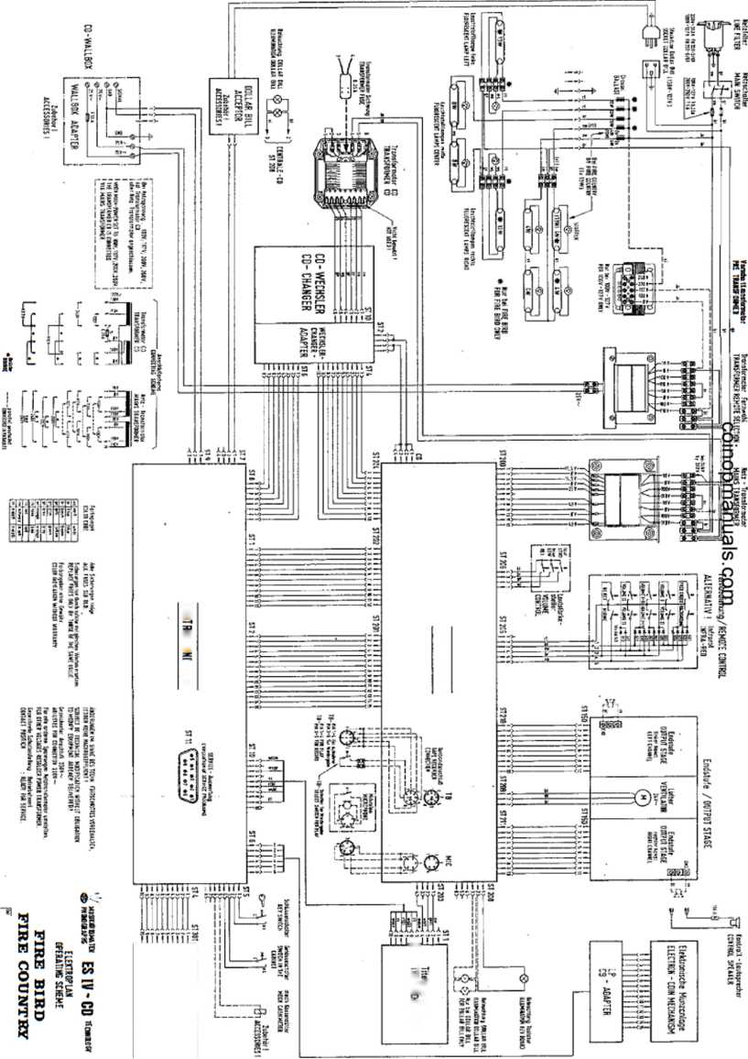
ill
ss g I *
3S5
is§§
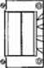
c
s
«
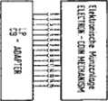
K>? » _
j
CJ
if
\ \
lï
ffâ

a¡31fi¡ as U36U1S (£Q î|Jîï3
El2-t02 sßBd ok ageispúeu?; _
ijspsjieyíf
2 MSN
. L

970 9L 070 SL 7LZ SL 997 7¿ IE8 7¿ E06 7¿I
..ONVaS., a3WÜOJH3d 3Hi

AaiNnoo/aaiaaaid aaisvwoNnos
NOUVNIOSV3 ÀMS d3AHS AilO bHAlIS
Aasy ‘uoi^BUUOjui |eo|uqo8i
Ol

AWTWÄÜ 6Ô-M m

SHdVdOONOHd-MSN HOd
V

SNOIlOriaiSNI 9NI±Va3dO

INDEX
%
- PLAYING SEQUENCE
  - Operation after switching on
  - i Standby
  - Credits
  - Selection
  - Play mode
- ADJUSTMENTS WITH REMOTE CONTROL
  - Volume controls
  - Muting
  - Freecredits
  - Background music
  - Key switch
- SERVICE OPERATION - short program for price settings
- CD change / cash collection
o
o

SELECTION -v  NOW PLAYING | Y“^{t0f}  -RANK- | TEN HITS —  .TrtiSJLÛ£Àl!0ti ..  p—TUNE NUMBER —
UHI | 88 | 8888  .; .I.' A\  * ’ -
topi
ol
ten hits •fthis location
background credits your select Ion
lEllHllBl
OllOllBl
OllBlljgl
lallBllcil

O
o
1 PLAYING SEQUENCE
The functional sequence, starting with "power on", standby credit, selection and playing of selected title to the rest position Is described below.
The technical assembly and the working together of the components can be seen in the ."electronic schematics". Compare the descriptions with the Illustration of the display / keyboard above.
Ope i
Immediately after swltch-on the memory components
the'CONTROL UNIT-
y com;
and all preprogrammed vafups are checked.
Display 1 shows then for 2 sec. the program index
If an error is found during checking, error display Er xx Is then shown for 2 sec.
With Er 31 (unverified memory contents) and Er 40 (price settings incorrect) Display 1 with Pxx shows the correct program step which needs to be reprogrammed. See description of service programs.
With other Er-dlsplays, even during operation, proceed according to the instructions In "Trouble Shooting".
- Stan dby
Hit display:
The. microprocessor of the CONTROL UNIT figures out of the 30 titles just played before the ones played most.
On Display 3 the title numbers of the 10 most popular titles, whose rankings (1-10) are shown on Display 2, are changed In intervals of 2 sec. Also “10 top hits" lights up.
When pushing ”H“» the hit display can be stopped for 16 sec; every press of the key causes an advance to the next hit.
Note: When the popularity counters are erased (program step P 10), the hit parade is erased, too. In that case "O” appears for ranking until records are played again.

Random Play:
In program step P24 a time Interval can be set for random tune playing.
Conditions for a random title to be played: S Phonograph in standby mode 0 No credit available * Microphone switch not being used ■ No muting N Set time is expired
- Credits (not for HIDE-AWAY)
See unit description "Coin and Bill Validation".
After Insertion of a coin the “hit display" Is Interrupted, lamp “10 top hits" goes off and "credit” and "your selection" light up. Display 2 shows the number of credits.
For every selection credit Is deducted.
If not enough credits are available for the selection, "credit" lamp flashes.
If no more coins are inserted within 16 sec. or no selector key is pressed, the mode changes to "hit display".
Frea-credlt switch (add. key), below the mechanical coin acceptor or on the adapter PCB with electronic coin validators, is only possible when the cabinet lid is open and the cabinet Interlock switch Is In service position (press add. button once = 1 credit). These credits are not registered statistically.
Starting with program index 0003 selections can be made without credits after pulling out the cabinet switch and going back to the regular program (2 x "C“ key).
Attention! The machine Is furnished with an interlock switch which must be manually set in service position (pull out). The switch resets automatically when closing the lid.
Note: Credits remain stored during "power off/on".
If the computer detects no activity on the phonograph within 1 hour, the stored credit is cancelled.

Title Selection: The four-digit number of the (2 digits each for disc and track). "Credit" The selection can be corrected by pressing the 4th digit.
desired title has to be entered and "your selection” light up. "C" up to 2 sec. after pressing

Album Selection: When entering Track 00, all titles of a CD are automatically played (i.e. 0100 = all titles of Disc 01).
The number of credits which are deducted when selecting an album can be programmed in step P46.
When programming "0", album selection Is blocked.
With open cabinet switch (interlock lever pulled out) no credit is deducted when selecting.

If the entry is incorrect, e.g. higher than the programmed number of CD tracks which can be selected or an unallowed selection of albums, "error" flashes. In that case, press "C" and repeat the selection.
One credit is deducted for each selection of a title. With album selections credits are deducted as per the programming in program step P46. If there is not enough credit available, "credit" lamp flashes.
16 sec. after selection "hit display" Is switched on automatically again.
Note: If a background or random title is playing during selection, the volume is fading and the selected tune Is being played.
When selecting a higher title number than recorded on the CD, the first title (track) of the CD will be played automatically.
1-5 Play Mode
After selection the microprocessor of the CONTROL UNIT moves the pickup of the CD changer to the selected CD and pulls ft with its holder out of the magazine into the pickup. The pickup brings the CD to the disc player where it is then played.
Just before play the number of the title is shown on Display l ("selection now playing"). After the disc Is played, the display is erased and the CD is transported back to Its magazine space.
Note: If a error occurs with the CD changer or the player, "Er 7x" or ”Er 6x" appears for 2 sec. In that case proceed according to the description In "Trouble Shooting".
Limiting Playing Time for a Title (Track)
In Service Program P30 the time that a title is to be played maximum can be set in minutes.
After expiration of this time the volume for that titfe Is fading and then muted.
When setting "0" (default), there is no limit in playing time.
Sequence of Tunes Playing
In Service Program P31 one can set in which sequence the selected titles are played.
Settings: 0 = In sequence of selection (FIFO)
- = in numerically increasing sequence
- = random sequence
Limit of Plaving Titles on the Same CD
One can set in Service Program P32 how many titles can be played consecutively on the same CD.
With 0 (default) there is no limit.
Attention!
When playing a test compact disc, the description that comes with the test disc is to be exactly adhered to. By any means, it Is to be, avoided to give sine signals with peak signal “OdB" at full volume level to the loudspeakers for more than 1 sec.
But also other unfiltered noises and high-frequency signals (which are only used for measuring purposes) can damage the amplifier and loudspeakers at full volume.
When checking channel separation, this test can only be done with a frequency of 1 KHz.

w mi i# 8Whn m /115 /115 0« / in oe
205
By pushing the keys respectively title holders aré moved into the corresponding direction. Upon each key operation two new CD-covers including titlestrlps are shown. In case of a limitation of selectable CD’s via service step P22 only the corresponding title holders are shown.
Note: A problem with the title display will Initiate error code *Er 9x". Following Instructions In paragraph 14 (trouble shooting).
2 ADJUSTMENTS WITH,REMOTE ■ • • f
CONTROL g*
The phonograph can optionally be equipped with cable-type remote control or Infra-red remote control. All functions and the operation of both models are Identical. Therefore, this description is valid for both of them.
The button-control box attached to the rear of the cabinet allows common'" control of both channels **+" or and “REJECT“.
Information about the functions of different controls is presented in the unit description ’’Remote Control".
Note: The button volume control is not present with wall boxes such as the "CD FIRE“ or the "CD HIDE AWAY“.
  - Volume Controls We differentiate between two volumes:
- ) The normal volume of selected titles and random play titles
- ) The background volume of background“titles
For selected titles and random titles or with microphone and tape mode the corresponding volume is adjustable; background volume only with background mode:
Key "I" for the left channel; Key “11" for the right channel; ”+” = louder, s quieter. When pushing center key (I+II), the channels are regulated together. If they werp differently set, they are first ’.’balanced" and regulated together.
When no selection is taking place, the volume for the channels are shown in Display 3 during the adjustment in steps of “1" to "31".
At "muting¹’ function ’’OFF" appears In Display 1; no more titles will be played until MUTING is cancelled.
The volume set at the end is stored during “power off”.
The maximum possible volume for normal and background mode can be limited In service program P28 In steps of “1" to “31".
Note: To protect the amplifiers a check is made whether an overload occurs due to mismatching In 250 ms cycles.
Upon recognition of an error the volume of the corresponding channel is reduced step by step automatically by the computer until a non-critical point is reached.
“OFF” no more records are played until MUTING Is
Note: With display switched off.
”0” by pressing the MUTING of the MUTING key a VOLUME the previously set volume for
The volume of both channels' can be set at key; "OFF" appears on Display 1. Re-pressing "+ key causes the system to switch back to both channels.
  - F nee Credits
With an "open" key switch free credits programmed In program step P23 can be called up. The following free credits are possible depending upon the settings In step P23:
- ) Number of set free credits can be called up individually step by step.
- ) Unlimited free credits can be called up individually step by step.
- ) Permanent credit when pressing key "FREE CREDIT" for the first time (credit display "99"). When key "FREE CREDIT" is pressed again, permanent credit is blocked.
2 .A- Background Music
With an "open" key switch the background mode can be switched on with the BACKGROUND key. "Background playing“ lights up.
When pressing this key again, the background mode is switched off. In the background mode "random" records are played from the upper area of the magazine. The area can be set In program step P25. '
The records are played at a "specific" background volume which can be changed as desired during playing cycle from ”0” up to maximum volume set In program step P28.
A "normal record", selected while background music is playing, Interrupts the background disc and the selected tune Is played act "normal volume".
mro I row / ro « MI527I / us no/ih o«
207
A key switch at the side wall serves as protection against unauthorized calling up of free credits and switching on the background mode. When the key switch is "locked", settings from the remote control are disregarded. Key switch "open" permits programmed free credits to be called up and the background mode to be switched on.
• FREE BACK- CREDIT GROUND
- 0 +
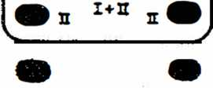
REJECT MUTINE
REMOTE CONTROL

3 Sor-vice Operation -Short Rr~ogr-am -for- Rice Settin 9 s—
This description is a summary of a section of the service program.
A detailed description and the corresponding tables are contained In chapter 1.3 "Price Settings“ and 1.4 "Monetary Value Settings“.
Practical example for setting the “plays per monetary unit" and the "monetary unit settings": 1 play s 30 p 1 play = 2x25 c
2 plays s 50 p 2 plays = 4x25 c
5 plays = 1 £
Setting the price able (plays/monetary unit):
Programming information | Operation | Displays 1 2 3
Switch-over from play mode to service mode | pull out plunger | POI XXX
Select a program step | Press key(s) | SP; GW:
Select a program step | "C" | P
Direct selection of program step, Display of previous setting In P41. | ”41 ”, "H“. | P41  XX XXX
New setting In P41 “1 play/30 p”. | "01“, “02“, “H“. | P41 01 030
Advance to next program step, Display of previous setting In P42. | "H" | P42  xx xxx
New setting in P42 “2 plays/50p“. | ’02", *050", “H". | P42 02 050
Advance to next program step, Display of previous setting In P43. | "H | P43  xx xxx
New setting In P43 ‘5 plays/1 £". | “05", “100", “H“. | P43 05 100
Advance to next program step, Display of previous setting in P44. | “H“ | P44  XX XXX
For only 3 classes setting "00 000“. | “00", "000", “H". | P44 00 000
Advance to next program step, Display of previous setting In P45. | "H" | P46  XX XXX
For only 3 price classes setting "00 000” | "00“, "000", “H“. | P45 00 000

Caution! Press “C" key In the event of incorrect programming or when display flashes.
Press "C" key twice or close hood to return to standard program (play mode).
w «s / m au tu« / ii zw / re mb / ite oc

Monetary Value Settings:
The individual coin channels must be programmed for the associatea monetary values In the corresponding program steps: Channel 1 for 20 pence In program step P51, channel 2 for 50 pence In program step P52, channel 3 for 10 pence In program step P53. Channel 4 (P54) and channel 5 (P65) are not used; both must be programmed with the monetary value "0"!
Checking the monetary value settings: Select a program step between P50 and P55 (see description under "setting price table"). After inserting a certain coin the channel associated with the coin is displayed, e.g. 50 pence in. channel 2: Display P52 050.
4
Changing the monetary settings: As a example, the 20 pence slot (channel 1) is not to be used: First enter program step P51 as described in point 1. In the coin acceptor or on the adapter PCS of electronic coin validators the respective channel has to be blocked also so that these coins drop into the coin return.
Programming information | Press keys | Displays 1 « 2 | 3
Direct selection of program step, Display of previous setting in P5t. | See teyt. | P51 | XXX
New setting; no coin conversion | "000", "H". | P51 | 000
If the standard setting according to the table Is to be used thereafter, frist switch on program step P50 (as described previously).
Ready for standard setting P50 through P59See text. Program standard table 1. "1", ”H".
P50
P50
Press ”C" key twice or close cabinet hood and return to standard program (play mode).

A- CD CHANGE / CASH COL LECTION
I Open machine and activate cabinet switch (pull out plunger) to enter i service mode. Display 3 automatically shows the least p*ayed CD.
nto
to
wn.
the
- By pressing "I” successively, the next best CD is shown each time.
- Unlock magazine, swing out; pull out the corresponding CD holders change CD’s. After changing push back CD holders until they lock in.
- Change corresponding title cards, unlock flip-chart unit and flap do Get desired program tables in position with the button on the PCB of right-hand side of the unit.

= Cash total = Counter for plays = Number of selected titles = Number of selected albums = Number of free credits provided = Number of background CD's played
*
P03 P04 PO 5 PO 6 PO 7 P08
■ Read counters:

- Erase counters: P10, Code "1”, counters P01 to P08 are erased.
- For more information see 'Statistics and Service Programs", Section-1.1, Statistics Program, P01 to P12!

.„_{a} 'TOfriopmgiigais.com

Poz
BUT.
0
1
2
3
4
Popularity beginning with least played CO upwards
no. or least played CD No. of next least pi ay ad CD Rank of CD displayed Times played
information about a certain CD
Pop. beginning wjth most played CD downwards
No. Of most played CD No. of next most played CD Rank of cd displayed TJmea played
Information about a certain CD

P03
P04
Total cash In monetary unit a
Total cash cumulative In monetary unita/100
Counter of played titles
Counter of played tltlaa accumulated

P05
P07
P10
P06
Counter of album selections
POB
Counter of played album titles
Transfer of DATA PRINT **) Counter P03-P08
Counter P03-P08; 6attlngs P21-P58
Popularity, Counter P03-P08
Credit
H
- H
- H
Pit | Data transfer and memory (storage) *) |  |  |  |  | 1. K
P20 | Autom. programming of the prog, stepe P21-P39 according to table |  |  |  |  | 1, H
P21 | Unit code | P22 | No. max. CD-Tracks to bo selected | P23 | No. of free credits | x, H
P24 | Random play Interval | P25 | No. of CD’s progr. f. beckgr, musto | P26 | tight gener. f. stand by ***) |  | H
P27 | tight gener./organ for play ^*) | P28 | Maximum volume |  |  | x, M
P30 | Wax. play time for a title ") | P31 | Sequence of piaye *) | P32 | Max. titles 3n CD sequence *) | x. H
P38 | Autorlzatlon wltn code numb. | P39 | Code number |  |  | x. | U
P40 | Autom. programming of the steps P41 thru P48 (play/cash value) according to table |  |  |  |  | x. | H
P48 | No. of credits for an album eel action |  |  |  |  | X, | H
P50 | Autom. programming of the eteps P51 thru P56 (ooln value acceptance) to table |  |  |  |  | x. H
PS8 | Bonus credit for BUI |  |  |  |  | x, H
PC0 | Teat programs |  |  |  |  | x. | H
P51 | Programming optional Numbers of CD-Tracks |  |  |  | jxxxx. |  | H
P62 | Read-out of error oode |  |  |  | [O, \l 2; 3; 4 | 1, 1. | H
Pop. counter P03-P06; Settings P21-P58
At H
Cancel of counters
Popularity, HIT-Parade, counter Pi
Popularity (P01, P02>, HIT-Parade
Counter PQ3-P08
Credit
Number of frae credit
Pt2
Number Of selected title
cw*) if Installed *) from Progr.-Index 004; from Prog/%-Index 003.

(Interrupt / run)

Display 2
Display
*60
Display 3

Error Display

r-T-
p 1 f 2 F 3 F 4 F 5
Display and light test:
Input tost;
Continuous Run 1 (playing continuously):
Continuous Run 2 (repeatedly playing):
CD s Changer teat:
"2“ “ Lift upwards "0“ - Lift downwards "4“ = Grip left » Grip right "5" = Return holder "O'* * Keep »ft position "3" - *9" =
- K
- H
3» K 4> H 5i H
Port-No.
Blt-t
Statua
Number of errors
I
Number of errors
OPSTP
OPENO
OPGRR
OPPUM
OPGRL
■ OPTO stepper control * OPTO endposltlon OPTO grip right OPTO pickup center CP TO flrlp left
With Display "I With Display "
lit up darkened
Motor step, upwards *)
Motor step, downwards *)
Number of track numbers
P61
P02
{xxxx, H
2
3
Error code of least error
Error code of previous errors (up to 10)
No. of CD at which error occurred
Time In hrs./min. since “power on" or start of P6Q/3 or P80/4 when error occurs Cancellation of stored error code

*) from Progr.-Inde* 004
Error Moasaqos
Er | Error | Action
Ox | EPROM | Check or replace corresponding component or unît. See special information In "TROUBLE SHOOTING ^{M}#
1 X | RAM
2x | Program
3k | Verlfactlon
4x | Price settings
'3* | Coin mechanism/ Bill vallldator
fix | CD-Player
7* | CD-Changer
ÙX | wall box-Oonnectlon
3k | Title Indication

SHORT INSTRUCTION
for statistics and service programs; test programs, error displays.
Detailed description In Section 3 "statistics and Service Programs" as wall as Section ti “Trouble-Shooting*.

STATISTIC“ AND SERVICE PROGRAMS FOR NSM-PHONOGRAPHS


174 903 174 831
- 486
- 274
- 040 7 6 046
Assy
SILVER CITY
SILVER SKY
FASCINATION
SOUNDMASTER
FIREBIRD/COUNTRY
THE PERFORMER "GRAND”

3
Page 301-314
«nut
SjarlandsfraSe 240 5530 Slrpn am Rbtin

INDEX

with least played title with most played title
upwards
downwards
.2
.3
.4
.5
SERVICE PROGRAM Statistics program Popularity beginning Popularity beginning Reading counters Erasing counters and credits Data transfer

1.2 GENERAL SETTINGS
- Standard settings
- Code for DATA PRINT
- Position settings
- Free credits - .
- Random discs
- Light organ/generator (only for phonographs with LP ligh*.
- Volumes for normal and background titles
- Maximum playing time
- Sequence of CD’s played
- Maximum of tunes played on the same CD
- Authorization
- Change of key code
- PRICE SETTINGS
- Standard settings
- Price table (plays/monetary value)
- MONETARY VALUE SETTINGS
- Standard settings
- Monetary values (for Channels 1 to 5)
1.5 TESTING PROGRAMS
- Display test, Display 1 "PCO"
- Entry test, Display 1 "P60“
- Continuous Run 1
- Continuous Run 2
- Test CD changer
- Selection of CD and track numbers
- Read-out of errors

1 SERVICE PROGRAM
When opening the cabinet and activating the cabinet interlock switch (pull out plunger), the phonograph is automatically switched from play mode to service mode.
In the service mode the user has available many valuable and easy-to-use aid programs. There are five main sections:
- Statistical programs which support the reading, evaluating, printing and erasing of all counters (P01 to P12)
- Programs which permit a standard setting by the manufacturer as well as settlhgs for customers of all machine parameters (P20 to P39).
- Programs which make possible an individual setting of a price table, but also offer the selection of a standard table out of 20 tables altogether (P40 to P46).
- Programs which make possible the individual coin value setting for five channels, but also permit programming of one standard setting avaiiabie for many countries (P50 to P56).
- Testing programs which support a quick functional test of units as well as locating an error on location (P60/P61).
At delivery the phonograph is “non-coded", e.g. all data and programs are accessible in the service mode. Of course, all confidential data - they are marked in the last column of the following table by an "X" - can be locked via entry of a 4-digit code number (P39).

Short Program
After opening the cabinet and activating the cabinet switch manually, the statistical program "popularity" is automatically turned on. Display 1 shows program step "P01", Display 3 shows the least, played CD.
Continue on to the following program steps by pressing “H".
When desiring another program step, press "C", Display 1: *P“. After that one can select a program step directly by entering the desired program number and pressing "H".

Return to normal program by pressing “C” twice.
Information (read-out of counters) of certain program steps through entry of code numbers.
Additional functions of certain program steps through entry of a code number and ”H".
Standard settings in program steps P20, P4G and P50 through entry of table number and “H" within that program step.

o
o
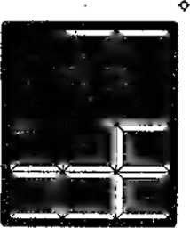
top ten hits of this location
miglimi
HIIHIIMI
letel ol IoIIbI ml
TOP TEN HITS—X
Al THIS.LÚCAliQfj.
TUNE NUMBER
PLAYING
■O|y.j r
1 .i *
RANK
credits
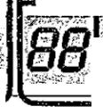
or L
■^{c}>
erroi
background
your selection
press
SELECTION

m «a j m i m «51 its m / its «o / ira o»
303

1 - T . ⁻ | 1 Pop ularlty -from 1 east |  | played 1:1 tic* upward
Display | Designation | • | Remarks x
POI | Number of least played CD. |  | Enter number ~o"  (Is switched on automatic ally).
 | Number of next least played upwards 10 the most piety ad | CD, ate. CD. | Advance with "T.
 | Rank of CO displayed. |  | Enter the number ”2'\  The next display corresponds to the rank of this record Example display “5" cor respond a to the fifth least played record.
• | Total of thfa CD played (max. 258). |  | Enter number ~3~. If a pop. counter la greater than 200 at "power off*, «11 counters are divided by 2 (normalized). An ^{m}r* appears on display 2 until the counters are reset (tha pop, display Is relative).
 | Information on a certain CD. |  | Enter the number "4*, tha desired CD number and “H". Tha desired Information on this CD can bo called up as described previously with the keys "1" throush “3“.
1 .1.2 Popularity, -from | best -tl-tle upwards
P02 Number of most played CD, | Enter number “O'  (la awltchad on automatically).
Number of next most played CD etc. down to the least played CD. | Advance with *V‘,
Rank of CD displayed. | Enter tha number *2”,  Tha next display cprresponda to the rank of thla record. Example display “5“ correspond® 10 the ffftri least played record.
Total of this CD played (mex. 255). | Enter number T: If a pop. counter is greater than 200 at "power off, all counters are divided by 2. An V appears on dlaplay 2 until tha counters are reset. Get actual popularity» multiply all by 2,
Information on a certain CD. | 1 ■  Enter the number “4", the desired CO number and *h\  The desired Information on thla CD can be called up es  described previously with the keys *1" through "3“.

OlepJay | Designation | Remarks | X
P03 | Cash balance In monetary (as programmed by the settings In P51 through P55).  5 digits. | Enter number "0"  <le switched on automatically). | X
 | Cash balance-accumulated 5 digits. | Enter the number "1".  value shown must be multiplied by 100 to get total monetary units. | X
P04 | Play counter | Enter number “0“  (Is switched on automatically). | X
 | Play counter, accumulated. | Enter number "1". | X
P05 | Number of selected title. | Enter number "0"  (la switched on automatJcaNy). | X
POO | Number of album selections. |  | X
^PO7^{r}Number of free credits.) |  |  | X *
PO0 Number of background titles. x
1.1*4- Counter and Cred l*t reset
PIO Total reset of popularity (P01, P02) the  KIT-parade, the counters P03 through POtì and credits. | Enter | number | ■v | and |  | X
Resetting the popularity (POI* P02) and HIT-parade. | Enter | number | ^{h}2" | and | "►r.
Resetting the counters <P03 through P08). | Enter | number | “3" | and | "H". | X
Cancel credits. | Enter | number | -₄- | and | "H“.

.1.5 Data transfer

>11 Data transfer and memory (storage) with the DATA PRINT.
(from Proör.-Index 004)
Plug OATA PRINT into "Service Socket" of control unit.
Enter Code ’V and "H\
Counter* (P03-P06) and popularity will be transferred.
01 splay 3 "E0^{M} appears In case of arror during data transfer.
Also see description DATA PRINT.

=>1 2 Transfer to DATA PRINT.
Note: If phonograph Is "coded*, only the decoded values are printed out unless the code number Is entered.
(from Progr.-Jnde* 003)
Plug printer Into the "service socket" on the oontrol unit. Enter
"1 ** = counters (PQ3 through PCS) or "2^{J>} - counters (PQ3 through POB), settings (P21 through P37, P39) or *3" « counters (P03 through POO), popularity (P01# PQ2) or
-4" = counters, settings, popularity,
If overflow has taken place, the popularity la relative, the multiplying of overflows Is printed out also.
If the Printer does not operate, "EO" appears on dlapley 3.

StreincJ ai-cf Settings
Remarks
Display
P20
Designation
Programming of etapa P21 through P39 (for factory setting see table 1).
Press “I” and ‘'H".
If values deviating from tha table are deilrad, they⁴ can be entered according to the following program stePe.
Standard table for specific settings In program step P20.
Tha following table shows the basic setting (factory setting) of tha phonograph.
Tab.~Na.Rf»utt In the Individual program ateo:
P21: 0000 * unit code (for recording device)
maximum choice CD/track (lOO CO'e/24 tracks) free credits
interval for random play In minutes Number of CD** for background
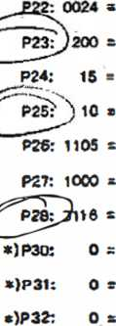
light organ during standby tight organ during play
P39: 0000
Only for models with light organ / luminous effects
maximum volume of both channels for coin selected titles and background CD No limit cf playing time for a title Playing In sequence of «election No limit on playing titles on the same CD
number (data and program setting* not coded)
s code
*>
from Progr.-Inde
x 004
.2.2 Code number 'for* DATA PRINT
P21 Machine code number for DATA PRINT
Enter code number between “IT*
and “9999“ as wall a*
.2.3 Position Settings
P22 Number of maximum choke CD's and tracks
Enter desired number between "0101“
100. tracks: “DC
and
as wall as "H’\ CO-ffT. 00 “ Example for 100 CD's / 24 tr
. 2.Free credits
P23 Number off free credits.
Enter desired number and "H“..
"0“ to "199": The number of free credits set can be
. released Individually by the FREE CREDIT key on remote control.
“200“: An unlimited number of free credits can be set and released by the FREE CREDIT key on remote control.
”201“: The phonograph is continuously switched to “free credits“ when the FREE CREDIT key is pressed (Credit Display "99“).
The phonograph Is switched back to operating mode whan the FREE CREDIT key is pressed again.

Display | Designation | Remarks |  | X
>24 | Time Intarvat for random title. | Enter desired time Interval between "0" and **255" minutes, followed by "H". (No random titles are pleyed when "0"  Is entered), |  | X
P25 | Number of background music CO. | Enter desired number between *'Ò“ and "100", followed by "K\  Background starta counting downwards starting with maximum number of CD's up (P22) to set number of background positions.  With setting "G*⁴ no background operation.
i •.
1.2.0 Light consola / Light Organ (Only for models wlth^ 11 g hit organ / lumlnou« effects)
* »
 |  | A B C D
P26  P27 | Luminous effects for "stand by mode", or  Luminous effects for "play mode" | - 0 0 1 Setting "A" corresponds to the switching  - l l 1 characteristic: "O’-slow to "1"~faat.  * ♦ ♦ * Setting "B" corresponds to speed of Inter- t 3 1 5 v*lg (0-3).  Setting "C-D* corresponds to the various types of light effects "1" through “15". Complete entry with the ^{M}H"-button. |  | X
P26  P27 | Continuous light for "stand by mode" or  Continuous light for "play mode" | 0 0 0 0 Setting "B" corresponds to the desired 4 brightness ("0" through "3").  3 Complète entry with "K"-butfon. |  | X
P27 | Light organ In "play mode". | 1 0 o 0 Setting "B" is for the desired basic 4 brightness ("0" through "3 ).  3 Complete entry with the ‘«"-button. |  | X
1.2-7 volumes for Regular |  | and Background Music
P2Ô | Maximum volume. | Enter two dig normally chos e.g.: 3 | Its each for desired maximum volume of en and background titles m well as "H". \ 24  r 7  * Background  —— Normal | X
.2.0 Max I m i-jm Playing 'Time
>30 | Maximum playing time for a title (from Progr.-lnd ex 004) | Enter desired time In minutes between 0 and 99 and then preis "M".  With "0“ no limit of playing time. |  | X
I .2.0 6equan oe of CD * « playing
=>31 | Sequence of CD’s playing (from Rrogr.-Index 004) | Enter Number 0, 1 or 2 then press "H".  - * In sequence of selection (FIFO)  - z In numerically Increasing sequence  - s random sequence |  | X  1

of ^TOhopmarfuafsvcorrr ^{CD}
Dlaplay | Designation | Remarks | X
P32 | Maximum of tunas plaed on the same CO (from Progr .-Index 004) | Entar des’/red maximum number of tunes played und than Press "H'\  With "0" no limit. | X
1-2.11 AuthorfZÄtlon
P38 Authorization. ^{Er,ttr} correct code number and "H“.
Eech of the four digit« 1« confirmed by “P". After closing with “H" °PPPP* Is shown and the operator Is theretay given authorization.
Only the correct code number enables access to protected data. After closing or cabinet or doing bach to reguler proorem by pressing "C" twice, the programs are protected again _{r}
1-2.12 Code number
P39 Code number. Changing of code number 16 only possible when operator x
has beer authorized In program step P38.
Enter new code number and ^{,T}H".
Each digit la confirmed after entry with "P⁴\ After dosing with "H“ "PPPP" la 6hOwn. Possible entries between “OOOO" and "9999",
If "0000“ Is programmed, the machine Is not protected and ecceaa to all programs is possible without authorization.
A programmed cede number la not 6how anymore, so please remember your oode number!
1 .3 | PRICE SETTINGS
1 .3.1 | 1 Stnn dard Settings, from Progr.-Index 00-4
P40 | Programming of tha program steps P41 through P44 (Standard setting). | Enter corresponding table No, and “H", x If values deviating from those In the table desired, they can be changed according to the following program steps (P41 through P46).
Standard settings for play a per monetary vaiua In program atep P40. The result of the Programming of a table ("0“ through ~r0") shows the number of plays per monetary value «located to the program steps Pit through P45. The monetary values ar programmed In monetary value units aa they are set In PSO through P55: example table 17, P41: If no bonus la to be given for a high monetary value, It Is sufficient to program only the small monetary value, the total of the small values results In the larger value; example table 17; 1 X 25 C a 1 play + 100 c s 7 plays.
Stondard settings for P4S * "0".
Table-  wo. | Display of Program Number  P41 P42 P43 P44 P4S  Sp/Qw So/Qw Sp/Qw Sp/Gw Sp/Gw | Remarks/  as set by the factory
0 | 00000 0000000000 00 000 00 000 | r.o coin conversion In this setting.
1 | 01 050 01,050 01 050 01 050 01 <*0 | New Zealand 1 ploy = | so c
2 | 01 020 01 020 01 020 03 050 03 050 | Belgium 1 play = 3 plays = | 20,- Bfr 50_{r}- Bfr | CD
3 | 01 005 01 005 03 010 03 010 07 020 | If desired, please adjust 1 play = 3 plays - 7 plays - | 5_{f}-  10,-  20,-
& | 02 050 02 050 05 100 05 100 12 200 | Austria 2 plays s 5 plays - 12 plays = | 6*- 08 10,- OS 20,- PS | CD

Monetary setting for electr. Coin Acceptor see chapter 10,
5. | 02 010 | 02 010 05 020 | “eoirropmwraals.com SK  12 plays |  |  | 3 |  | 1.- 2r . St- | DM  DM  DM | CD/-
« | 01 050 | 01 050 01 050 | 03 100 03 100 | USA | 1 play 3 plays | = | 2x  4x | 25  25 | c  c | ■(«£>
7 | 02 010 | 02 010 02 010 | 12 050 12 050 | Norway | 2 plays 12 plays |  |  | U-  5t- | Kr  Kr | CD
8 | 01 010 | 01 010 03 020 | 03 020 03 020 | Venezuela | 1 pi*y 3 plays (7 plays |  |  | V  2r  5,- | Sol  Boi  Bol) | CD
9 | 01 010 | 01 010 03 020 | 03 020 10 060 | Ireland | 1 play 3 plays 10 plays |  |  | to  20  50 | P  P  P | 0D
10 | 03 010 | 03 010 07 020 | 07 020 18 050  % | Switzerland | 3 plays 7 plays 16 plays | £ |  | V  2.-  5*- | sfr  sfr  sfr | CD
11 | 01 030 | 01 030 02 050 | 02 050 05 100 | United Kingdom Denmark | - Play  - plays 5 plays | - |  | 30  50  1 | p <3> s <3D
12 | 01 020 | 01 020 01 020 | 03 050 03 050 | Yugoslavia (Oln) Finland (mK) | 1 Play 3 playa | 3  3 | 2x | t.-  5.- | CSD®
13 | 01 020 | 01 020 03 050 | 03 050 07 100 | Union of South Africa France | 1 play 3 plays 7 plays | B  S |  | 20  50  V" | i
14 | 01 040 | 01 040 02 060 | 03 080 04 100 | Australia | - play  - plays  - plays  - plays | £  S | 2X  3x  4x | 20  20  20  1 | c  C  C  Dollar | CM)
16 | 01 025 | Ot 025 01 025 | 01 025 01 025 | Canada  butch Antilles | 1 play 4 plays | s |  | 25  1 | c  NAF Q | LSs*i>  D
16 | 01 025 | 01 025 01 025 | 05 100 05 100 | Spain (pts) | 1 play 6 plays | = |  | 0,25  It- |  | CD
17 | 01 050 | 01 050 03 100 | 03 100 18 500 | USA | 1 Play 3 plays 18 playa | ; |  | 50  1  5 | c  S  %
18 | 01 100 | 01 100 03 250 | 03 250 07 500 | Netherlands | 1 play 3 plays 7 ptays | n 4x |  | 25  2.5  5 | C  hfl  hfl | OD
19 | 01 too | 01 100 03 200 | 03 200 05 300 | Japan | 1 Play 3 playa 5 playa | 3  3 | 2x  3x | ioo  100  too | Yen  Yen  Yen | CD
20 | 01 040 01 040 01 040 |  | 03 100 03 100 | Italy | 1 Play 3 plays | 3 | 2x  2x | 200  500 | L  L | CD
1.3.2 Price List (Number of* |  |  |  | Selectlons/Mon etary |  |  |  | Veti ue)
Display | Désignation |  |  | Remark* |  |  |  |  |  | x
P41  P42  R*-*  R-<4B | Number of selections per coin (smallest value).  : t  Operating display are analogous to program step P41 |  |  | Enter desired number of plays coin (smallest value) and "H\  Entry sequence: 2 digits for number of plays. 3 digits for corresponding coin e.g. 01 020 correspond to one play for 20 pence.  Largest programmable number of play6 up to 63, price list from 005 to 995.  Note: Ail five program steps must be programmed with the price classes In the sequence or their priority. For less than 5 price classes program more than once or set to “00 000". |  |  |  |  |  | X  X  X  X  X
P4© | Number of album. | required credits for one |  | Enter desired number and "H". At "0" selection allowed. |  |  | no | album |  | x
Monetary wettings coinoDm?
Table-  No» | Display of Program Rumbe PÓ1 (IMI) P52 HMD | ir  P53 (Dtnd!) | P54 IQvdO | Remarks/  P55 (QewH) as set by the factory
15 | 100 020 10 Fr 2 Fr 1 £ 20 p | 010 1 Fr  10 p | 050 5 Fr  50 p | ⁰⁰⁰ CT)  France ^ ^{v}—-r  united Kingdom
16 | 050 010 5,- DM 1»- DM | 000  *r | 020 2,- 0M | 000  Germany | CD
17 | 050 010 5.- sfr i,- sfr 500 L (100 L) 50 c | 005  1/2 sfr (50 L) 5 c | 020  2,- sfr 200 L 20 C | 000  Svftterlanrf  Italy  New Seeiand | CD  <3D
18 | 100 050 10 dkr (neu) 5 dkr | 010 1 dkr | 100 000 bel 4-channel (1 A) 10 dkr (alt) Oenmark
19 | 200 050 20 S 5 S | 0(0 1 S | 100 10 5 | ooo  Austria | CD
20 | 025 250 500 25 C 2 1/2 hfl 5 hff |  | 100 1 hfl | 000  hetherladtd | CD
1 --4.2 | Monetary Val ues C A. Il ocatod through ©> |  |  | to co 1 n channels 1
Olsplay | Designation |  | Remarks | ♦ | X
PS 1  P52  P53  P54.  P65 | Coin value channel I. \  Operation and display are analogous to program step P61. | Enter desired ooln value for channel 1 and "H". Example: "010" corresponds to 10p, "020“ to 20p and Monetary Setting “100“ corresponda to t £.  for Note: When a coin Is Inserted In the program steps electr. Coin P50 through P55 the channel assigned to this coin ' Acceptor see la automatically displayed on display 1; P51 for channel chapter 10, 2 etc. to P5S for channel 5.  1 Not used channels are set to *0"J  The progrfvrvned monetary units for P51 through P55 1 must correspond to the unit programmed by the cash counter P03>, e.9. 050 units for 50p, 020 units for 20d and 100 units for 1 £. |  |  | X  X  X  X  X
P56 | Bonus credits for bills. |  | Enter desired number and "M~. when a dollar bill Is Inserted (Channel 5/P55>, the programmed value Is added to the credit. |  | X
The displays In this program step actCAlPQPPTS'Q U£pn«r.w-uun.* - -
In the event of a malfunction the defective unit can be determined or a malfunction resulting from Incorrect settings can be recognized in a simple manner with the aid of these tests. Certain displays are elds for the adjustment of the playing mechanism.
Switch on test program: Open ceblnet lid pull out Interlock cabinet «witch Display 1 shows "POT, press letter ”C\
Display 1 shows "P".
Press number 60 and "H^{M}, Display 1 shows "PEO".
.5.1 Dlsplay Test, Display 1 *’ F⁻¹ ©O'
This program tests the lights and appears on display 2.  The test Is run through In steps:  The FI" Is displayed for approx. | displays on the display circuit board. After starting "FI" (first function test)  - All S display lights together.  - The digits are switched on one after another Individually with "8’'.  - The display lamps 1 through 5 individually.  - Displays together, running through the numbers "0° through ^{M}9".  2 seconds before the test repeats, Itself.
Designation | Remarks
Display test -continuous test-. | Enter "1" and "H\ Display 2 "F1".
6top test sequence. | Enter "H". The li&ht "10 top hits' comes on.
Contlnne test sequence. | Enter "h" again. The light "10 top hits" goesoff.
Terminate test. | Enter "C" once, display 1 "P60^{M} or actuate cabinet Switch, the unit returns to the regular program.

,5.2 Input Test, Display
P60*
In the following test the functions of all entries of input Ports 1-6 can be tested*.
Port 1, Port 2 : Control Unit
Port 3 : Keyboard (Display Board)
Port 4, Port 5 I Pickup Driver
Port 6 ; Title Indication
Every Input change is shown on the display as follows;

Enter ^{M}2" and "M", Display 2 "F2* (second function test). 2 3
Input Teat
Display

 | z | X | X
F 2
ICS
IC9
1C 304 1C 1
1C IC
2
Bit Information -(Switch Status
-Bit-Number (0
-Por t-N umber;
Control Unit Control Unit Keyboard Pickup Driver Pfckup Driver Title Indication
1 or 0) to 7)

Meaning of the displays:
 | 1 | 6 | 0
"F2" * Input Test *T “ Port 1 (ICS)
'6" s Bit 6 (Key Switch)
"0“ s Switch Status 0 (closed)

Instruction: The accuracy of the Inputs from tho keyboard can bo checked due to the entry Connections simply by selecting a title!

Enter "C" 1, display P60" or actuate cabinet switch, the phonograph returns to the normal program.
Terminate test.
312
mm/maw ro«/as m/l* mo/row

UNIT DESCRIPTION CONTROL UNIT FOR NSM-PHONOGRAPGHS
m xv-c© Tscmxum

74 903 74 831
- 486
- 274
- 040
- 046
to
Technical Information, Assy
SILVER CITY
SILVER SKY
FASCINATION
SOUNDMASTER
FIREBIRD/COUNTRY
THE PERFORMER "GRAND"

1 | FUNCTION
1.1 | Control unit
1.2 | Processor
1.3 | Reset
1.4 | Low voltage recognition and power off
1.5 | I/O (Input/output)
1.6 | Output enable
1.7 | Service plug
 | Spare parts list
 | Schematics CONTROL UNIT CD
1-1 CONTROL- UNIT
The heart of the control and credit unit is a microprocessor from the proven Rockwell 6500 family.
All unit’functions such as keyboard, display, remote control, carriage (light generator / organ), coin mechanism, title indication etc. are controlled by this unit.
Different types of malfunctions are recognized and reported as such on the display. All statistical data such as phonograph status, price adjustments and bookkeeping data are stored In the CONTROL UNIT. These as well as credits remaining are stored when the power is switched off.
Connection of the DATA PRINT is provided at Plug 11.
A number of service programs allow the read-out of statistical data, Individual as well as test programs.
.2 Rr~ocesso

The processor consists primarily of the microprocessor IC 2, the battery RAM IC 3 and the I/O component IC occurs via IC 12.
IC 1. the EPROM 4. Address coding
(4 MHz) and the
The tact generator consists of a quartz oscillator with Q frequency divider (1:4) IC 14.
3 Reset

The Zener diode ZD 2 with transistors T 1 and T 2 serves to activate the reset when U (+5 V) is less than 4,6 V.
Transistor T 2 with Its antenna connection serves to recognize static discharges and Interferences.
When T 2/C is LOW, reset is activated via IC 16, Pin 10, Pin 11. HIGH, reset remains stored for approx. 200 msec, over the monoflop 1/2 IC 13 with timing components R 14, C 19 vis IC 16,
If T 2/C is subsequent Pin 9.
1 .A- Low Voltage Recognition and Rower-
Off
Resistors R 15, R 16, R 18 from a voltage divider for low voltage
recognition.
R 17 and D 6 generate a hysteresis when the voltage rises again. The positive edges (10 msec, at 50 Hz, 8.3 msec, at 60 Hz) coming from T 3/C retrigger the monoflop 1/2 IC 13 with timing components R 20, C 20 (approx.
20 msec.) and IC 13, Pin 4 at LOW.
This signal is monitored by the processor via IC 4, Pin 6.
When IC 4, Pin 6 is HIGH, the program is prematurely deactivated.

All I/O operations are controlled via a serial bi-directional Interface (IC 4, Pin 18 = CLOCK; IC 4, Pin 19 = DATA). IC 18 selects the different input
channels; IC 11 decodes the load Impulses for the output channels.
Output: IC 5 and IC 6 are output ports.
Resistors R 22-40 together make two D/A converters. The DC signals obtained thereby control the volume and are conducted to the amplifiers via plugs ST 2, Pin 2, Pin 3.
Input: IC 8 and IC 9 are Input ports.
The resistors, In sequence to the Input pins, protect the CMOS components.
Serial interfaces are available:
At ST 3 for control of the light generator
At ST 4 for display and keyboard
At ST 8 for control of CD changer
At ST 10 for control of Title Indication.
- Output — Enable
A clock signal is sent by IC 4, Pin 5. Capacitor IC 26 is charged keeps IC 15, Pin 8 at LOW.
If the clock signal does not occur, IC 15, Pin 14 is LOW and OE of IC 5 and IC 6 is inactive (outputs In tree state).
OE also become inactive via D 1 when reset (IC 16, Pin 11) becomes LOW.

- Service Plug ST 11 serves to
Plug connect with the DATA PRINT.

8
¡e
8
¡e
5
Q
§
j*
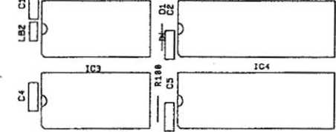
ICS C6 (C4
CONTROL UNIT CO
*IC2
STll
> |  | i
) | II
 | icn L
IC12
IC17
IC13
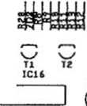
BBUy
th
1
bis ^{ICIS} i
L|o | >
icm ci icia
£
m
^ £|Eb
Tfll
T5
&
mum
]U. -C i^{Q(}—
3 ICl4 ^
]M* e=i[> nmma
MiMWI C
O
&=□ D:
IC23 1C24
NSM
IC15
ica
>

iczc ^{lcn} cm ^{1CZZ} n “ ,
ISZC
o
•<
DC
LCD
ci6 ST 1
ST2
ST3
ST4 ST8 ST5 ST 6 ST7 ST9

174 873 CB-CONTROL UNIT CD. ASSY

225
225
225
225
225
225
225
225
225
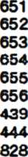
PANEL | 4 | prongs
PANEL | 6 | prongs
PANEL | 8 | prongs
PANEL | IO | prongs
PANEL | 12 | prongs
PANEL | 15 | prongs
PLUG | 3 | prongs
PLUG | 8 | prongs
ST 07 ST 03.06 SI08 STM ST01 ST 05 ST 06 ST 06 ST 11
PIN PIN PIN PIN PIN PIN PIN PIN
D-SUBMINIA7URE-CONNECTOR
SLEEVE 9 prong:
221 535
Qt
IC 3
IC2
OSCILLATOR QUARTS
IC-SOCKET
IC-MEMORY
4 MHz
24 prongs HK48 Z 12-20
446
423
222
231
222 447 175 102
28 prongs AM 27 256 DC
IC-SOCKET
IC-MEMORY
Program 007

P 2 P 2
2
2
3
IC 1,4 222 448
ICI 231 413
IC« 231 415
IC U 221 763
IC 5,6 221 771
IC 21-23 221 541
t16 221 665
IC » 221 525
IC 17 221 652
IC 14,50 221 705
ICH 221 792
ICC 221 653
K16 221 852
IC 11 221 796
IC 1$ 221 813
IC 26 221 497
IC-SOCKET IC-MICROCOM PUTER IC-MICROCOMPUTER
IC-CMOS
IC-CMOS
IC-CMOS
IC-TTL
IC-TTL
IC-TTL
IC-TTL
IC-TTL
IC-TTL
IC-TTL
IC-TTL
IC-LINEAR
IC-LINEAR
40 prongs R 65 C 02 R 65 C 22
HEF 4021 B HEF 4094 B F 4049 BC SN 74 LS 00 SN 74 LS 03 SN 74 LS 04 SN 74 LS 74 A SN 74 LS 123 SN 74 LS 139 SN 74 LS 151 SN 74 LS 138 LM 339 ULN 2003 A

!21 115
03 01, 4-i ZU 1 20 2 1(0
221 114 221 539 221 948 221 466
SI-DIODE
SI-DIODE
TRANZORB DIODE
ZENER-DIODE
LIGHT EMITTING DIODE
1 N 4004 1
1 N 4148 16
IC TE-5 1
ZPD 3,9 1
LR 3160-F 1

2
2
T1, t 221 757
- 221 283
TRANSISTOR BC 547 B
TRANSISTOR BC 212 B

220 181 220 242 220 185 220 263 220 341
C 22 C23 CM C 16,28 C 21 CMS, 25,27 C B, 20,
220 334
63 V
63 V 63 V 10 V
220 159 220 162 220 160
26
C !i C11
RU,
116
R12,1! 73
221
600
099
622
029
031
033
- 172
\ W
i w i w i w Ì w
221
221
221
221
R 93 R 10, 87 R13 R 2-6, M, 106*18)
R 84. 88, 89,34, 110,101, IDS, 113 R1,15 R 11, 18, 20.47,
74, 76,
82, 63, 90-92, 96,111, 112, IK, 115
R16,21, 27,13*40 73,75,
85
R17 R 22*26, 28*32, 41-72,
98,99 R 14,81, 88,95 R 80
221
i W i w
i W
221
221
22
036
604
601
038
048
273
i W
i W i W
i w i w
i W
221
221
221
221
221
CE R.-C APACITOR 47 pF
CE R.-CAPACITOR 68 pF
CER.-CAPACITOR 270 pF
CER.-CAPACITOR 1000 pF
CER.-CAPACITOR 4700 PF
MKT-CAPACITOR 0,1 pF
LYTIC 4,7 pF
LYTIC 10 pF
LYTIC 100 pF
RESISTOR 100 0
RESISTOR 470 0
RESISTOR 820 0
RESISTOR 1 Kfi
RESISTOR 2,2 KQ
RESISTOR 3,3 KQ
RESISTOR 47 KO
RESISTOR 100 KO
RESISTOR 10 0
RESISTOR 4,7 KO
RESISTOR 8,2 KO
RESISTOR 22 KQ
RESISTOR 27 KO
RESISTOR 10 KO

^ X 2 Sßö
*§2 —
B SB S ux 3gR
S biôi
8 3? S ST5
^•7: X vuMiiuuiw , ¹ -‘ H w W » «r» S«IK» j ,_
H 8 9 UnmUW i' I—
Mil» n IK 1 .
sf Zi 5 «MH I ** P, %. O«' ' f-
M¡0IUS*WI1S¡_ -l£.
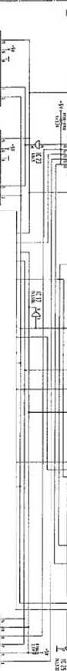
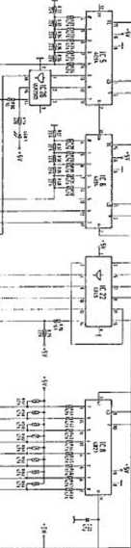
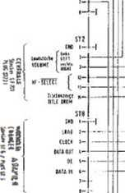
sí"
It
« till
j-
' Mme / MMKi I §f - «ma / :«*. ;
imx/cumi
f? *• vwi I íilIHi i §" .K
—2 - «
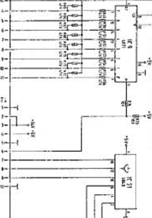
hoAKMM £>rçeM UH*«* 7.1S mi-
itXl r- ®8J *■<
iua
fWIÎCIÔ
mti
ICI«
SiriT
:
««
- uv
- a* •ÎT us
ils II IIS ce
cwu
;c*
us
¡I
© :•
171 ^{s}? *1 Pli • 5? ?! h gl
V 1" ^{ä|} í»i ^{f} ¹ a M
PS? p-i ^{r} s 2 =ï ^
r- o -Si
ì * I 1
- U S 5 5
«fil
ï**i
f
mi
H ^
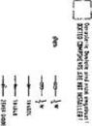

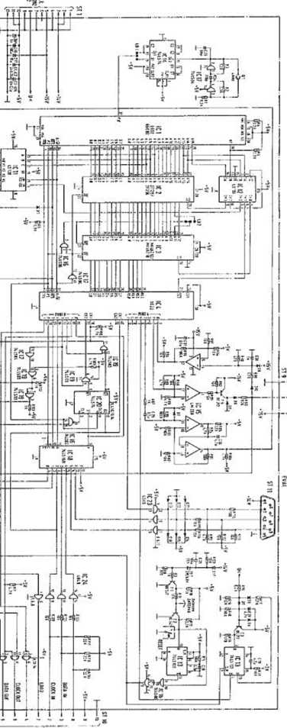
o
o
i
p
IÛ)
ID
c
(/>
b
o
1§ ³
«a
lì
RS
» C
S3
I
1
«il
I'«
éJ¡
£
I

UNIT DESCRIPTION

DISPLAY/KEYBOARD FOR NSM-PHONOGRAPHS
38 ¡T9-® S3 tSBÈBWBS

to Technical Information, Assy 174 903 SILVER CITY 174 831 SILVER SKY
- 486 FASCINATION
1 75 274 SOUNDMASTER
- 040 FIREBIRD/COUNTRY
- 046 THE PERFORMER ‘GRAND’

5
Page 501-505/511
ttnjpHt
Saarlandstraöe 240 BÏÏ Bingan am Rtwin

IND EX
1 FUNCTION
- Display
- Keyboard
Spare parts list
The shift registers IC 301 through IC 303 are the output ports for the display control.
The display is operated in the multiplex mode.
The segment information Is prepared for one digit with IC 302 and IC 303 via drivers IC 308 and IC 309.
The transistors T 303 through T 305 are controlled by IC 307 via IC 301 and switch on the appropriate multiplex level for 4milliseconds.
Resistors R 332 to R 345 determine the segment current.
Lamps L 1 to L 5 are controlled statically via IC 307, Pin 12 and 14 and IC 306, Pin 19, 11, 12.
Resistors R 325 to R 329 limit the transient current.-;
The load signal for the output shift registers is monitored by circuit IC 306, Pin 4 and 13; R 306; C 303; D 301.
During the duration of the load signal the display is dark.
C 303 is discharged via D 301 and IC 306, Pin 13.
OE of IC 301 to IC 303 becomes LOW and thereby inactive.
If no load signal occurs, OE becomes inactive via R 305.
Capacitor C 302 avoids lighting up of the digits after switching on.

1 .2 Key board
IC 301 is an input port for the keyboard which Is connected 302.
to plug ST T 307 codes
The circuit with diodes D 302 - D 307 and tranfeistors T 306, the keyboard matrix to a 4-bit signal combination.
ST381
5T302
□ CH5
JIL
r~~icn<
flT'
o
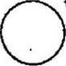
^¡lili lllsV_y 116 il
n  a  T3M | a | \ T»
sÿ***¹
BZH BIT *t% ftZT
«4 m, nt mi _{E2}£ > v O
BHBH~Oi
150» O
O
Mil
Jl
n
6L

u

POS. PART-No. DESCRIPTION DATA QTY
ÇB-DISPLAY CD. ASSY
173 664

p;
P
ST 302 225 553
ST 301 225 664
PANEL 8
PANEL 10
prongs 90 1
prongs 90* 1

«1-8 231 416
TD SL 5150
DISPLAY

TUBUS
HOLDER
173
171
384
629
1
4

573
771
763
491
1
3
IC 310 221
ST 301-303 221 IC 304 221
ST 306-309 221
IC-VOLT AGE IC-CMOS IC-CMOS IC-LINEAR 12 V 1 A HEF 4094 B HE F 4021 B ULN 2003 A

0 301-307 | 221 | 114 | SI-DIODE | 1 N 4148 | 7
20 391 | 231 | 079 | ZENER-DIODE | ZPD 4,7 | 1
7 »1-306 | 231 | 240 | SI-TRANSISTOR | BC 636 F | 5
1 306, 307 | 221 | 283 | SI-TRANSISTOR | BC 212 B | 2
MKT-CAPACITOR 0,1 nF
63
63
63
63
i W i W
2
w
w
w
w
T 303-3ÛJ 220 334 C3CS, 3» 220 332 C 302 220 249
C3ÔI 220 162
R 381 221 611
R 306s
332 350 221 627
R 302-304,
301-309,
314-117,
319-323,
354 221 033
R 310-113 221 038 R 3CS 221 009 R 325-329 231 366
MKT-CAPACITOR 0,33 PF
LYT1C 1 pF
LYTIC 10 pF
RESISTOR 10 O
RESISTOR 1,2 KQ
RESISTOR 3,3 KQ
RESISTOR 47 KQ
RESISTOR 1 MQ
MET.-RESISTOR 10 fi

173 900 KEY BOARD, ASSY

_{r}.
1“
ifl
t=»
oc
li
IS
w
S'S
■<( C3
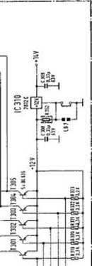
fe §
I I I ~ %
Ü s *“
Ï St»
IL. 5S 5»
sg 3» ¡“¡
* = sis CO
gS?5 " *1 S| gs
lisi ¡1
Ig 6k 2s
IIii si *©
« =j
•f|
}
i
is
15
■25
Is
X
II
2:
•=i
si
S.U
~J
—. é
gioì 5® 2 . 5© ®
§ »Ëà
I
s(g) sE - 3E <S> 3E SE
■H
i
?
11
If
i!«
ili
iíí
il
U , M
1 ill 0 ?ï©o
•ÜJ-
II
is
IS
ttT
ï-îT
iv'E'i
IÏÎ
Q
_{V}J“
5 ® ul
Q.|—
Sq
3S
>-
jp<t
sg
<t o C3
iS
If
«Í 3
Ü2
"t
i'

OE
I-cbIS

83
!ä
S
s-
o»
•■**
S»
88 8
*e s
is i
«« ■£
s§*
ss_s
55»
ß» ¿K
2 5«
ff« »
gí ç

.si.
s
i
en Ç co "
5=>et
•D"
co
CO -T en g
U³rv
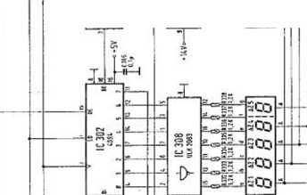
T
JL
SI
¥
T
fr
•■*.
2
x
5
a
7;
x
V
Ä
5
s
t
L=.
£
&-Ä
fc-A
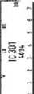
*ZE
« *5
o £.-
, «i
Q.
O
Z
5
P
5
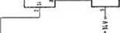
S
-i-l
§5
■»-I
k
T s * h"h
sco ■4 co Seo SCO SCO
^{L}^fr
•<S^

u.-
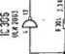
Si
A
H
Hl-I
5=

153

Ì ?
*¿S
H—
I“
¿I
If
•d. <*
la

C-O
co
H
a
Ils

UNIT DESCRIPTION CENTRAL UNIT
\

FOR NSM-PHONOGRAPHS

to
Technical Information, Assy
174 903 SILVE
174 831 SILVErc 5>M
- 486 FASCINATION
- 274 SOUNDMASTER
- 040 FIREBIRD/COUNTRY
- 046 THE PERFORMER "GRAND"

Itcpttl
Saartmdstraflt NO 5538 Bftgen n Rhein
6
Page 601-611/621

INDEX
1 | FUNCTION
1.1 | Power Supply
1.2 | Amplifier
1.3 | Signal path
1.4 | Adjustment of controls
1.5 | MIC socket, microphone connection
1.6 | TB socket
1.6.1 | Tape recorder connection
1.6.2 | Connection of auxiliary amplifier
2 | Adjustment instructions for trimmer of central unit and output stage
3 | Repair aid
3.1 | Output stage
3.2 | Control of volume and muting
3.3 | Tracing sound signal

The power supply, fan controls, stereo amplifier with inputs for microphone, CD and tape are all integrated on one circuit board.
The output stages and the fan are connected to the central unit via ST 209, ST 210, ST 211. The music power per channel is 200 watts when matched to a loudspeaker impedance of 2 ohms.
- Rower Supply
.The power transformer supplies 22 V, 2 x 11,5 V and 2 x 43 V from three separate secondary coils. The supply voltage for the output stages Is supplied with 2 x 43 V by a two-way rectifier (D 206) and the center tap of the transformer.
The supply voltage for the voltage regulator VR 201, +5 V Is supplied with 2 x 11,5 V by a two-way rectifier (D 201/202) and the center tap on the transformer. The tow voltage recognition is accomplished by D 204 and D 205. Fusing is accomplished with Si 201 and SI 202. Fusing for the output stage Is accomplished with Si 204 and SI 205.
The non-controlled voltage +14 V for the display and key Illumination is being picked up at capacitor C 201.
The control voltage of +15 Va, for the pickup driver, coin mechanism, control unit, remote control, luminous effects as well as the supply voltage for the preamplifier of +15 Vb, are supplied by the 22 V transformer coll and rectified by D 207 through 210 and VR 203. Fusing is accomplished by Si 203.
The LED’s indicate the following supply voltages at the same intensity:
LED 201 = + 5 V
LED 202 LED 203 LED 204 The TRIAC
+60 V + 15 V a +15 V b TIC 200
controls the output stage fan depending upon the operational state of the amplifier (REJECT); i.el the fan only runs when the amplifier is not muted.
- Amplifier
The stereo amplifier is equipped with two tone control ic’s, one AF switch IC, 50 diodes and 17 transistors.
The output stage is designed without Induction coils or transformers and is therefore Ironless.
At full volume level the music power Is 200 watts per channel.
3 Signal path
to microphone amplifier T 230 and background 4 and B of IC 230. The TB input is connected to is connected to Pin 2 and Pin 6. goes from Pin 2 to Pin 15 respectively through
The Input signal MIC goes mixer of TA, TR 231 to Pins Pins 3 and 7. The CD input In the play mode the signal Pin 5 and Pin 9.
When the microphone switch is actuated, the signal goes from Pin 4 to Pin 15 or from Pin 8 to Pin 9.
In the tape mode (TB/Pin 6 to ground) the signal goes from Pin 3 to Pin 15 or Pin 7 to Pin 9 when the switch is actuated. In the MIC, CD or TB stage, muting is switched off regardless of the operating state of the phonograph. The stage '■MIC" has priority switching.
From the AF switch {IC 230) the signal goes via an AVC (automatic volume
control) T 250, T 251 at Pin 9 of the tone control IC 251 with associated basé booster. Treble control Is accomplished with TR 252 and bass control with TR 253. The control voltage for the volume and muting is on Pin 5; approx. 2,5 V at full volume, approx, 0 V while muting.
The 0C signal for the volume setting is supplied by the control unit.
Signal Output Pins 3 and 6 of IC 251 are routed through a network to the
driver stage for the output stage.
The parallel complementary power Darlington transistors T 151 through T 154 In the output stage allow a minimum loudspeaker Impedance of 2 ohms. Quiescent current compensation and thermic stabilization Is accomplished with T 150, the quiescent current setting with TR 250. The amplifier Is equipped with three protective circuits against overload mismatching, thermic overload.
- ) T 155 acts as a threshold switch for the electronic fuse. When the emitter current of the output transistors exceeds a certain value, T 252 is switched through by T 155 switching on the muting and thereby limiting the current.
- ) The actuation of the electronic fuse at collector T 252 is controlled by the control unit.
When its fuse Is tripped a number of times within a certain period, the volume Is reduced automatically by one step each time until the electronic fuse Is no longer activated.
- ) The thermal switch on the heat sink switches off the power supply to the output stage when the heat sink temperature reaches approx. 90 C (cooling malfunctioning). LED 150 Is dark. The switch-on point (following cooling down) Is approx. 60 C (switch-on hysteresis).
The terminating impedance at the loudspeaker output should not be less than 2 ohms. In the case of mismatching (less than 2 ohms), or short-circuit in the loudspeaker cable, the limiting circuit Is actuated.
The result Is distorted sound reproduction or reduction of the volume. After elimination of the mismatch the amplifier Is ready for operation and the volume can be readjusted.
The volume difference between the two channels is compensated at the factory by setting the levelling potentiometer TR 254.

1.4- Adj ustment of Controls
TR 230 - microphone volume
TR 231 = music fade-in for microphone mode
TR 252 = treble control
TR 253 = bass control
TR 230 for setting the microphone amplifier:
This adjustment is dependent upon the position of the phonograph in relation to the microphone and required microphone volume.
In case of feedback while paging, the control must be turned counterclockwise or the microphone be positioned In another direction to the speakers.
TR 231 for music fade-in in microphone mode:
There.the desired music volume level during paging can be controlled.'
TR 252 R and TR 252 L, treble controls, are to be set
according to the rooms only, according to the
locations. .
The maximum.position Is suggested In acoustically balanced
TR 253 R and TR 253 L, bass controls, must also be set locations and the desired bass reproduction.
- 5 MIC socket, Microphone Connection
A dynamic microphone with an Impedance of 200 ohms - 600 ohms with switch for relay control can be used.
NSM option accessories:
Microphone Order No. 224 223
Connection cable Order No. 171 880 (10 m long)
_© T E3 Socket
-5-1 Tape Recorder Connection

The TB socket allows the music from the phonograph tape recorder as well as music from a tape recorder phonograph.
to be recorded on a to be played by the

The AF signal (analog signal) for recording with a tape recorder is on Contacts 1 and 4 and can be connected directly with a stereo diode cable; Contacts 2, 7 and 8 (8 is ground).

- 6-2 Connection of Auxiliary Amplifier
An auxiliary amplifier can be connected to the TB socket. The AF signal can
be fed directly from the TB socket (Contacts 1 and 4) to be Input of the
amplifier with a stereo diode cable.
The input sensitivity of the external amplifier should be 200 mV at a minimum Input impedance of 47 KOhms.
Note: A stereo diode cable with a 5-pln plug is suitable for the above
connections. In this plug Pin 1 must be connected to Pin 1; 3 to 3; etc.
The stereo recording cable is not suitable because in such cables Pin 1 Is connected to 3 and 4 to 5 (crossed).
2 Adjustment Instructions for. Trimmer of Central Unit: and Output Stiage
TR 150 for quiescent current adjustment of the output stage: The quiescent current must be set to 40 mA +5 mA. After replacement of the output transistor T 151 through T 154 a correction may be required.
Important! Muting is to be switched off for measuring and setting. The lift will be put In play position, the volume control is set at 0 and Si 150 or the thermal switch are repfaced by an ampere meter.
TR 201 and TR 202 for adjustment of volume control voltage:
Maximum volume for regularly selected titles in program step p 28 must be programmed to "31 “ (full volume).
Take measurements at test points TP-L and TP-R to ground; nominal value =
- V (factory setting).
The Internal resistance of the measuring Instrument must be greater than 1 MOhm!
After replacement of IC 251 a correction may be required.
TR 254 R and TR 254 L, level controls for adjustment of the total amplification: Set at factory to correspond to the output voltage of the CD player.
Muting must be switched off. Volume, treble and bass set to maximum.
The output voltage on the loudspeaker connection with a load of 4 ohms is approx. 10 V - 25 W power per channel, with the AVC at full level. At minimum Impedance of 2 ohms the RMS output corresponds to 100 W RMS or 200 W music power at disc playing.
3 Repai r Aid
Amplifier integrated in central unit ES IV Malfunction: No sound, no output power:
It is assumed that LD 201 to LD 204 glow with the same Intensity and that
the power supply is therefore O.K., the CO Is on the CD player being,
played, and normal volume was set in program step P28 to "31".
- 1 Output Stage
LD 150 on the output stage circuit board is dark. Malfunction probably located in. the output stage; check Si 150 and replace if required. If the fuse blows again, the output transistors are defective.
Remove output stage unit, pull out cover plates on the bottom. Check for
short-circuit on transistors T 151/T 152 T 153/T 154 with ohmmeter. Since the transistors are connected in parallel, It Is only possible to test them In pairs.
For individual testing one transistor must be unsoldered from the defective pair. After replacement of the defective transistors the quiescent current must be readjusted with TR 150 according to the adjustment instructions.
  - Control o'f Volume and Muting
In the play mode approx. 2,6 V must be measured on Pin 5 of IC 251 (for full volume).
If the voltage is near 0 V, T 252 or the control "volume L and R" from the computer must be checked (reject line).
3_3 ~T r~a ci ng Sound Signal
Trace the sound signal arriving at CD plug according to the table.
The point where the signal is missing is probably the cause of the malfunction.
AF Signal Point | Cause of Malfunction When Signal Missing | >*•
C 237, C 238 | IC 230
IC 251, L/R Pin 9 | T 250 / T 251 (AVC)
R 269, L/R (2,6 V am IC 251/ Pin 5) | IC 251 L/R
T 255 L/R (collector) | T 253 L/R | •i
If the signal is there up to T 255, but no output signal arrives at the output stage, plug connectors ST 210/211 as well as th.e output stage have to be checked.
o
& 8 M _ M
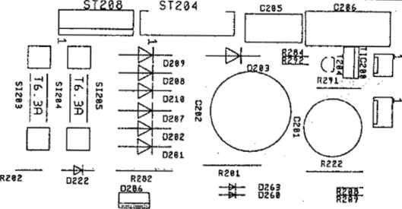
co
—<
r\>
o
O
to
—4
r\>
CD
U)
□
□ □ “4 “4
u) ¡2 ro
r» J)
S *
□ □
en
—i
ro
09
ro
w !2
ro
ro ®
S ^{M}
□
§0 ¹ °Q I
wl y tn
5^ S
ro
CD
*
w
-4
no
®
h*
0204
3È
IC273U Ü255L —* y «I^{ra} (]{! H
R283
“K?¥SU
R276L
ctr7¿ rj CZ73R S
-4
, -ro
r"
en
—i
no
es
W
en
—4
r\>
CD
er«
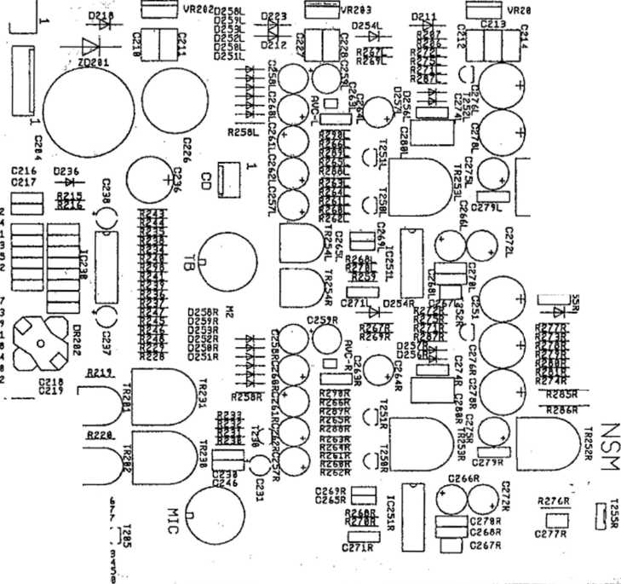
c
£
■ç
ä
et
C?'
C
Q
3
~'R28£L"
D
CZ3I
C23
CZ4
CZ3
C23
CZ4
CZ4
CZ4
CZ3
C28
CZ4
CZ4
CZ4
C28,
\
en —» ro
CD
en
O
n
;z
-H
PO
D
r*
n
i
o
o
cia
—4
-ro
Cls
cm
i—i C=J cm
,[râS
>CZZ1 j C2Z2 )
* —W— OZI —&f-~ 023
Râfc ⁰²¹ gztfcr (
OZI M- • OZI W -- OZI Z025
■o
i
70
-Í
T>
174 903 / 174 831 / 174 486 / 175 274 / 175 043
eo©

173 666 CENTRAL UNIT. ASSY 50/60 Hz

FUSE
FUSE
FUSE
by 50 Hz T 2,5 A T 3,15 A T 6,3 A
538
029
374
SI S3 225 SI 201, 22 225 SI20i, 205 225
1
2
2
SI 203 225 220 FUSE
SI »1,22 225 225 FUSE
51 205 225 218 FUSE
by 60 Hz
T 2,0 A T 3,2 A T 6,25 A
1
2
2
COOLING PLATE FUSE HOLDER PROFILE, ASSY SHIELDING COVER
SOCKET
SOCKET
17 3 730 8 2012« 225 689 173 698 173 944
1
0
2
1
KIC
79
225 244 225 749
S 5 Mab
prongs 8 SV
225 439
PIN PLUG RM 2,5 3 prongs
Sì 209 ST 203, 206, CD ST 205 ST208 ST207 ST 200 SI 2W, 210,211 SI 20? ST 201
1
>
3
1
1
1
1
>
3
1
1
PIN PLUG PIN PLUG PIN PLUG PIN PLUG PIN PLUG
225 418 225 443 225 804 225 444
225 807
RM 2,5 RM 2,5 RM 3,96 RM 2,5 RM 3,96
4
6
6
8
12
10
12
15
prongs
prongs
prongs
prongs
prongs
pron gs prongs prongs
225 654 225 714 225 656
PIN
PIN
PIN
PANEL
PANEL
PANEL
RM 2,5 RM 2,5 RM 2,5
VR 3)1 221
VR 202,233 221
572
476
IC-VOLTAGE
IC-VOLTAGE
+ 5 V + 15 V
1 A ,5 A
1
2
JC ¿jo 1C 251 RL D 201-202, 207-120 0211,212. 218, 222, 223,254 RL, 255 RL D 204,205, 213-217, 235, 237, 251-253 fit, 256 RL D2G6 ZD 201 10 20I-2G4 TIC 200
IC-LINEAR
IC-LINEAR
SI-DÎODE
231 236 231 089
TDA 1029 TDA 4290-2
BY 251
1
2
>
221 463
>
9
>
>
>
SI-DIODE
221
5
N 4004
SI-DIODE SI-DUO-DIODE TRANS20RB-DI0DE LIGHT EMITTING DIODE TRIAC
221 114 231 202 221 821 221 466 231 028
1 N 4148 BYV 32/100 TVS 515 LR 3160-F TIC 206 D
27
1
1
4
1

63 V
63
10
40
10
25
40
25
25
40
LYT
LYT
LYT
LYT]
lyt:
LYT!
LYT
C 253 i | 220 | 342
C 277 Rl | 220 | 185
C 287 RL | 220 | 274
C 241, 242 | 220 | 241
C 246 | 220 | 263
C 243, 244 | 220 | 400  401
C 269 RL | 220 | 400  401
C 218-222,
265 Rl,
279 RL | 220 | 435
C 268 Rl | 220 | 429
C 270 Rl | 220 | 335
C 2*. 217,
230, 234,
235, 239,
2«, 271 RL,
273 fil, 28L
282 | 220 | 334
C 274 ft. | 220 | 333
C 210-214,
227, 22k
230 RL | 220 | 332
C 206 C 206 | 220  220 | 336  450
C 258 RL,
259 RL | 220 | 243
C 260 RL | 220 | 249
C 231, 237,
238, 257 RL,
262 RL, 284
RL | 220 | 159
C 261 RL,
286 RL, 275
RL | 220 | 162
C 272 RL | 220 | 389
C 278 RL,
278 «. | 220 | 158
C236 | 220 | 160
C 251 | 220 | 250
C 226 | 220 | 289
C 201 | 220 | 283
C 202 | 220 | 286
C 204 | 220 | 287
T 204,253
RL 221 459
I 230, 250
11,81ft 221 249
7 255 RL 221 488
7 252 RL,
206 221 332
SI-TRANSISTOR
SI-TRANSISTOR
SI-TRANSISTOR
SI-TRANSISTOR
CE R.-CAP ACIT OR
CER-CAPACITOR
CER.-CAPACITOR
CER.-CAPACITOR
CER.-CAPACITOR
KT-CAPACITOR
KT-CAPACITOR
MKT-CAPACITOR
MKT-CAPACITOR
MKT-CAPACITOR
TAN-CAPACITOR
LYTIC
KT-CAPACITOR
MKT-CAPACITOR
MKT-CAPACITOR
MKT-CAPACITOR
MKT-CAPACITOR
LYTIC
LYTIC
LYTIC
 |  |  | >
PNP BC | 556 B |  | 3
 |  |  | >
NPN BC | 550 B |  | 5
NPN BD | 13 9—1C | ) | 2
 |  |  | >
NPN BC | 337-16 |  | 3
100 pF |  |  | 2
270 pF |  |  | 2
330 pF |  |  | 2
560 pF |  |  | 2
1 nF |  |  | 1
1,5 nF |  |  | 2
3,3 nF |  |  | 2  >
4,7 nF |  |  | >  9
0,15 pF | 100 | V | 2
0,022 UF | 63 | V | 2  >  >  \
0,1 UF | 63 | V | /  >  >  13
0,22 UF | 63 | V . | 2  >
0,33 pF | 63 | V | >  9
2.2 pF | 63 | V | 1
3,3 pF | 63 | V | 1  \
SF 100 | IlF 3 | V | /  4
1 UF | 63 | V | 2
4,7 MF
10 uF 47 pF
47 pF 100 MF 100 pF 1000 pF 2200 pF 47CX) pF 4700 UF

POS. PART-No. DESCRIPTION
DATA QTY

095
611
620
- 600 635 614 099 622
10 q
22 G 56 G 100 G 180 G 330 G 470 G 820 G
>
6
2
2
>
3
2
>
W
W
w
w
w
038
- 629
044
048
045
049
- 041
009
- 230 183 210
692
232
086
233
234
- 278 414
470 | KG
560 | KG
820 | KG
1 MQ
3,3 MG 470 G 1 KG 1,5 KG
0,15 W 0,15 W 0,15 W
4
1
>
6
2
2
 | 221
fi 29,279
Jl, 287 RL | 221
3 206 | 221
R2JTRI | 221
R 2.7D RL | 221
R 263 RL | 221
R 264 RL | 221
.8 208 | 221
R 267 RL | 221
R 206, 287.
259 RL, 288
RL | 221
R 275 RL | 221
R 209, 283 | 221
R 278 RL,
2S8 | 221
R 252 RL | 221
R 266 RL,
226, 28«.
289 RL, 292 221
R 21k 220 | 221
R 268 RL,
227 | 221
R 290 RL | 221
R23Q 249-
248, V\ RL 221
R 274 RL | 221
fi 258 Rt | 221
R2S1 RL | 221
R 278 RL | 221
R2T2 RL | 221
R 215, 216,
234-241 | 221
R 265 RL | 221
R 260 RL | 221
R 22k 229,
232, 233 | 221
R 231 | 221
R 285 RL | 221
R 291 | 221
R 286 RL | 221
R 201, 202,
282 | 221
R 222 | 231
TR 252 RL,
252 RL | 231
IR 230 | 231
7R231 | 231
IF 352 RL,
252 RL, TR
283, ÎR 231 231
TR 201,202 221
TR 254 RL | 221
029
030
031
033
172
035
501
604
037
RESISTOR
RESISTOR
RESISTOR
RESISTOR
RESISTOR
RESISTOR
RESISTOR
RESISTOR
RESISTOR
RESISTOR
RESISTOR
RESISTOR
RESISTOR
RESISTOR
RESISTOR
RESISTOR
RESISTOR
RESISTOR
WIRE WOUND RESISTOR WIRE WOUND RESISTOR
TRIMMER RESISTOR TRIMMER RESISTOR TRIMMER RESISTOR
SHAFT
TRIMMER RESISTOR TRIMMER RESISTOR
RESISTOR
RESISTOR
RESISTOR
RESISTOR
RESISTOR
RESISTOR
RESISTOR
RESISTOR
RESISTOR
RESISTOR
RESISTOR
RESISTOR
RESISTOR
RESISTOR
22 KG i W 3
33 KG i W 2
>
47 KG i W 9
56 KG i W 2
68 KG i W 2
82 KG i W 2
100 KG i W 2
150 KG i W 2
>
10 KO i W 7
18 KG i_{w} 2
>
>
10 1 W 3
6,8 KG 1 W 1
' ' ' >
>
iw 10
i W 2
i W 2
>
ì W 4
i W 1
i W 2
i W 1
iw 2
W 5
W 1
W 2
W 2
W 2
W 2
W 1
W 2
>
1 KG 1,5 KG
- KG
- KG 8,2 KG
10 KG 1 MQ 2,5 MG
6,8 Q i W 2
>
rot Nr. 5214 10 KG 0.1 W
100 KfJ 0,1 W

6
fi
e»
o
•
co
UlI
Sïü E ~ ~
98«
££’ fi
8 8*
3 £ £
s
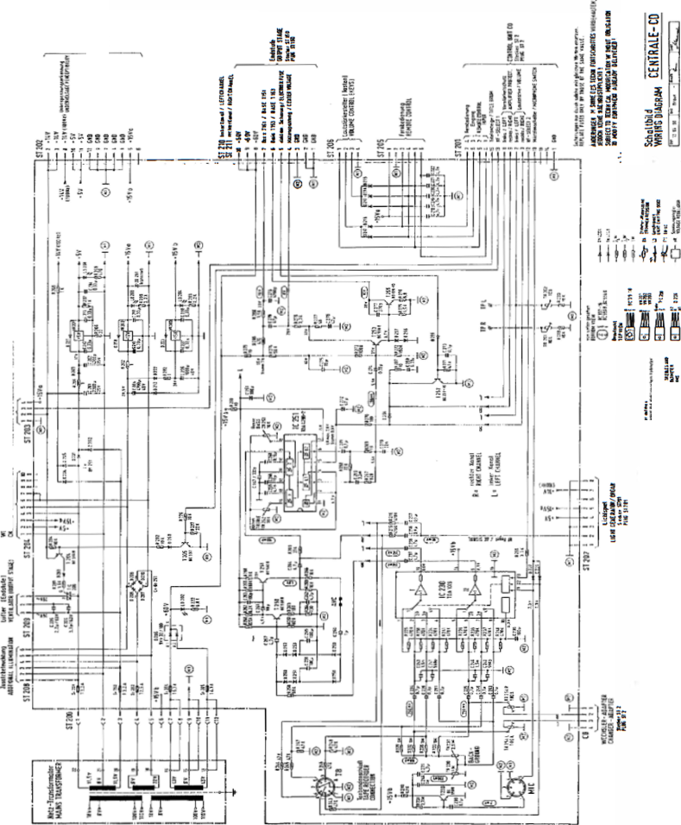
ti
IS
ss
®
-
-^{f}íi
«i $
‘7 >>
í ¡I
§&
-o-
CL
ry
i
es 5
ces
*? æ ü
«SIS
aSs
»se

UNIT DESCRIPTION

I CD CHANGER FOR NSM-PHONOGRAPHS
88 XV-CD SSSWSS&SS’

SILVER CITY SILVER SKY FASCINATION SOUNDMASTER FIRE BIRD/COUNTRY
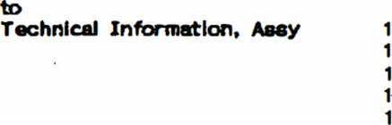
903
831
486
274
040
74
74
74
- 75

SSmfiSfl
Serlavjstrsfli 80 Page 801-815/821-822
6530 Sirwen » Rhein

INDEX

PICKUP FUNCTION Transport Pull holder Return holder Feature
1.2
1.3
1.3
2
2.1
2.2
2.3
3
3.1
3.2
4
5
6
6.1
6.2
6.3
6.4
PICKUP DRIVER Lift control Grip control CD-Player control
PLAYER
Disc player CDM 3 Servo panel
PC8 DECODER BOARD
MAGAZINE
CD CHANGER 100, test, set, adjust
GENERAL INFORMATION
MAGAZINE
PLAYING UNIT
LIFT
Spare parts lists

1 PICKUP RUNGTION
The pickup serves to transport the CD’s between the magazines and the player.
ATTENTION! When the CD changer has the switch at the window (upper right), the transport does not function if the window is open.
If the window is opened while the CD is playing, the title will be played to the end, but the CD will only be transported back after the window Is
closed.
- Transport
The lift is moved via a stepping motor controlled by the microprocessor of the control unit. The distance between 2 CD slots is 8 motor steps (1 opto counter step).
During the run the light barrier OPTSP, which Is directly connected to the drivewheel, checks the motor’s position every 4 steps. Stepping errors are immediately recognized and displayed with Er 75.
Together with the light barrier OPEND the end position of the lift is verified. Should a mistake appear here (signal too late or early) the display shows Er 76.
- Pull Holder-
r
With both grip levers, brought into lock position by CD motors MOGRL for left and MOGRR for right, the CD holders with their CD’s are pulled out of the magazine. The light barrier OPPUM reports the correct position of the CD holder in the pickup unit.
If there is no report 2 sec. after switching on the motor, the display will show Er 71 for the left magazine or Er 72 for the right magazine.
- Return Holder
To return a CD holder to its magazine, either motor MOGRL for the left magazine or MOGRR for the right magazine Is switched on In the opposite direction.
Light barriers OPGRL or OPGRR report the end position of the grips.
If the report does not appear within 2 sec. after switching on the motor, the display shows Er 73 for the left magazine or Er 74 for the right magazine.

.3.1 Feature
to remain on the player after it finishes playing, the the pickup driver board must be connected, is pulled out, the tray with the CD is returned to the
rf you want the CD solder bridge LB3 on If the cabinet switch magazine.

2 PICK UP DRIVER
- 1 Control
With output port IC3 the microprocessor of the control unit controls Switch transistors T 2-5 via drivers T 6-9. These drive the unipolar coli of the stepping motor (ST4, Pin 1-6). Using signal OPSTP (ST4, Pin 7) the microprocessor controls the position of the motors.
Together with signai OPEND (ST 3, Pin 6) the end position of the lift Is reported via input port IC 1.
  - Grip Control
Both of the grip motors (MOGRL for the left magazine and MOGRR for the right magazine) are driven from the double motor bridge IC 6 via output port IC 3.
While pulling a CD from the magazine the signal OPPUM (ST 3, Pin 7) reports the end position of the CD holder in the pickup to the microprocessor of the control unit.
While returning the CD it recognizes the end position of the grips via signals OPGRL (ST 3, Pin 5) for left and OPGRR (ST 3, Pin 6) for right.
- 3 Control of "the CD Player
Microcomputer IC B (T01B) is used to convert the Incoming serial data in I²C-Bus format from the decoder processed.
panel Into parallel signals that can be unit communicates with it via ports IC 4
The microprocessor of the control and IC 2.
- Disc Player C D M 3
The COM3 contains the components laser diode, play motor, radial motor, and focus unit.
It reads the data from the CD.
- Ser~vo Panel
The servo panel contains the components to control the COM3.
They consist primarily of the photodiode signal processor, the radial error processor, the drivers for the laser diode, the focus unit, the radial motor and the playing motor.
- RGB DE COD EE R BOARD
The components servoprocessor, decoder, digital filter, DA converter and NF output driver are combined on the decoder board. It also contains the circuit to process the complete power supply for decoder board COM3 and servopanel.
5 MAGAZINES

with 50 CD holders each are in the CD is possible to play 5- or 3-inch CD’s, out.
6imply by the holder
2 equal magazines that are equipped changer. With different CD holders it The magazine can be swung out and totally taken Equipping with or changing CD’s can be done respective CD holders, inserting the new CD Into back till locks in the magazine.
taking out the and pushing it

