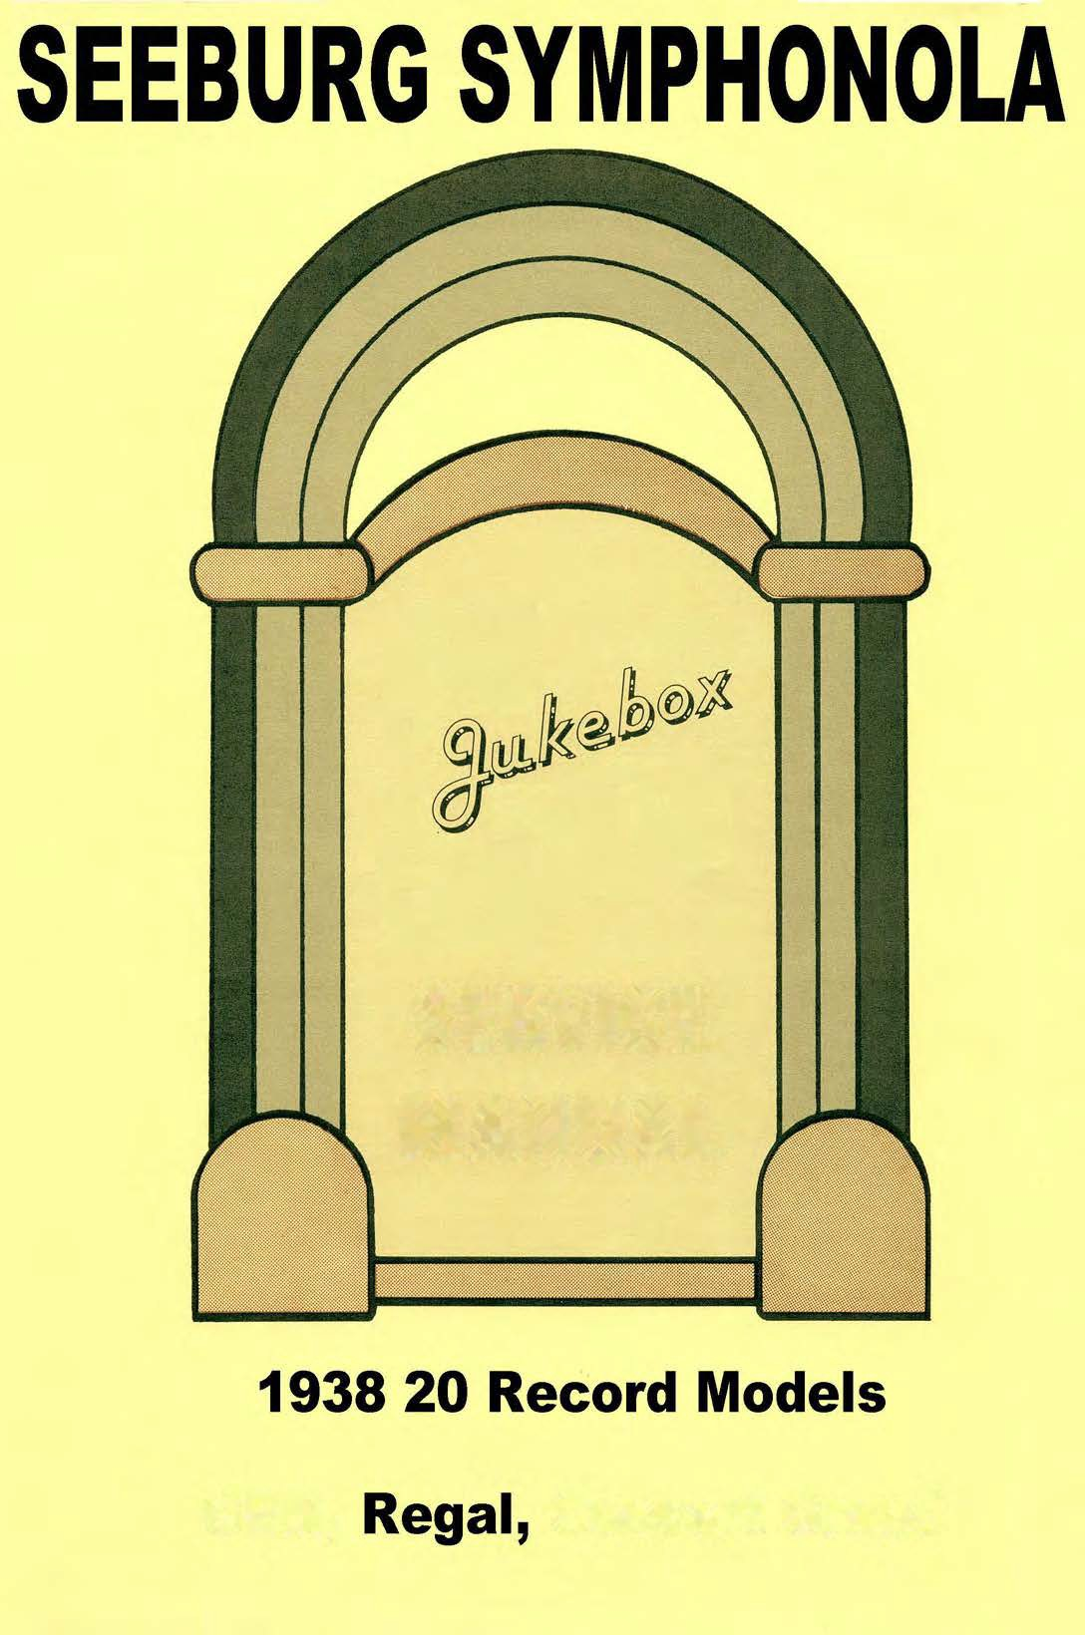

SERVICE
MANUAL

GEM, C.once'l Gr.and

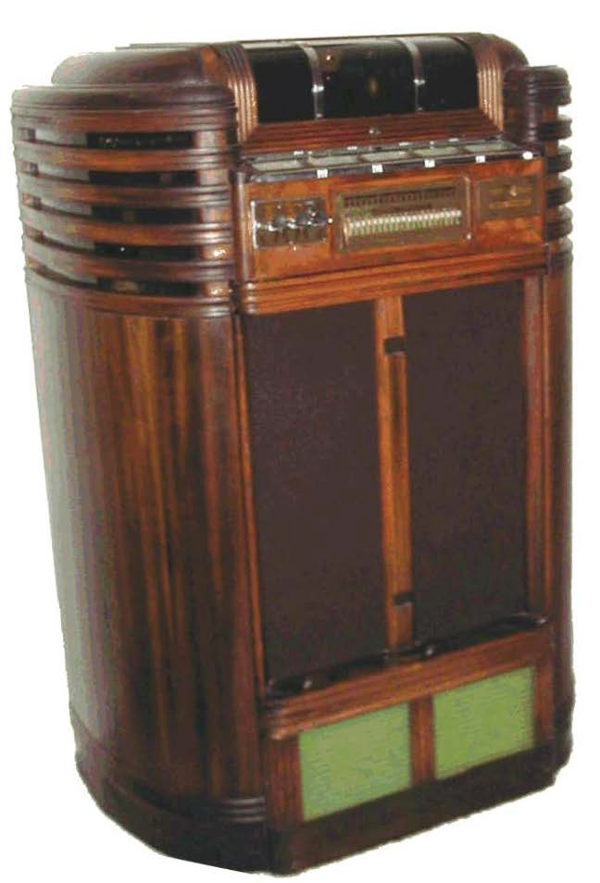

MODELS MANUFACTURED .AND THEm COMPONEliTS

.A!!PLIFIER PHONOGRAPH

SB-7•••••••••••••••••••••••••••••••••••••Uodels A. B. C.

SB-B••••••••••••••••••••••••••••••• v•••••Uodel D

SB-9-30••••••••••••••••••••••••••••••••••Uodel F

SB-lo-2o•••••••••••••••••••••••••••••••••Uodel H, I, Queen

SB-lo-200••••••••••••••••••••••.••••••••••Rex

SB�llWB••••••••••••••••••••••••••••••••••�egal

SB-1120•••••••••••••••••••••••••••.•••••••Model J, :Jelo�y King, K-20;. Royal

SB-ll20WB••••••••••••••••••••••••••••••••Regal

615-3••••••••••••••••••••••••••••••••••••7B60ES

615-3Y•••••••••••••••••••••••••••••••••••7850ES

625-lY•••••••••••••••••••••••••••••••••••Caoino, Vogue

625-lZ•••••••••••••••••••••••••••••••••••Casino, Vogue

625-�o••••••••••••••••••••••••••••••••••Caaino� Vogue

625-a•••••••••••••••••••••••••••••••••••. Cadet, Uajor, Envoy (ES and �S)

025-ZC. • •••••••••••••••. •·•••••••••••••••• Cadet. Major, Envoy (BS and !!!S)

625-SYo••••••••••••••••••••••••••••••••••Cadet, J.!ajor.., Envoy (ES and MS)

625-3YC ••••••••••••••••••••••••••••••••••Cadet, !bjor, Envoy (ES o.nd MS)

626-3Z• • • a ••••••.•••••••••••••••••••••••••Cadet� 14ajor. Envoy (F.S and 2!S)

720�•••••••••••••••••••••••••••••••••••••GGm

720B•••••••••••••••••••••••••••••••••••••Gam

720Co••••••••••••••••••••••••••••••••••••Gem

720C-2ooo•••··�··••••••••••••••••••••••••Plaza

725-lZ••••••••••••••••••••••••••••••••••·Pla:a

725�2 ••• Q••••••••••••••••••••••••••••••••Pla�a

S2o-A••••••••••••••••••••••••••••••••••••Regal

620·B··�·••••••••••••••••••••••••••••••••Regal

a2o-AB •••••••••••••••••••••••••••••••••••aegal

UOIELS UANUFACTURED AND THEm C02lrolfm1TS

AMPLIFIER PHONOGRAPH UOD�

B 20C- 2••••·••• • • • ••••••••••••••••••••••••.J4a,y-tair

825•5••••••••••••••••••••••••••••••••••••9800 ES

ezs-lo••••••••••••••••••••••••••••••••••• aeoo ES

83Q-lY•••••••••••••••••••••••••••••••••••Clasa1o

830-lZ•••••••••••••••••••••••••••••••••••Yayta1r •. Clasa1o

83o-2•••••••••••••••·. .......... .. ..... ..... Clas•1o
Pnga 2o

83o-2Z••••••••••••••••••••••••••••••••••• Clasa1o
830-3••••••••••••••••••••••••••••••••••••Colonel. Con:max1der. Conaort :Maetar. (ES.us)

B3�3C•••••••••••••••••••••••••••••••••••Colonel. Cc::un:u:Ld� • Conoert lla8ter (ES.us)
83Q-S"l � •••••••· .... ... ......... . .. . o ••••••• Colcnal. Comrnn.ndor. Concert 2.taotsr {ES.�)
.
830-3Z •••••••••••••••••••••••••••••••••••Colonsl� C.ommand�r, Concert !.bater (ES,US)

920A••••••••••••••••••••••••••••••••••••• crawn

1!30•••••••••••••••••••••••••••••••••••••Conoert Maestro -Telephone - Sing. Chan.

1265A••••••••••••••••••••••••••••••••••••Conoort Grand (ES and US)

1255B••••••••••••••••••••••••••••••••••••Conacrt Grand (ES and MS)

!.:;ODEI.S lWJUFACTURED .A!W Tr.:E!R C01IPO!U�ITS

'
MODELS MODEL· UODEL !!ODEI.3
A. B. & C D F H. I AND QuEEN

SB-7 sn.. a· SB-9-30 SB-1020

TUBE:> 1-67 l-57 3-56
2-66 2•66 2-56 2-2A3
.

K-20
Model. J IU:I
Uelody
Kipg

SB-ll20 SB-lo-200

2-67 3-66
2-66 . - 2-2A3

2-2A3 2-2.\3 4-2.A3 1-80
2-Z.\3
l-80

l-6Z3 l-80 l-83 1-5Z:S
1-80 1-SZ.3

l-5Z3 1-80

1-5Z3
.
\
_.J \

POUER TRANS. WP-3010B WP-3038 WP-:5035 'i1F-3064
l'!P-3072 WP-3075

FILTER CHOKE

lJC•1002 'WC-1002 !IC-10l7V l!'C-1002-V
Jl:-
2� WC-lOOSR .
nC-1002-V lWC-1002-V

n-IP""liT XIWrs. m:-so2o-a \'1.I-502o-H I UI-5020-R WI-6041-H I
\10-2030-BV f \'10..2044-V W0-2057-V

fii-504leai:I r1I-604l-R

W0-2089- V W0-2089-V

TlWIS.

S!.i.ALL SPE.\KER OUTPUT TRANS. TONE CILOXE

TREBLE

-- --

- --
I -- --

WC-1020

•
I

WC-1020 WC-1020

I

P•3103 P-310S P-3103 P-3103
P...3l03 � P-3103

BASS CONlaOL P-3101 P
-

3101 P-SlOl

P.:.310l

P...310l

P-3101

VOI.mJE CONT.

· F-1344 F-lS44 F-lS-44 F... 1344

F•l344 F•l344

SPE.AXER. {3)
(UAIN) B-l9la 12101 12102 3282

SPEA..�
CONNECTIOnS I I B
(MADl)•

.
(SUATJ,) - - 2356 - --
-

146004 3282

B B

63069 -

SPEAKER
COlnlECT!ONS -- B
(SMALL )�
Dt1MMY PLUG

- A --

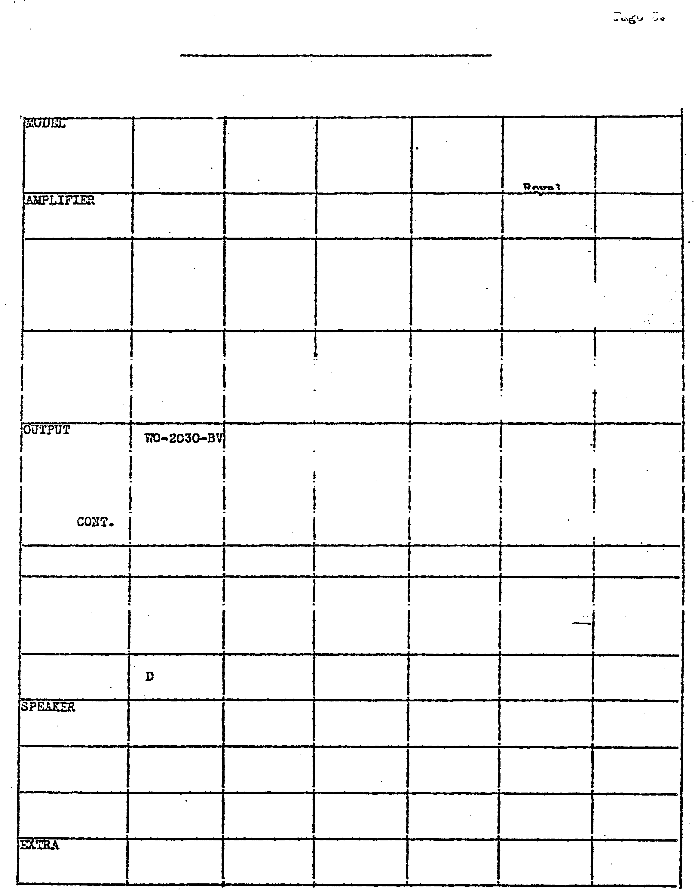COmJECTIO:USc: 4 4 - l 1 1

SPEAKER
PLUG WIRmG* )I or ll 0 or U p I X K

.MODELS 1WroFACTURED JJTD THEm COlU'01lEl1TS

GEM

•
I
CROmi CONC�l Q.P,.MID

72o-A.z. ·
72o-B
720-C

( 3-76 JB&C
2-2A3
1-6z3 l-60

(3-56) A

820B
820C
SB-llWB
S�- 1 1 ?(1rJ;t

2-6C6
2-76
2.. 2A3 l-5Z3 l-80

820A .
82Ct3

2-57
2.. 56
2-2A3
l-5Z3
1-80

920A

l-6C5G
�76
. 2-2A3 l-6Z3 l.. eo
...

125M .

l--6L7
l-6F6G
2-6J5G
6-2A3

2-5Z3

l255B

·l-6L7
.
l-6FSG
2-8J5G
6-2A 3
2.. sz3

PO•'•rli A al0040 Output
B&l023.� 10287 ·10040 10267 1029'1
10336
c
Outp�t lo;;:;s

Dr: 10318 Dr. 10318

10314

c' 10272
10272 1 Q •
__
·

TONE . lOS3S l003S 10033 10033 lOS27 10327
'

. 10286

B.-\.SS CONTROL

EXP.ANDEa
A2 10038
Ba 1028 8 10039 10038 10��8 10325 10325
Ca 10039

·-

CONT!iOL VOLU11E COliT.

F--1344

I F•l344
....

F-134.\
10322 10322

A-5434

SPEARE&
(lfAIN )

SP�
· CO}lN ECT IONS
(�.!Am)*
SPE.AlCER
(SMALL )

6864

B

5867

l6..H-l

B

.(2)
8-C-101

15-B:-l

B

(2)
8..0-101

l5-H-l
•

B

(2)
8--C-101

c c

lOEll lOBll·

CO!iNECTIONS* A .A
(Sl.J.W.)
DtThU.tY PLUG
CONltECTIONS• 2· 1
&TRA SPF.A.Km
PLUG wmmG• L
A A A A

1 . 1 1 1

X X

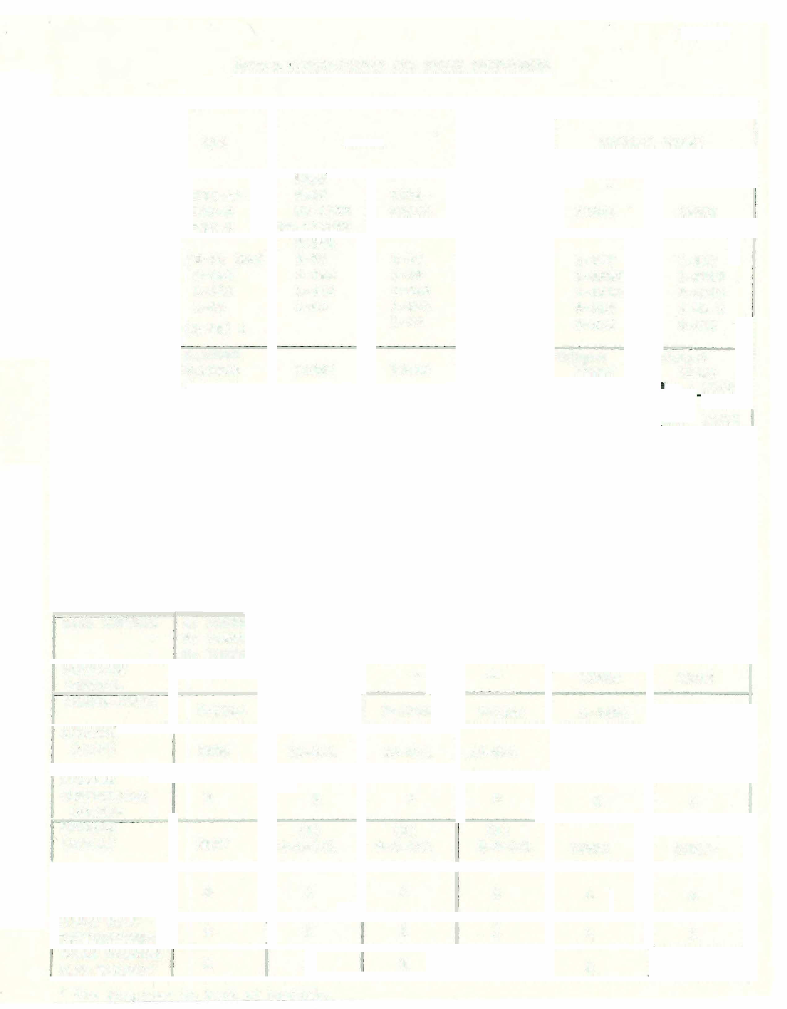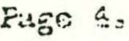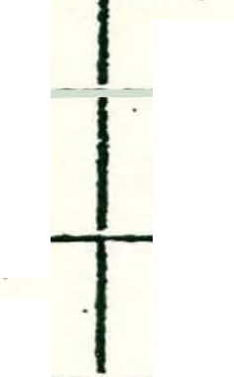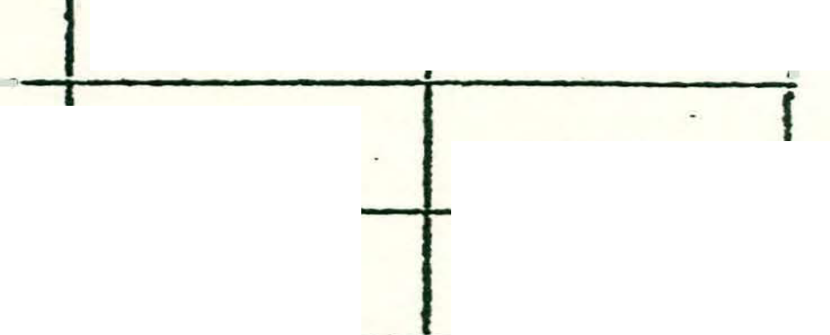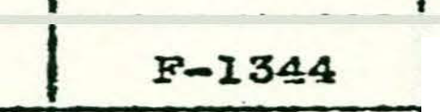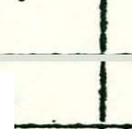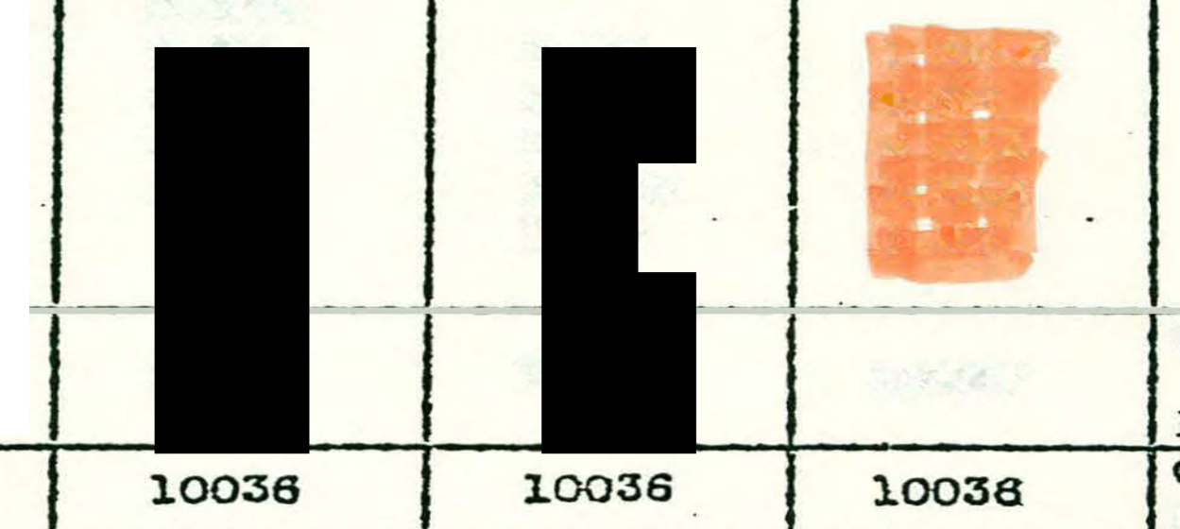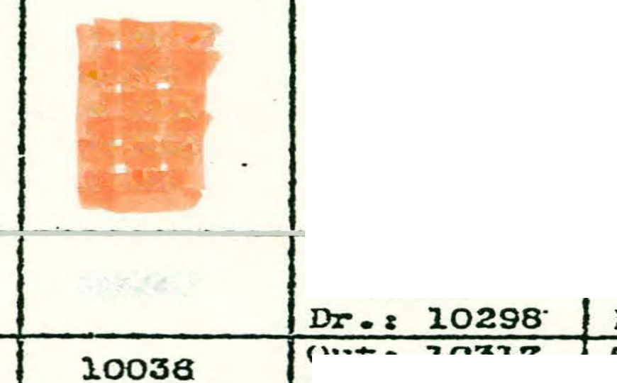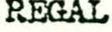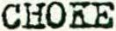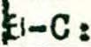
* See di��ram3 in baok of booklet.

AMPLIFIER

CASINO
.
VOGUE MAYFAIR

625-lZ 83()-lZ

725-J.Z

PUZA .

, COLONEL
Cl.J\.SSIC COl&�iDER
COU'CERt MAS�

830-lY (25) 830-3
83o-2Z 83Q-3C

626-2Z 620-C-2
625-1Y(25
1•76 2-6C6
725-2 720·0·2
2•6C6 3-76
a:so-u 63C>-3Z
8�50-2

2-606 2•6C6

l•SJSG 2•76
·
1•6J5G

2-2A3
2•76
2-76

2-2A3 2-2A3
2-24.3 l•6Z3
2-?.A3 2-2A3

l-80 1....
1•80 - 0

l-6Z3 . 1-6Z3
l-6Z3 1-eo
1•6Z3 1-5Z3

ao 1 8
1-:-80

root mANS. lZ-10710 lZJ 10792
I
l0'192•lZ·,

: ··-.-
j

mrou
J

2Z-11192 o2t 10333
lY-11191

10038 10036
I
10111

10710 10333

10038 10036

10711 10034
3-3CalQ'192
1ll95-2Z 3Z; 11195
• 31"! 11194 I
10036 10036

10711 10111

OUTPUT
10711
C2t 10034

10 272 10272

10272 10272
10272 .

11341

BUS CHOKE lZ: l079l
C2c l�onfl
l
.... --

l079i

10791

CEDAE
J
I -

10402
lZt 10402
C2; 100S3
lZa 10688

10402 10033

10402 11072

10688
JC2s 10286
BASS COH�L
10688 10286
10688 10688
I

I 10667
I 10039

10039 10039
•

10039

10039

VOLlP...fiS •
.F-1344 F-1344

F•l344 F-1344
I

F•l344 F•1344

SPEAKm F•9024
I
(UA!U) F-7018 15-R•1

F•8024 F•8024

F-9024 F·9024

CONNECTIONS B B
(nnr)• I
- -
B B B B

S.PF.A;<ER
{SJA:AIJ:.)
- -

SPE..Iti\ER
CONNECTIONS*
-- ....
-- -
.... F-6354-A :ffo

CONNECTIONS• 1
El.TRA S.PEAKm
- ·- . F

3 ·

PLUG wntiNG* 1: 1:
Jt l!t
lC K

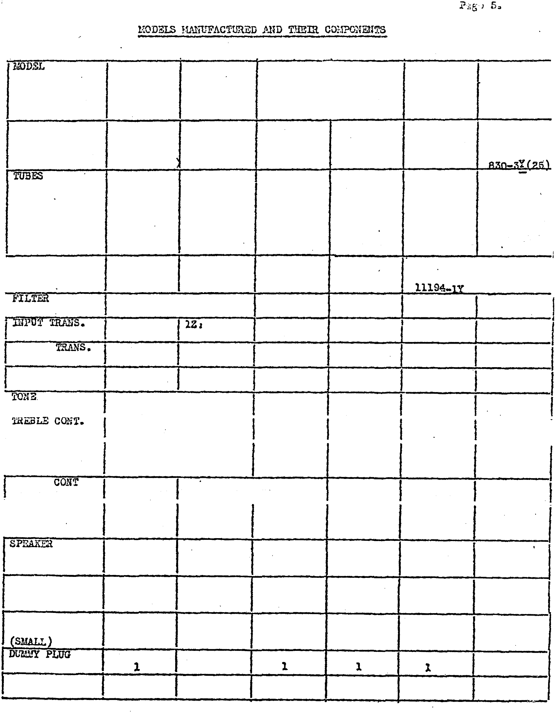
N'otl!u Early procluotion ot the ''.Mayf'4.1l"11 used the azo-c-2 am.pl1f'1er. 'rhe majority of
thie Symphonola used the 830-lZ amplifier. It is reoommendod that &m9litieJ.•
model number be u�ed 1n ordering parte.

MODEL OADE'l'
 | 7850 | 8800
1940 | ES | ES

626-3
. UAJOR
1625-�C 615-3

625-3Z .. YCS-lZ 6l5-3Y(25)
625-3!(25}

s.c

MCS25-6

621i-3Yc ( 2n l
l-Slm 2-2A3

2•6i:7 2-6J5G'l l-6SQ7 S-6JfjG!
3•6J5G! 2-6X7

l-6J5G
l...
6J5G.
1-5U4G 2-SLS l-6X5G!r

2-2M :!•6C6 l-5Y3G l-50'4G 1•6SQ7 l-5Z3 8-16 1-SYSG �-6li6
. n-u.s

. l-80
.:•5U4G
fl•SFSG ,..sLe
)....2A4G . 7·..o2o�l
).-6X5G 1·6!�G
l-5ZS

3-ac. 1ono lloll?a 11307 3: ' ,
1-80

TRANS:rom4lm 3Z , 11192 s ..n.. , 11s1o 3Yt 12079
s.l..� 122C�
. AI.'!.

.._

a
-- l�.·�-36
_
--
--
11�:15

1221::1
F-7813

12223

•.i
.
1;43

- I - R.F. COIL .. In. - Inter. --
I
Diode --
ot..r:r:Put con.

-
-
OSCILLATOR
COIL

-
-

SPEAKER !!

!" m..rMMY PLUG cotm. • �
CONMECTIOM*
·
E;\.l'RA SPJ::AKER
..
B:

-

,,"""'
.......v ...v

'D
...

IF-�076 p.. goa.&

--
--
30191
30192
. 301S3
--

--
--

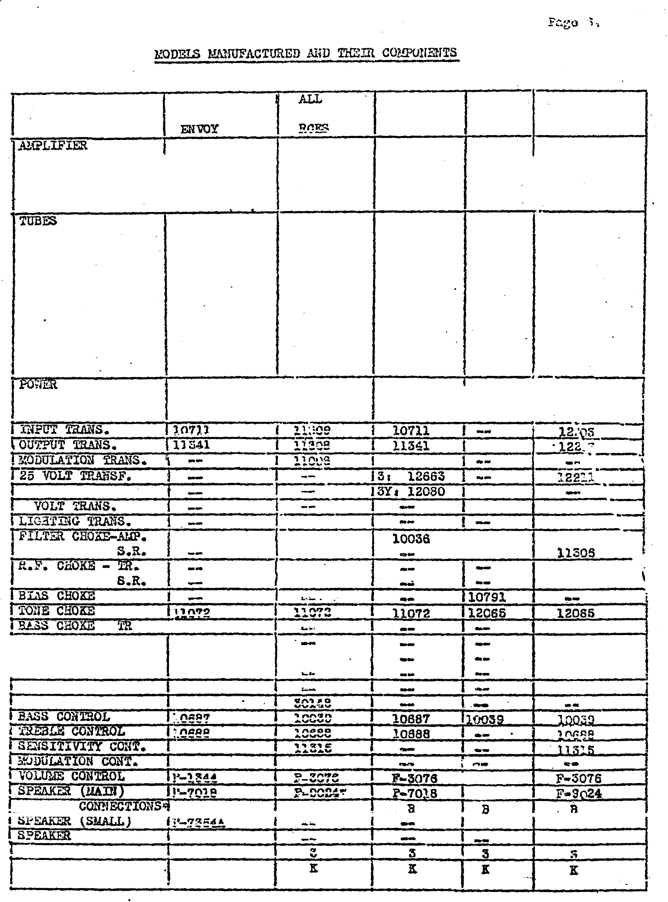
PLUG lllRnfG*

.,.11r1ng aonneot1on� in back of booklet.
� Exoept Envoy RCES. Envoy Spaaker F-7734

l.IODELS UJ'.NUFACTURED AI.'1D THEIR COlJPOliEr�TS

MODEL

9600 ES 9800 RC 8200 RC

AMPLIFIER
825-6 ucs 25•1 UCS··25•15

3-SJSGT 3·6J5GT
1-6SQ7 2•6It'T 2-617
3-6J6GT 1-6X5GT 1-axsdT
2-6L6 1-6SQ7 ·1·6�7
1-6t14G l•6H6 l-61!a·
l-5l13G 1-6U� l-6t140
2-6L6 2-6LS
1•2051 1 -2051
1•5Y3G 1-5Y3G
12959 12204 12308
S.R. - 12202 12 301

INPUT TRANS,. 12066 1 2203 1.2203
I OUX?UT TR..'UJS .. 12068 1.2059 12217
25 VOLT TR.A!'lS. 12063 12211 12211
6 Volt 'f.r�:u:s .. 12060 12213 12303' I:fG F-7613
11316 12223 .
s.a. -- l1306 11306
-d .. Fo CHOh"E 'i'Ro -- -- .....

s.n.
l03�3 10843

-T01iE C!iO'f� 12055 J.2065 12065
ll.F,.. - Input - .
Intarstage -- 30192 S0192
Diode -- ::o19s· 30193
t .S.:l.SS co:;T.:i.OL . 10039 lOOS9 l0039
�
T.RE.3LJ:j CQ!;TROL 10d86 10688 losas
COlJTROL -- ll3l5 llSlo
F-3076 �'-3076 F-3076
10791 --
t $P3..URa F•9624 F-9824 F-9024

Cr.l..:d-:!· .PLUG a 3 3 cc:-nmcT!O!iS .,.

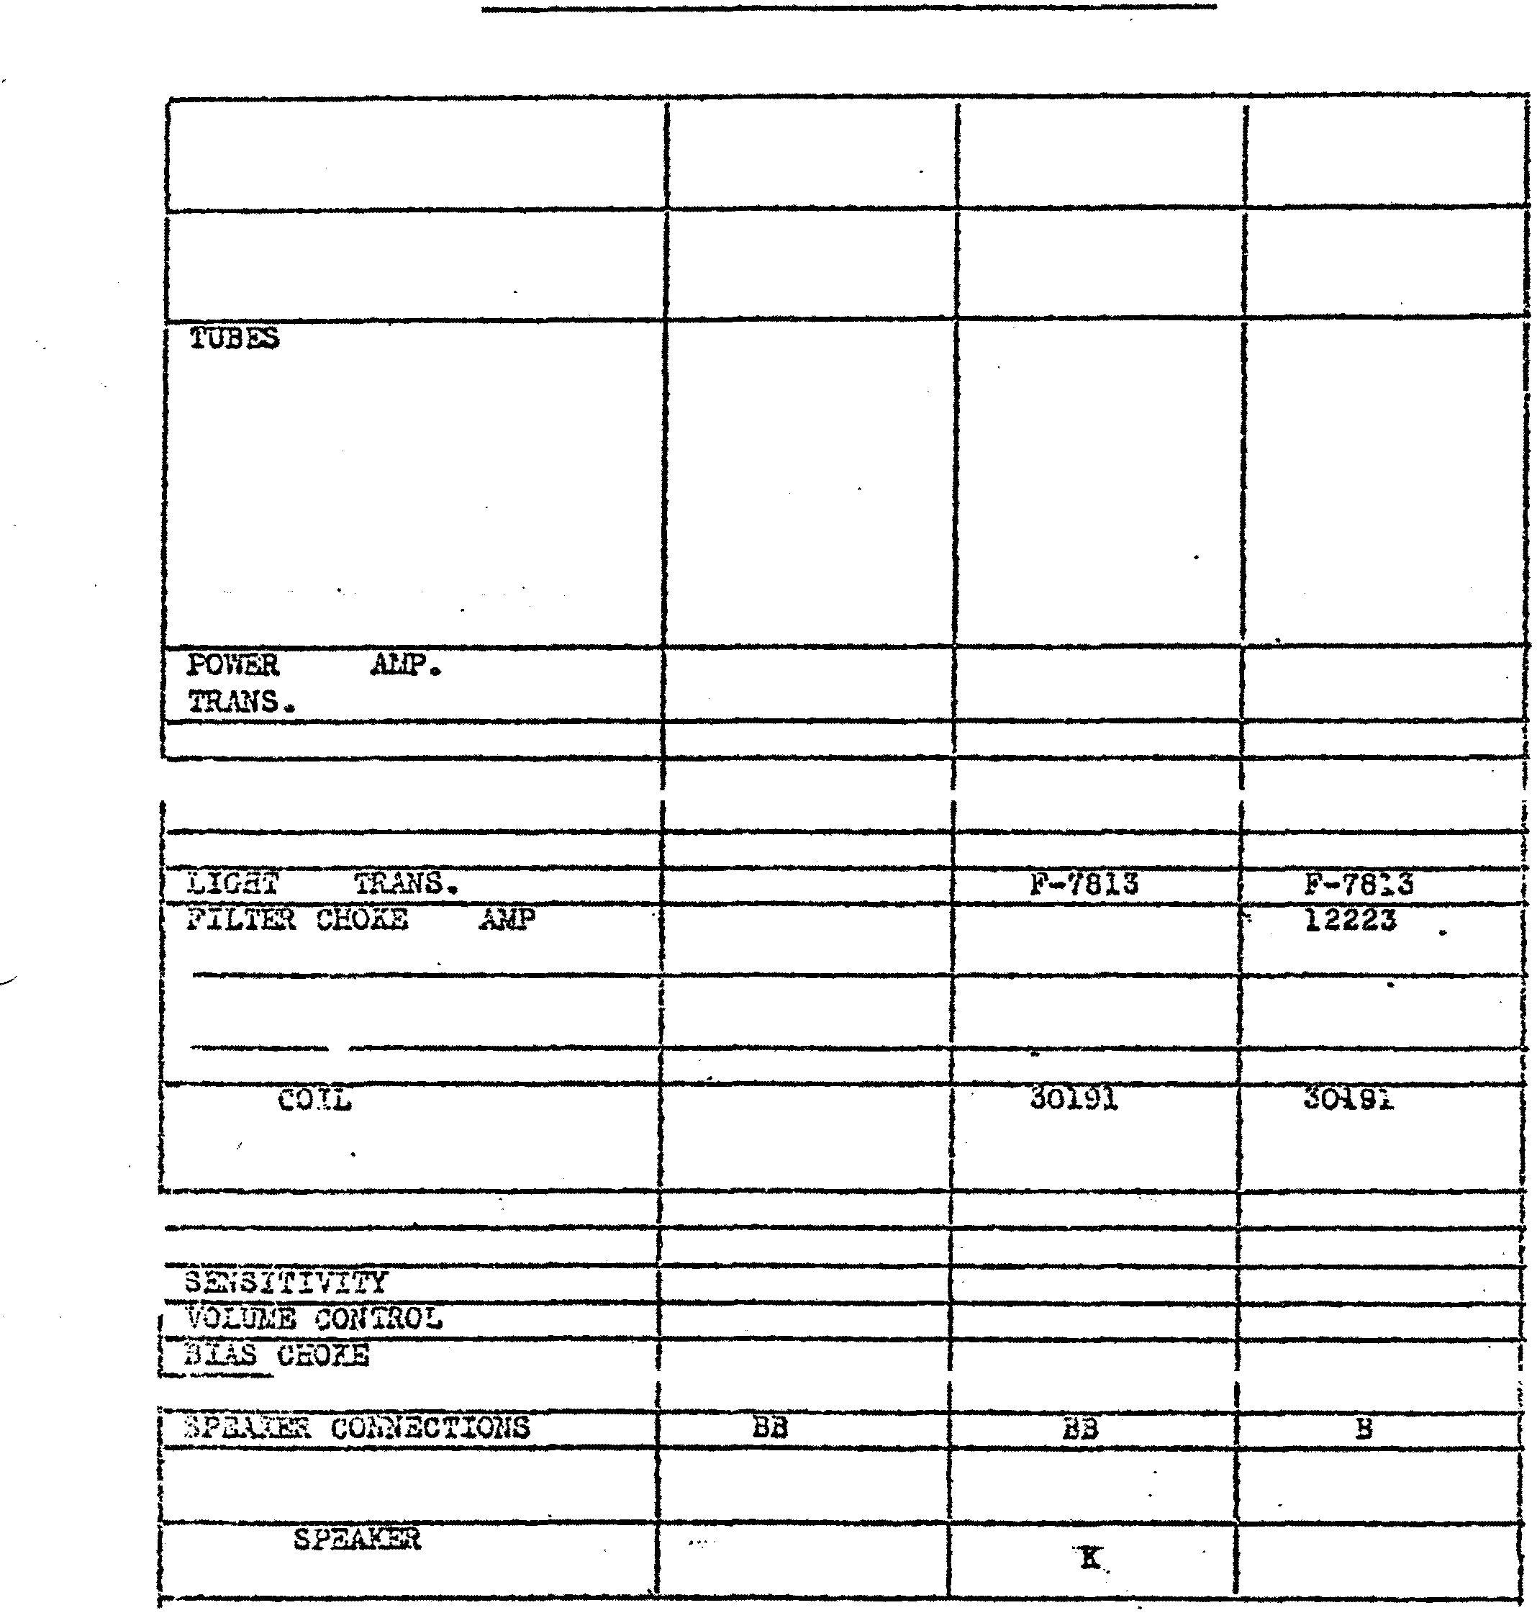d:Xnt.\
?LtiG rilRJ1IG

.J: K

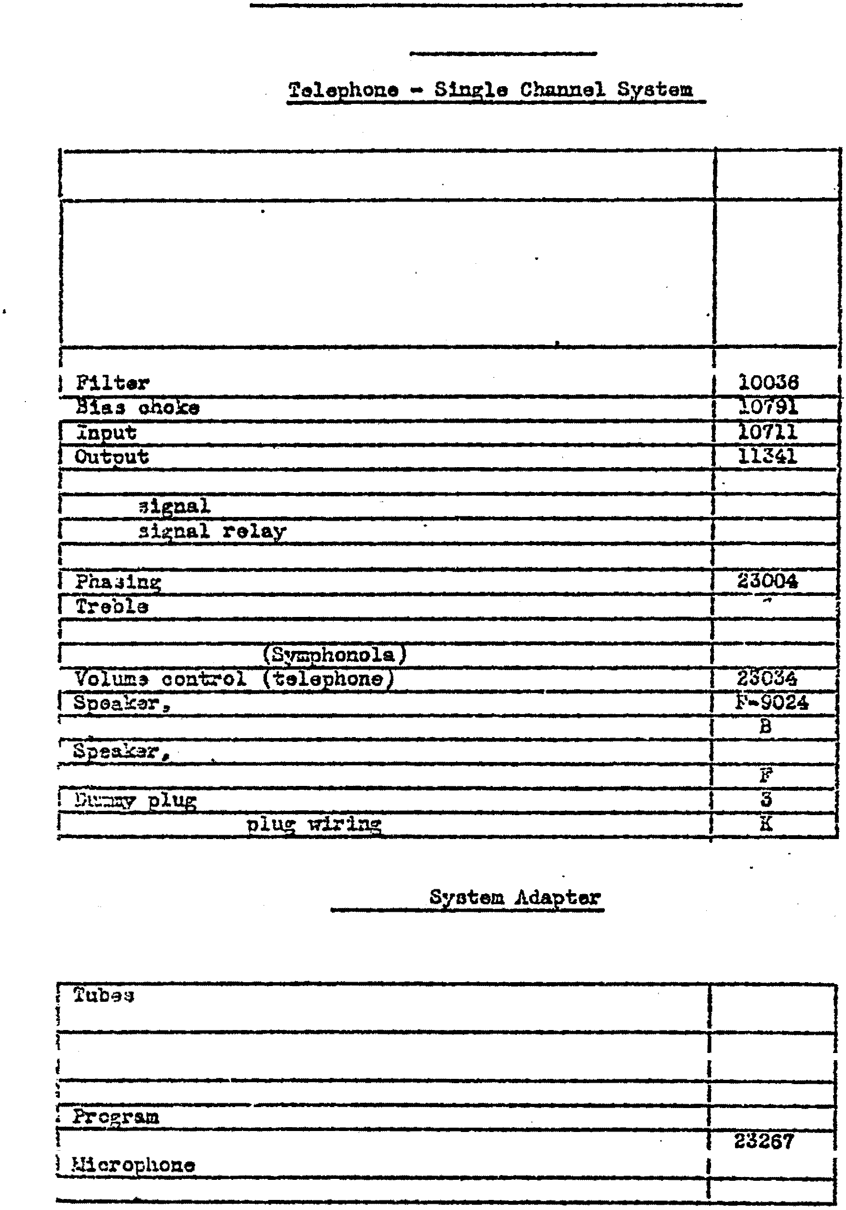

l:�ODEI..S MANUFACroR.BD AND TllEIR COMPONENTS

CONCERT !�TRO

A:nplif1er llSO

Tubes used 6-75
2-6C6
2-21.3
l•6Z3
l-80

.Pa.ge a.

PO'IIf'l!t:' trans:f'crm.er 23003
choke .
1
transformer transt"crm.er
Lic.e trans:torz:.er · 23002
Coin transformer 232�2
Co!n 23188
Micronhono vo1u.� control 23005
control
control l0o88
Basa ootl.trol lOOS9
Volux:e OD!lt::"ol P-1:544
4
main
, SD&�r connections
• tott F•6364A
1 :l'Daa.ka:r connections
ocnneotiona
E....-t::-� s,eR�er

Central

(Used with Type B� 2-ohannel �ystem)

used 2-6J6GT
l-5Y3G
Power tranof'or::wr 23278
Filter oho!m 23280
Coin credit tran:�formei:" 23242
lina t:-cnaforC1er 23276
Order l ic.e trana!'ormar
tra:1sform.er 23312
I �crochone volume control 23005

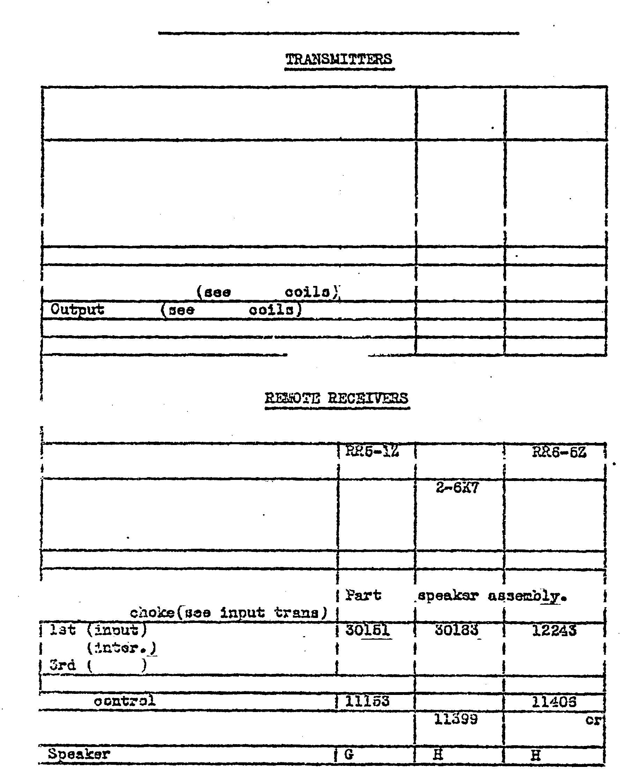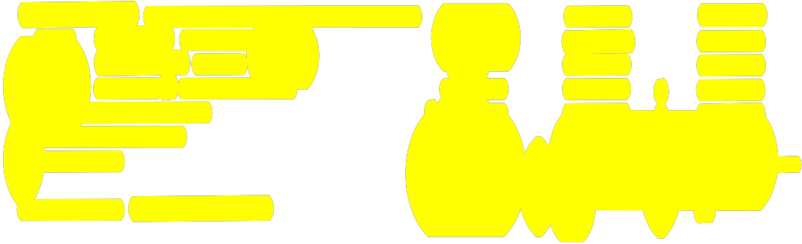

:UODEI.S ?.WWFACTURED .AND THEIR COMPONENTS

�an3mitter T-l.Z �-6Z T-3Z
-.

Tubea used 2-SFSG 2•6F8G
1•6J5G l-6J5G
1•80 1..;.80
..
Power trans�ormer 11022 11022
Filter choke 11007 11007
Baas ohoks 11072 11072
�odulatio� transformer 11006 11008
03o1l1ator oo11 r.f. 30148 30148
oo11 r.f. 30167 30179
R.f'. oho� 11012 11012
�adulation control 11010 11010
..
�--·-.1-.t- � .

l

a�o!Ji'Vor R.it6•2Z R.�8-SZ.
Tubso used 2·6X7 2-8�7
l-SDS l-5SE7 1•6Sa7
l-2A3 2·6V6G1' 2-6VoG1'
1-SZS 1-SU�-G l-5U�G
?ower ��nnsformer 11037 ll:S97 11397
. Filte;- oilo�e l10Sl 11396 11395
1 Ou�"Put i:Tan:sf'c:-cer of
I Counl� --· ll�OO 11400
r.t. coil
2nd r.f. coil -- 30184 30181/t
diod.:� r"t•,. coil 30J.52 30185 30185
Vol.� oot::trol t 11152 lll62 11152
1 Xo:o 11-1es
f Spoak-Jr Jll069 11399
16018
I aonn�tion:s

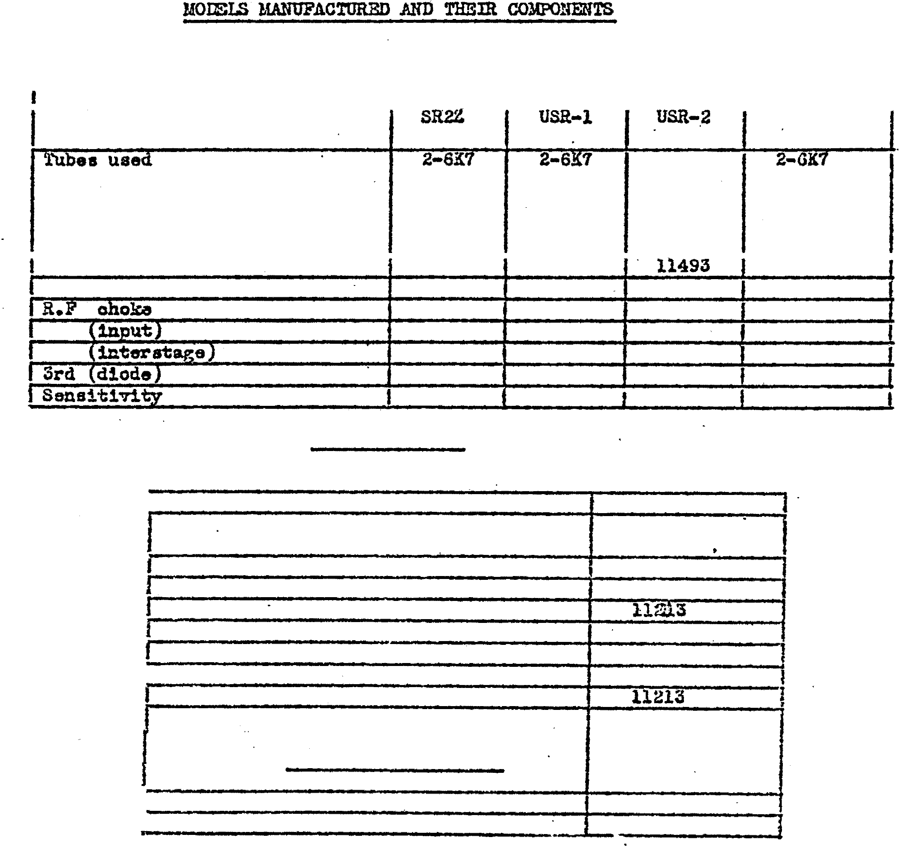P::.go lOo · ·

SELECTION RECEIV:mS

.R.eoeivar GS..�-1
.

2-6X7
. l-61Ia 1-6B6 1-eas 1•6B6
1·6X5G 1•6X5G 1·EW5G 1-SXSG l-2A4G l-2A4G 1•2061 1-2051 l-80 1•80 l-80 1-ao
PO'Ini" transformer 10844 11388 11462
F11ter obolm 1084& 10840 108:40 10840
.. 10843 10843 · 10843 10843
r.:f. coil 30160 30182 30196 30202
2nd r.f. ooil 30113 30180 . 30197 30203

r.f. ooil
30181 30}.98 30204

control 10839 11316 11316 11316

POWER SUPPLIES

I 'Unit �ans:f"orcu�r

S?S·l� 11213
Sl?S-3Z. 14182
SPS-6Z
S.fS-'lZ. 14182
?SS-!Z 11213
1 relz..sz 11213
25v"T..lZ

STEP SELECtOR SS2o-l

l Powsr tranarormer 12002
I Filter ohoko 10840

Console
I

Selector
Speaker
.

Speaker aonna

\'l3ca20Z l\'S-20Z
16018 F-7634
or
1A048
H A
(10 +.h l.1-;()46 '
DSC•lZ
IS'.o-2oz. la04a
A.

Reoe1ver
Spea.kar Field
RRA•fi?.

SS:FS-15
(�:f:l\ \

9SFS•l6 (w;t.+.h

'trans.
Power !rranafcrmsr ·
18001 l,ROOl
12196 (9SFS•l6l

SPEAXORGA.i1S

12195 lAA'FS-l n l

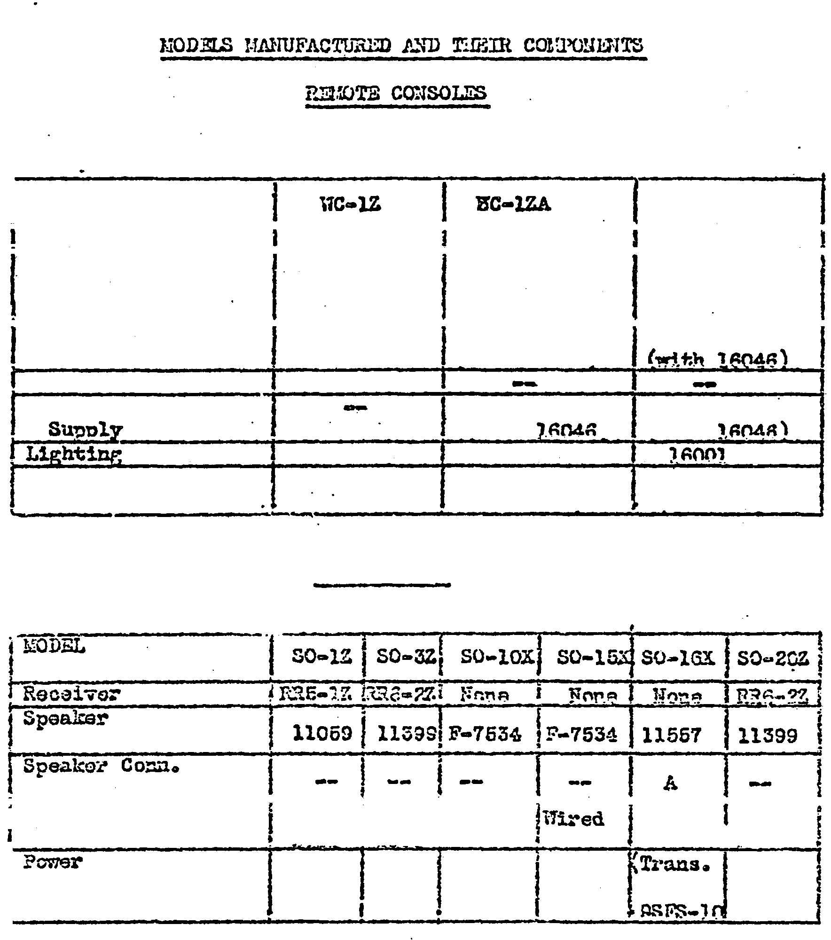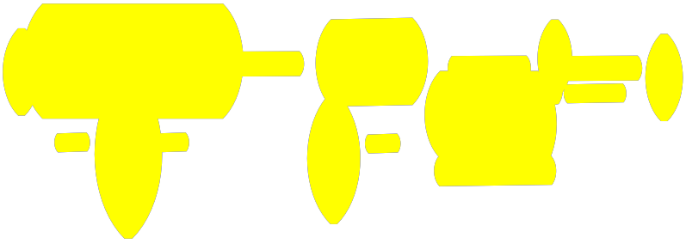t Typ'9

supply
!1ire-J11h-e-f":Fired

-- - .. _ --
,.,.q� ,,. ....

111red l"lire-
J , <:"'!!!'

12195) --

J.S

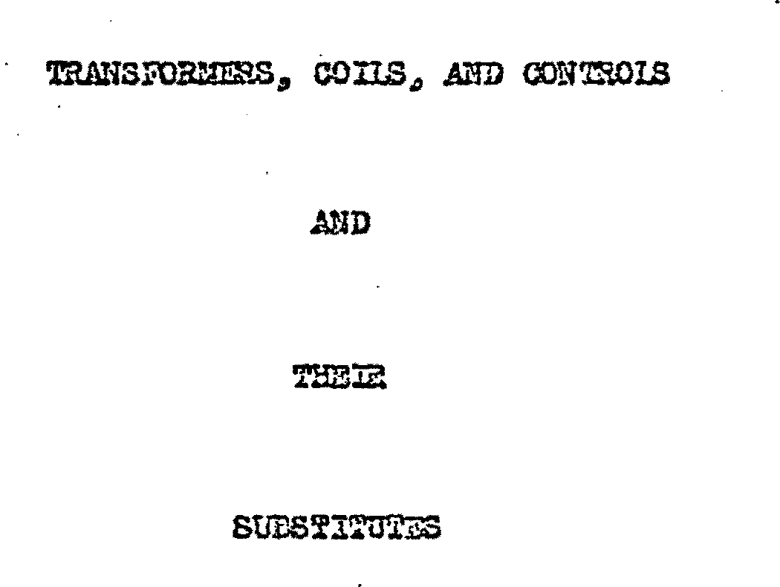

1'3..-\.'fSroP..uER.S, CO!IS, AND CONTROlS
Page

P1lt� Choke•••••••••••••••••••••••••••••••••••••••••••••••••la Input franaform4r s•••••••••••••••••••••••••••••••••••••••••••la· Output Translormer3••••••••••••••••••••••••••••••••••••••••••2�
. ·�
Tone Choke•••••••••••••••••••••••••••••••••••••••••••••••••·•�
P�er Tranaform�s•••••••••••••••••••••••••••••••••••••••••• �3&· Pwer Transforma:-a (oontd.). . ....... ... . .. .... .. ......... .. ...� R. F. Coil=a.:••••••••••••••••••••••••••••••••••••••••••••••• .-5& Cont::r-ola•••••••••••••••••••••••••-••••••••••••••••••••••••••••aa

Amplifiara••••••••••••••••••••••••••• -·•••••••••••••••• ••••••1
.Amplifiers (oontd. ) •••• •. •••••••••••�•••• .;·.;. •••••••.; •••••••••2 . ·
Uodsla .. A.- B._ and 0•••••••••·••••• �••••••· •••;···••••••••••·-�··••3
Model D•••••••••••••••••••••· ••••••••••.••••.••••••••••••.• •• .�3
Uod.-l P•••••••••••·•• e·••••••••••••••.'..... ;;. �••••••••••••• • e �3
..
Models H� I. and Quoen•••••••••••••••••••••••••••••••••••••••3
A-20, Uodel J, Melody Xing, Royal••••••••••••••••••••••••••••3
Rax•••••• �.�•••••••••••••••••••••••••••••••••••�•••••••••••••3
Gem••••••••••• ••••••••••••••••••••••••••••�••••••••••••••••••4
Regtl•••••••••••••••••••••••••••••••�•••••••••••••••••••••••·4· Crcwn•••••••••••••••••••••••••••••••••••• •••••••••••••••••••·' Concert Gran4••••••••••••••••••••••••••••••••••••••••••••••••4
Caa!no1 Vcgus••••••••••••••••••••••••••••••••••••••••••�•••••6.
�ytair•••••••• �••••••••••••••••�••••••••••••••••••••••••••••5
Plas.a. . . . . . . .. ... ..... ... . . .. . ........ . .. . . .. ...... . .. .........6
Claoaie•••••••••••••••••••••••••••••••••••••••••••••••••••••• s
Oolon"l, O�dor. Concert Ma.=ttar•••••••••••••••••••••••••••5
Cadet, MAjor. Envoy•••• ,..,. ........... ,. ••••••••••••••••••••• � •• 6 liod;,l RC.ES ..., 19-40.. . ... . . .. .... .... . .... ..... . ..... . ... ... . ... 6
7360 ES••••••••••••••••••••••••••••••••••••••••••••••••••••••6
aaoo zs ••••••••••••••••••••••••••••••••••••••••••••••••••••••a ..

eeoo ac••••.
••••••••••••••••••••••• • ••••••••••••••••• � ••••••••�

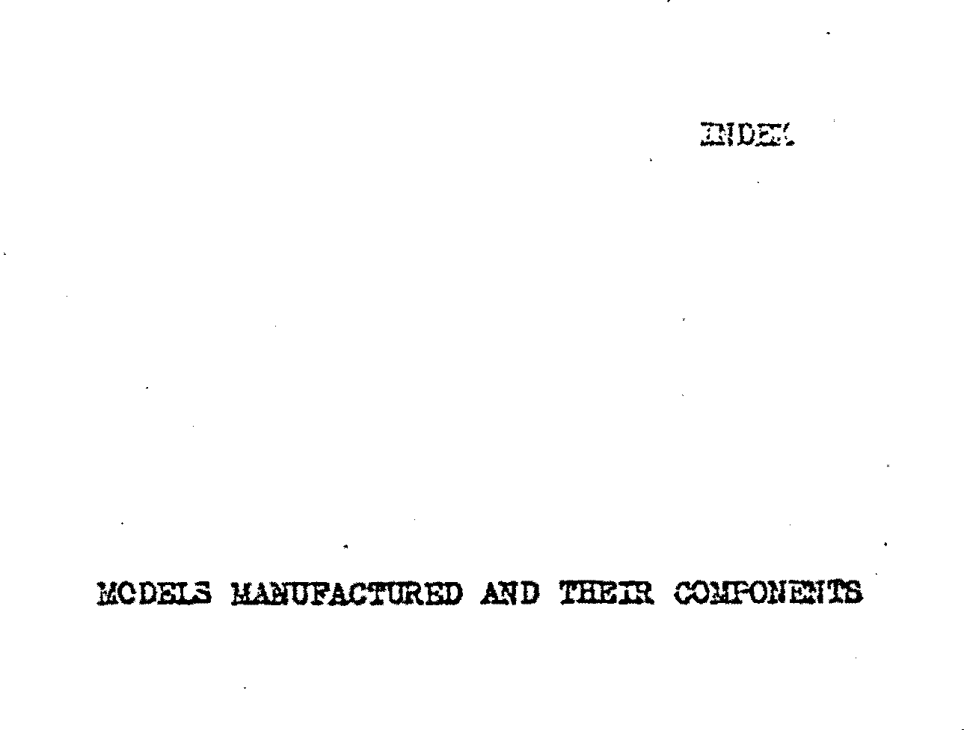9800 ES••••••••••••• • •••••••••:••••.•••••••••••••.•• � e ••••••••• 1
asoo .Rc••••••••••••••••••••••••••••••••••••••••••••••••••••••rr
a2oo ac •••••••••••••••••••••••••••••• �·················-·····1
Centrsl System Adapter•••••••••••••••••••••••••••••••••••••••8
Concert llaestro-Telcephor:.e - Single Channel S:ratem.••• ;•••••••• a. fraA�ttera••••••••••••••••••••••••••••••••••••••••••• ••••••9 li•ote Reoeivero. ........ . .. .... .. ..•••-.•· •••••••••••••••••••••9
Selection Reoeivera•••••••••••••••••••••••••••••••••••••••••lo
PO\...er Suppl1e••••••••••••• •••. •••••-••••••••••••••- •••••••••••10
Remote Conaol.ea••••• �•••••••••••••••••••••••••••••••••••••••1. 1
Speakorgaaa••••••••••••••••••••••••••••••••••••••••••••••••• 11·.'!

SPEAKE2 Dli'ORlLAnOS
Speaker Speo1.t1oat1ona•• .-.-••••••...:................... • .;·.; ;: ....12 a: lS Uotea on Speakera•••••••••••••••••••••••••�•••••••••••••••••l4
Speaker Conneotiona .. 1••••••••••••••••••••.•••••••••••••••••15
Spi!Hlkel" CoiUleotiona - 2••••••••••••••••••••••••••• � ••• •-••••16
Extra Speak:ar Plug· l'f1r1Dg•••••••••••••••••••••••;• . ;;� ••••••••17
·
�Plug Coaneot1ona••••••••••••••••••••••••••••••••••••• ;l8

vn.�m cEom;s

l!CcalOOZV WC•1006H VlC•lC11V
10033

10840

1031?

10318

11001

11061

11306

11310

11398

12�23.

S3230
U::se 10036

Uae 10840

UDG 10311

No cubstituta

11

tt

" • R

E'o o:ot substitute. U�a 12223 mth d:ltferetl.t rn.ouo.t1tig ..

• " 11061 r.

" a 11316 n n

fll�5020=H Subu�itute 10711, llS09

lO'lll..- 11309

lOO� "
10314 l0Sl5
l03l4

100�

10711

11309

11400

.1206�

12066

12203
Suoat1tuto 11309

10711

No �Substitute

Substi·�e 12 03 .

1.2226

12006

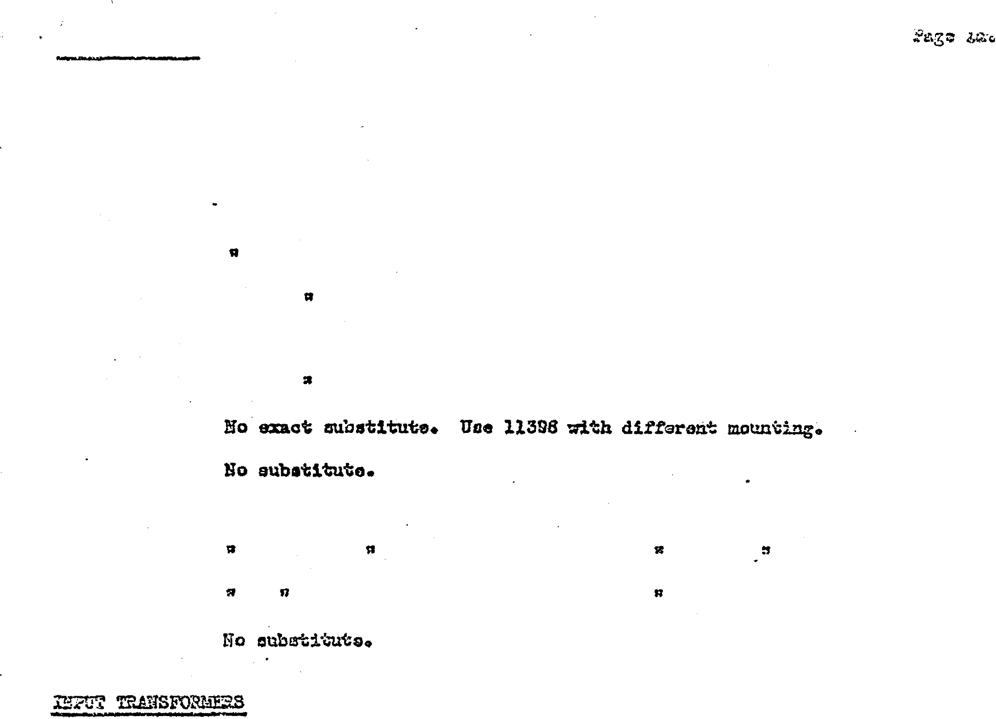. r :
).2226
l20Sil

r.'0-2030B�. Subat1tute 1003511 102r12

W0-2044V l'S0-2061V li0-2089V
10035

10272

10318

11308

11341

12058

12217

12053

ll0'72

lC033)
10327)
10402)
II 10035" 10272

" 10036. 10272

• 10036. 10272

ft 11308. 11341 (tape yellow lee.d)

• 11308, 11341 (tapo yellow lead}

No eubatitute.

Subatitute 11341 (8ame e%oept le&d lsagth)

.. 11308 (Same exa�pt lead lan�h)

No aubstitui;a.

El�otriaal chal•e.ot31"i:r�ioD :J;laa �:J 10035., lOS27, 10402 but counti� dif!or�t.

All iz:::terolu.ulgable eAoop·i: fa: lead lo%16th. Use 10�02 far longo�t loads.
Subat1��te 11072 and �111 nmpl1£1er for dif�er=nt
m.ount1.ug.

WP-3010B

WP-3035

l'-7813

lOa.o

1028'1

10297

10298

10335
No uaot auba'bi·wte. Use 10710, changing 2-56 tube11 1l1 amplifier
to 2•'13

Substitute 10040

No substitute.

Subatituta 10040

Ho cxaot aublltituta. Uae 10040.

Bo e::mot substitute. Uoe 10040. D:uoont1Uue &-vo.L� ugzo

Bo -.ubatitute.

llo exaot subatitute.· Use 1.0333 whioh luo.a· aaca dimsnaionn cand .
m.cnmting� replao1Jig 56 tubes with fl6 and 57 tubea with sea.
' . - .. .. .. . . .
Subetitute 10333• 10'110., 11192o 10792 can be uaed but tape up
b1ae laada. 12067• a ah1o1ded upright mounting., c:m be uraed, Subat1tutu 10336
• 10336

Substitute l07l06 111 92. (10792 can bG unad but tape up.bi�a lGads)
12051., a. uhieldcd upright noun1:1ng., cnm. b0 uaocl .. · • ·

Subati�ta 10297

l03�6

10710

...

lead&Jo
10298

l0333.,'lll92D 10287. 10792 � ba UDed but· tap9 Up biaS
12057, a shiolded upright mDUnting a� ba uasd�

10792

11022

11037

10844
Substitute 11196 (26 oyole eq�1V.lent)

No substitute.

" .

Use 11462 by �ng1ng 2A4G tube to 2051 (oonneotins 2051 heate�
terminals to 6XSG mookot) end tape up 26-Yolt lGado. Subst1tuta 113SSo
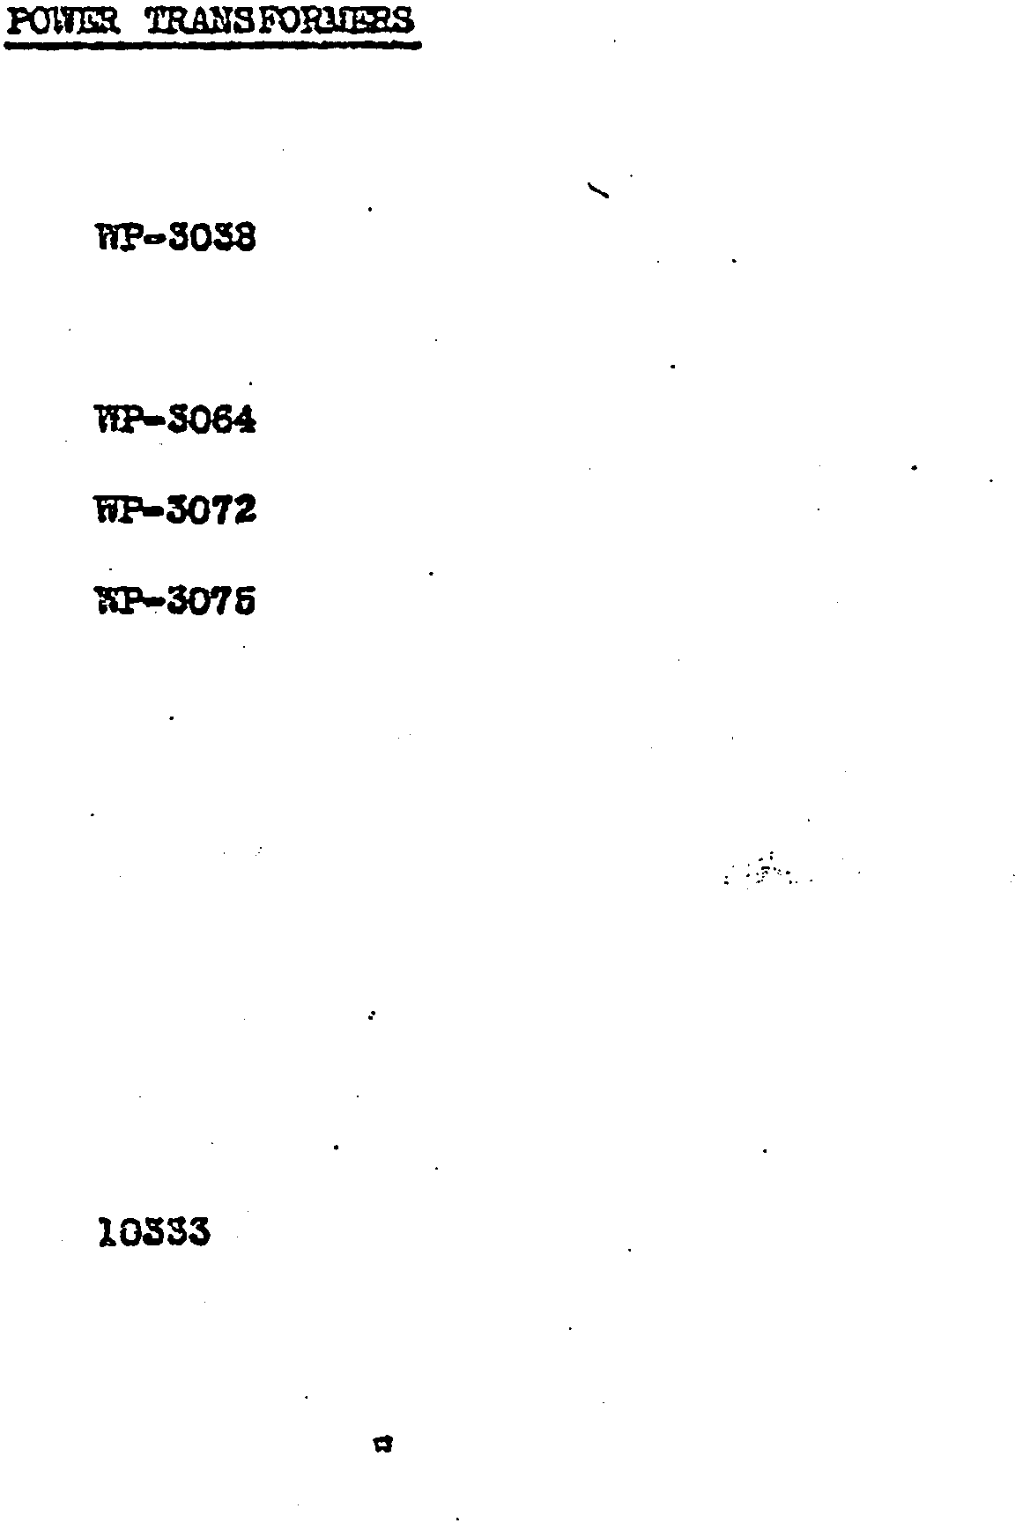· ·

Use 11493 by oh:mging 2A4G to 2051.

11191-

11192

16001

11325
No exact aubatitutoo Us� 11194 and tape up bias wincing leada or uao
12079 wh1oh ha� di.fterent zounti:lgo ·

Uao l033�.·10710D 1028 7. 10792 oan be usad bu� tApe up bias leads.
12061� a �bielded uprisht mounting oan be used.

Substitue P-7813 but renove plug iron wire.

SubiJtitute 21369 but IC.OWlt in naw plaoe�

111!74

11195

11213

11307

11310

11388

11397

11462

11493

12002

12067

12059

12060

12063

12079

12080

12195

12202 .

12204

12211

12213

12301

12.308

14182

2ZOC3

No aubatitute. Subatituts 1 0792
12211,. 12063

No IIUbetitute.

No exact sub•t1tuteo Use 12202 and o��e amplifiers to uae 20 61
tube in p1aoe of' 2A4G.

No exact aubatitute� Use 11493 and ohangs ampl1tier to use 2051
'tube 1n place of 2A4Go

lfo aubetitute.

• •

No exaot aub�itute. Use 11462 and tape up 26•vol� leada. No substitute.
No exsot substitute � 105338 11192 oan bo used but will raqairo change 1n mounting.

ilo aubatituteo

Sub�1tute 123038 12213.

• 12211.o 11213

:5'o au.bat1tutaa

IS .•

• n

No �ct substitute. Use 12301 and change biaa·cirou!t to correspond
to o1rou1t used 1n YCS25-15 amplifier.

Subst;:t.tute 12306.

Suba�itute 11213. 12063

12060,. 12303

llo substitute

lfo substitute

• •

tl •

.. .

Ro F. COILS
.
1305'1 Use 13129; connecting green lead to i5 soc� terminal.

1310S Bo au.bot1tute.

13129 SUbatitutG 13296

13295 • 13129

12243 II 30183.,

30112 .. 30191

30113 .. 3011'1

30114 n 30193

30148 So aubatitute• .

30151 Substitute 12243

30152 II 30185 .

30160 " 30191

.· 30167 'D'ae 30179• ahcrtlng out .001 mica cond�Ber ill pla.t9 leado

•
30119 Ill 30167.o a.dci.ing oOOl mica. condenser itt plato lead of ef13G...

30180 Substitute 30191

30181 :t 3019S

30182 II 30191

30183 " 12243

S0164" No aub•titute.

30185 " ..

30191 Substitute 301sa. 30160. 30182

30192 1t 30197

30193 .. 30198. 302Cf:

30196 1t 30191

�0197 1t 30192• 30203

30198 • 30193

30202 II 30191

30203 n 30197

3C2C� " 3Dl.9�

:O'BTROLS

Substitute 10139 (l meg)

· 10039 {lOOM)

" F-3076 (l6".J)

F-3016
No aubat1tuts

No aubat1tute
(l&f)

·(lOW.)

Subat1tute 11406 (l Meg)

lfo aubstituto (100!!)

" " n 10688
tt " n 61 n

No aub®ituto (2002.1)

Subotituts 10139 (l msg)

No eubs�ituto
n " (lOOM}

If n {l m�g)

II n (25�)

n n
.o2· 5-3

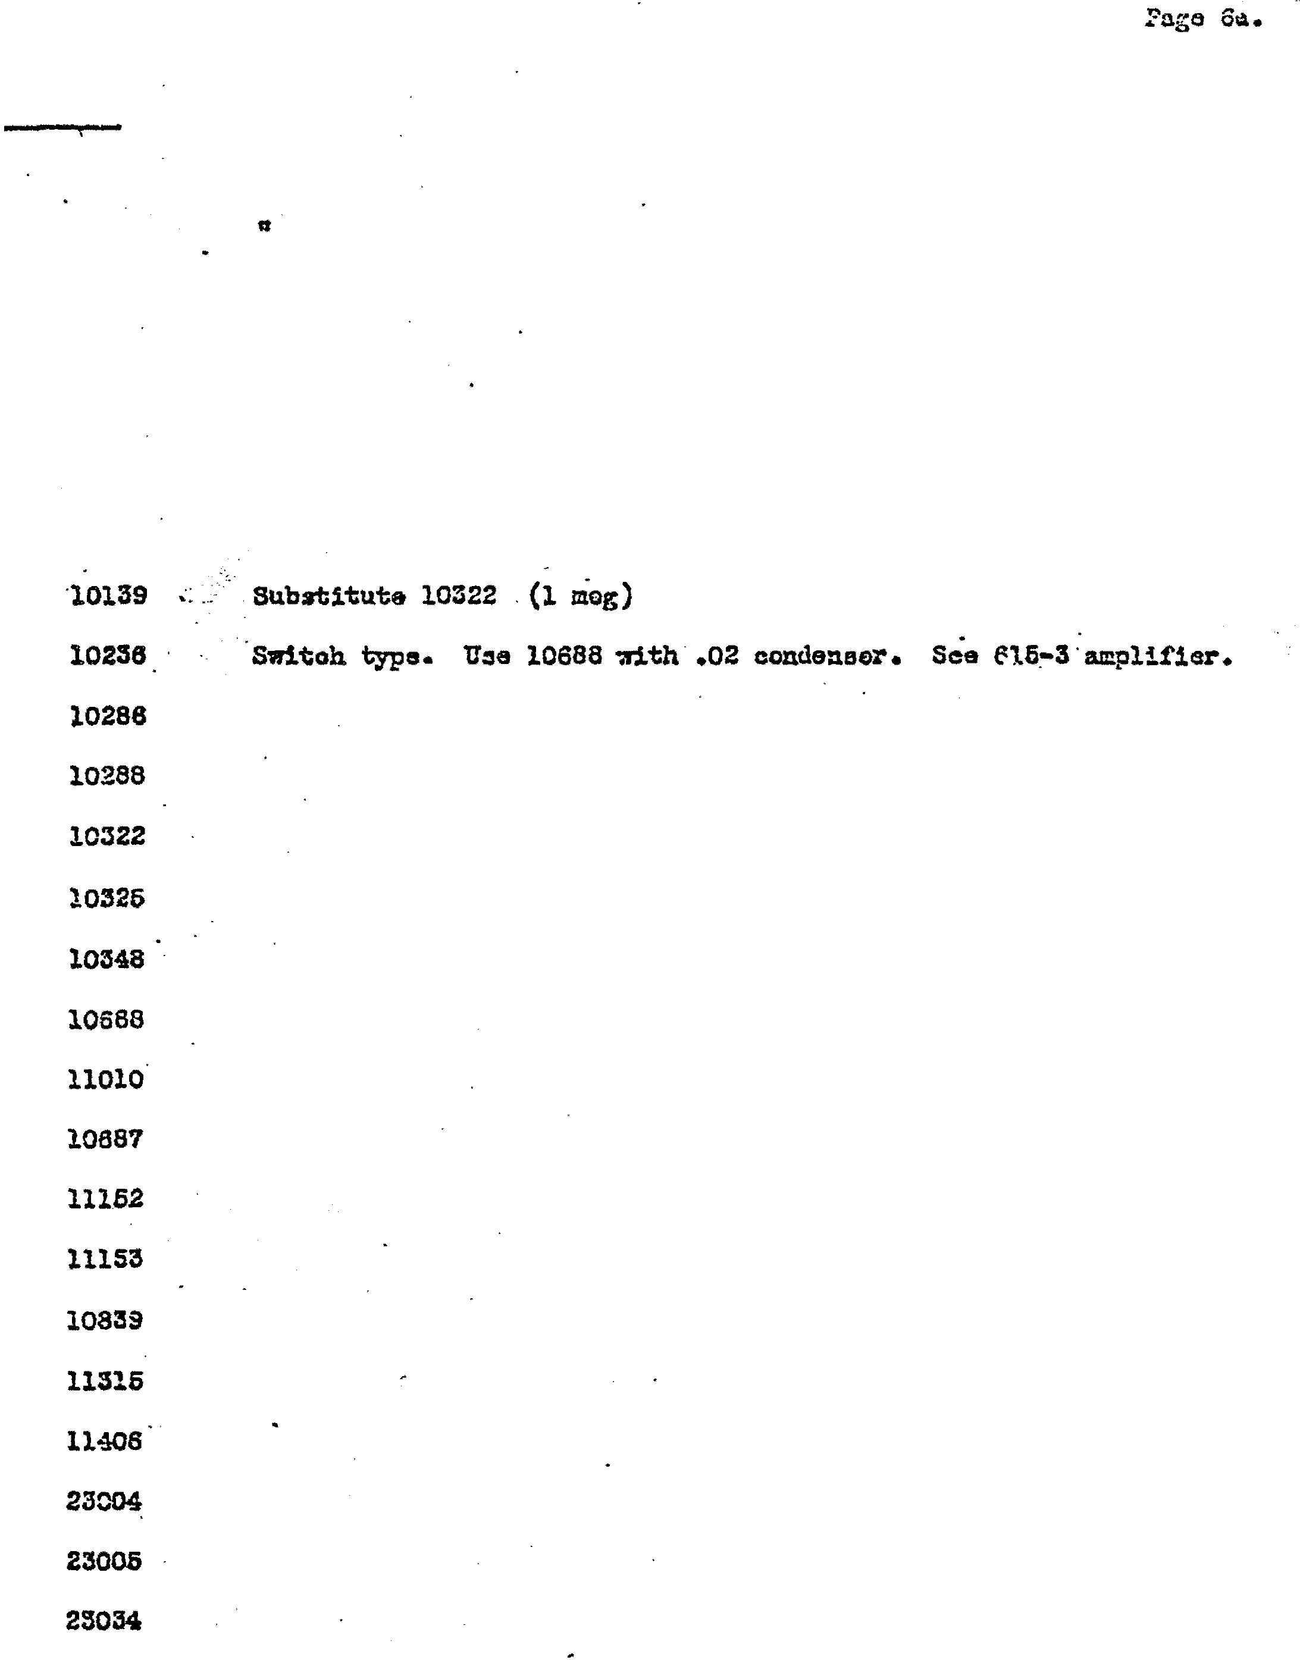
" n (2em.t)

n n (1 1!'3�)

(4ml)
n n

{40lf).
" n

Substitute 10033 (1 :n�g)

!lo sub:Jtituto (50".4}

n If {SOOU)

n " (lOOU)

SERVICE
MANUAL

INSTRUCTION BOOK, MECHA NISM CHARTS, WIRING DIAGRAMS AND AMP L I F f E R CIRCUITS C 0 V ER ING T�E 20-RECORD MODELS: GEM, RE G AL AND C 0 NCERT GRA ND SEEBURG SYMPHONOLAS
1-15-38

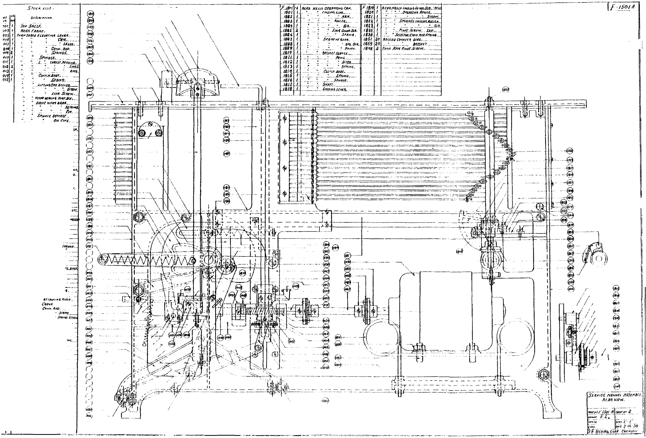

!JI6 I
'Jfl i
u., sa
.
;; i
>2 I
' i
'.efsl i
a
',12 9 r r l'l.fl.f' If,._ .sc.ur< . _
' .3 NT.f8)£fJ.(,.,..JHtiS/'«<Jfl{]f,$(fl
J'f_ ! ff /V$!JIJP< fV 11Ttfll1!114'-,
711 l $!1 ,- ..
'f' . J.II! I(. ----- --
•fl J ' "It/!_"'·
'1f f W#11f/l #IF'(.
1>! •. -
f,
1? ' (i,.t<iHfEUUiA. :
I .,..._
§·o I _.. Jf.f4£1t
!i I ., ,$111-#FM.tfltt,.
!Z i "A..flillHHf,lllf/!t.
,5J Yll# t.,
S>t I .P!JV,
1 ;- : :: ::
!11 :;:; ;.;,!::;.'-!:-
J .ilt'JNIWN!a /)JtiK !.
! lf T(Jif lyt SNfti!C.
ll t:ffH $1(-ffl ··----- -·- , .. Q) 1 lll foiS#JUI-QifflfE t: td"'"" It! /'16i'"()ll - --
,... L.
ll i .. Iff/J"JF.
Itt 1 " •.
:)p j Flflhtl Til ;,9o. /I.IJ.I.fk
"I :t - &'d... - .
II I
u· l :: ,,,,..qrur lf.
-f l '" O ?}!ff $/'llili(tl;..__
a'f! l '- /J H!Ntf .fl'tf.f!Vf 1'/ff;.
II I f!qlfp UAmML .
!(I I. $ 1--L(f(}/t .SUDE .•..
tl l ' ' IJU.<,, ......
. ; . f-t ...!-..-
..
ffl .:.Jr..... _
J'" ! f'!lt' '· - •
II I
1B I
lq I
'I l
u .IJt ii..
'0 iJ IIA. .
J IUiflt N£/_p. i.9CN .Sni (JIEF,
l.t .lw .
U :Z, - OJ.Uif,
tS I " ,,;, $._. . l' tr<vtt•.,.
u I /DAM PIY"T _j{llflf,
-' I flUttto;'( $1JDSPIIIIYV 1'/P.

SFO(A. it..; I

ffiJJt('JF,,
lftKA MHt,
'' It·
r"'!fltlEUINiflf(t
Clllt•....
'"" o- llrlil•.
C.A._bil ..
h•Ntft.
" SPH<IiJt .••
' .. IJ# .t-..

. ...
.. 01'/t'l(,ll.#'(,- -
.tn-.
i•c-r+.

INIIf kJUf"',_
: .,..fJit•r.N•.
'" Hid Wlf4'f IUA- _
• • N
. -· - l'#t•..
• S,.Ht M fiF
(Ia Jill.
lP 4Nil/" XII- " • •• - fltlfN 141/4 EJt P N4.11¥rl•ll1f. $(If fflfi'•IJrJ-11•,Mlll/lldr.
SJU,.r
-.
(l rlt•
.tiMrt()MtwJ?I•
.,.,illlf Pol'#

t"lffl'•-411T.Uit ...
vw .,
•..
.. j!uut
"'Mil•.
UH JI;,r l .
lll.fk ,._". "'·
rut 1-/WP!f. ·-

·- .
t!f.. •---

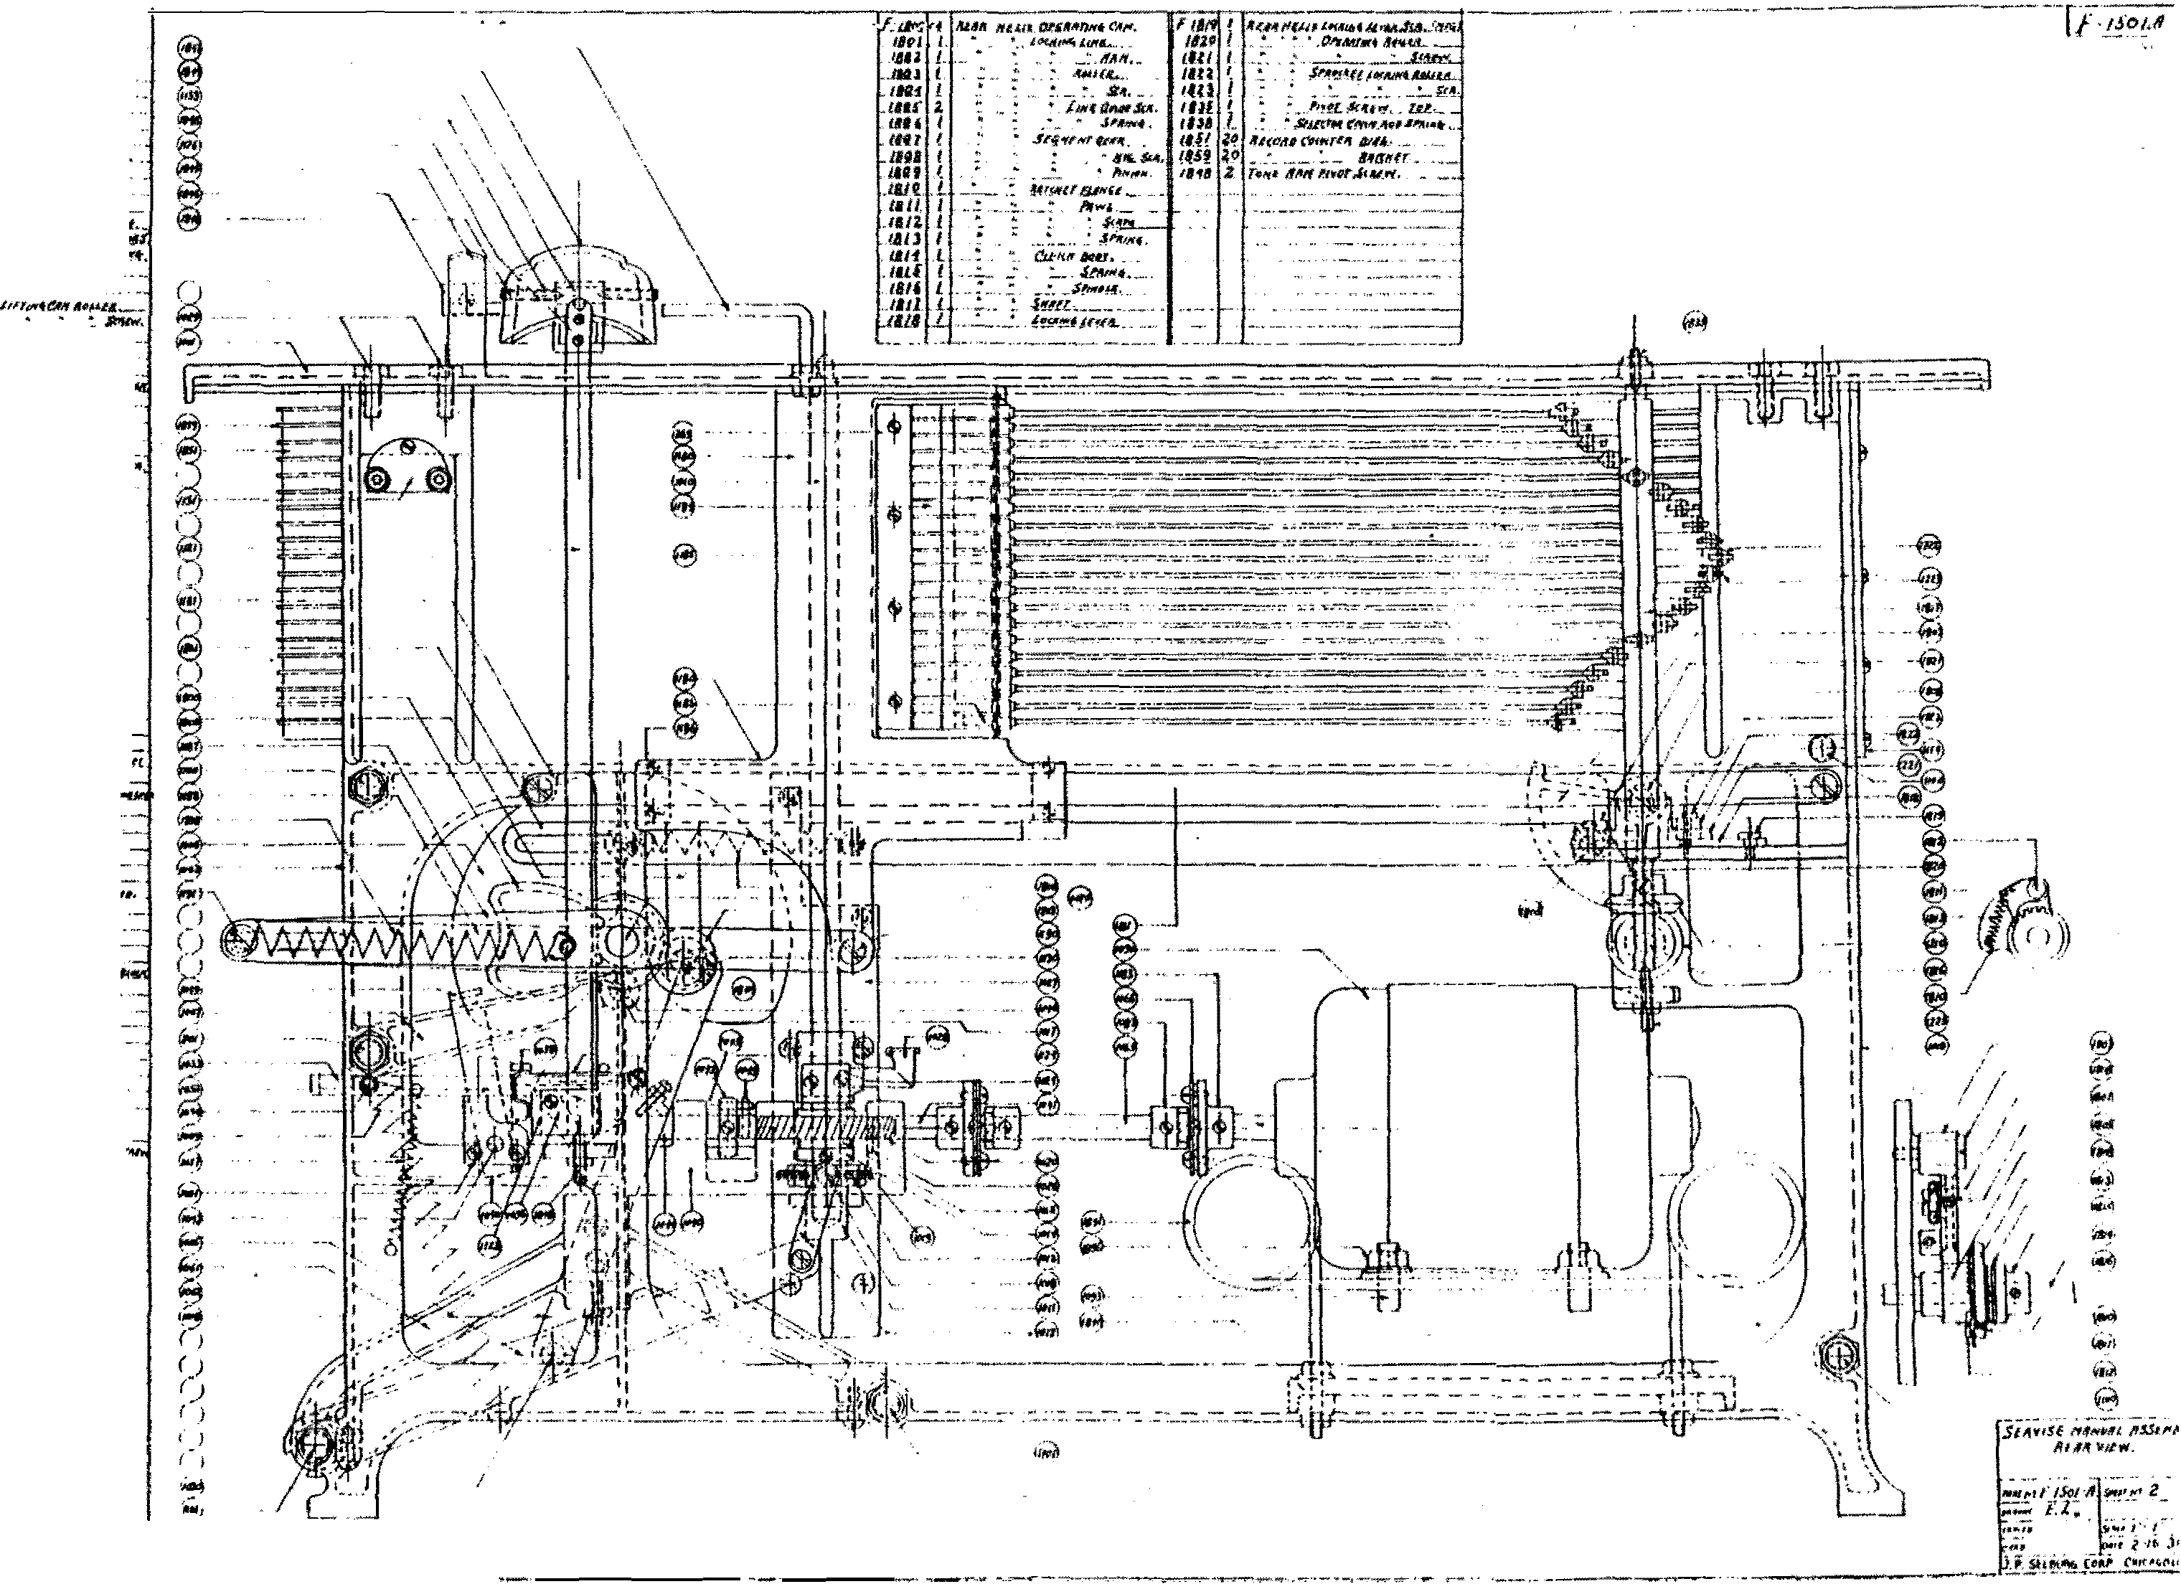/JIT.f , ·r,
l lflf#C"Jff(
,.,.,,H.trtr ltlt c. *

#If Slfii'T
llf ""'tPt,.lufiN.,.,.,,- £t ...
1/ UPII _
lrl4 4•1·
fi/#T,.
! lfl 11# IIJil, "c--::_·'A!-··
, ,llflfS/'1• .
"' flf"4/'1' II Wit,
A-#trlt .l!tbh....
fW.fnctt tlfFfr,
f:flfP FON L
sr. ..J. "p• .SU•fJI -J-UH..,
..'16..----­
.lnfl"f,
'11'1/fll'fll'<"t,'.'#r6.
"--··

'" t .
JJtrtt i-l'<M .JJ J'*I
/flflf t'ICH I.HAI, I'.
• 111111.
l'tr'#f "'MW ..,N/If..
J'!AIIIt,
ltt/'16 AM '""'IJ fi(Jf,
SlJttEDif SuDl ,l'lff"'l(i -

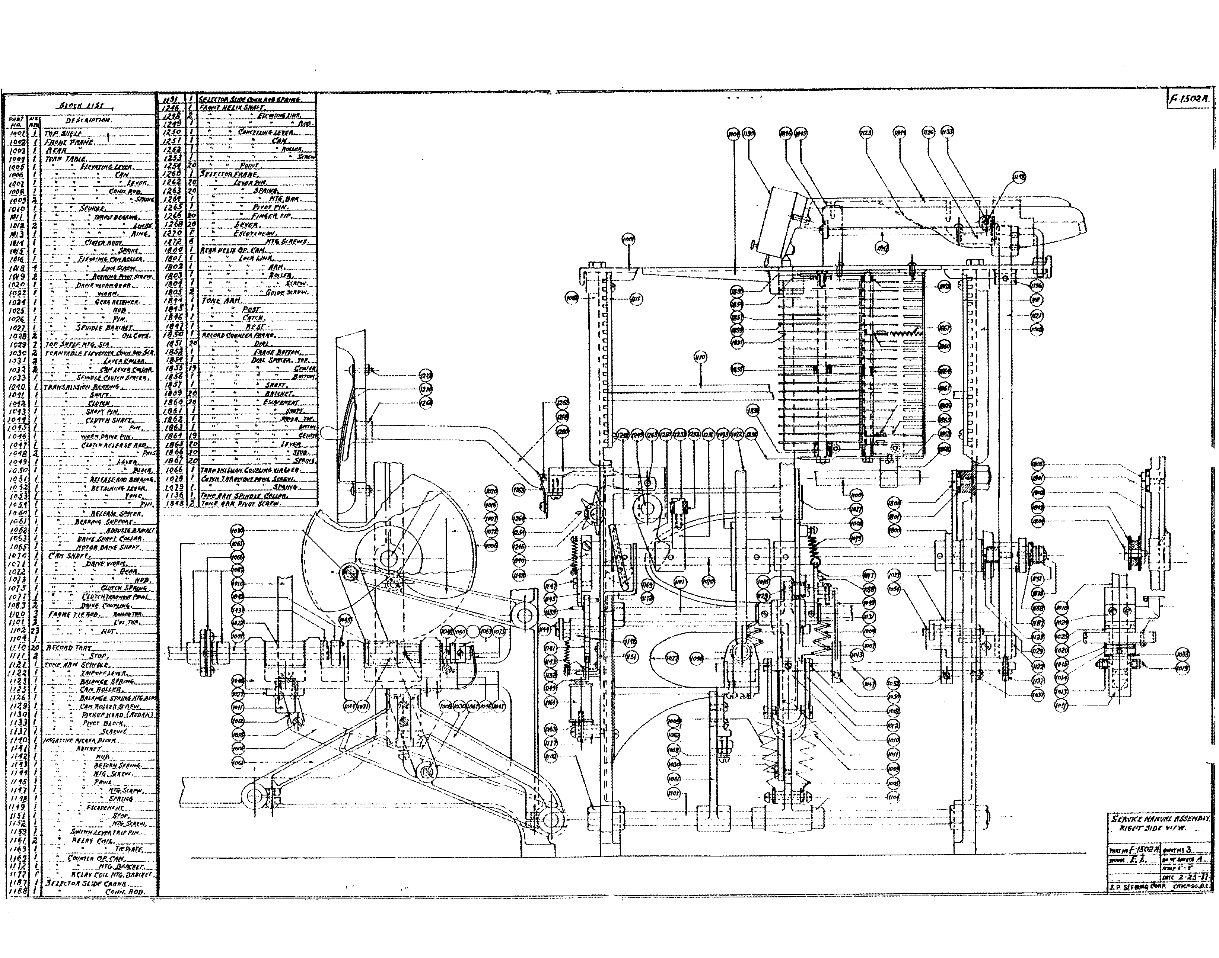

----�

.:' _"!11'!·--op
.. : .. tt'•fn t--rK._
. _: lf.r6 •..
_ _:_ :,_J'pf_ -- ,
::····; J"!Wt-.&!f"41I.
···----- (JI<(M,
1f1.J!.Jfi.FV;_ft1_1"-Jf4.., ----­
f#AI>I1:1Jlu E.Jn#'l!H.
.:,... !_ ,_../t_MUL._
• • -.•• ,...111'1110:<-­
:. ..... $';.1NDU..(Jf'lfl!tSJ'ftt'l6
--- -------,
TI'- HIJII$1iM .}UMN.,_ ---
•

.• J3.ml!.._ --- ·- •
. S/(IJ.!b ....:.-.-- •
C"lifflf J/lf'L
;M - ,;; _·_
.. (J.,ft•A.o·; •Jr __....,_,...
----- € :!:i;A.
: tii!WU¥ IJM..,.,4,
_ ,IT.IJHII"f../Ufll.
:i.:.·... -:! .
- "-.llrtiM£4/tll!llf •
. . JJ'.f.S.f.L.""!r..J.
.! •••.llhi!JAifi"'Nf
·- I..$/IHL(JIY11_4!.-·
--- 11'!•1f ,.,.tNn
{"6/f .$/M'".s--- ----··
:' : ]J _N;. u.._..
- · :; _Lik':;
- ... C/l_'.fll.
.:.. _:.JIP'i#.t" "--­
rlf!M r:" -·--.A'!!t
• . :· _:_ .-l'•rJII!f.
::.. - :.Jr••r._
-i-£:(;4-i _ih::r._--s,-.·.--·------­-
T'fM:t .,fA31if lf/1.!11.....----
,. .. I'! '..J.l.., --­
IWf'<Jti$1'Jt"'f
C t:t ft.PI lf .... _
4'U_IIi"(L - (:'.ltqtltlfklf.E!* ­ P.Jt•fii'.Jtl;fiJ,(/1##11l1
'IIAN!f.._.
. -- •.. - •_ _Jeff'¥(
,wtf$/llti!U .4K414t.l.nWJ(
- /tArr,,r. _
!'.II.IJ- ·- --- -
({111 /l'ttlii!Nf.
.. l'f.Stll ·-
.• /'l,l_w,i.._. s;.;;., .-
..., .:.1,.1,.,,
." LSIIHI"II.[_ • -
•. _.. - 1!9"----.
• : . •lfhf,S't_ l-
.fW'II'f'lf£#"W.1AI/'Jivtt.
Sl FJ•¥ - tJII., _
H • (;,;;,..;,;. ;;;"..r.Twlt.i UTI.: --

-- J
9---.

--·,·

"' ... -"' JIA«Nt:._

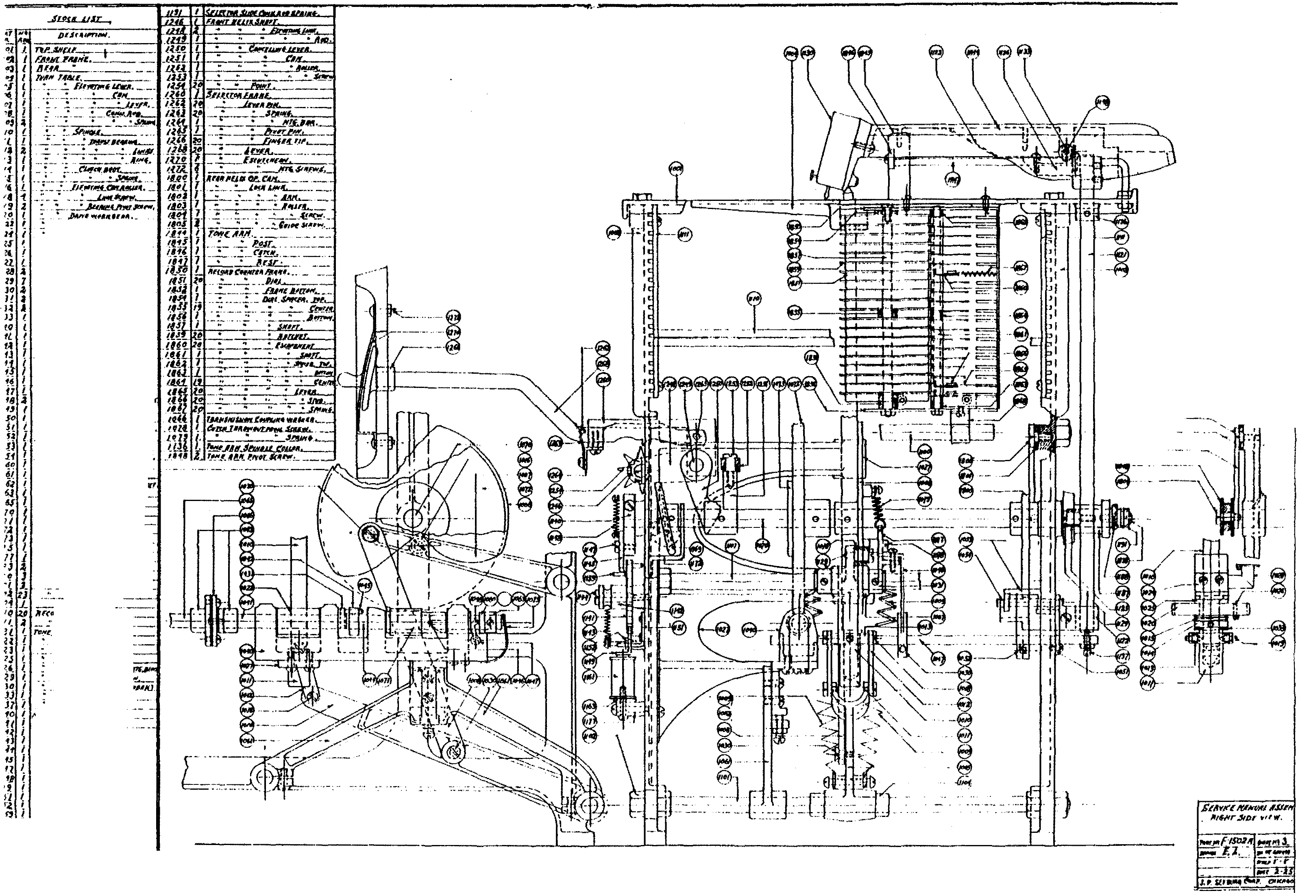17 . _ lf(l.fr C' tt. lfTf,fJII•¥rr.
f7 $1/LcTIM .'ltl«CA6.f1'· --
4: a " f!•J<FN, lftf/J.

--·-·--- -==w.z: ·· -·--- -·---- -

. :!roc/1 t 1llr.

196< j
1'66 :
ltl.l�C. '­ lct/3 6 tu�q I
JC�6 1

l/(1() j
:f_
1/DJ
1/0� .:!.1
/Jf)J �
/tJtJ I

111j I
1111. I
Jlf�

£1!, JJ5/!
1/5.1.
111'1:.

usq fL.f?.
UR<1 L
((�{ .a
UO.J_ 1
_/.��.£ -

U65
tiLO. l
1/lL '­ NIZ l
iififirt ;({MR. 'RI#IE/)}'¥.

: i'<vrS· ..
� • _·· flJIJ C'�#ft/1..
P/(lfQP lfCRD·. __ .AVO/II(,
/IIUr!Nif lfff/t'/tj!!ltx:l(
� Jltrf<ll'l'
/II'PI/INJnft.fif,
/fl'6,$Mr,.• .
/tWA:...
� PIN,
"'!/qcw
;_ _ $���- -
: e&�_,,tllL�---·
::_ _ _: ��'H<f'
" .fwir.('K/M$�_
. . .Jb'l'� --

/f'J

l�tc. {
.
m* �
,2fJ,. � $NII�T.JJJ111vf)_

ll<.J: � - -
::___ 'J.I:•!I'#Nf._,_

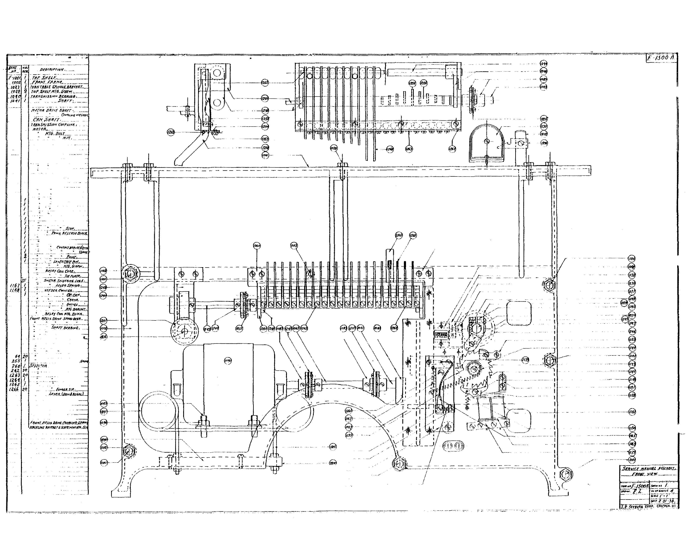l�'f� f. {I'IO!V�_IUI!j, �!Mfl;_ -� -·--
: �'�""""""""----
_ .. � R•D·.
" _F.ur,m!l'r/UI(Isrrlf
/.enii..I!Jf!.,_�-
llf!l I
/2.
-.
1
_j f.Ml1i.____ ""----�
I
.. ,$P}ft�-�-
-- i'!!l:.Mn•
. - �- � --� f't�r liM,_.
.
!A68 2D __ �·-
181.6 /.. f<EIII{.lfLJ.�I)IJI'(�Sn�>��--
18.1<:! { lfCUJif ltl'r.r,IJI/.Y,____
!:1J � -,.�;;;;;� e!'::_�·"
181'.! .: • • :·_ rtt<tf.____ _
Ill,£ � _ .
1/S'i'. I ,

��­
�­
fti1)
�toI}
Vi�

. . . .
�------

((>6$ i lf66 z ll.lf) (
1113 6
iff� l
IIIJ. 't
1{/#6 �
iii. :ii!E�.i:_":� --
.F��""'-'.Jf-*"� - -�-­
fTIIHfi4JE �C'I/tf.,_
{11/1 S!i1V.Hl4, .t'M'tt'! ._ ____
flfiiiSifiJIHfiV 40tltllit#. ·-·-
.. :IIfi·Ff'; -·-·
;¥(1j(,if iJ�II'T JMFr ·, �·
, �... • • .. . C"-......-t wfJ"�
CI!R .'JH�rrr. ... .
fM11tS1t1SSHN C'�l'-#�tf , JlrC1Cif.,_. _ � - . _ ,
' HT6. I!IH._
.. . ����- -

lffl.l. 3. ,. � ; . � r�A . IICZ 2J . """"' _
.
.iaUF#iW. .
iilf j iii�i TIEiJ4;,.
IICJ � • . :· f¥'11(!(..-T�II• .
IIJD I Ptfltfl, HEAD . __ JIIIIJilf. tJfC I /tN.fiiNI IIIfll#/1 Jjitll(ff.
!Iff I � Jl'"rtnf' • . •
f/fJ I - 6TfTIIKJ*'Aif
!114 I lf/"6, $-#N,
1�11 i Jlo��VA. . . llf" i � "'"" llf1 I : s-.;._
.
JNI.. I
!Iff I . : i!&i�!fllfl«--,.
:� � : .............. _•.
1i : _ . • .$/111'....
:- /'lw,f �t:Jffll /)1 .
�
'IJ_f � $wi�t•Mit
1/I'S: I . . • J.�wNI . ttS6 I
fldi i
11It .t '
'15� I
·if.i l t6/ z
'-�� _(
'IH
116[ I
·t,�l 1
1/ll?_
•fU i
-�J: �
t'tf" I I
tlfl ( I
z.,t , . L•nini,;i;-�
I
HI, i • . .. Sl"f· flltfi«J. _ I U.T � -� - . :• . . ·-� -�-
t1� ! . /4111ff lltiiJ SIN'!- _ . _ _ _ I
-
lfl. t ' ' FIN- UM. •• . I
111. '

2o
�u o
'113 �· Zf1 �
��� �� • .:: · l.t.•<•.'M�<III<
fl6 � /IIAif /UJJl M•l �11-'«IV. -�·­
l.f.f? { hl:l�lf lllff. IJJII.f�- . ---
'::.: i t�k�;;�� ;:;:�£ --
11' I . : . . :.. <'tlflt... . . --­
IU. � FJt4U¥L/i'�"· MI'I'lt �...JHI! .
IS'l I UJf11llifk.Wrii�WT#Ifl.:/t •

� -- --

���
� -
'�
v"'9
Vi�

I I
.. .l
I
I
I
I I I
I I I
I

) .

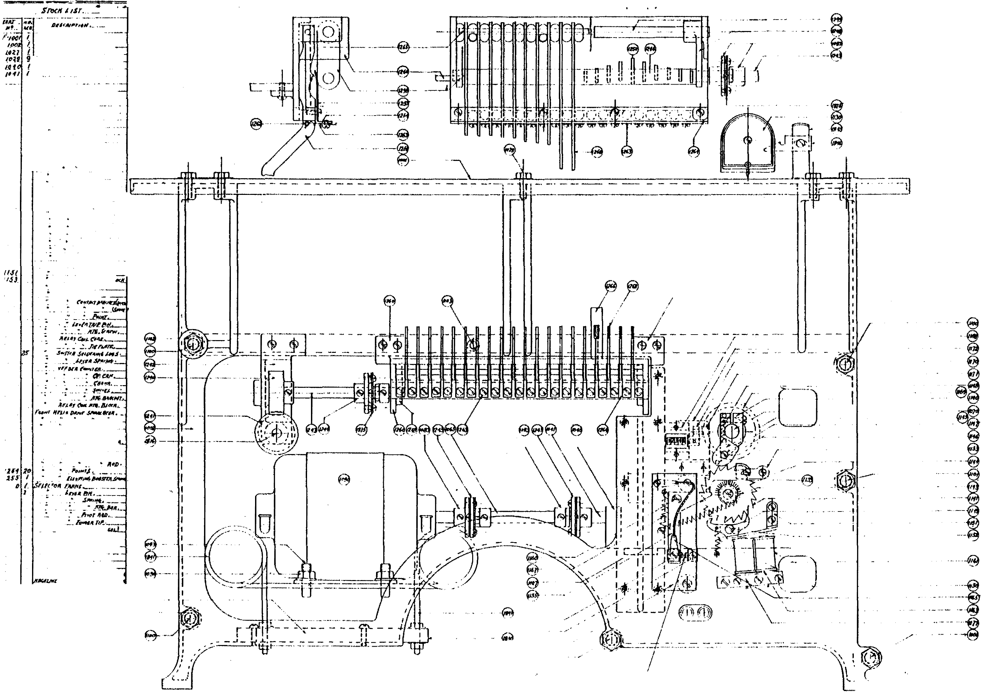._.
...J

·� .

'P/i4T. .Hi­
-�L ·'� JCIQ f
itJ�t. I
1tll!) !
_Sroot Jllf. lltjrlt JPf/.31'1
I�P SIIELI FliONT FRI/Ifl' REIIR
"
ror iHtlF HT� $CAEW.
tttJToR.
lfft;.iJoiT Nt!T,_
!617 9
(O!JO I
/0�6 1
//P� l
ioo io
_ _

FH.111C TIE JJIIII. {/IO,lJ.�ll flfff.1 --
..
"
/1£(0/lf) TA� r.

• /.ou; Sfllftr� l'l�tlr,
1111 I

.1.31(! �
_ti. IZ I
122 � I

5Pti'IP/.t CoutfJl . _
,gl'l[( 1f'J/f /)F•fl, (}�lilt __
IU"N!I H�/.IA. too( .5PitO.fN�r·
$rt-p .
1223 /0

Jk1J ! . SN�Ff.
ll21 I
1;1o I
l}'fl I
{JfV-f1th'fJ.tiii!J,
il1'J I
• fftJp .
8----- · - ./

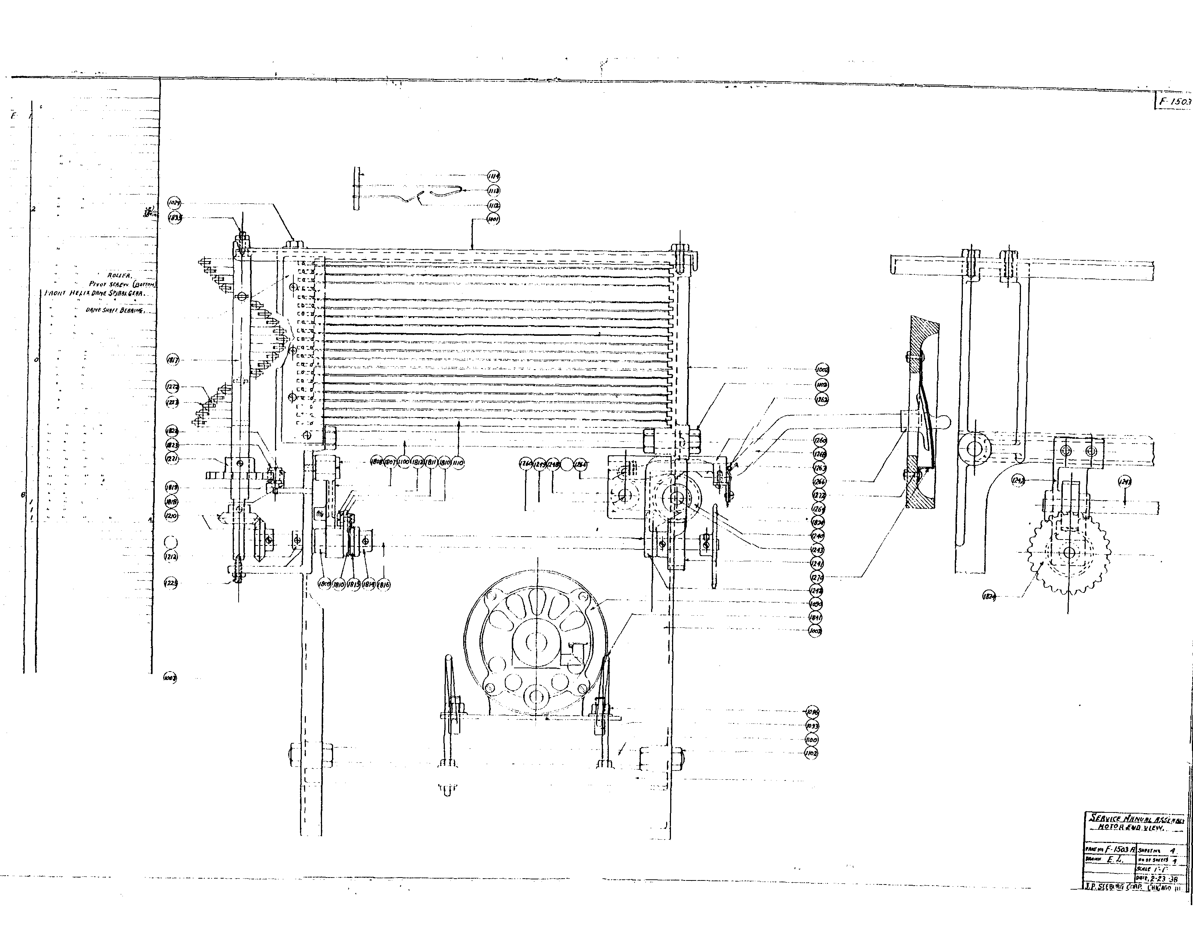126� ! Sfl.tcron l.lr��/lf/INr
IZ'Z 2P
bf'l· _ -
/263 l
f,l61 � • tf{q., 8.ffi ,
!!f!J /
1Zl6 lO i't,.f£1f rtP.
1).68 20
t).l() /
1172 '
1808 I

• "�· "'···
I
/AO 7 /trlfR l/t/11. OP. S£,11£1 Q�.tlf .
·
' lflf, .Sclf_,
1809 I
I'II'<IOtJ
• P�wJ..
lifO. I 111/rtiU F,i"N�t:
1911 I
1812 I
� Sr�Ew.! .
J8t4 I r:t.urcHSoot.

181 I J.ccN J.Enli
18/6 I
Sf'INDU,
1819
/822

M;� " $
:JP/IOOUT irK'..I/11� 1/D.IUif
�81.1 .2 DPU. S/'fl(}c/IEf. -
� · -···
t8JS I /lUll HEJJ?o PlwlcS!fFw. (/of!) _
18 1] I RIRII lffi.IA .5/f!ifT.

I
I

I

1- I
I I
I
I I
I

r
I I
-- €t.J
. 'ifJi'
I I I

·
._,;- ..... ;
� "'' I J�l I
Jtt•J !
IUJ 9
(D,O I
,,, '!

,,o l f/DI I
· ---

ICJP$1UI..E F.fDNT FA41f� lfl.flf ••
TOP .SHI lF Iff� $fAr�.
!ttJfcll.
.. ltlfi.8t�IT
•• . /Vtlf
FAI,l ''*JJIIIf (lftiNI�III'ItJ
. . . ""'·
/I£CDII/) Tll/11. __
"" ' J.«'l )�11111f.{f- .

• J.-..

r;n,, "Jf' �'''� if�� _
51'11'tDI-I. �t1UHI. ,
lf/"1111 H�IO• J.Hif Sl"'tfJrJUf ·
$T"'J .
p,�.,
/IIOHI fUJ.11 /)/IIff $f'.J/Ifl. &lllf,

• SIII/I
{1/ .-flllllfJ,III/f,
. ,,,�� ,

rr�-==-f
. . . - · - - - -- - - ----

.. - -
�: : ---·-·--.. -- -- ----
-- -·· ···- -- .. .. . . - .
- . · - -- · - - · ----
L
- · -·
·
·
- ·

I:Jf'l. ­
. S'lf•Nt,
. ,,,_,.,,.
!',•• , �·�­
l'.t,.4T• Tt�.
/.Ill/f.
Es,.m,,.,., l'llfl�- .
· 6�. �...
/lf#ll lltlll. D, �<T,"'"I�l-'lf .
• "" .U-1,
• l'�tol·�
"*'"'" ''tfltf�
. ,.....
. s,,,.,, ruttll l••r.
.•
.... S?•tlll<f ,
• .1f'llf #lf,

tfrt)

@·
;;,�

·
@- ' �- ·

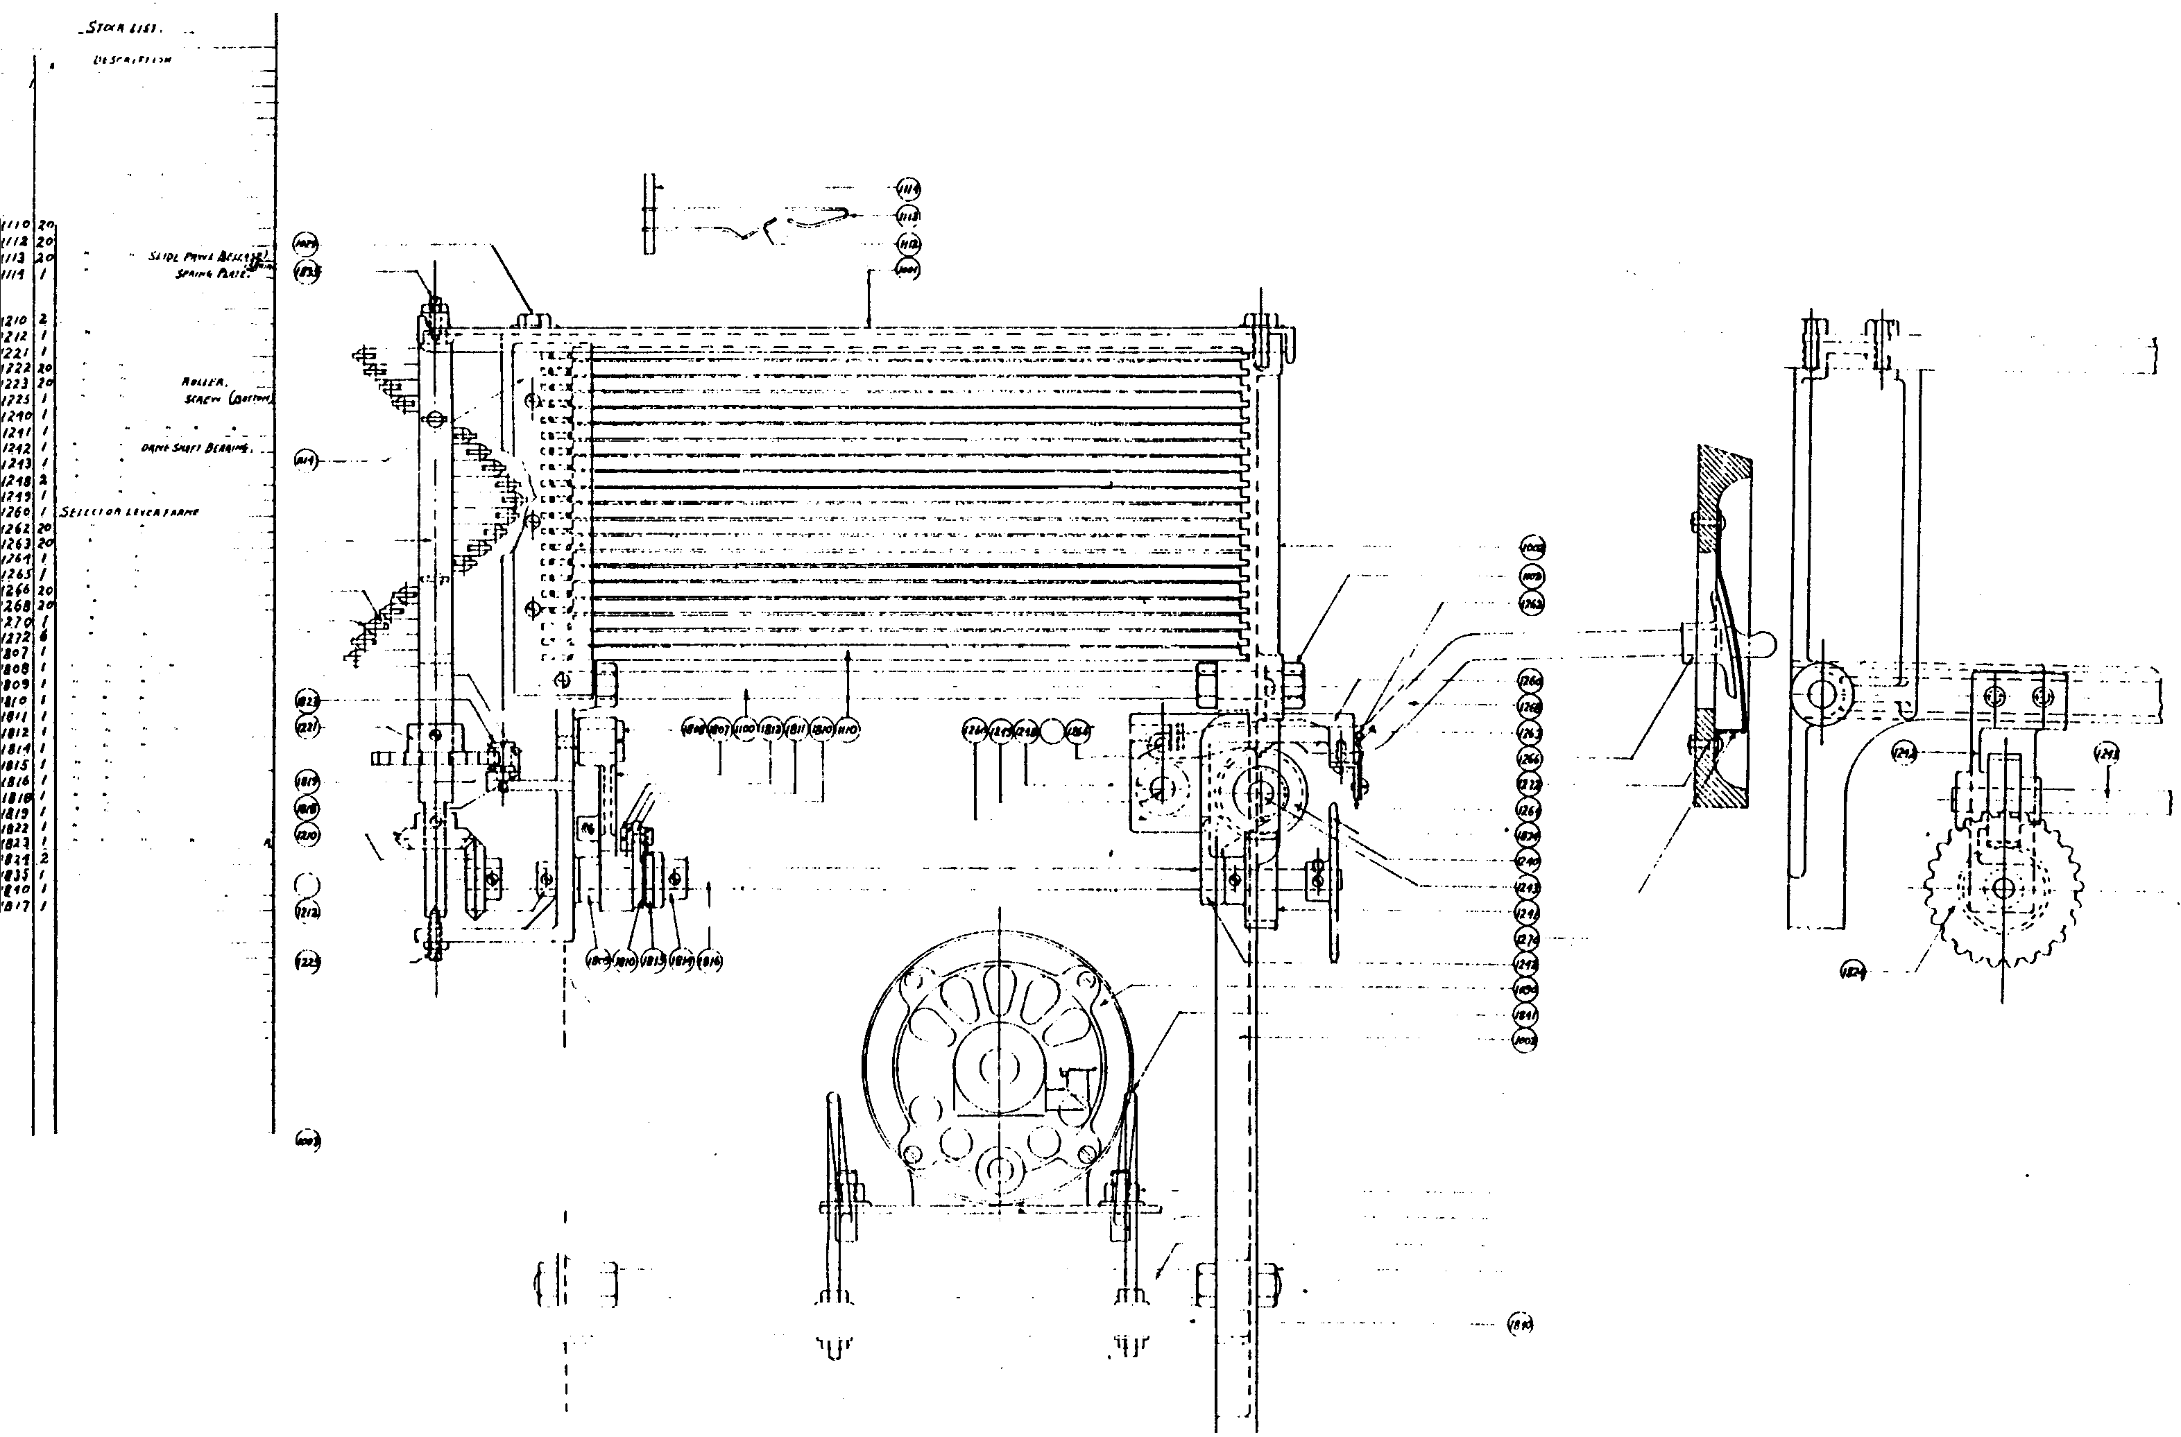J..CJI .lHOI
• lf". .$UIW
- j,,,,, ,,..,,,. "*""
· It
/J/#1. .SI'Iftxtl£1: . . - · -
11. n lfrJJ• hrrtl J!f'"· (/,,J _
/fOID/1 hlfr. AAS�. IHRR lflHA S/141T.
_/

I
I I I
I.
I
I ..- ..�*-.
..
I
I

...

r . l

SERVICE
MANUAL

',

:;j

� ��
I
I

CID
@

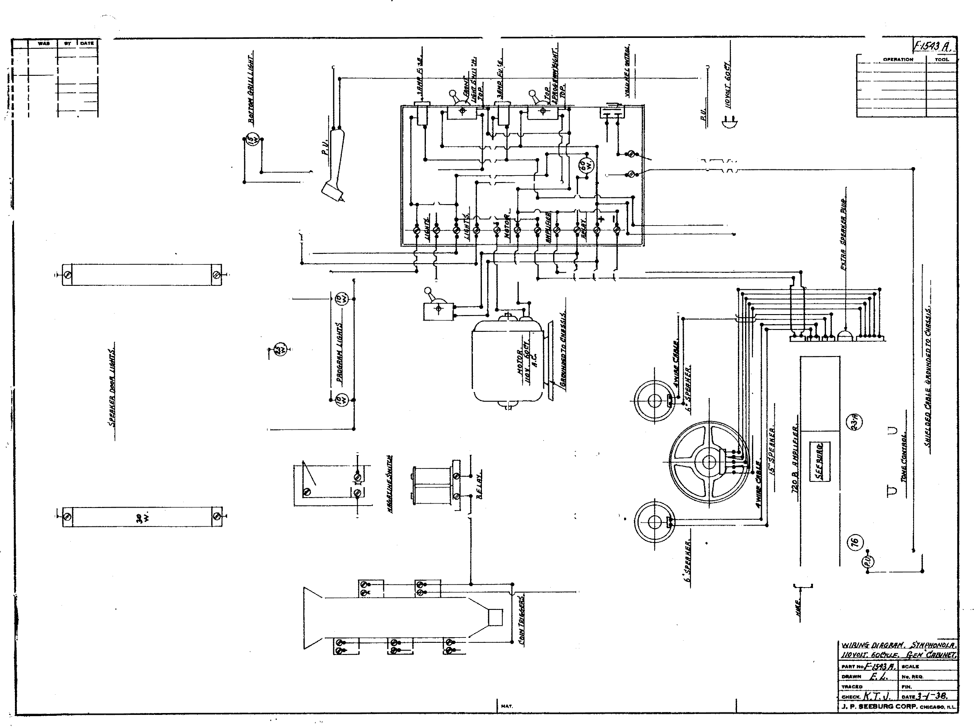
(!)
®
@

...... I'OAtoo�,

I ..

OPIJI'At10ft

�j
l
I
I

@ (!)
i

®

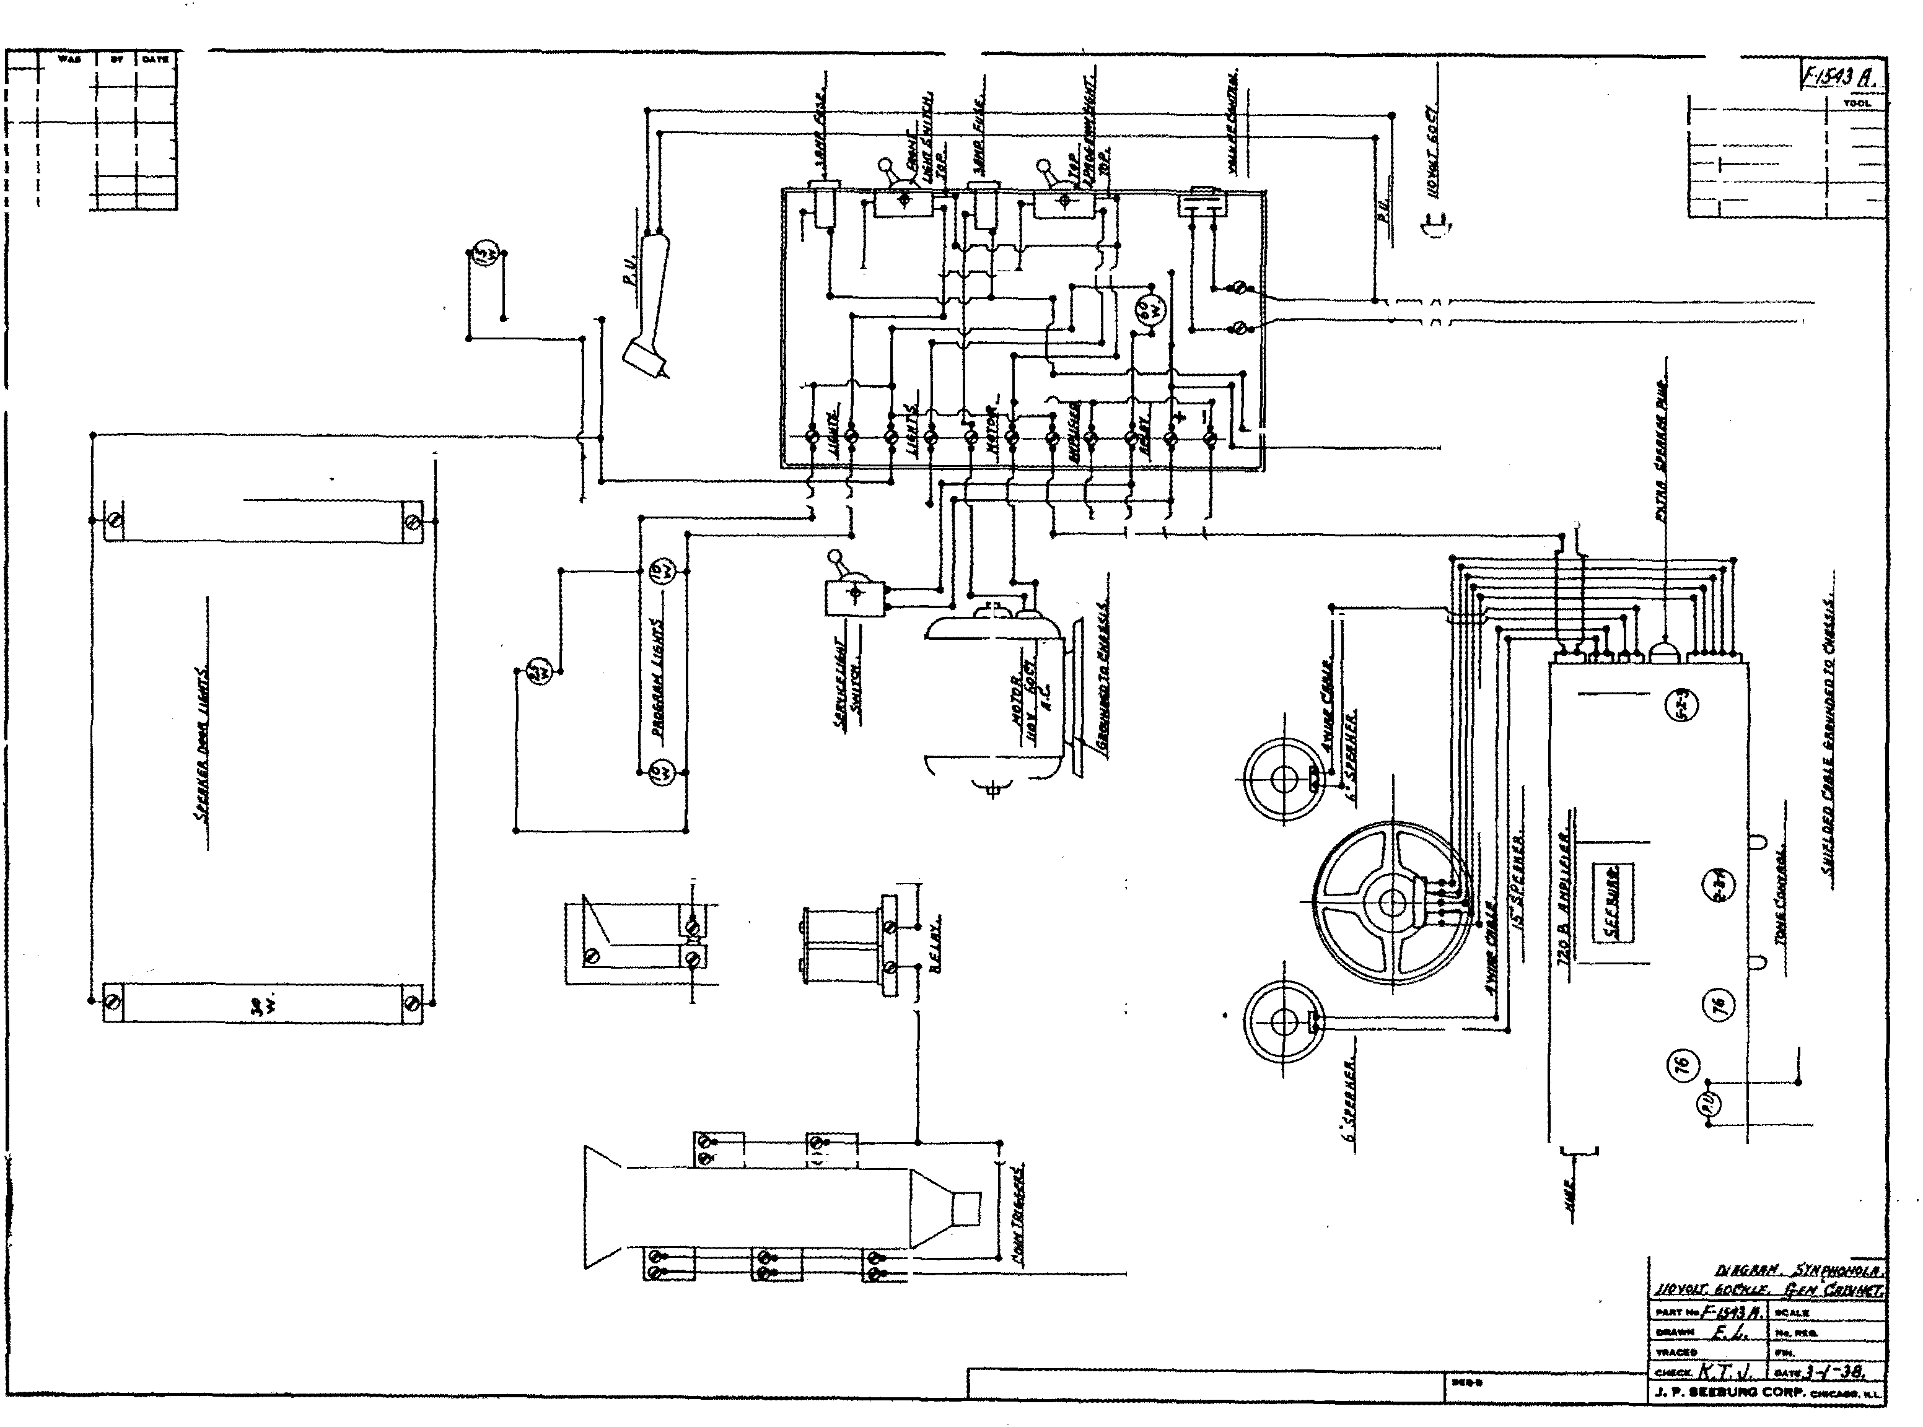

MA't.

,...... ,.. ,.,..,
WlBIJI!i:

ONRA'nOflt

�)

<ID
@
�l � (!)

[I ®
I
CID

®

WI!VHf Dllff.KIIH. IttiVOI:r /). •
GLH (68/N£,r.

....- ........
..

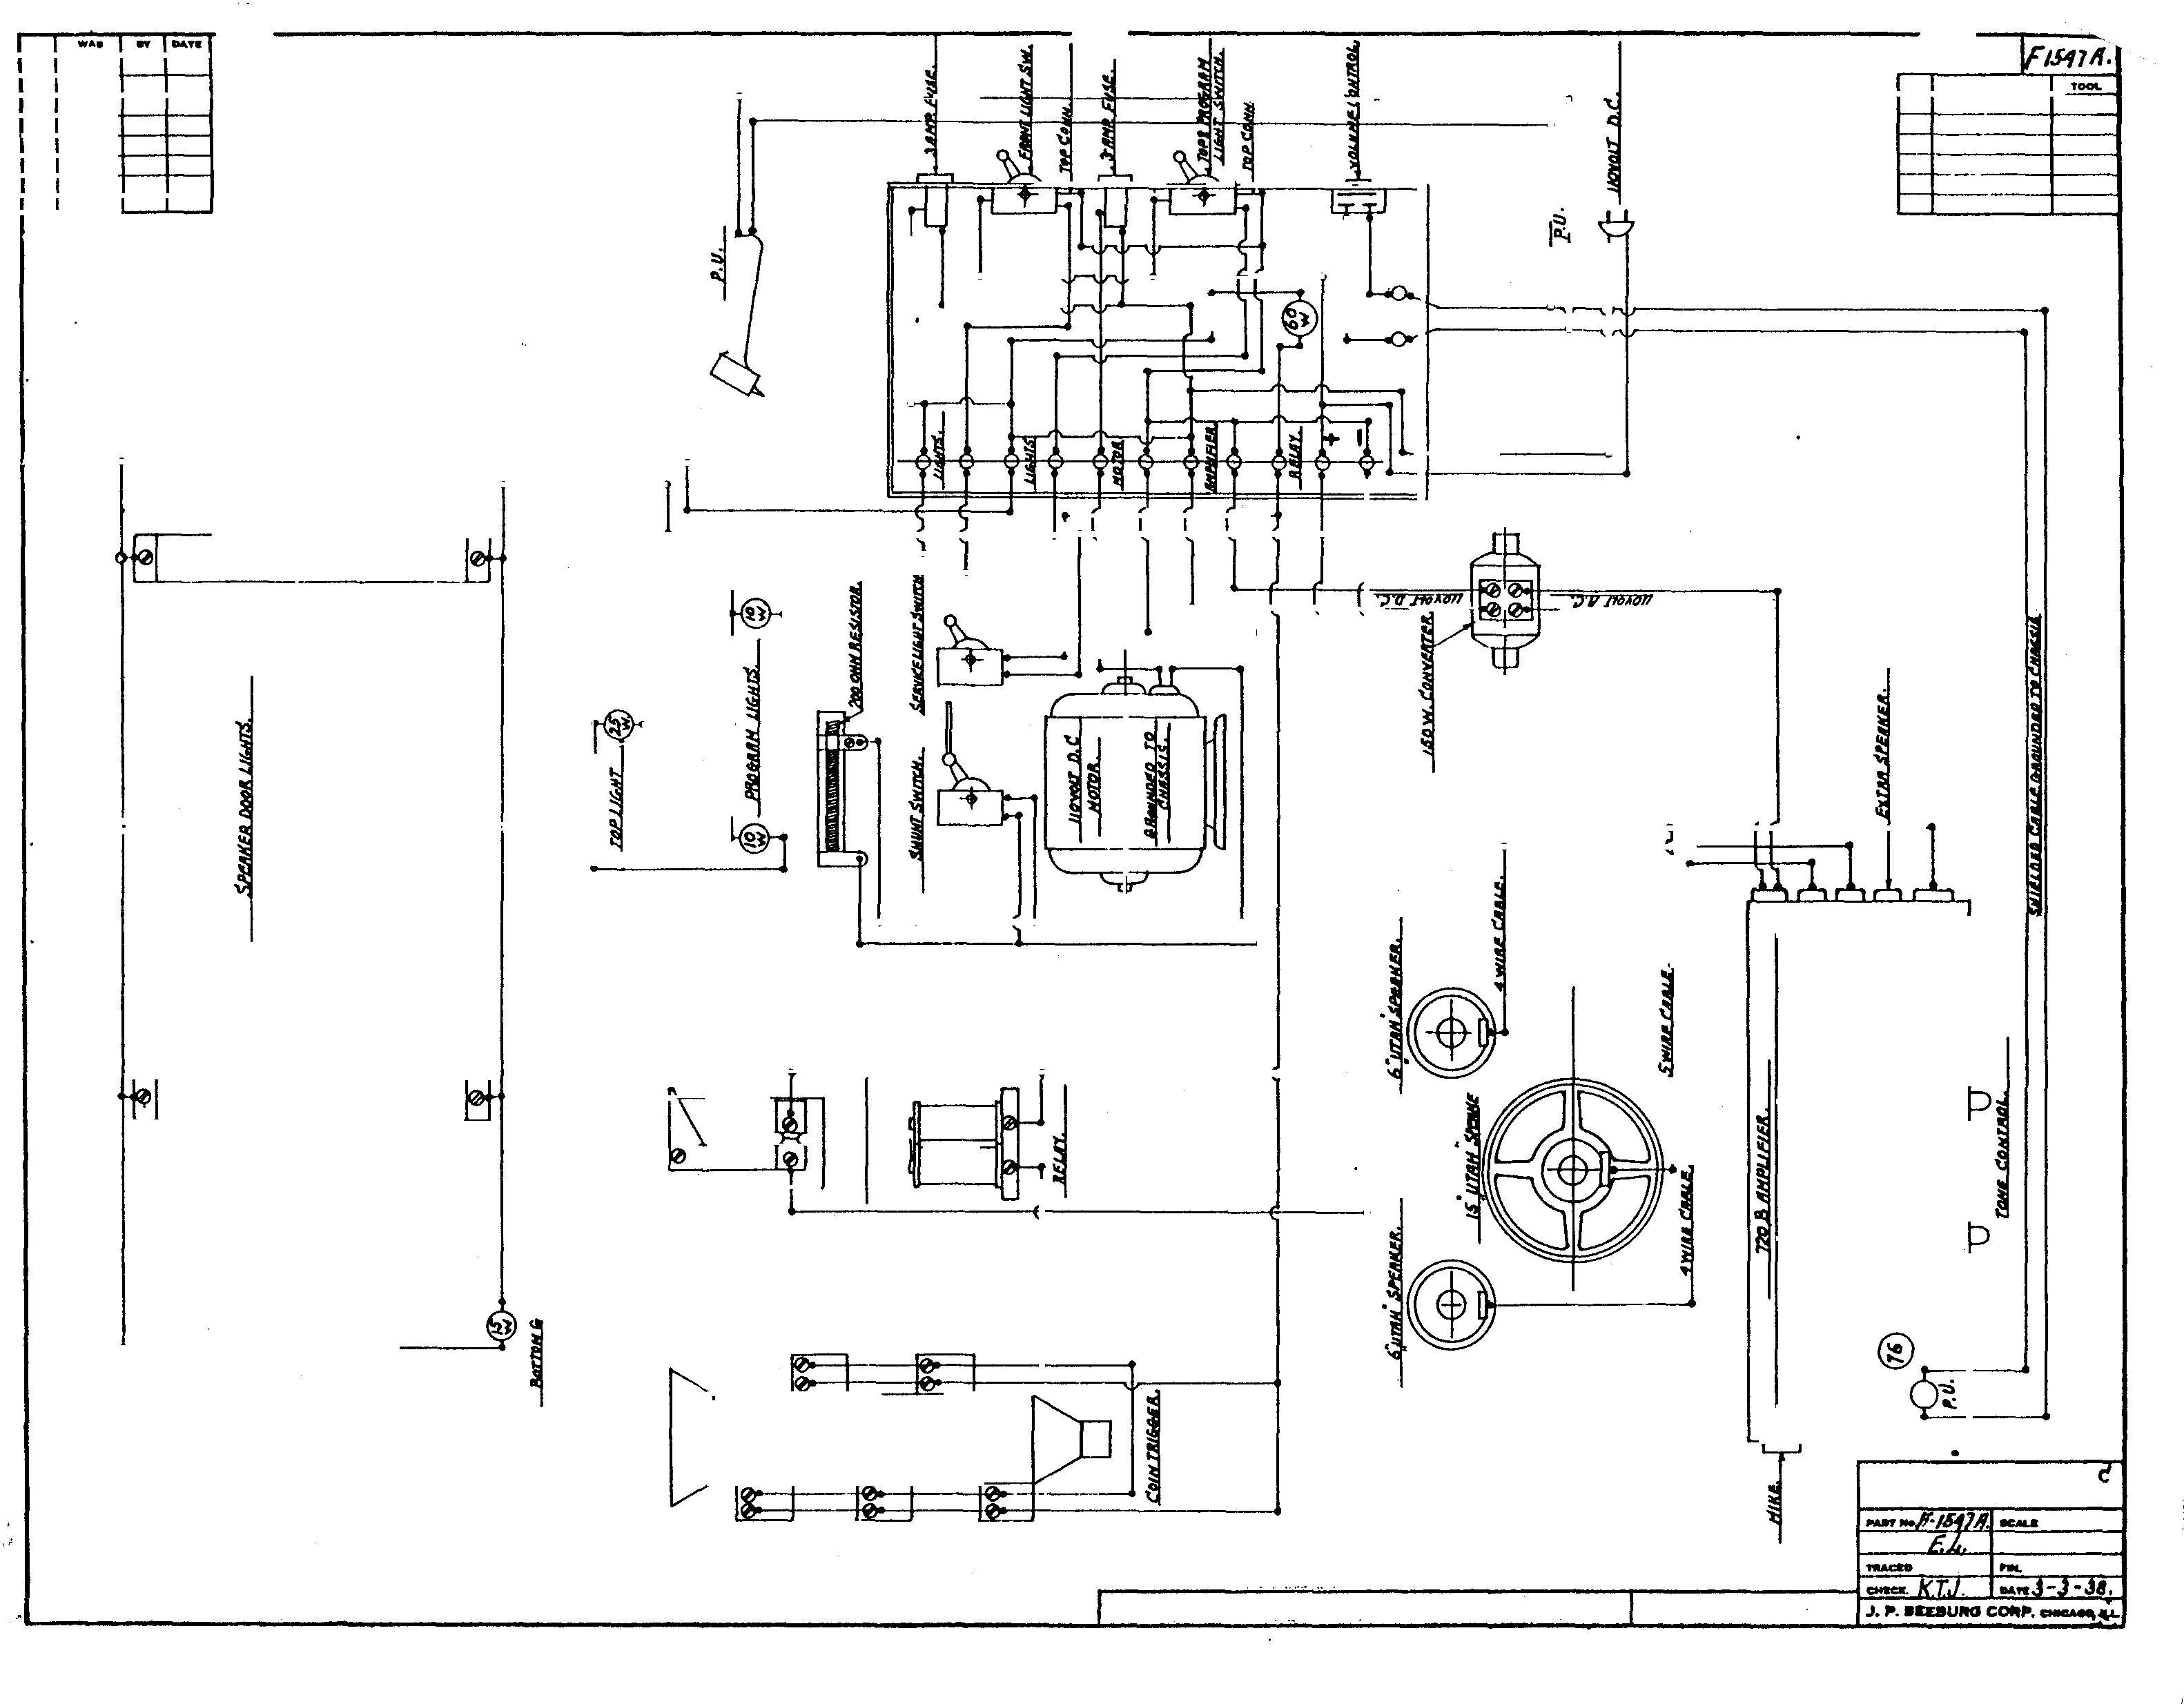....
,..... ....

..
- �
ON"A.nott

�)

�

��

I

j CID

<!)

®

@

<ID

®

.
WIR/Nt;-D//f.RHH. /IDV<"'-1' J). •

. . • • ..

PAJtf
ficH r.

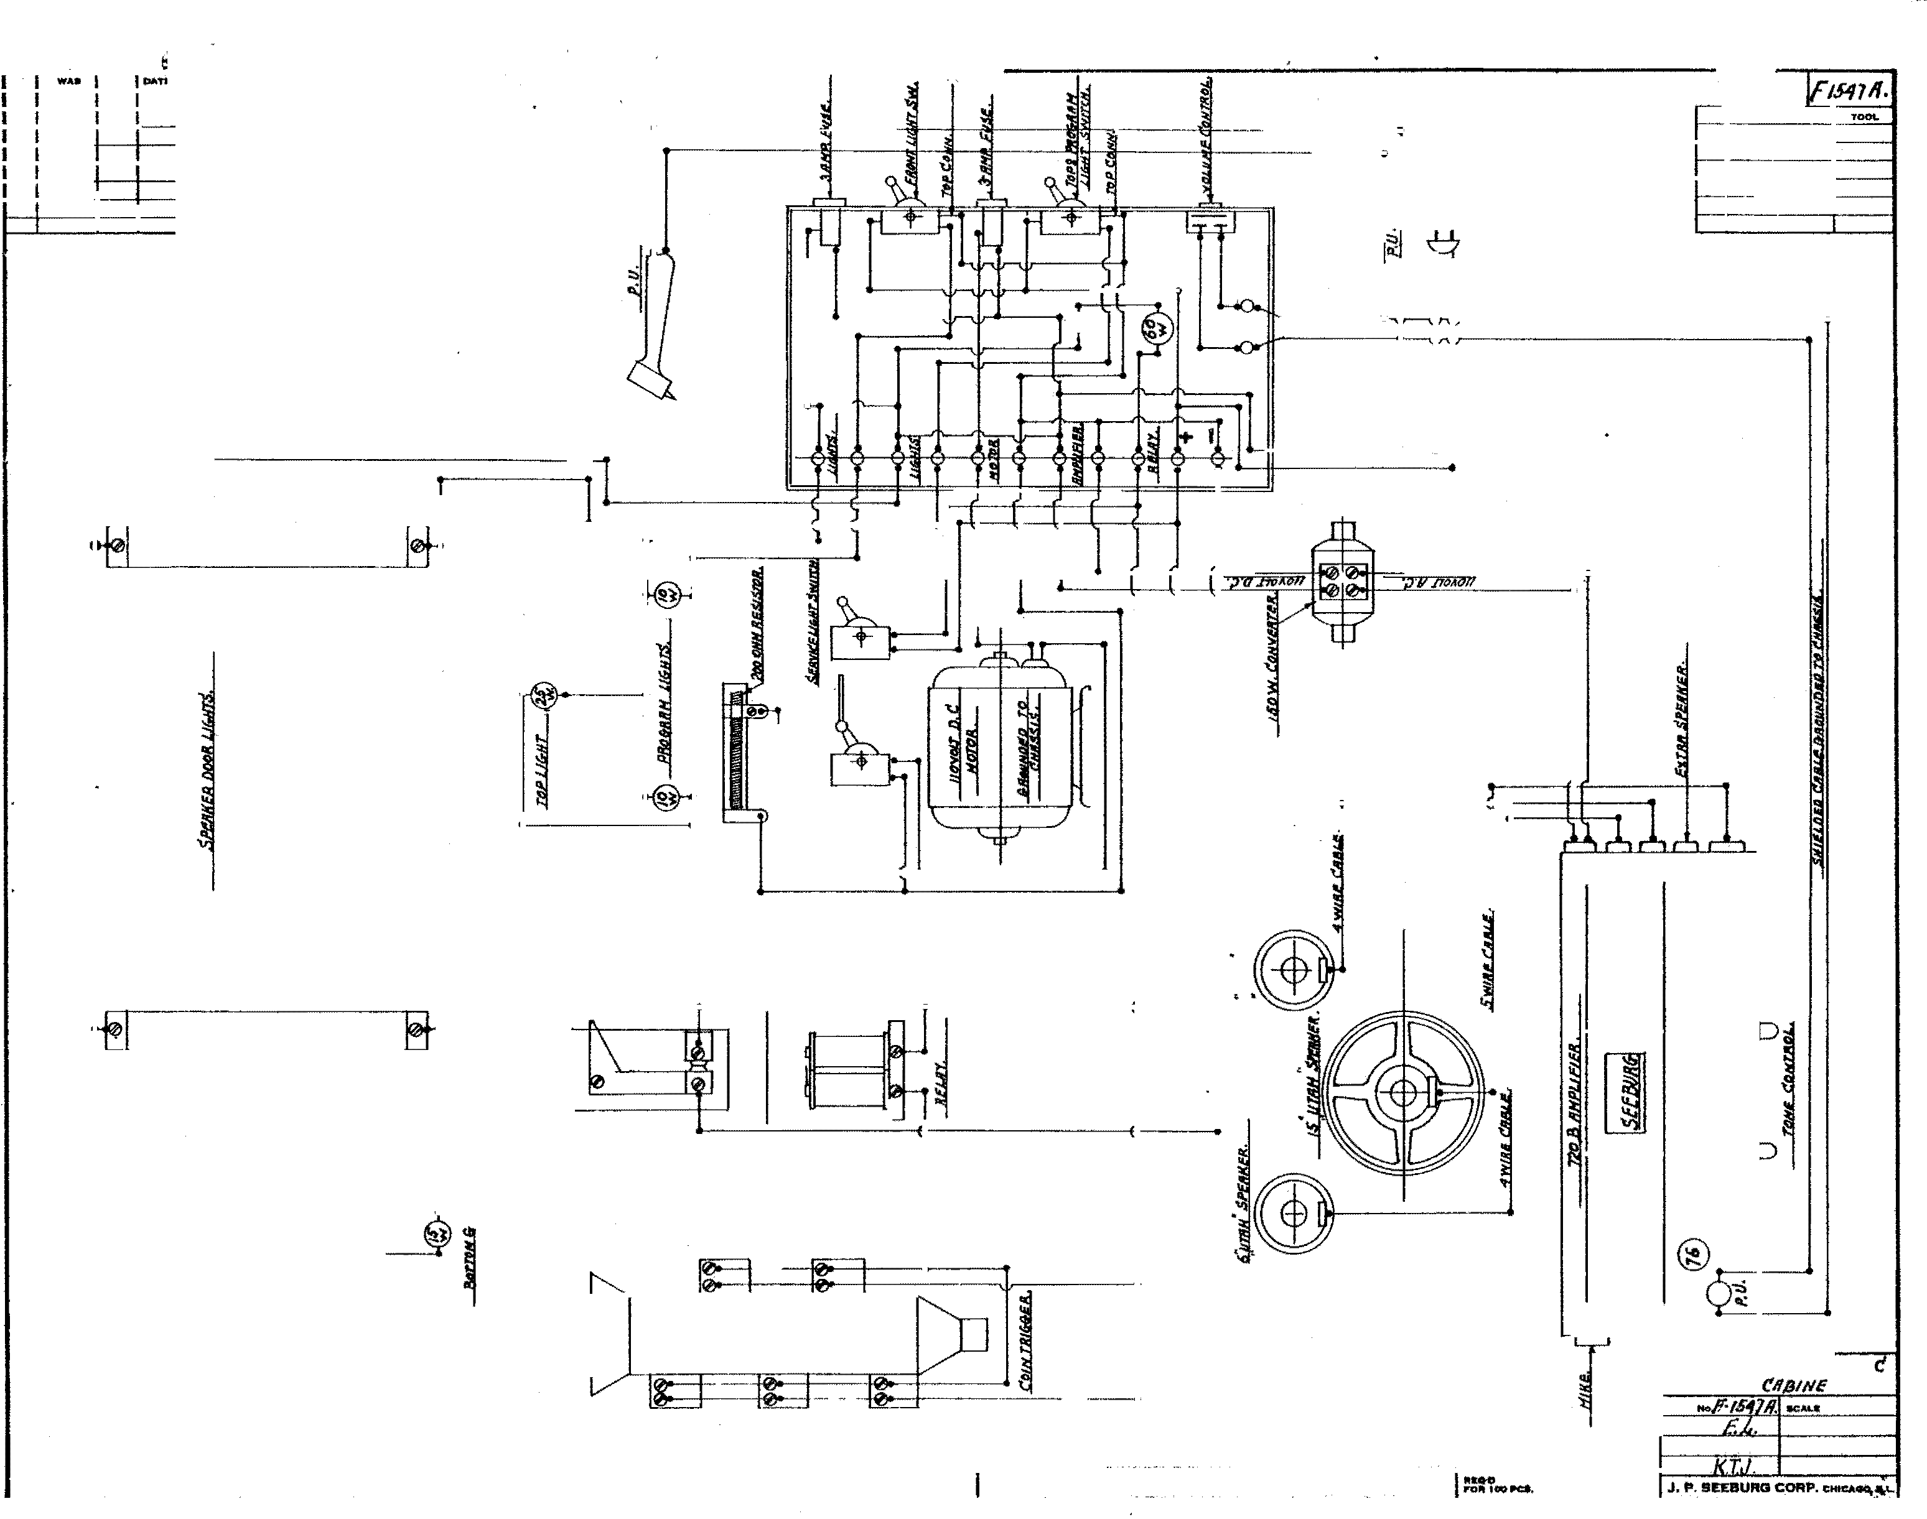.,.._ No.MO. TWAct:O hM.
··-- ••,.J-J -38.
.....

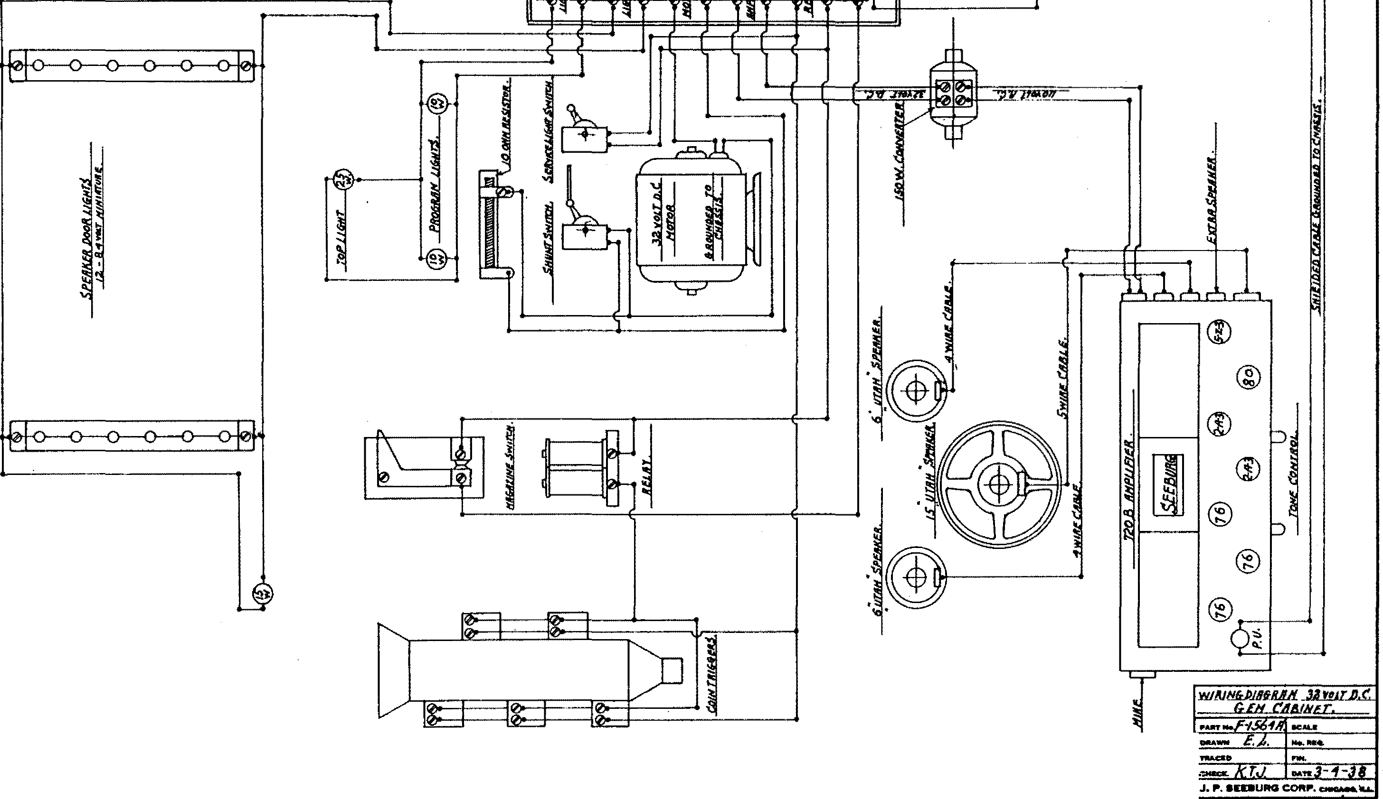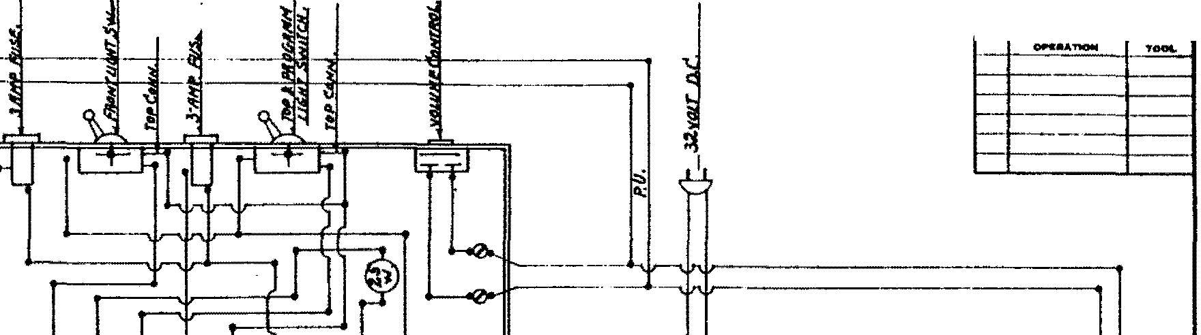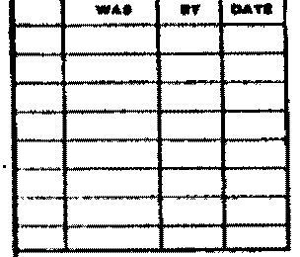r- _r.:::; ·!S6'111.

:v J!i : til'-#------

..... •r'O•f•iii•iOO iii'QI,

-·-·· J

0,._,.AT10N
1561/1,

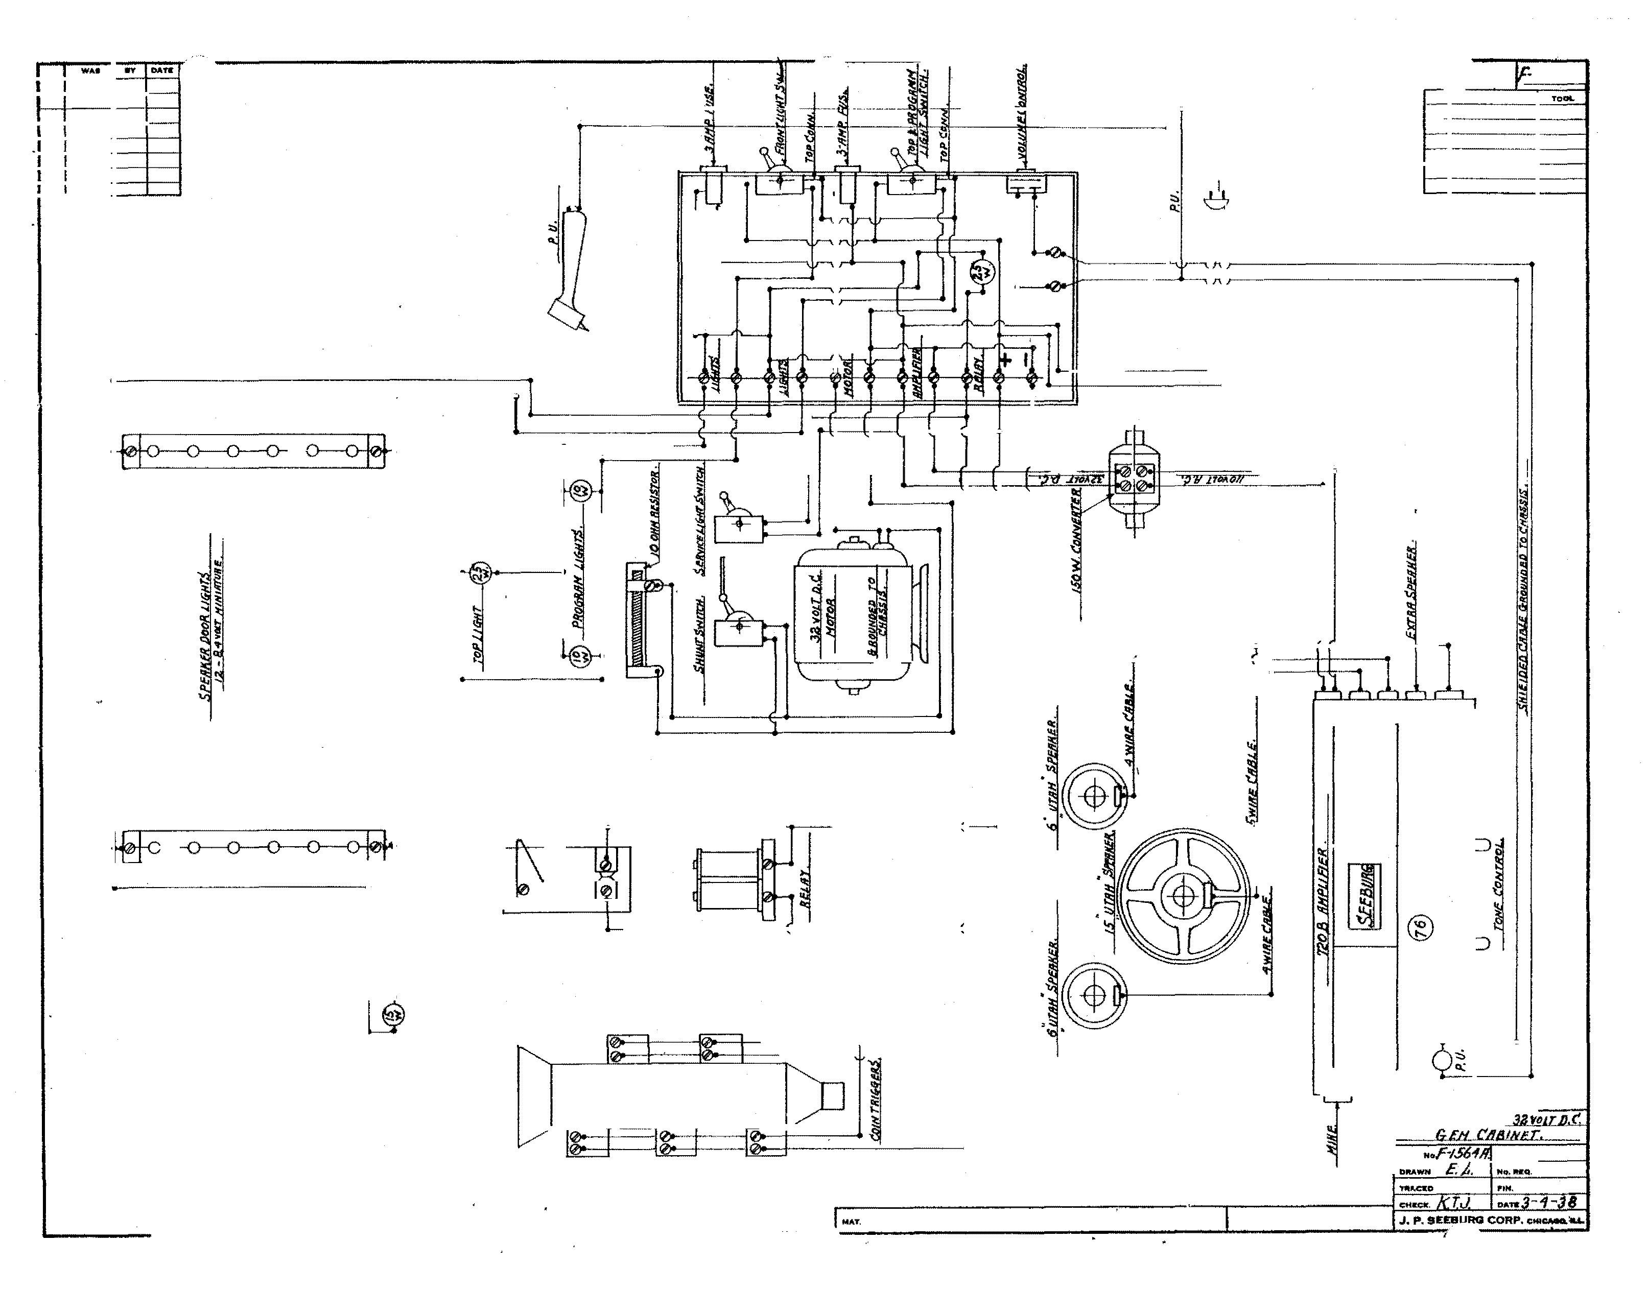�··
i

CID
@
CID
i ®
®

®

Y:JJJiJ!J.6:PJBHJlll.
.... tiCAl.a

..... Fotl toe�.

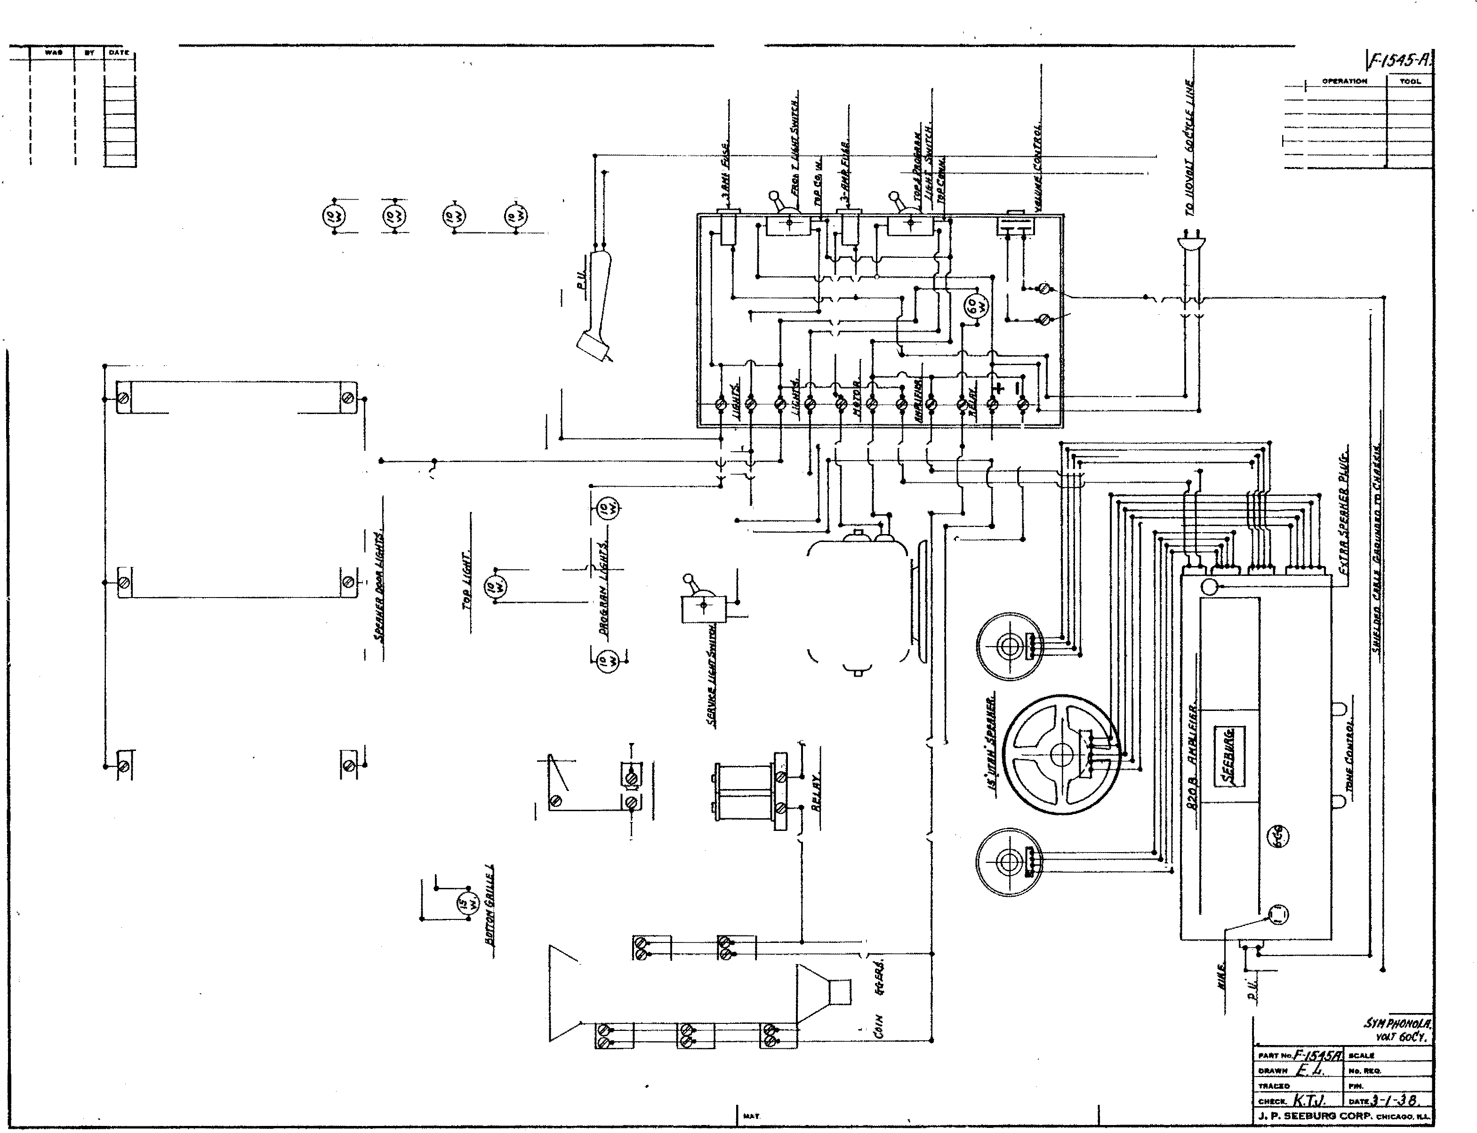

WIIIINfr /)IJifRH/f.
fl/.'li-111. • t:I/8/Nff. 1/tl

FOit 100 PC•.

�

:i

� i
�� �� @

(i)

�j
I ®
(!)

I
:!:
�

Will� IJMfltlllf. REf/fl." ""JlJNd. 1/tl

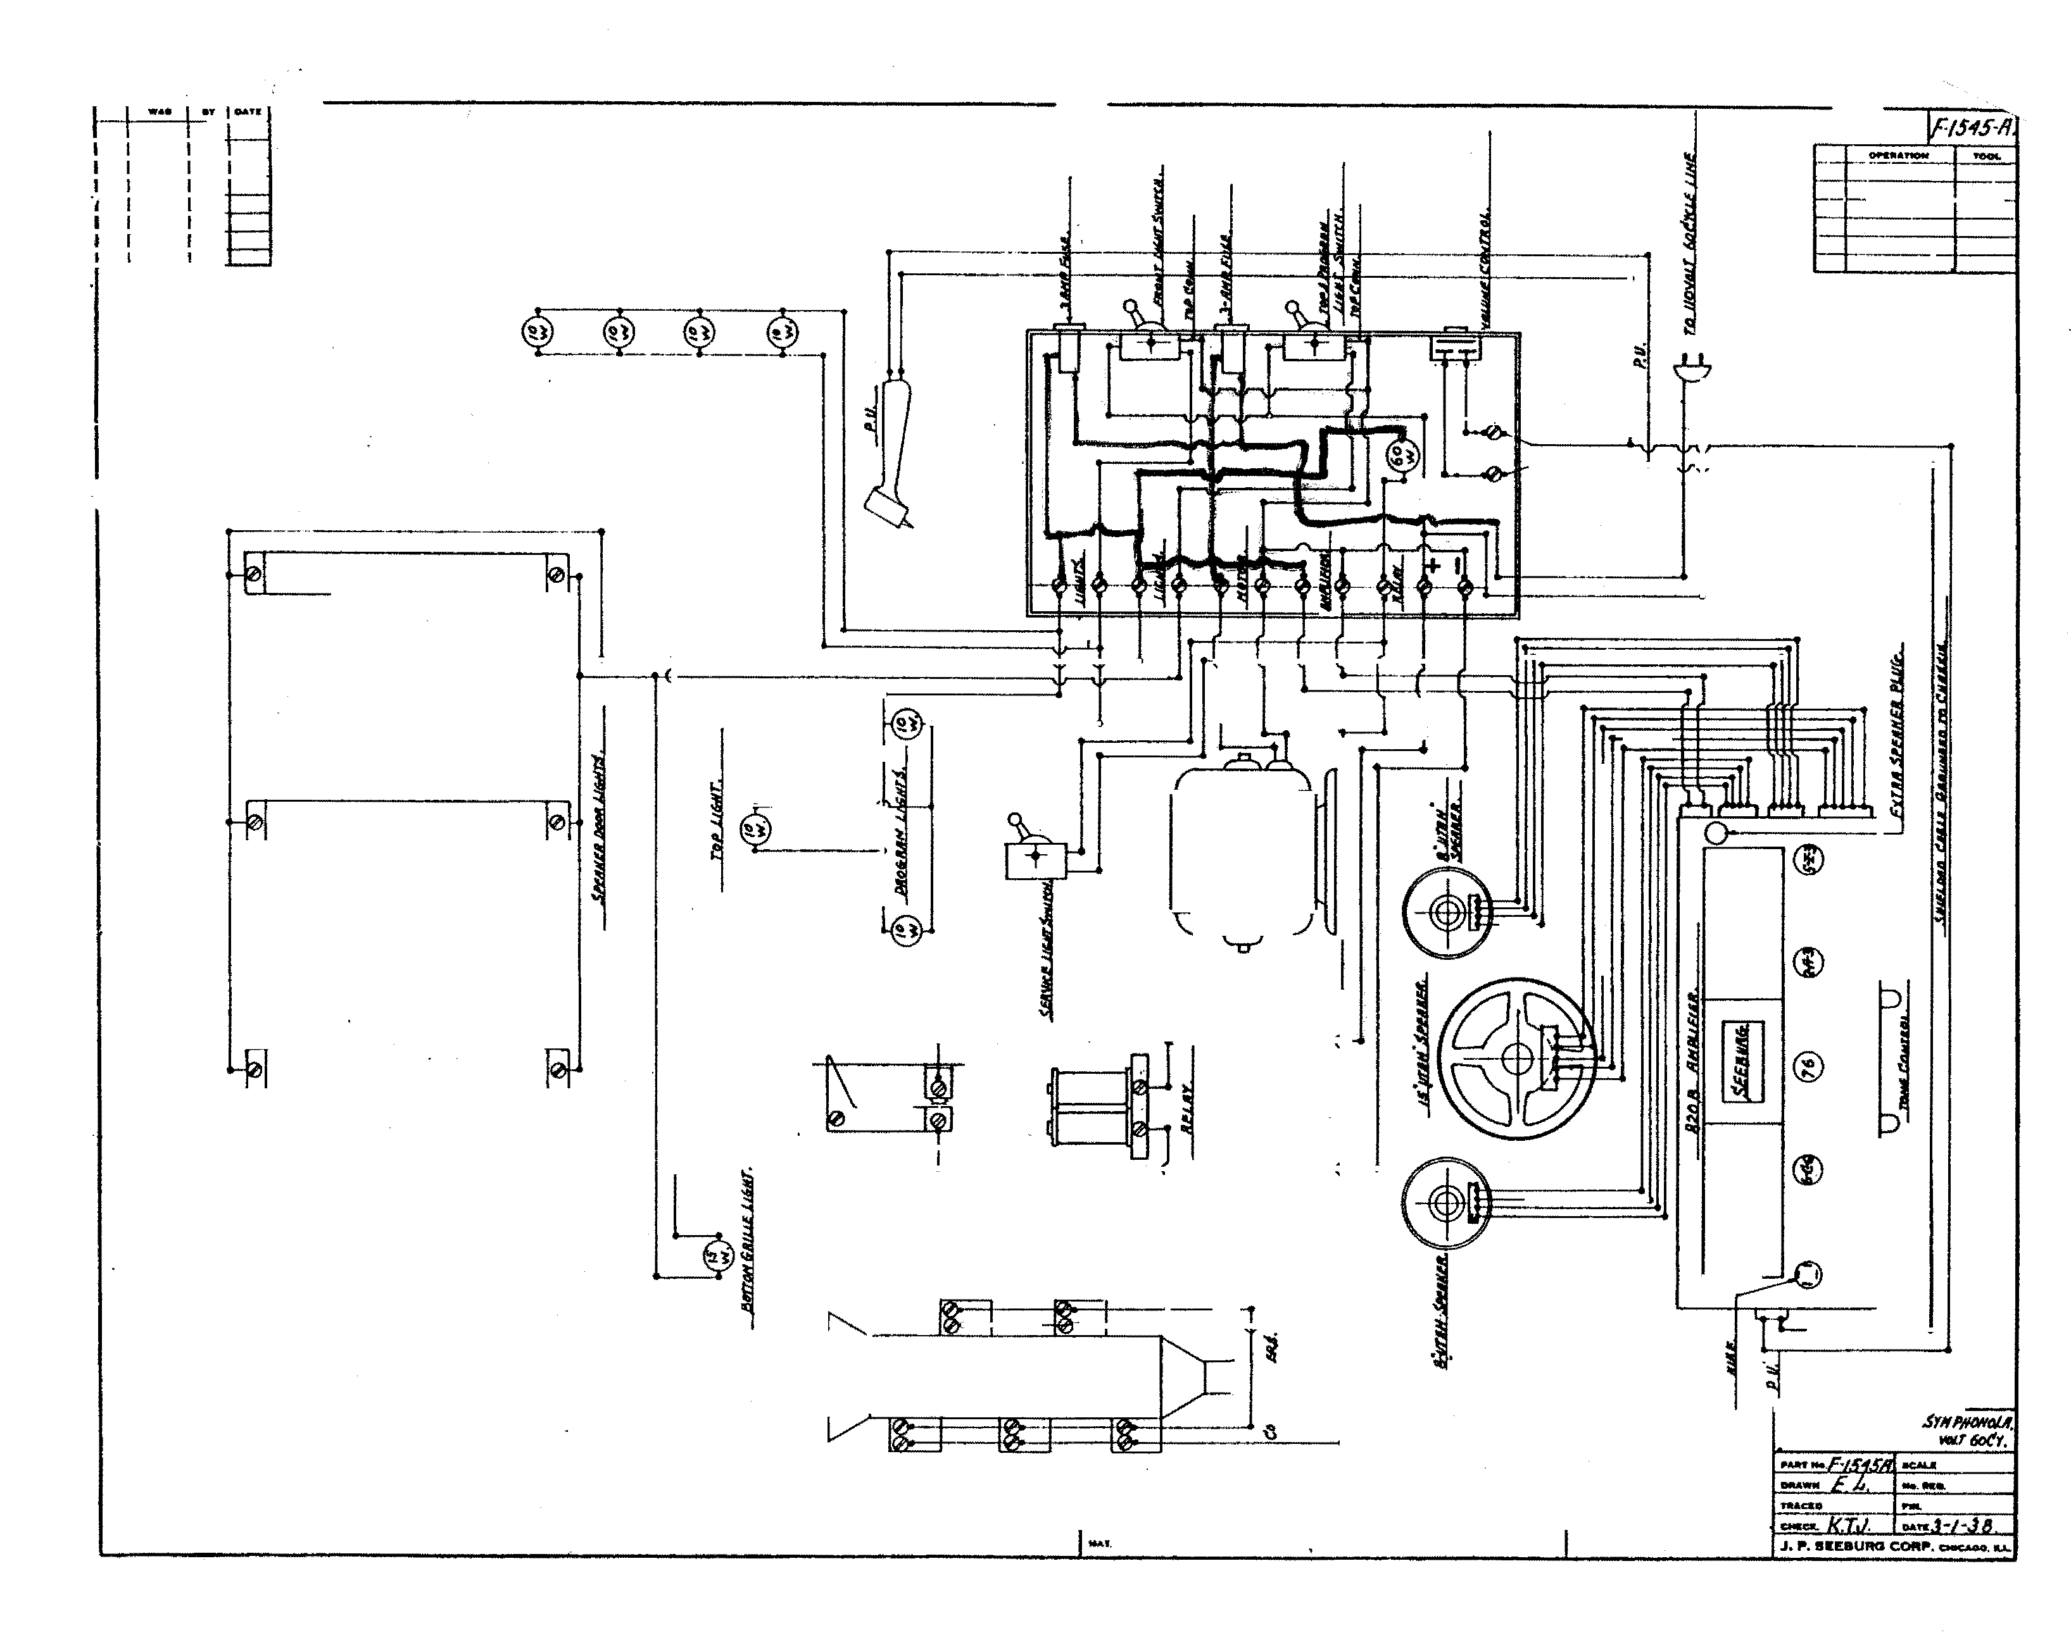

.......
,.. ,.rot;.

OP.ItAnON TOOL

�

"' �
�
"'' .,
..,

�
�
�
Q
...

�

0.:
�
..
ii:
': -l
i
[J]

� (!)
CID

({)

. KAL.
DOAWH E. .t. No. IIII:Q.

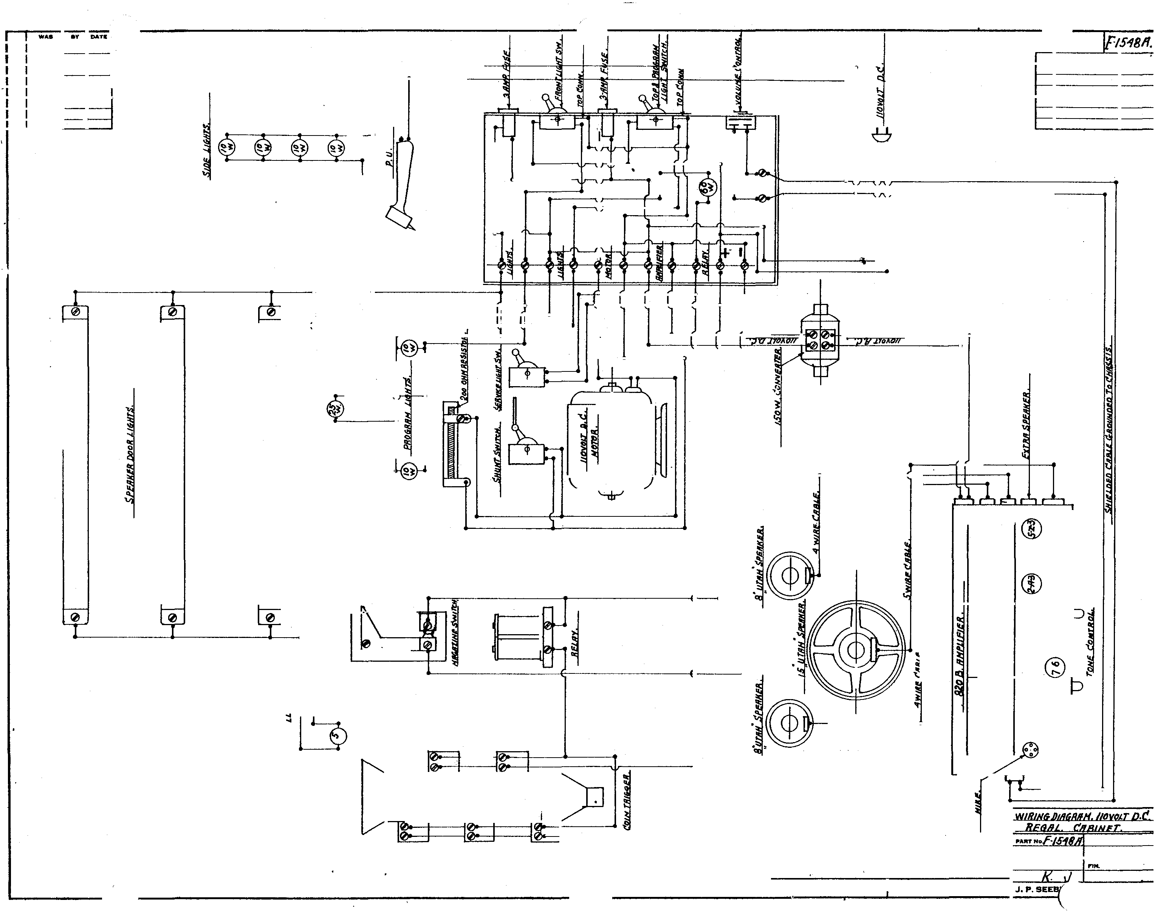

r. P'OIII ICO PCII.
••ctD
TIIACI:D
.,..•••. T. . •.. J-"1 -JS
'ORP. CHICAOO. a.L.

....._. e'f' .

�
0
...

.. OCAUr
-·· --

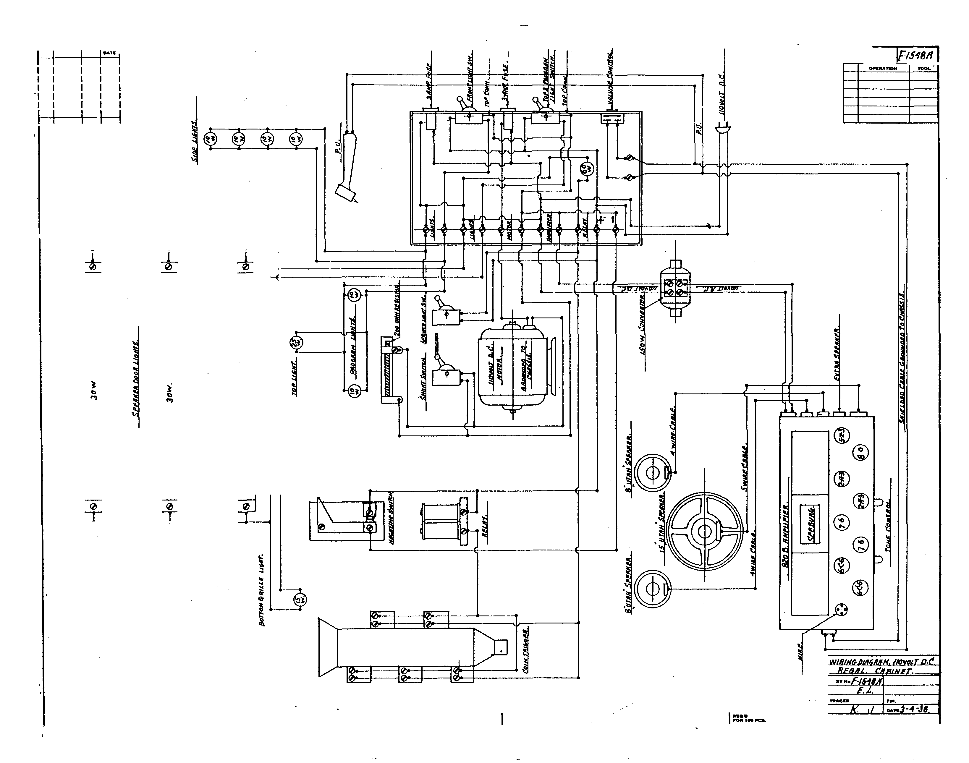

....

CMIICL T. ,
J. P. SI!.DIURG CO"P. CJeC.I.eO. LL

l- w.. lOY IDA
1 I I
1 I I
I I I
1 I I
1 I I
1 I I
I I I

JE!§_ ,
ONitll,noN TCOL

-

J hll
-
l r-- ·<ID

' ' = .. (!) p
rf\in ri+JJ ·' q 11 rn ® :
I I 4;· , ·!wl " ®p'.
:k J ;

('c.. --
I , JN1!1!Ni:Qfi/.Wt!JilYDJr: oL..

-..-------------==== ==1 : = .
==-
:-=-1

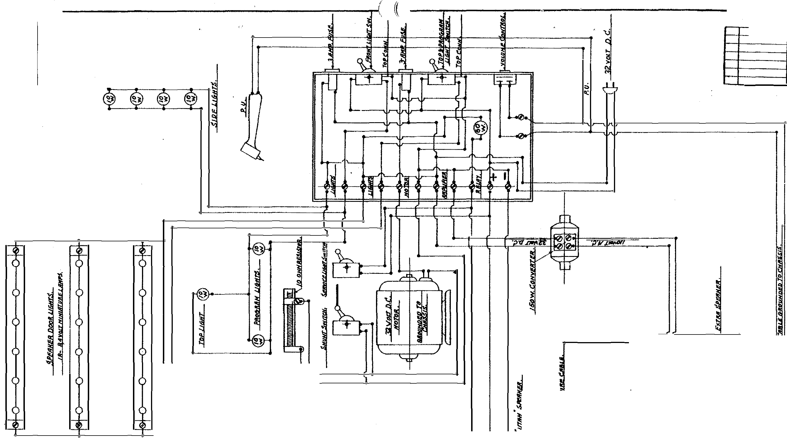1-·
= oo.-ce
J. p, SEEBURG CORP. e..rcAco "-L

I I ... I .. ID&'"I .
I I I I I
I I I I I I I I I I I I I I I I I I I I

ey eyl·j · )
..... lf-!S6.f,f,

::)
.._ .....
0:

I
t
9
I

(

()
l

( Q
J tt

= .=----1

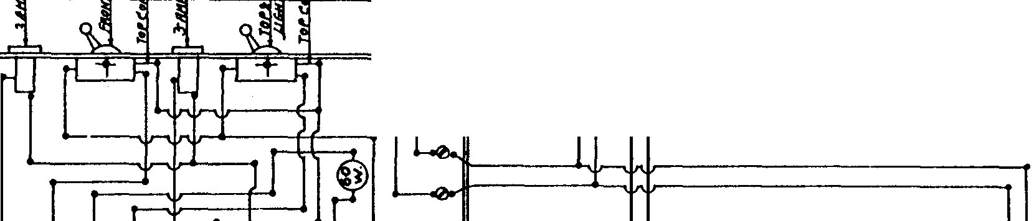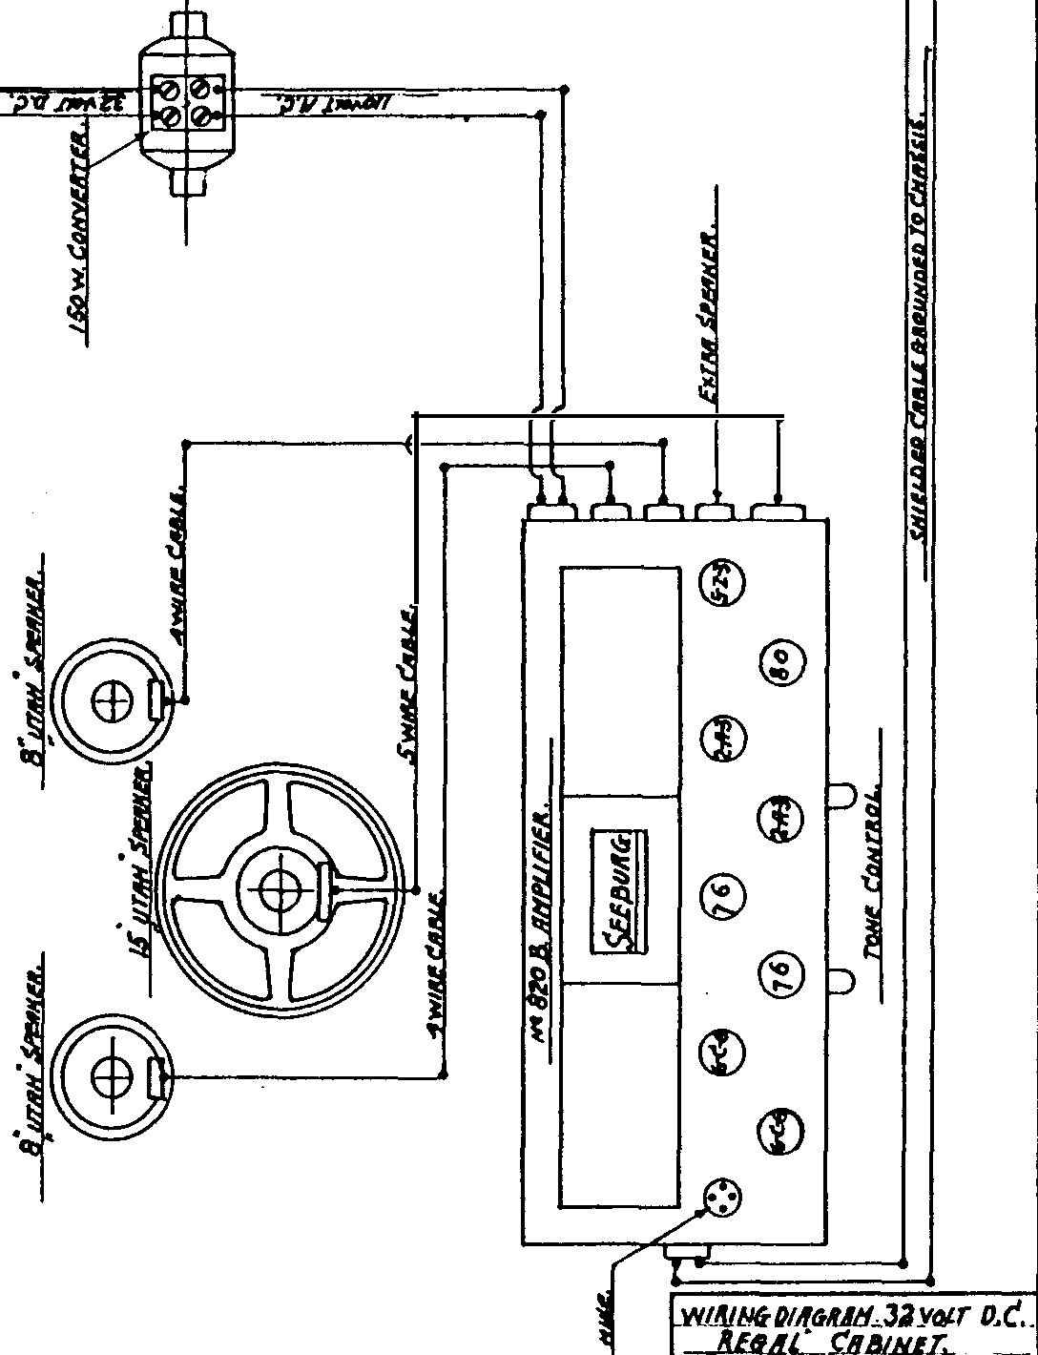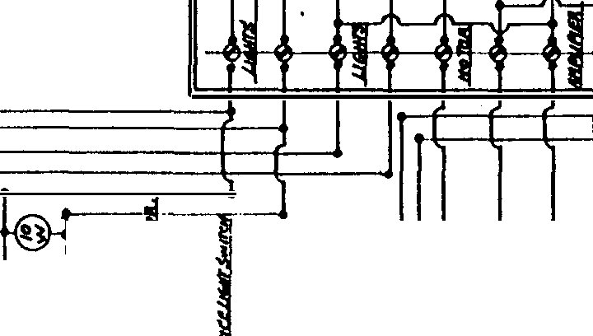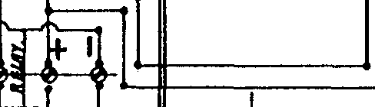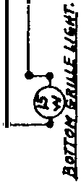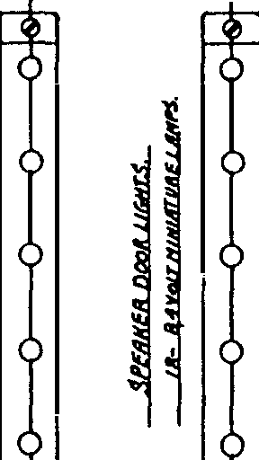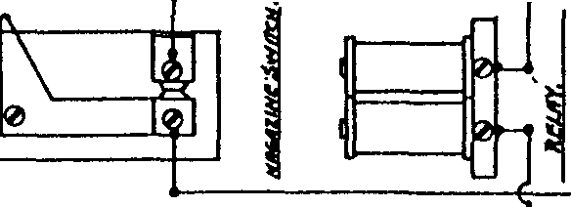

v 110--X: -1--
..,.. Snl
,.... .p.o•e.·- f'CI.

........t:.!S&slt, -·
-- f.J,, .......

'516-11.

OPII.UTION
I �

�
Q;

�)

�l

..,o '!:·
�� ��

:\
�

[J]
.

®
�
®
® (!)
®
@
®
@

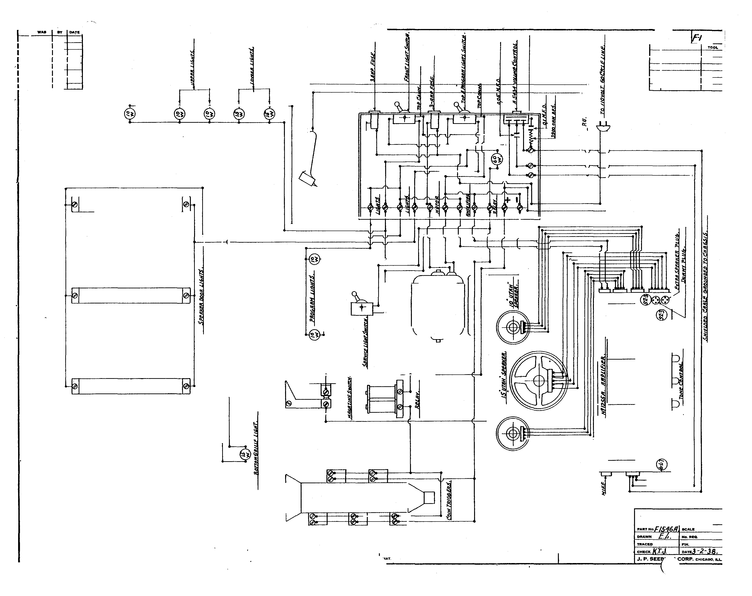W.lll{li6- 01/ft;RRH. l:DiiURT
fJRIIND l'RSINET. lltJ IJIJI1'
·

.....
P'OII IOO rc..

I �

�)

:!,l
�� �� :� ®

0 .
)
..,
<1)

® (!)
@

@
:\
�

Cl>

<!)

<1)

@

Wfll(/l(j DIAfR/IH, f:OI/CJ!AT
(JIUit/J C'A/JIIIET. INI IIIIT 64�1.

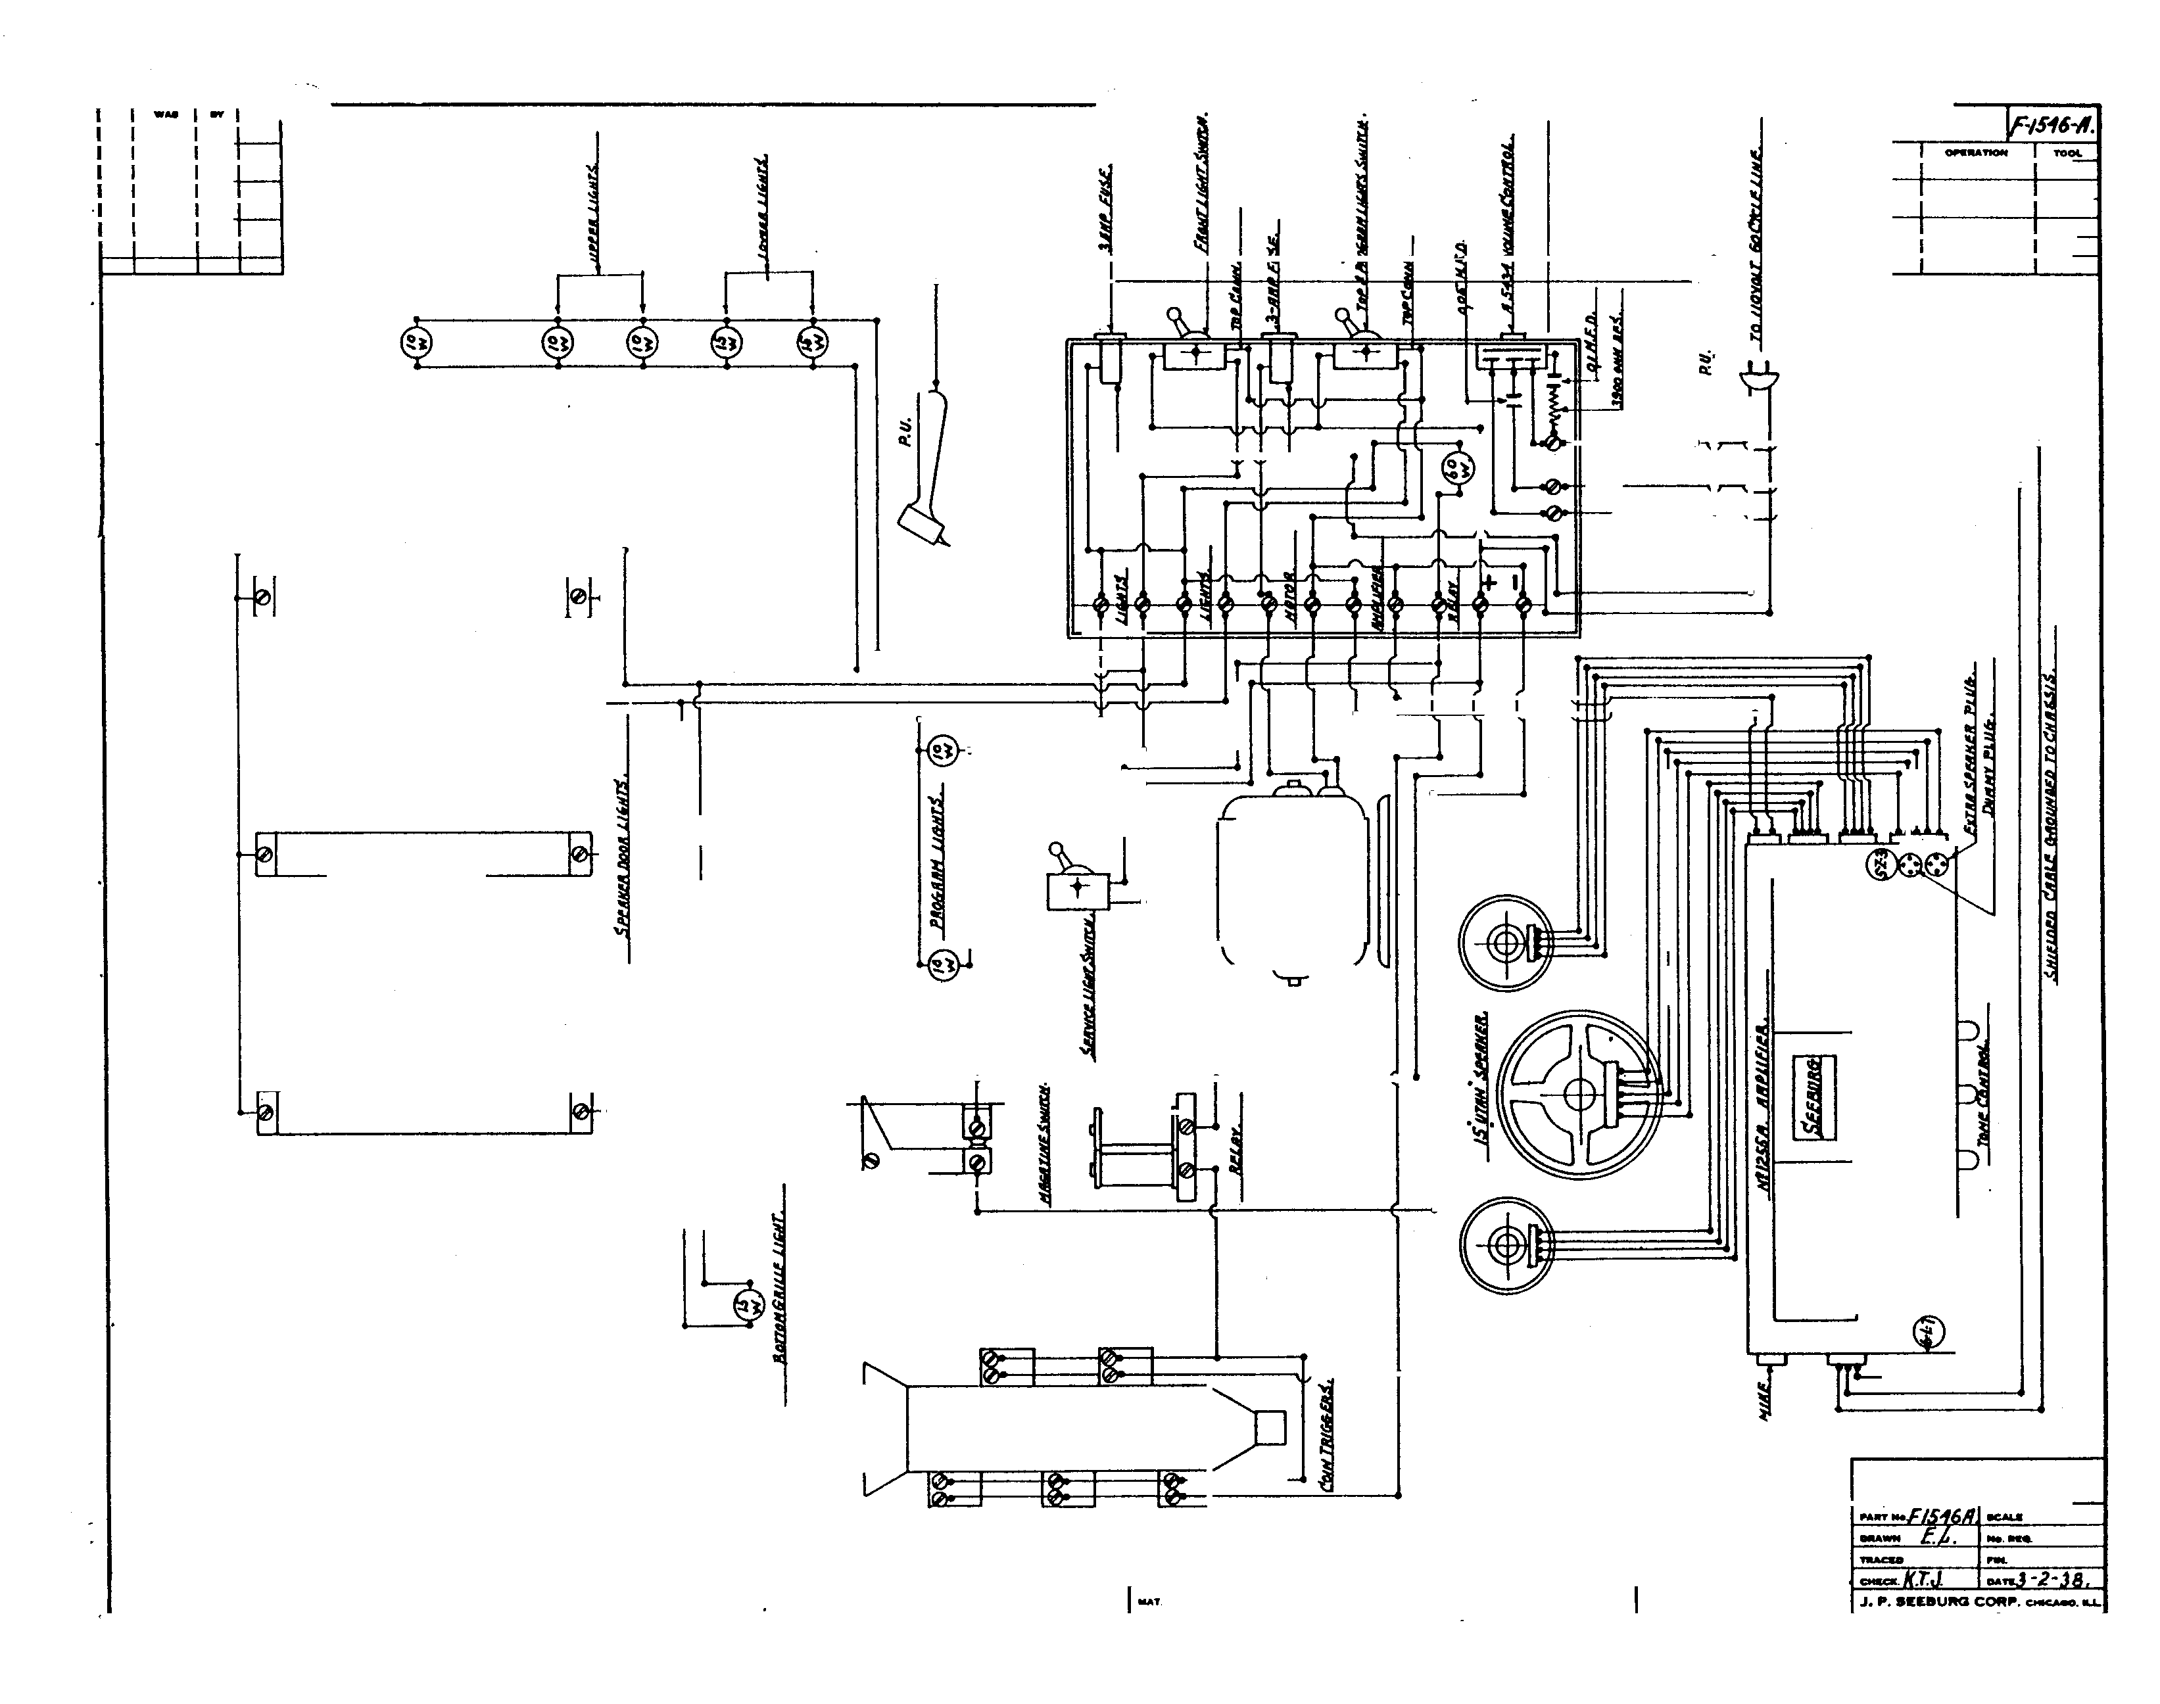......

.....

•
Qr".IUhOI'f

l:
�
:,:;<(

l

<!) (!)
D ®
@
(i)

® (!) (!)

@ (i)@

W//11116 DIII&MH. /ltJV�T (llll(�lfT (/l!ltNI> �1181/JET,
.......
-- . .... -

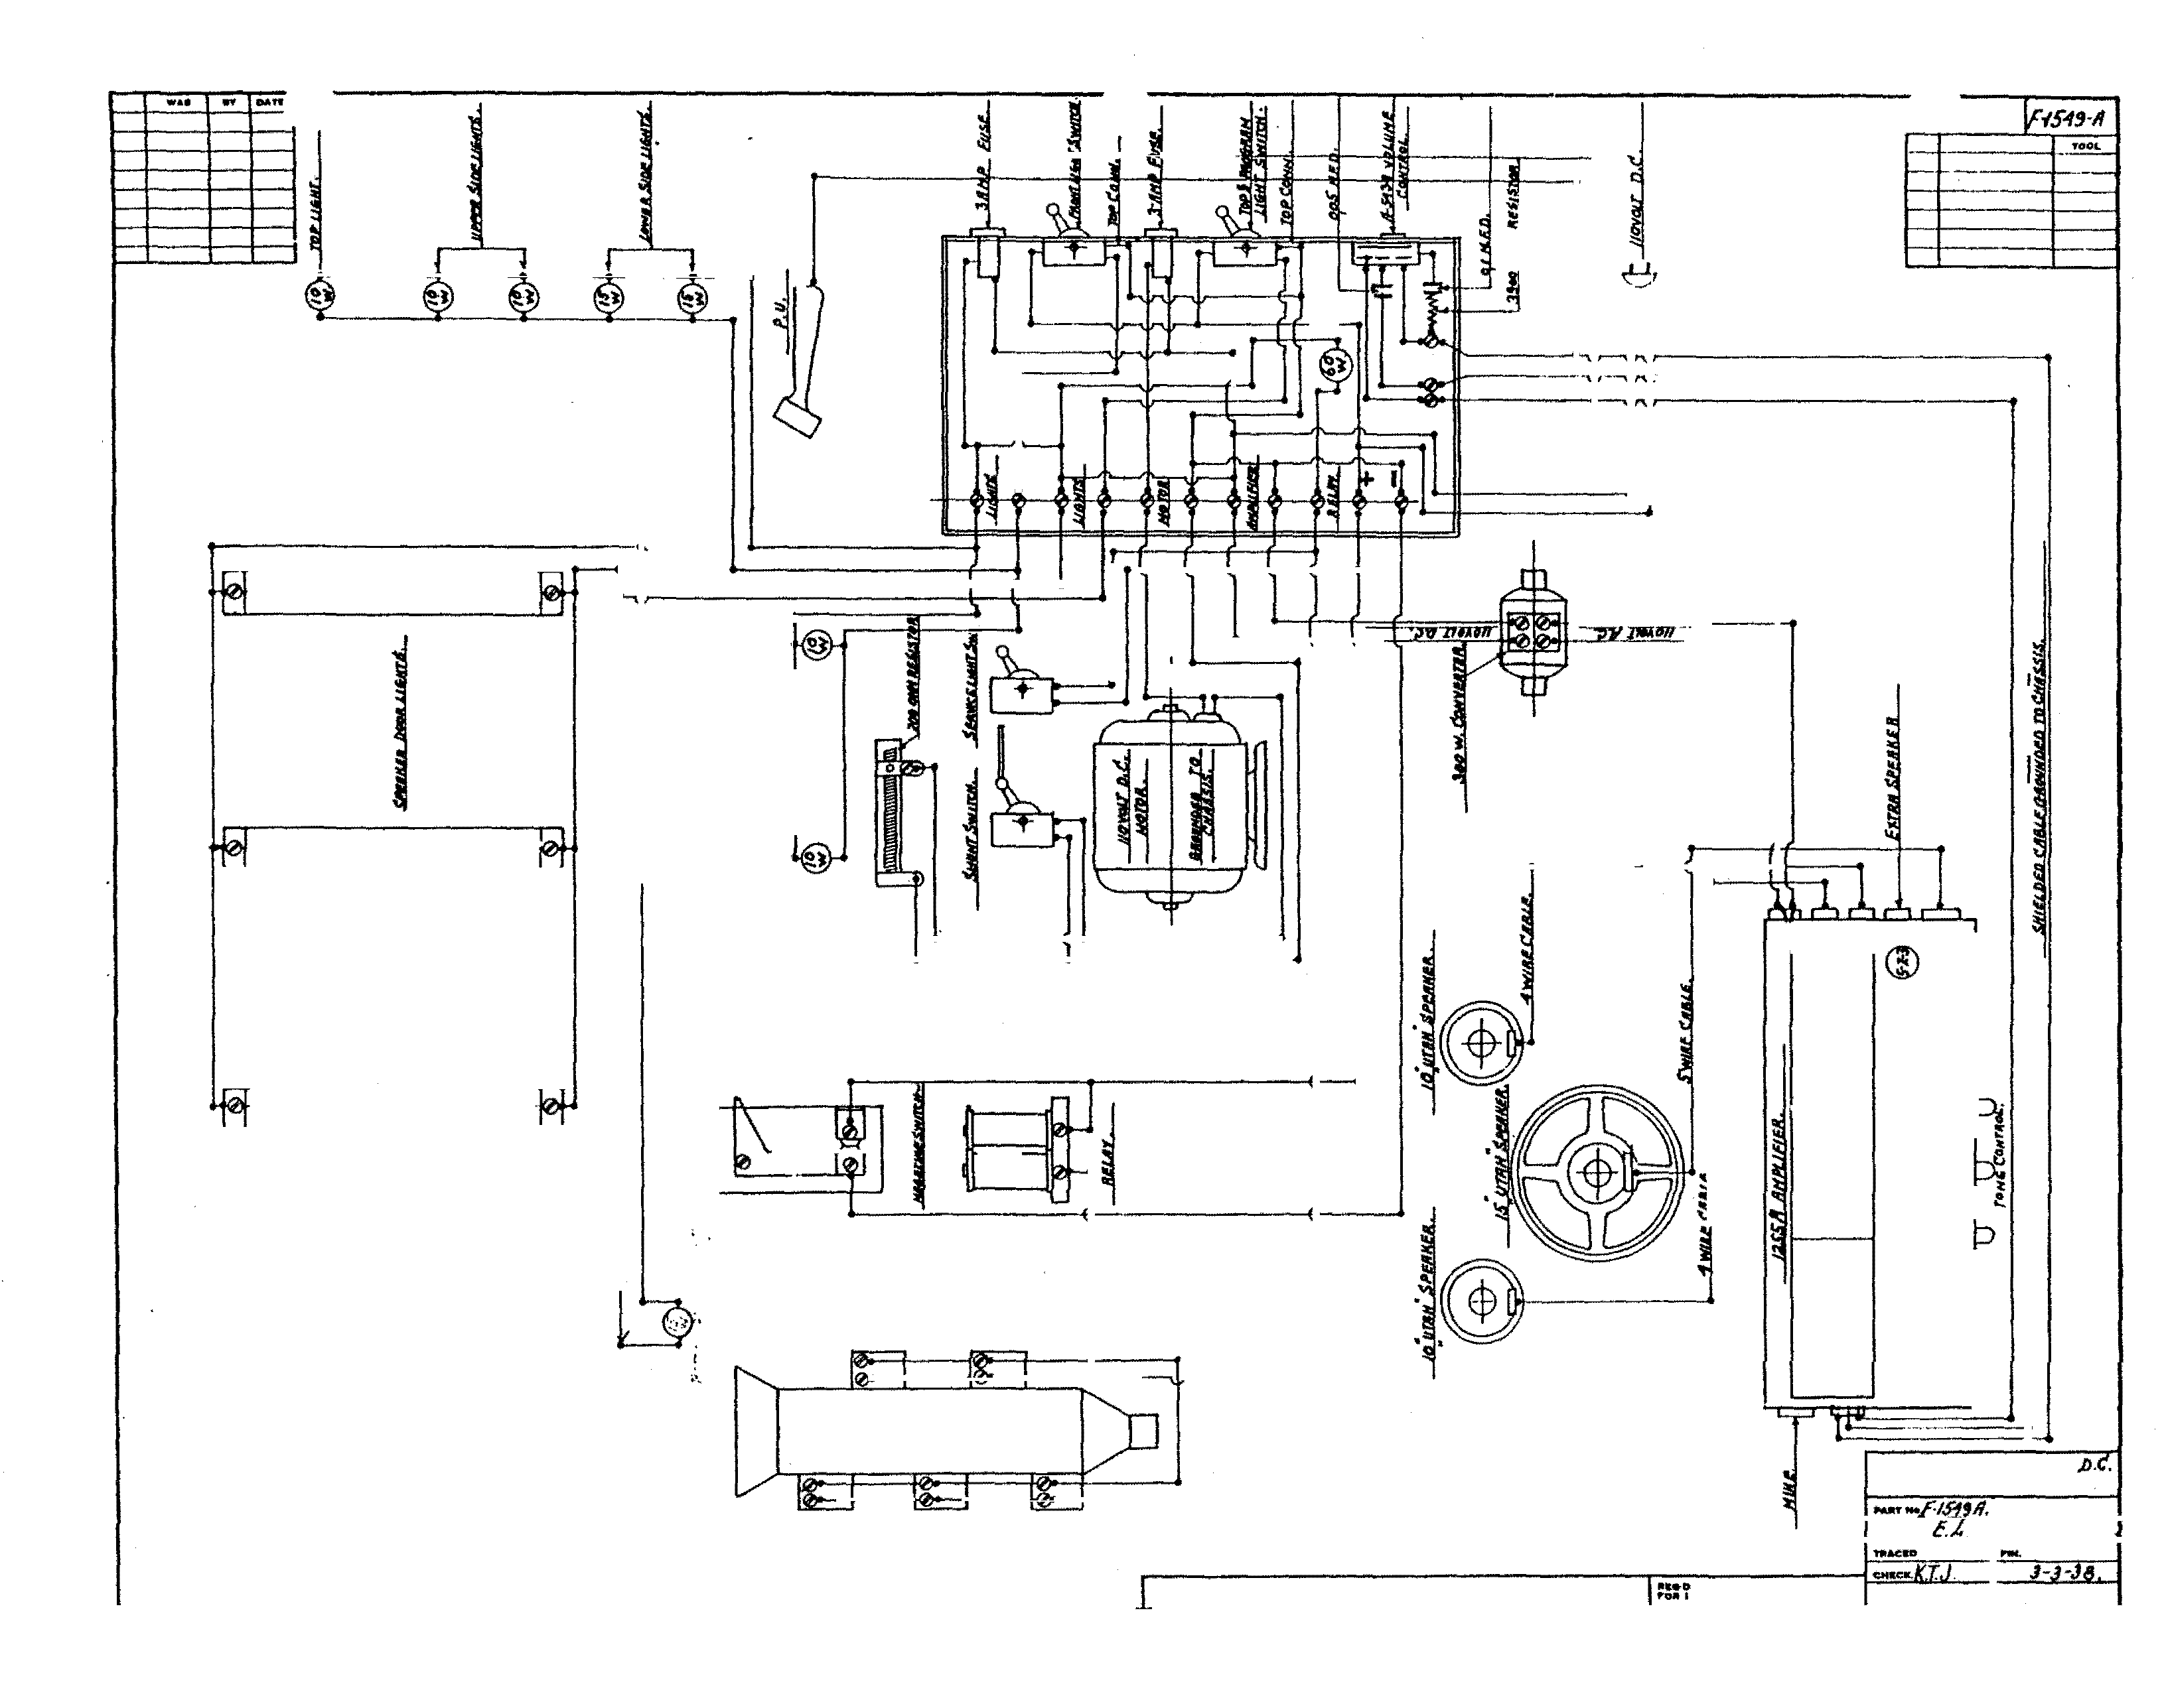
..... .. ....

....
J, P. SEEliUM CORP. - ILL

,;;
:;
. j 'f¢:01..
�

l

®

(!)

<!)

CID

®

®

I!,.

® I!
(!)
@

@@
�

WIRING DIII&RIIH. /10>/IJ/.T (fDNCERT {111/IN(J CRBJNET•.

.... - trfiJ.fl'ltQ.
,.
..,..

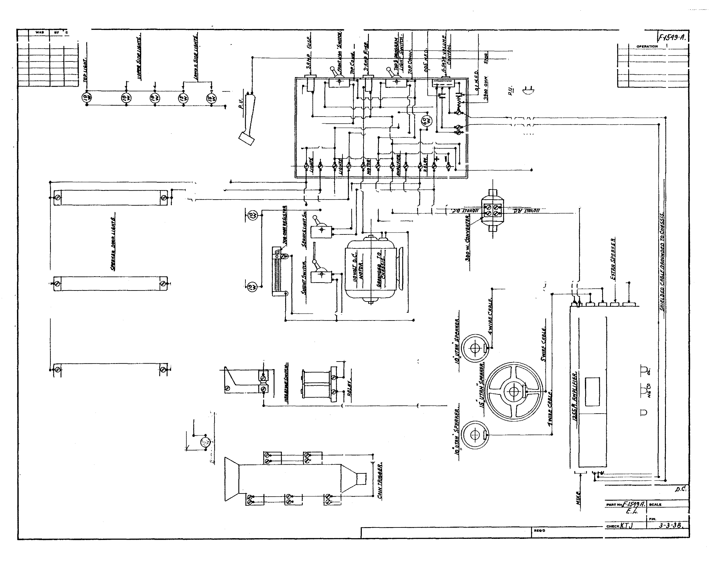
IU.T.

,.0.. 100f'Cfa.
. . ....
J, P. SEEBURG CORP• ...,.._L._

SERVICE
MANUAL

I N S T R U C T I O N B O O K , M E C H A N I S M C H A R T S , W I R I N G D I A G R A M S A N D A M P L I F t E R C I R C U I T S C O V E R I N G T � E 2 0 - R E C O R D M O D E L S : G E M , R E G A L A N D C O N C E R T G R A N D
S E E B U R G S Y M P H O N O L A S

1 - I 5 - 3 8

3CIIEI1A TIC DIA CITAI'f ?eos Al'fPL/TE!f

2. TYP£" 76
NOT£: - THIJ J#Vh T/rE.3AJ711Jf
(IJEP (JN/. 1'II' H4 1111.J, IJ/IJED
2- TJ'IY"2A3

�
�

..,

I- - �-
1
7'
/J NIT IUI'ZJ,.
- - - - - - - -- - - - -· - ·- ,

�
�
...
a
A I

I
�-- ------ -\

I I I I
I I I
k I \ I :
I ITJl,./fA \� 1
�
L - - - - - - - - - - - - --- -- -- J
,
( I I
-'I I
I
I I
\ I
,,
i
!5 ''

TYI"E 80

u .._
T/'fi"�LI" CQIYT.,_4. .)WITCH JO .ooa H'/'71.

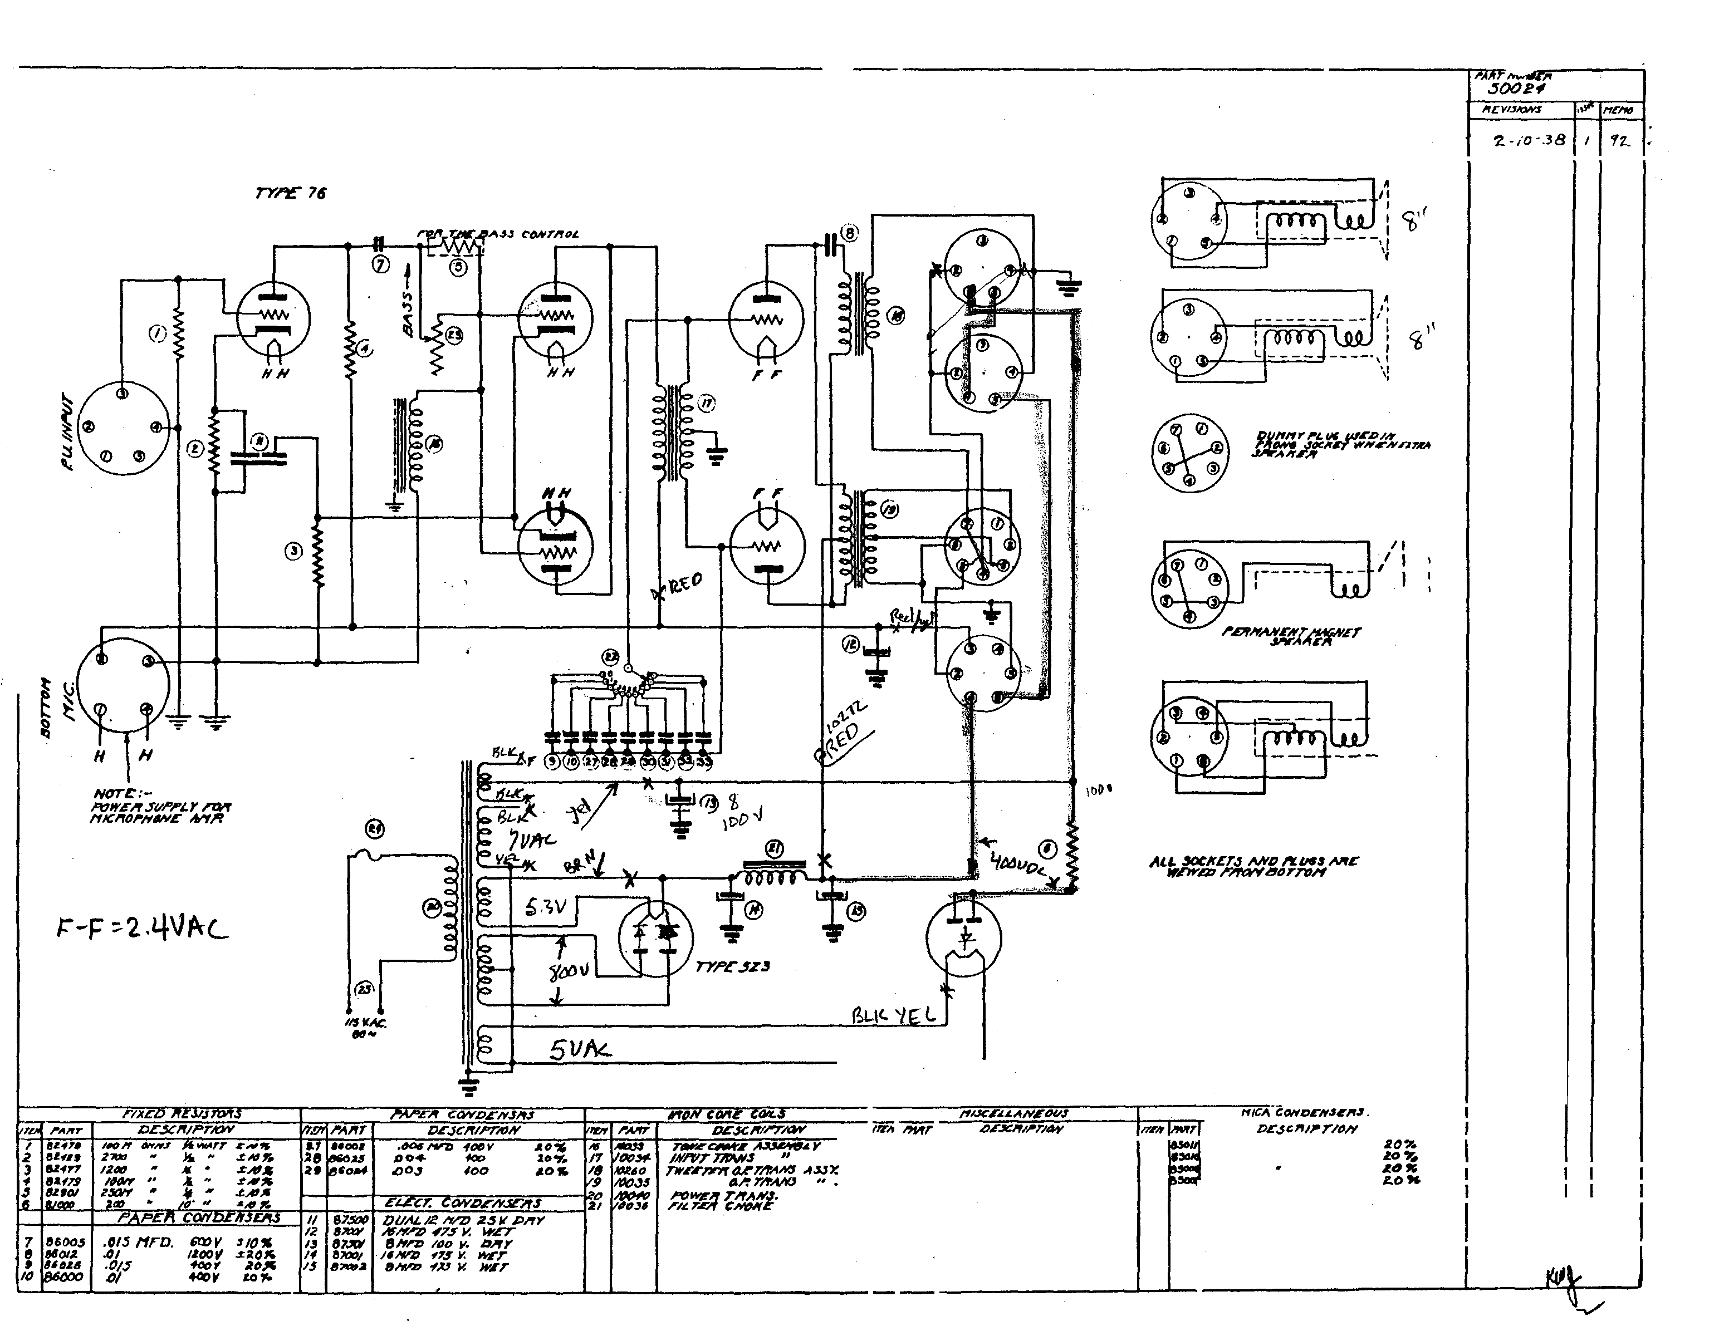"" l�liJIJ
... _
zs ....., II .W.I'
A-'U$ C-T/riiL )I
,-u�r ,.,. a ,.,,r J•
l.lh£ CM.P a .t.t.ICA#lt ,JS
D UNNYJ!It:"" /#JJ'J!
.OOIS' •
..o•/
. tJO(IS ,,

fi¥D O/II
Scc6ulfG RArW CMI!'
C"�tl*£,t.L..
lllrAMW C.E.Jf. 1··.14�3�
t::lf/Tt:AED �
...-ro

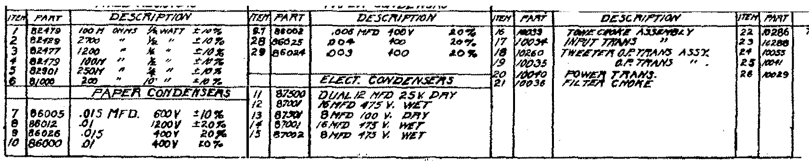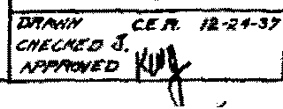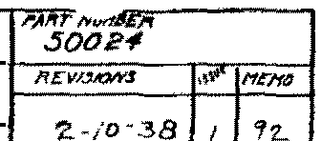--ISCIIEI'fATIC DIAC/fA/'1 7/!0B AffPLIT&IT

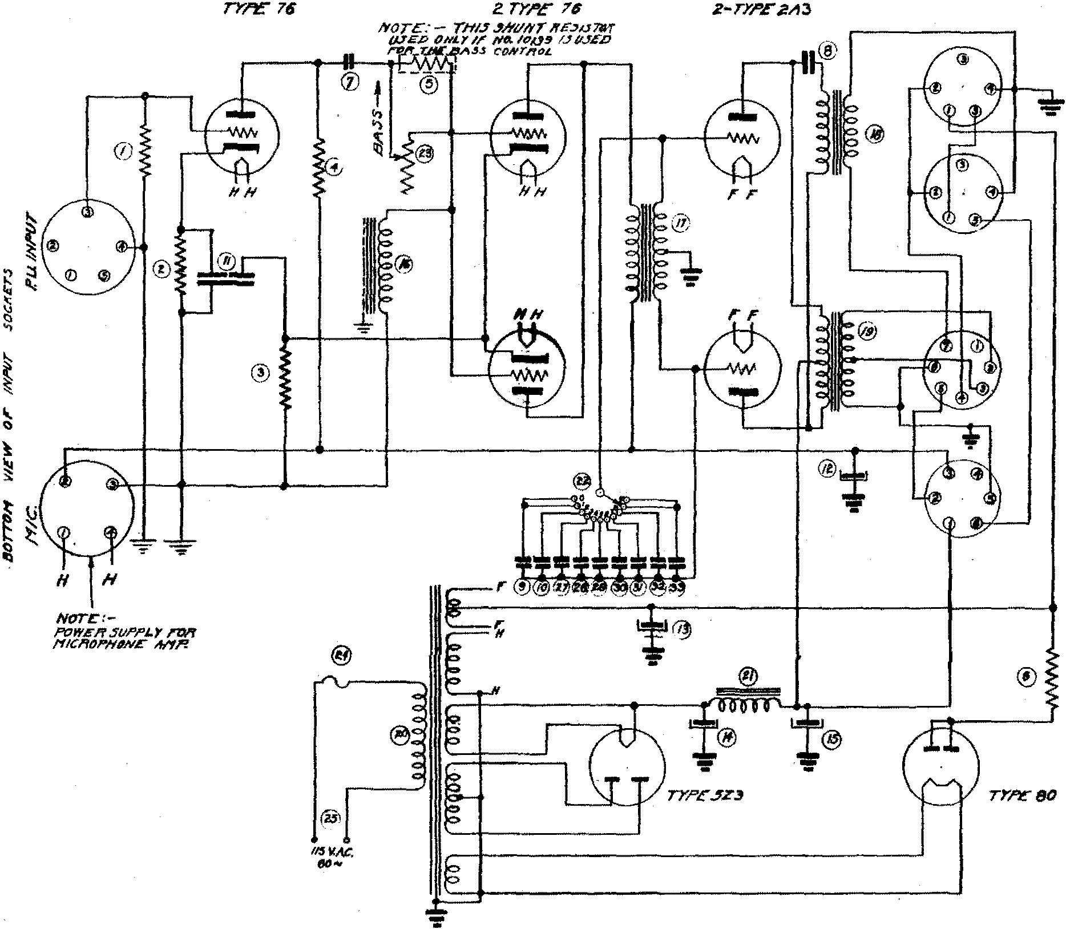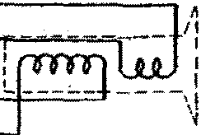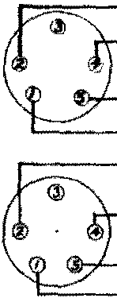

Dllltlfi"PI-11<1/H' P/h '1
f'flr /%tlX;;";;ff.::"ll'"

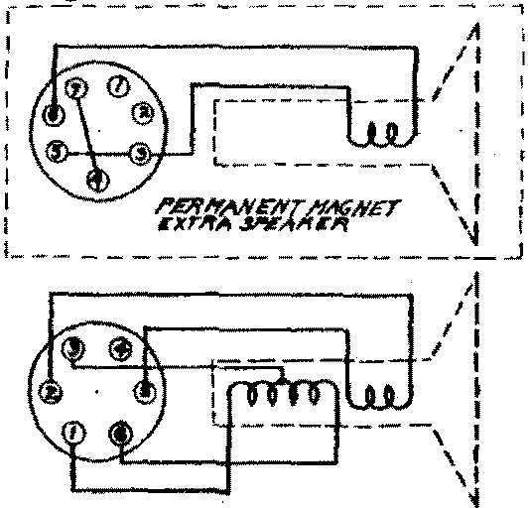@

•

r----------. »7---- -------, ---,-------- b?. -------- --------· A N. r----- ----------,H-.I CA-CCN D -.----------1
L>4"XI'fi?"TIIJIY D£$Cl'l/l" T/0/f
?llf"J!IC CliNT-""'" .1WITCif .00£ tf
6A..S.s ct:: YF/r<:l.t. .oo/:r 11
.I""VJE ,. a ?"v r .,D<tl
hEl'111'1D lld-t15A-SS)t ,Cf>OS .,
DUNNY/ff.V. /f-J.$1:
SECtJlllrG RADID COif!!
r:HICAG f.t._J.

PL UG C ONNECTIONS

Z- TY/'£ 6C6 2.- TYPF: 76 2-TYP£ .tA3

NOTE: -
""W£" JIII"I"L Y rtvr
�/Cift,I"HtiN£ 14/'fl".

M.L l"t.UGJ & S«IIETJ 1\lfE
YICWCD F/fD/1 BOTTIJH.

riX£0 !?£SIS TOifS OESC!fii"TIDN

It' .57f. s �

IZ-12/"frD IYfYDt/AL iiSY

TDNIC�I"
/II'.NT TAI'tNS,

BA.SJ CtwTifti.L
FVJI ,P.t Utl A�.JI-¥-/U.Y

... w /0 "'
� w 10 �
)t w
� w lt1 :r;
.II W /1? $
JtW 1 0 % J4W /0 "
.lilY 111 %
8
/6
8
/tl
4
l¥T
wcr
WET WET DlfT

�TJ V,
�'TSK
-f»"Y.
3SC WK
tiVTI"VT T/T;t/VS.
l"ttlwl",/f T/TNW,
IOtiJtl F/L TI',If CAN>KI
CONOCNJC�J
"" "
6.0 ,. IO "
a
1../#I!'CA'ID & '-llfl AIJrH/II.T
:DVI'f/'f 'Y I"J..Vi$ AJSFH6L }' TAE./1,/, C CNYT;fOL SWITCH

Ch'/t"AGo, ttJ.A.
DMw..V C. F. If. 1-#-.111
CH,c'C/1-..:D

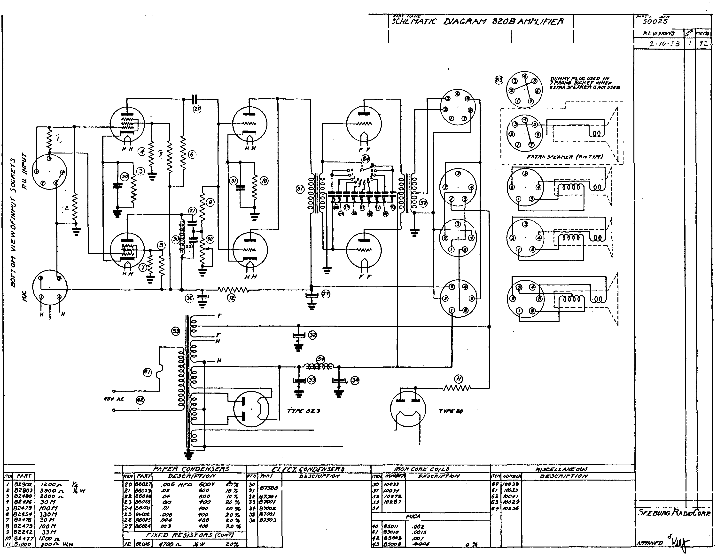

I SCfl£1'1/l T/C lJ/A G�A/'1 8ZOB A/1.PL !rl£/f

Z- TY/"E 6C6 Z- TYPI': 76

2-TY.P£ ZA3

PL /JG COIYNEC nO/'I.S

DUiflf'l ,PL t/G USED IN
7,PI'tDNIJ .1«1f�T WH�N
EXT/fA YEAJ(E, 1.1Nt1TUJZ'D.
Fl E VIS/0/V.S \"J'�"'
Z-tr> · .O':J 92

,- _j It .
�--- -- ·- -- - - -.

I ' I
L - - --��"� ::"-!'_" �"-'':." �� - ��J

QiI
�
d1I
\1

'-- - - - - - - - I
� I
6 "
�

NOrE:-
,f'OW£1f �VFPL Y rD?f
/'11CROPHON£' /I N!'!

/ILL FLV(;S & SIKifETS 1\lfE VIEWED rl'ltJ/1 BOTTDI'f.

NSV. AC @

!'ART
8290.2
riXED RESIS TO/'rS .PAPeR CO/YDe/V.5eRS
DESCifiFTION DE.SC?f/F'T/0/Y
IZOO..n.. jW 5% 600Y

DEJC/T/PT/ON p,E.sC/fii'T,b/Y
TO/YE cNGJ;!rr

l'fi.SCEL £AIV£0l/J>
DEJCI''U?T/0/V
IDD 3t BASJ CDNTJ"fiJL

8Z903
3900 .n. •., w J % 600
IZ-f2/'1rO D'YY O/AL 2SY
/.Y,.T
T/MIVJ>.
Ff/JFP.LVG A5J,£,1111!1LY

6z.f80
�000 .n... a . w /0 % (jOO
B 0/f]' /OO V. OVTJ"VT T/T,9N3.
/1701'1 1../A'ECOIYD 8- L IJIII A8.Uf"-¥8.LY

.,. 82-f76
30/1 � w
-100
/6 1'7..rY, !"' W£?f TitAN.$,
/!JtJ!l.9 :OV1"1/'1 Y rLUG A.SSEHDL J'

J 82479
/0011 J t W /0 % 'fOO I!O %
8 WET 1'7SY. 10036 F/L TE?f CAMirE
hJ2 31J T/r£.1L £ C<>/YT?fOL .FW/TCN

6 8Z1S1
3301'1 ! * W /0 ";{, -?Co .20 7.
16 WET
1'1/CA CoN/JeNJEI'IS
5£EBVflG f?llz:w oRP.

301'1 �w
1'00 2D 1;
4 .0/fT JsO W.Y.
CHICAGO, 1/.S:A.

·a BZ.-979
9 8/!IHZ
/00 11 JiW 10 7. oft»
33 1-f )4W /0 �
,()Oz. eo %
.0015
D'IAWN C. I!: If.

/0 61!.477 !Zoo n. Jill' 10 7..
,00/ �0 �

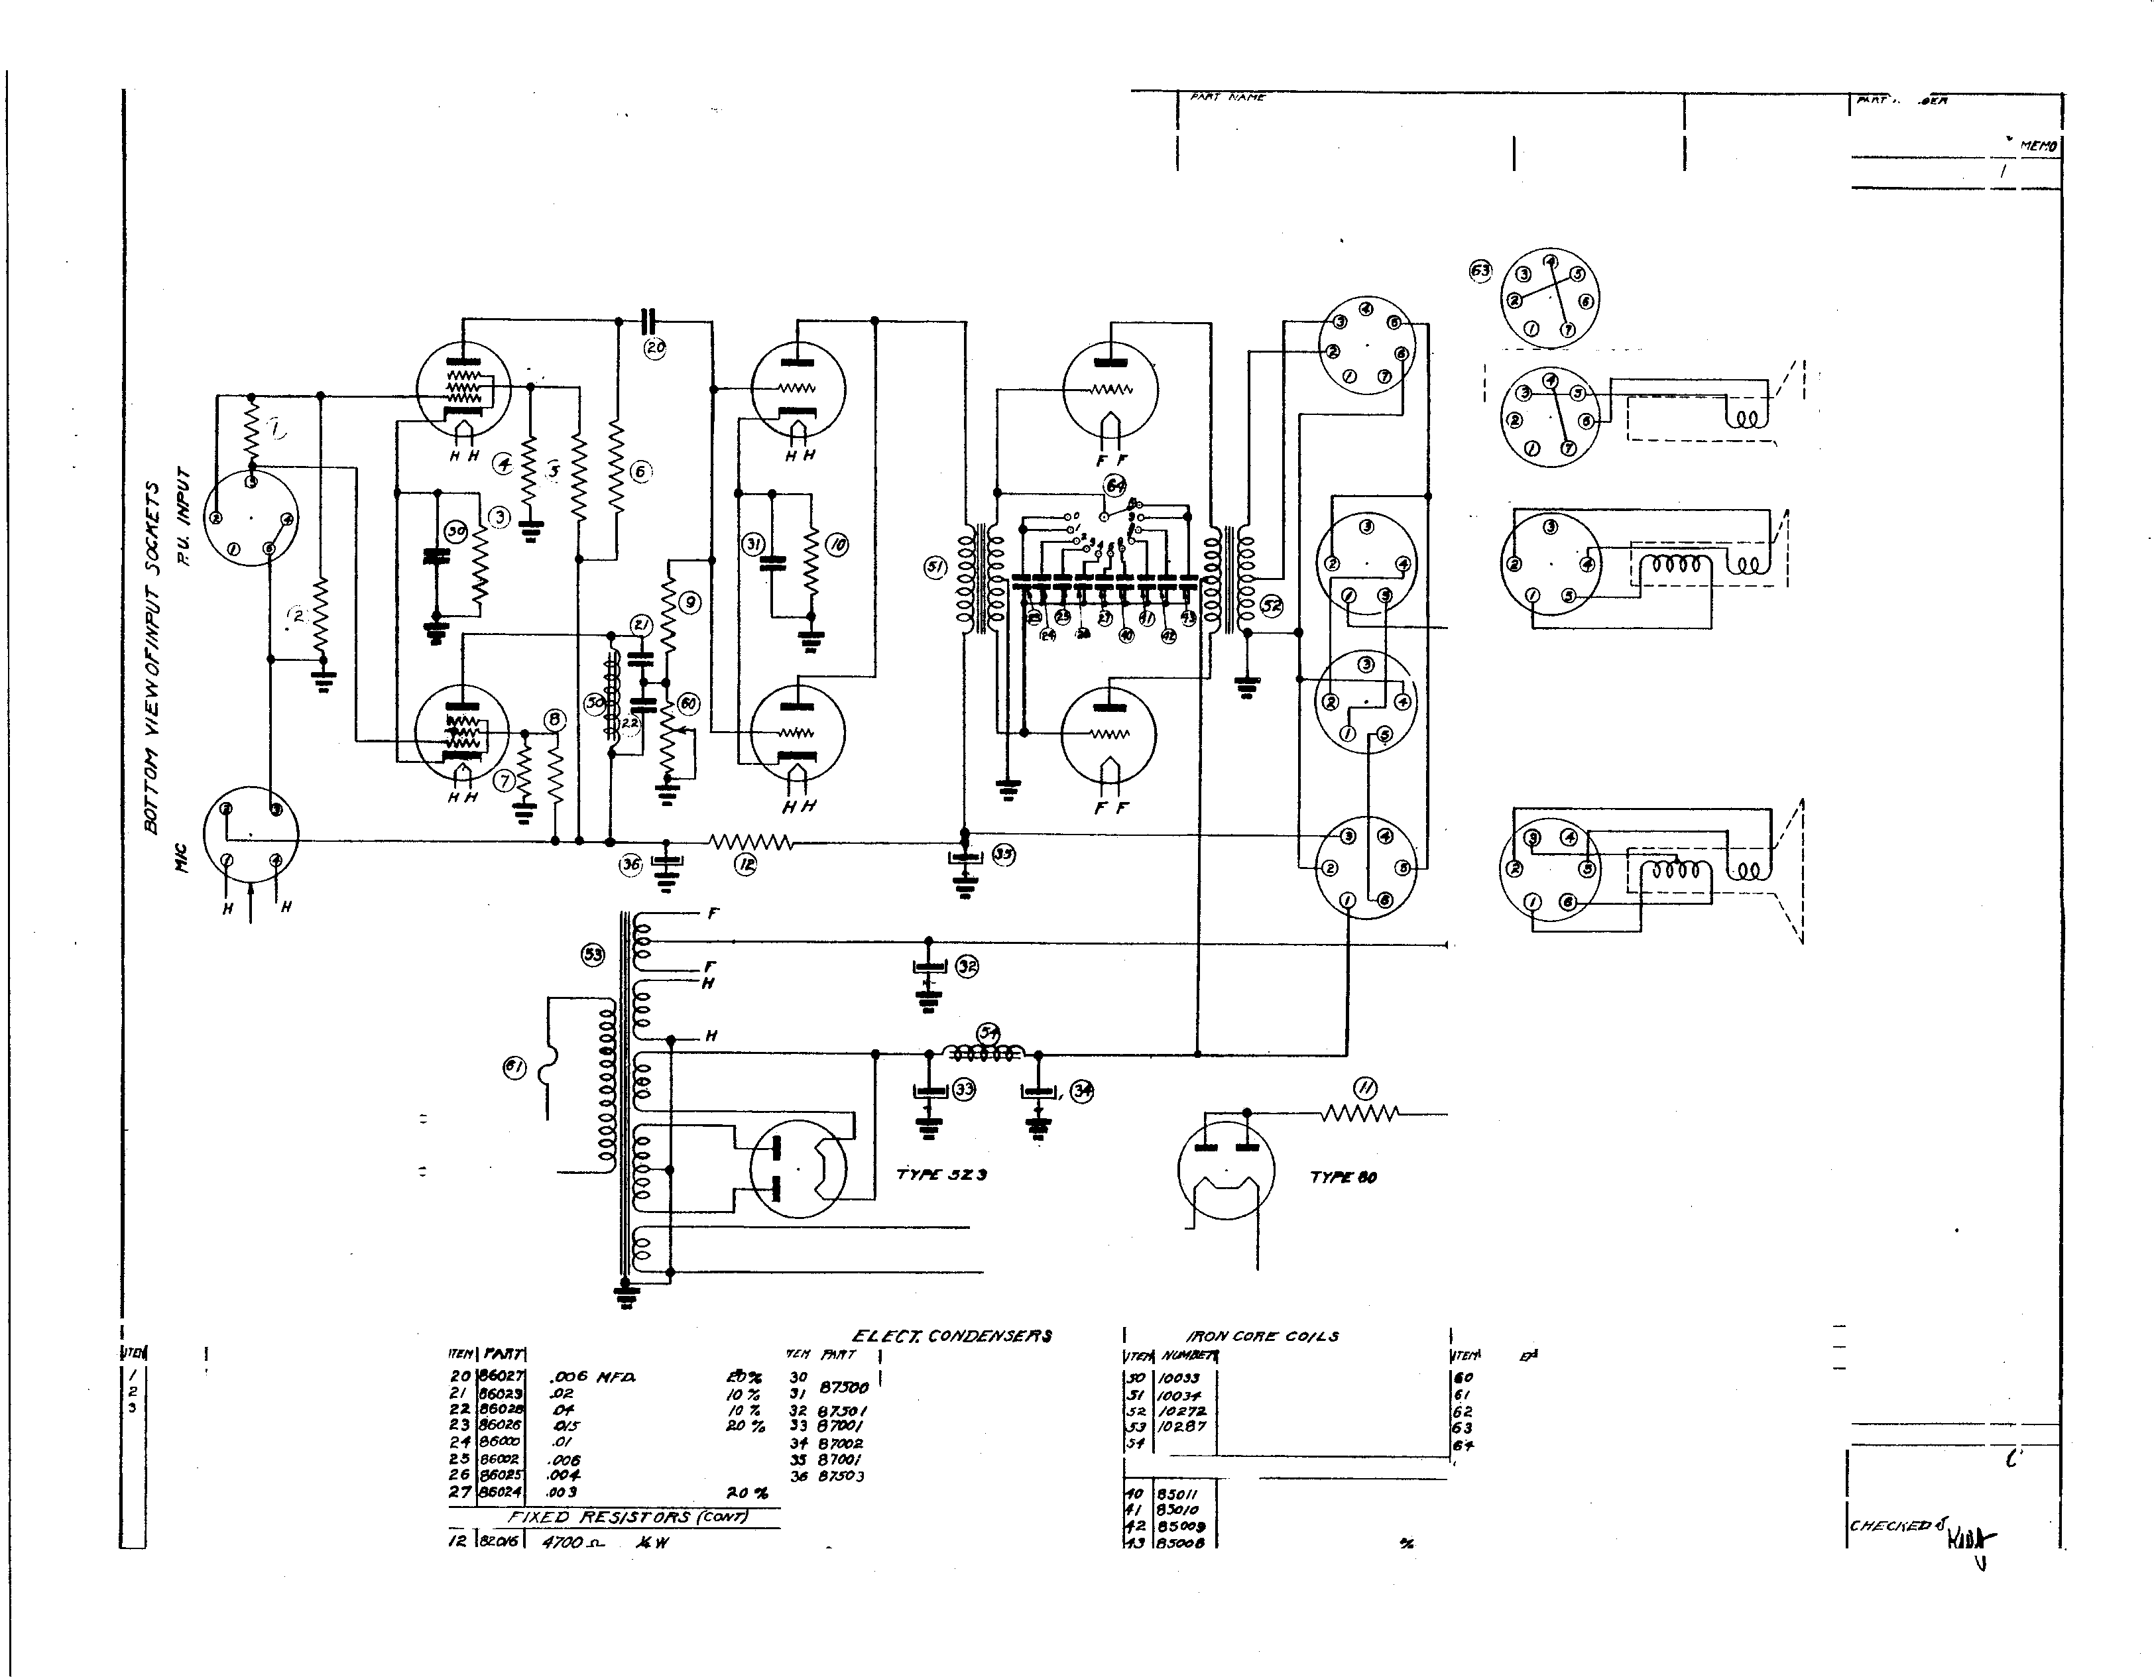II 61000
zoo.n. W.111 ZO%
·0006 2.D
.-flm'tJY£0

ISL1
fiJS

----s =e�---
<x

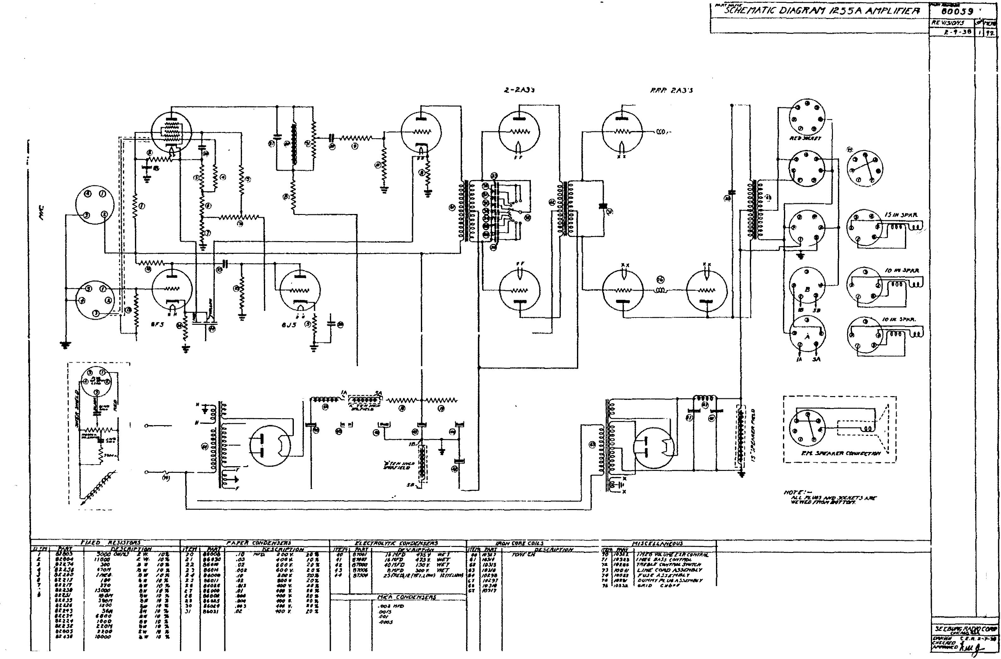

\
�

I I
I I I I
I I
I
I @
I
I I I I
'
.
•
I
'- -- -'

UtTKM/, ��� *"l
/!INI!Fif»Jfr.r JI.I0..11Ul �
fl.lr MANS 1soa..� fA,<fA,.,
,_.., TNw.t 1,)/l'r•N 1M.
'-W#:1t �'AM:� ,.,.r�IUI'K
/'11.711f ut. ,� ·· t:lllfll.·l>'ilftJII/4
t'lt TCif tJt.·all7.•�.t&VM·.-..Dc::

"' _,,
?J
If
.,, 3�­ JI 3$_,.
It �3 .,.,
"
IT

'""j'{-J;cl'i'A T/C DIAG')f'A/1 /�.5 5A A/1PL 1r!Efl

6L7
6JS Z-21'\J:S
P./?1? i'l'\3 J

: �
: �
: �
: .�
�
I
- J
-
-
-
r-- - - - - - - - - -- - -, I ,t I

L-- - - - - - - -\ :
:
: �N. S,.FA11C'R C'ONN�TKJIY\.� I
' - - - - - - - _ _ _ _ _ _!

- -
-
- -
'

I zw.

10$

.I 20
IRON COliC CiifZS - I� _,7$ V. W£1 10 1032.1

I YOL U

. EX'-COIYTifDL

.I..
j
1/0otJ
MD
470/1
IO l<
At. . W. .
10 •
·""
.02
.tJOi!
10%
""
•••
16hi'7J 47-' Y. WET
#01/.F£) I�Y WFT 6� /OJ/5
B/'1/"'D 3DIJ r: W.t7 63 /OJ/6
11'(1!6 6A.J.J CtJ�t'T-TOL TlfFJJLI CIWTJJ&.$W/1rN
L//YE COJJD 1'\.S.:aot'.&f Y

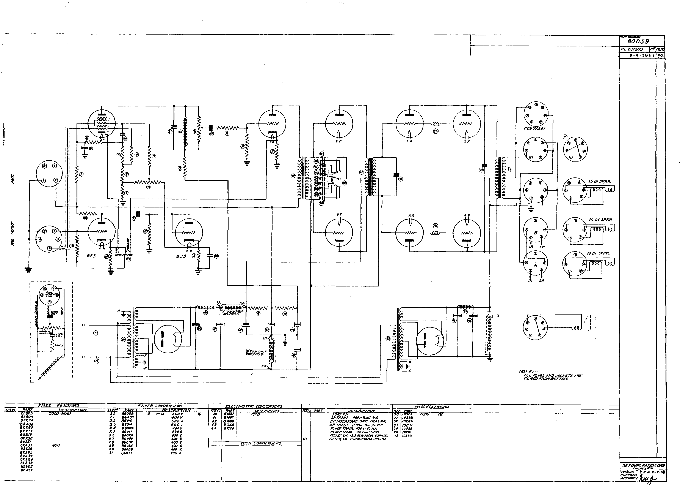•
7
j
/6
/I
II " I #
"
,I.T
1/YCS.
,..
... """"
,.,.,
,
5<it
1000
Z20t1
.. ,.
...
...
6W
.M..
t:
,••..
.,.
.,.
...
/Dn "" to ,...
/0 "
/(} ,., " "
10 ,.
10 ...
10 "
,. " ID "
,. "
./D
..•
,(J/S
,0/
....
·­
...,
·"'
.,,. ZO'J'.,
.. ,.
.. "
....
�0 �
.. z lD "-

::JO BS0/1
�
:u 8.5010
�ll 8!1'
33 8!1'1)(¥1
Z5(/'t£fi,12(Y£LLOW) JZ(r£/.1� • /Ot.98 f.S !dtZ97 f"li /OJif$
10"7
.,.

.(}I(); l'fnJ
.OO.t5
'"'
.(J(JI(J$
F"UJL ASSF/'f4L Y DUN/'fYI"'L.ti6.-1S�DYIN.Y r;.l'ffD ClliN<,

F I G . S

M·35
SC H E MA T I C D I AG RAM 0 T Y P E C S2 S - I M A STER CONT ROL STAT I O N

+'3 55 V

� ·2
C-24 r ?

M-37 M-38

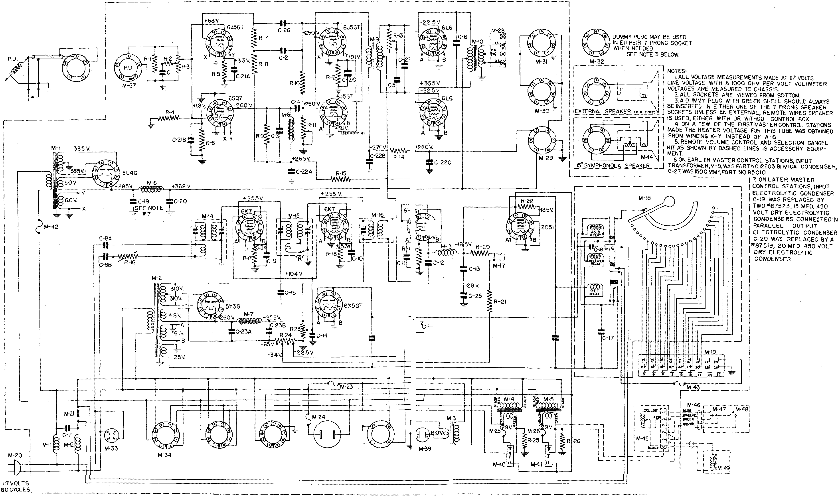
I
I
_ _ _ _j

SCH E MA T I C D I AG RAM 0 T Y P E

� -
1 + � 60V.
I
I
CS2 S - M A STER CO NT ROL STA T I O N

DUMMY PLUG MAY BE USED SOCKE
0

IN EITHER 7
PRONG T

I
I

M-32
WHEN NEEDED.
SEE NOTE 3 BELOW.

I
I
I M-27
I
I
_j
NOTES,
!. ALL VOLTAGE MEASUREMENTS MADE AT 117 VOLTS LINE VOLTAGE WITH A 1000 OHM PER VOLT VOLTMETER VOLTAG ES ARE MEASURED TO CHASSIS.
2. ALL SOCKETS AR E VIEWED FROM BOTTOM.
3. A DUMMY PLUG WITH GREEN SHELL SHOULD ALWAYS BE INSERTED IN EITHER ONE OF THE 7 PR ONG SPEAKER SOCKETS UNLESS AN EXTE RNAL, REMOTE WIRED SPEAKER IS USED, EITHER WITH OR WITHOUT CONTROL BOX.
4.0N A FEW OF THE FIRST MASTER CONTROL STATIONS MADE, THE HEATER VOLTAGE FOR THIS TUBE WASOBTAINED FROM WINDING X-Y INSTEAD OF A-B.
5.REMOTE VOLUME CONTROL AND SELECTION CANCEL KIT AS SHOWN BY DA SHED LINES IS ACCESSORY EQU IP­ MENT.
6.0N LATER MASTER CONTROL STATION S, INPUT ELECTROLYTIC CONDENSER C-19, WAS REPLACED BY
TWO "87523, 15 MFD. 450
VOLT DRY EL ECTROLYTIC CONDENSERS CONNECTED IN PARAL LEL. OUTPUT
ELE CTROLYTIC CONDENSER C-20 WAS REPLACED BY A
•87519, 20 MFD. 450 VOLT DRY ELECTROLYTIC
C O NDENSER

" ' I

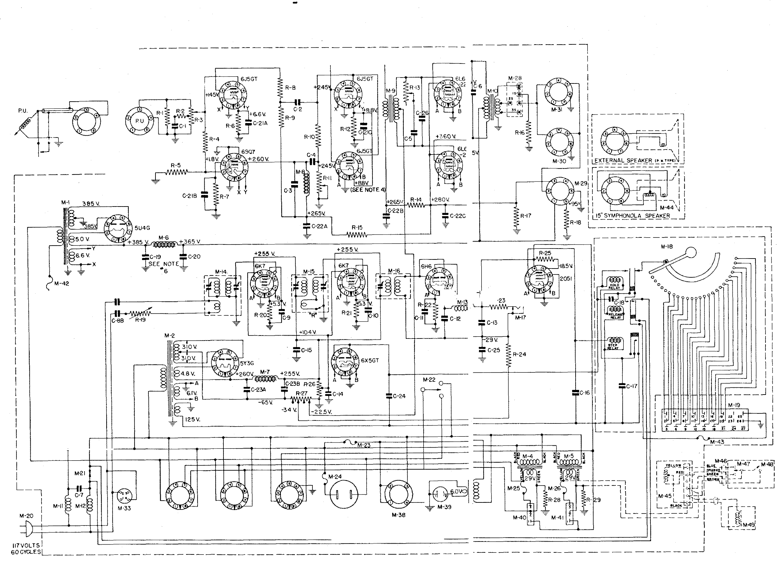M-34
M-36 M-37

F I G . 5 - SCH EMATI C DI AGRAM OF TYP E MC S2 5- I MASTER CON TROL STAT I ON

ITEM PART NO . DESCRIPTION PRICE

RESI STO RS

Rl 82433 S, 600 Ohms l/2 Watt 10%. . . . . . . . .0 7
R2 82482 500 Ohms l/2 Watt 10% • • . . .07
F-3076 16 ,000 Ohms Volume Control • . . . . . .7 S
R5 82433 S, 600 Ohms l/2 Watt 10% • • • . . . . . . . .
82448 100, 000 Ohms l/2 Hatt 10% . .0 7
R4
. .07
2, 200 Ohms l/2 Watt 10% • • .0 7
R6 82428
82443 39,000 Ohms l/2 Watt 10% • • .07
R8 824S2 220, 000 Ohms l/2 Watt 10% • • .07
R9 82 448 100, 000 Ohms l/2 Watt 10% . .07
RlO 82443 39,000 Ohms l/2 Watt 10% • . . . . . . . . .0 7
Rll 10039 100, 000 Ohms Variable Bass Control • . . . . .7 S Rl2 82423 820 Ohms l/2 Watt 10%• • • . . . . . . . . . .07
Rl3 10688 l Meg ohm Variable Treble Control • .7 S
Rl5 82433 S, 6 00 Ohms i/2 Watt 10% .
Rl4 82 424 1, 000 Ohms l/2 Watt 10% . . . . . . . . . . . .0 7
. . . . . . . . . .0 7
1131S 40, 000 Ohms Variable Sens itivity Control . . . . . . . . .75
6
Rl
Rl7 82424 1, 000 Ohms l/2 Watt 10% • • • • • • • • • . . . . . .0 7
Rl8 82424 1,o oo Ohms l/2 watt 10% • • • • • • • • • .07
Rl9 82134 4.7 Megohms l/2 Watt 20% • .0 7 lSO, OOO Ohms l/2 Watt 10% . . .07
R20
824SO

R22 82436 10, 000 Ohms l/2 Watt 10% • . . . .

. . .
.
. . . . . .07

11300 Candohm 2380-3260 Ohms • . . .40
R2l 82442 33; 000 Ohms l/2 Watt 10% • . . . . . . . . . .07
R24 12200 Candohm 400-127-88- 88·- 492 Ohms .40
R2 S 82424 1; ooo Ohms l/2 Hatt 10% . . . . . .07
R26 81006 1, 000 Ohms S Watt 10% . . . . . . . . . . . 25

PA PER CO NDE NS ERS
.

Cl 86043 . 2S Mfd . 200 Volts • . . . . .lS C2 86 031 • 02 Mfd . 400 Volts . . . . . . . . . . . .10
C3 86008 .1 Mfd . 200 Vol ts. . 10
C4 86013 . OS rilfd . 400 Volts . . . . . . . . . 10
cs 86031 .0 2 ��d . 400 Volts . . . . . .10

C8A .OS Mfd . 600 Volts . .
: }
} {:
C6 86069 .OOS Mfd . 1000 Volts . . . . . .1 0

C7 86 062 . s Mf d. 600 Volts • . . . . . . . .
.
.2 S

. .. . . . .
. 25

C8B
86061 .OS ��d . 600 Volts . . . . .
.
. . . . . . 10

C9 86008 • 1 Mfd . 200 Vol ts . .
Cl2 86013 . OS Mfd . 400 Volts . . . . . . .
. . . . . . 10

ClO 86008 .1 Mfd . 200 Volts . . . . . . . 10
C11 86009 . OS Mfd . 200 Volts . . . . . . . . . . . . . . . 10
.

Cl3 86013 . OS Mfd . 400 Volts . . . . . .

.
. . . .
.10

Cl4
86 008 .l Mfd . 200 Volts . . . . . .10

ClS 86 003 .1 Mfd . 400 Volts . . . . . . 10
Cl8 8601S . 01 Mfd . 600 Volts . .

Cl6 11076 s Mfd . 300 Volts
. . . . . .
l. 2S

Cl7 8601S .01 Mfd . 600 Volts . .10
. . 10
.

EL ECTR OL YTI C CON DEN SERS

eCm20 }
87S4l 16 ��d . 475 Volts Wet . . .

. 1. 00

Cl9 87S42 16 1-tl' d. 47S Volts He t. 1.00

C21C 20 Mfd . 2S Volts Dry • . . . .

.. . . . :
.

20 Mfd . 2S Volts Dry •
. . . .

C2lB 87543 20 Mfd . 2S Volts Dry • . . . . )
.40

C22A } 20 Mfd . 300 Volts Dry . . . . . . . . . . . :}

C22B 87S44 20 Mfd . 300 Volts Dry .
C22C 20 Mfd . 300 Volts Dry .
. . . .4 0

1 0

F I G . 5 - SCH EM ATI C DI AGRAM OF TYP E MCS25- 1 MASTER CONT ROL STAT I O N - Co nt i nue d

ITEM
}

C23A C25B C24
C25
PART NO .

87517
{=
87523
87521

20 Mfd. 450 Volts Dry .
20 11\f d. 450 Volts Dry .
15 Mfd. 450 Volts Dry .
10 Mfd. 50 Volts Dry •
DESCRIPTION

. . . .

. . . .

. . . . .
. . . .

:} $
PRICE .

.6 5

.4 5
. 25

M l CA CON DEN SER S

C26
C27
85 016
85022
.002 Mfd . 2000 Mmf. 10% • • • • • • •
• 0025 11\fd . 2500 Mmf. 10% • • • • • • •

M l SC ELL AN EOU S
. 20
. 20

Ml
M2
M3
M4
M5
1�6
M7
M8
M9
J'vllO Mll fv112
Ml3
Ml4
12204
12202
12213
12211
12211
12223
11306
12065
12226
12058
10841
10841
10843
30191
Power Tran sformer . Power Trans former .
6 Volt Tran sformer . . . . . .
25 Volt Transformer . . . . .
25 Volt Tran sformer . . Filter Choke . . . . .
Filter Choke . . . . . . . . .
Ba ss Choke Assembly . . . . . . Input Transformer .
Output Transf ormer . . . . .
R.F. Choke . . . . . . . . . . . . R.F. Choke . . . .
R. F. Choke . . . . .
1st ( Input) R. F. Transformer Assembly .

. . . . .
. . . . . . .
4.5 0
3.5 0
2.5 0
2 . 85
2.8 5
1. 5 0
1. 25
1.2 5
1.7 5
2.2 5
. 3 5
. 3 5
.2 5

Ml5
Ml6
Ml7
Ml8
11119
M20
M2 0 fv12l M2 2
142 3
M24
M25
M26
M27
M28
M29
M30
M3l
]1132
M3 3
M34
M35
M36
M37
M38
M39
M40
M4l
M42
M4 3
M44
M45
M46
M47
M4 8
1;14 9
30192
30193 lll88
50128
12022
F-1 369
12077
F-1349
12031
F-7 846
1417 3
1417 3
14173
84203
12216
84 201
84200
84 200
11367
12032
84248
84 248
84244
11401
84222
F-8897
12006
12006
F-7 846
12224
F-9824
12108
14215
12106
12105
14121
2nd ( Interstage) R.F. Trans former Ass embly .
3rd ( Diode) R.F. Transformer Ass embly . . . Diode Jack . . . . . . . . . . . Step Switch Ass embly . . . . . . . . .
27 Contact Male Socket • . . .
16 Ft . Line Cord and Plug .
2 Ft . Line Cord and Plug
Main Switch . . . . . . . . . . . . Light Switch . . . . . . . .
2-l/2 Amp . Light Fus e. . .
2.5 Amp . Non- tamperable l�otor Fuse .
2.5 Amp . Non-tamperable Fuse .
2.5 Amp . Non-tamperable Fuse .
Pi ckup Socket. . . . . . . . . . . Speaker I�tching Panel • . . .
Socket for Symphonola Speaker . Socket for Wired Remo te Speaker . . Socket for Wired Remote Speaker . .
Dummw Plug ( Green Shell) . . . . .
Socket for Transmitter Output . . .
Socket for Power to Transmi tter . . . . Socket for Power to Solenoid Drum.
Socket for Power to Remo te Control Equipment
Jl1o tor Receptacle . . . . . . . . Socket for Lighting Transformer . .
Socket for Elec trical Selector Lights . .
Socket for 6 DeLuxe Select-0-Matic s. Socket for 6 DeLuxe Selec t-0-Mati cs. .
2-1/ 2 Amp . Amplifier Fuse . . .
l/2 Amp . Solenoid Fuse • • . . .
15 11 Symphonola Speaker . . . Remote Volume Control Motor . . . Remo te Volume Control Cable .
Remo te Volume Control Switch . .
Remote Selection Cancel Switch .
Remote Selection Cancel Relay . . . . .
I I

. . .
. . . .

. . . . . .

. . . . .
. . . .
. . . .

.

. . . . .

. . . . .

. . . .

. . . .
. . .p er ft .
. . . . .
.85

. 3 5
10 . 50
1 .00
.8 5
.2 5
. 35
.45

. 10
.25
. 25
. 2 5
. 10
. 20
.10
.1 5
.1 5
.2 5

. 10
.10
.10
. 20
. 10
. 15
.1 5
.15
.10
.15
16 . 50
4. 50
.0 6
1. 2 5
.s o
1. 40

F l G. 6 - SCHEMAT I C DI AGR AM OF TYP E MC S25- 5 MASTER CONTROL S TATI ON

ITEJV[
PART NO .
DESCRIPTION

RESI STORS
PRICE

IU 82455
R2 8248 2
R5 F- 5076
5, 600 Ohms 1/2 Watt 10% . . .
500 Ohms 1/2 Wa tt 10% • • .
16,000 Ohm Volume Control • •
. . . .

.

. . . .
$ . 07
.07
.75

R4
R5
R6
R7
RB
R9
IUO
82615
82606
82435
82428
8244 5
82445
82443
24, 000 Ohms 1/2 Watt 5% • •
75 ,000 Ohms 2 Watt 5% • • .
J'
51 600 Ohms 1 2 Watt 10% • • .
2, 200 Ohms 1/2 Watt 10% • • •
59,000 Ohms 1/2 Watt 10% •
391000 Ohms 1/2 Watt 10% •
59 1000 Ohms 1/2 Watt 10% •
.
. . . .
. . . .

. . .
. . .
.
.

. . .

. . . . .

. . . . .

. . . . .

. . . .

. . . .
. 10
. 10
. 07
. .07
. 07
. . 07
. 07

IUl
IU2
IU5
10039
82423
10688
82424
100,000 Ohms Variabl e Bass Control
8 20 Ohms 1/2 Watt 10% • • •
1 Megohm Variable Treble Control • . .
1000 Ohms 1/2 Watt 10% •

. . . .

. . .
. . .

. . . .
. . 75
. 07
.75
. .07

IUS IU6
82435
81039
51 600 Ohms 1/2 Watt 10% . . . . . .
20 Ohms 5 Watts 10% Wire Wound •
. . . .
. 07
. 20

IU7
IUS
81041
81040
11,000 Ohms 10 Watts 10% Wire Wound .
2, 000 Ohms 10 Watts 10% Wi�e Wound •

. . . . .
. . . .
. . .
. .2 5
. , 25

Rl9
R20
R21
R22
11515
82424
82424
82134
401000 Ohms Variable Sensitivity Control •
1, 000 Ohms 1/2 Watt 10% • • • • • • • • • .
1, 000 Ohms 1/2 Watt 10% • • • • • • • • • •
4.7 Megohms 1/2 Watt 10% •
J'

. . .

. . .

. . . .

. . 07
.07
. 07

R24

R26

82450
82442
82536
11500

150, 000 Ohms 2 Watt 10% .
55,000 Ohms 1 2 Watt 10% •
10, 000 Ohms 1/2 Watt 10% •
Candohm 2580-5260 Ohms . .

. .

. . . .

. .
. . .

. . . .
. .

. . .
. . .
. . . .

. 07
. . 07
.07
. . 40

R27
R28
12200
82424
81006
Candohm 400-127-88-88-492 Ohms
1, 000 Ohms 1/2 Watt 10% . . . .
1, 000 Ohms 5 Watts 10% • . . . .

. . .

. . .
.40
.07
. . 25

PAP ER CON DEN SER S

Cl
C2
C3
C4
05
C6
C7
}
C8A C8B
86045
86031
86008
86015
86031
86070
86062 -

86061
{:
86008
. 25 Mfd , 200 Volts . .
• 02 Mfd. 400 Volts •
• 1 Mfd . 200 Volts . .
. 05 r·tfd. 400 Volts •
. 02 Mfd . 400 Volts
. 01 Mfd , 1000 Volts . . . .
• 5 Mfd, 600 Volts . . .
. 05 Mfd . 600 Volts . . .
. 05 Mfd , 600 Volts .
.1 Mfd . 200 Volts . .
. .

. . .
. .
. .
. . . .

. . .

.
. . . .
. . .

. .

.
. . .

. .
. . . .
. . . .
. . .
. .

. . .
. . . .

. . . .
.
. . 15
. . 10
. . 10
. 10
. 10
. 10
. 25
: }
 | .10
. | . 10
. | . 10
. | . 10
 | . 10

ClO Cll
012
Cl5
014
Cl5
016
Cl7
018

86008
86009
86013
86015
86008
86005
11076
86015
86015

• 1 Mfd . 200 Volts . .
. 05 Mfd , 200 Volts •
• 05 Mfd. 400 Volts •
,05 Mfd . 400 Volts • .
.1 Mfd . 200 Volts . . . . .
.1 Mfd . 400 Volts. .
5 Mfd . 500 Volts • .
• 01 Mfd. 600 Volts • .
• 01 Mfd . 600 Volts •

. . . .
. . . .
. . . .
. . . . .
. .

. . . .
. . . . .
.

. . .

. . .
. . ' .
. . .

. . .

. 10
. . 10
1. 25
. 10
. 10

019
l
020
C21A
021B C21C C2 2A C22B C22C

87542
87541

87543
EL ECTROLYT I C CON DENSERS

16 Mfd. ' 475 Volts We t.
16 �lfd . 475 Volts We t. .
20 Mfd . 25 Volts Dry •
20 Mfd . 25 Volts Dry • • .
20 Mfd . 25 Volts Dry • .
20 Mfd . 500 Volts Dry.
20 �lfd . 500 Volts Dry. .
20 Mfd , BOO Volts Dry. . . . .

1 4 :

. . . .

. . . .

. . . .

. . .

1. 00
1. 00

.40

.40

F I G . 6 - SCH EM AT I C D I AG RAM OF TYP E MC S25- 5 MASTER CONTROL

STAT I O N - Co nt i nued

ITEM C25A }
C23B C24 | 87517
 | 87523
C25 | 87521

PART NO .

{=

20 Mfd .

450 Vol ts Dry.
DESCRIPTION

.
PRICE

.
:} $

20 Mfd . 450 Volts
15 Mfd . 450 Volts Dry . . . . . .
10 Mfd . 50 Volts Dry •

Ml CA CON DEN SERS
. 6 5

. 25

C26

Ml
M2
143
M4
MS M6

M8
M9
MlO Mll Ml2
Ml3
Ml4
Ml5
Ml6
Ml7
Ml8
Ml9
M20
M20
M21
M22
M23
M24
M25
M26
M27
M28
M29
M30
M31
M32
M33
M34
M35
M36

M38

M40
M41
M42
85010

12204
12202
12213
12211
12211
12223
11306
12065
12203
12217
10841
10841
10843
30191
30192
30193
11188
50128
12022
F-1 369
12077
F-1349
12031
F-7846
14173
14173
14173
84 203
12216
84201
84200
84200
11367
12032
84248
84248
84244
11401
84222
F-8897
12006
12006
F- 7846
• 0015 Mfd . 1500 Mmf . 10% • . . . . . . . . .

M l SC ELLAN EOU S

Amplifier Power Transformer . . . . . . . .
Selection Receiver Power Transformer •
6 Volt Transformer •
25 Volt Transformer .
25 Volt Transformer. . . . . . . Filter Choke . . .
Filter Choke . . . . . Ba ss Choke Ass embly . Input Transformer . . Output Transformer R.F. Choke • . . . . .
R.F. Choke • . . . R.F. Choke . . . .
1st ( Input ) R.F. Transformer Ass embly .
2nd ( Interstage ) R.F. Transformer Ass embly
3rd ( Diode ) R.F. Transformer Assembly .
Diode Jack • . . . . . .
Step Switch Assembly • . .
27 Contact Male Socket • . . .
16 Ft . Line Cord and Plug . . . . . .
2 Ft . Power Cord and Plug . Main Switch . .
Light Switch • . . . . . .
2-1/2 Amp . Light Fus e. . . . . . .
2.5 Amp . Non-tamperable �lo tor Fuse
2.5 Amp . Non-tamperable Fuse
2.5 Amp . Non-tamperable Fuse . Pickup Socket . . . . . . . . . . Speaker Matching Panel • . . Socket for Symphonola Speaker . Socket for Wired Remote Sp eake r.
Socket for Wired Remote Speaker. . Dummy Plug ( Green Shell ) . . . . .
Socket for Transmitter Output . . Socket for Power to Tran smitter . Socket for Power to Solenoid Drum . .
Socket for Power to Remote Control Equipment
Motor Receptacle . . . . . . . . Socket for Lighting Transformer • •
Socket for Electrical Selector Lights. . Socket for 6 DeLuxe Select-0-r�ati cs . . . Socket for 6 DeLuxe Select-0-Matics .
2-1/2 Amp . Amplifier Fus e. .
. . . . . . . . . . 20

. 4. 50
3.5 0
2. 5 0
2. 85
. . . . 2. 85
1.5 0
1.2 5
1. 25
1.7 5
2. 2 5
. 3 5
. 35
.25
.75

.85
.75

. 3 5
10 .50
. . 1. 00
.85
.2 5

.45
.10
. . . . . .2 5
.25
. 2 5
.10
. 20
. 10
.15
.1 5
. 2 5
. . . . .15
. . 10
.10
.10
. 20
.10
.15
.15
. 15
.10

M43
M44
12224
F-9024
1/2 Amp . Solenoid Fuse •
15" Symphonola Speaker •
. . .
. . . .
.1 5
11 .00

M45
M46
M47
M48
M49
12108
14215
12106
12105
14121
Remote Volume Control Motor. . Remote Volume Control Cable. . Remote Volume Control Switch Remote Selection Cancel Switch Remote Selection Cancel Solenoid •

1 5
4.5 0
. .per ft .• .06
1.2 5
.5 0
1. 40

SERVICE
MANUAL

Nota la

Not3 2a
S�honola model lioted ia r�preaentative� not the only �odGl to use the epeaker dE:signa·t:od.

Speak=r field reai otance shown aa measured between indicated
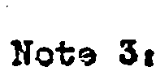plug prong number s.

l!hcn it is desired to uae an amplifier without the instrument s�aker� al! on remote· "hide-away., installation� it must bo kept 1n mind that the speaker fields - both high trequonoy.
'When used, and main speaker • are used as bleedar and in some
instances aa filter choke s. The SB-7 and the 1255 amplifiera are 1n tha latter olas a . The other amplifiers ·may be so used
by sub stituting for ths field ooil aeotions, wire-wound re­
eiators of the same value as the field oo11 and of: 20 Watt
.

capaoity.

liots 4:
Voice ooil �p edanoe �t 400 cycles. Thio value 1s not ths
CF:JJ:le as would ba indicated by e. 00 Oh!um.eter .

7ihero sub atitutions �a indicated, it io �ac�d that auch 3Ub-
3"titutio:l is to 'ba !:lade o.nl:r when the c o1•rect t• epl:t.oe�snt is
no·!: e.vnilable. In sctno instano a;s the substitute apaaker , while
sati e taotory, �ll ;�v� field raeiotano s diffa�ing £.o� t�a
original opeaksr . !� such cas�5» tha ampli fier output may �ufa
£sr a�ew.hat du� tQ a ch3ngo in tho voltage di3trioution to tho vs.rioua high-vol·:.ag() oiroui·ts.

Spe �ksr field re oiat�oa ae��urad hot (after attaini�g no:nal
op�rati:g to�peratu:o }.

SPE.AIO!llS

}o'-6354 ....

-- as 'rtop OpEJak,gr
(part N.o . F-6364 ) in ).900 I
. . � models, Cad�t , Colono l,
I
eta. and aa PI: typo wed
'

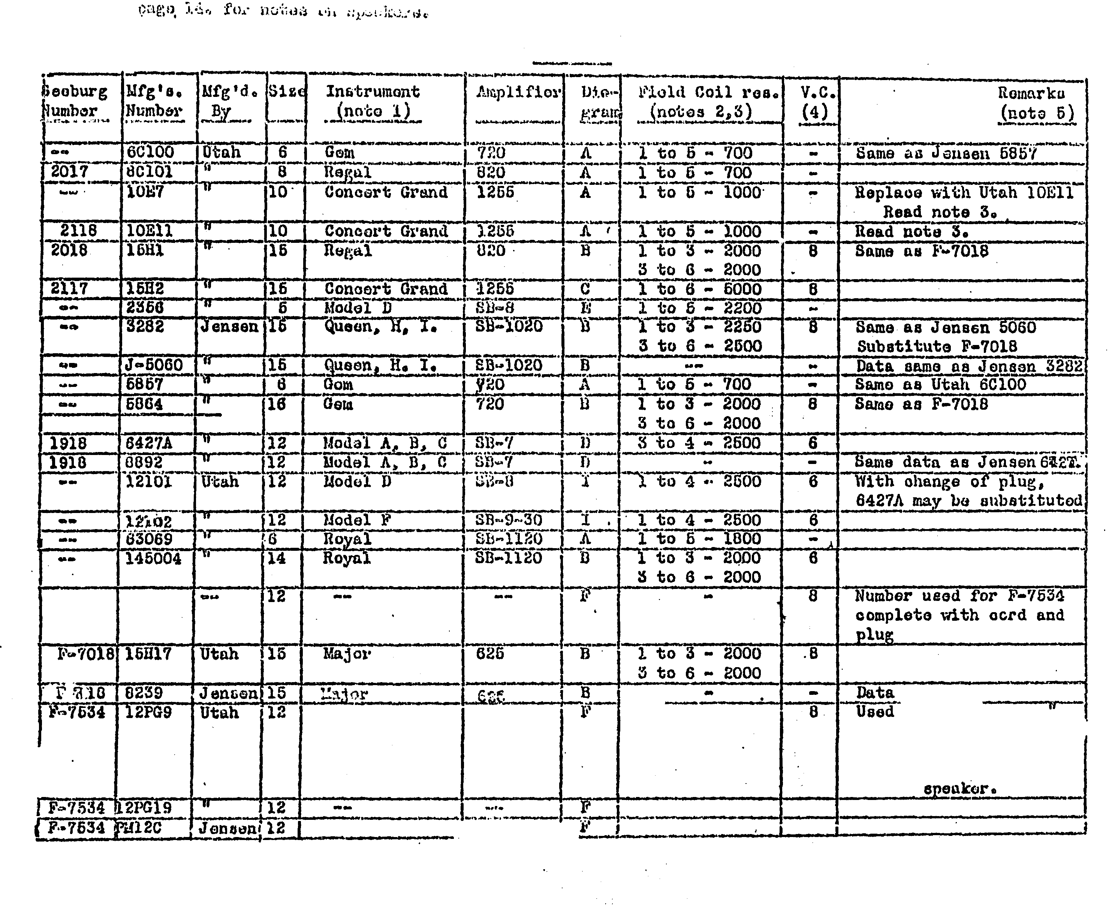--
.L:.:
, __

SPEAKERS

F" 902�hav1ug unme ol uo
tr 1cal obnractor�atioo
but of higher off1o1ency
be

.. |  |  | '1060 | 615.... | D | l | to | 3 | - | 2000 | 8 | 9024.  Same as F•'IOl8
,.. |  |  |  | �5 |  | 3 | to | 6 | -  ... | 2000 |  | Subatituo F� 7016
 |  |  |  |  |  | 3 | to | 6 | - | 2000
F• 9024 |  |  | Cla wuio | 6�0 | B |  | to | 3 | � | 760 | 8
 |  |  |  |  |  | 3 | to | 6 | .. | 3 240
 | l6Ul00 | 16 | 9000 | 625·6 | BB | l | to | 3 | - | 760 | 8 | DO NOT uoe 9024o | F• 96 24
 |  |  |  |  |  | 3 | to | 6 | ,,. | 3240 |  | re quires higher | fi0ld
 |  |  |  |  |  |  |  |  |  |  |  | current thnt vou | ld ovor�

- - ..
F- 9824
field.
F-9024
s�u
1 to 2-:-mo-- e
oal except tor longor
loads .
11199 | l2J 61 | 12 | so... |  | 2 -
 |  | 12 | SO•l.6 | 9SJ."'S. ...

....

.. ..-
• • • 460 3. 2 Used in NUS� l, oonnoat-
without
12 li to - 6960. 2 Mote a. Same a a 11399
leada o
DSC... lZ 9SF'S•l5 ..\ to 5 .. 1 600 . 8 Sarno aa 1. 1 667 exo opt
"
leada .

... •
Cent1•a.l
· '
..

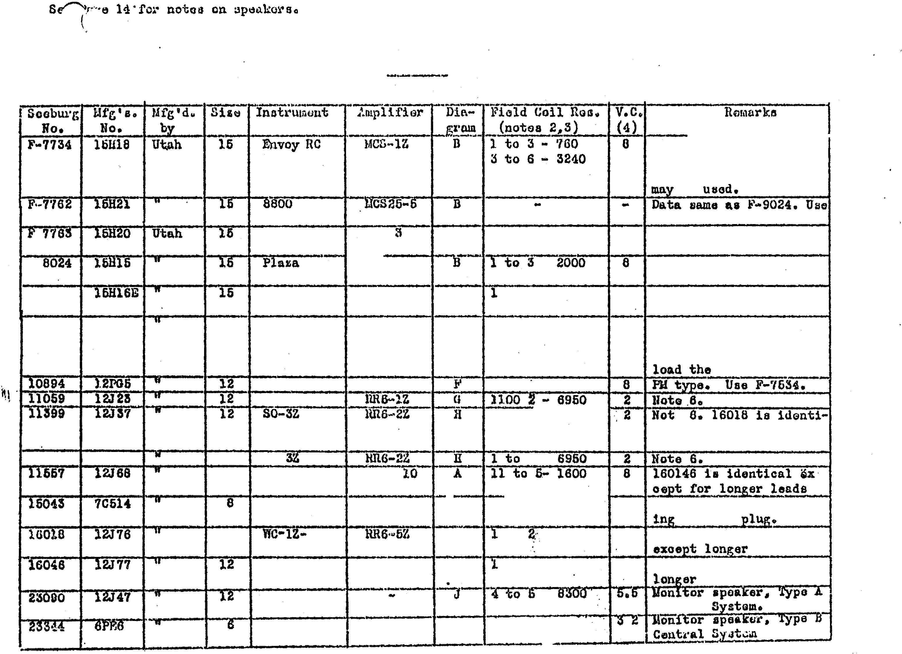- ... ..

FM 'ty!!� ,..
\.

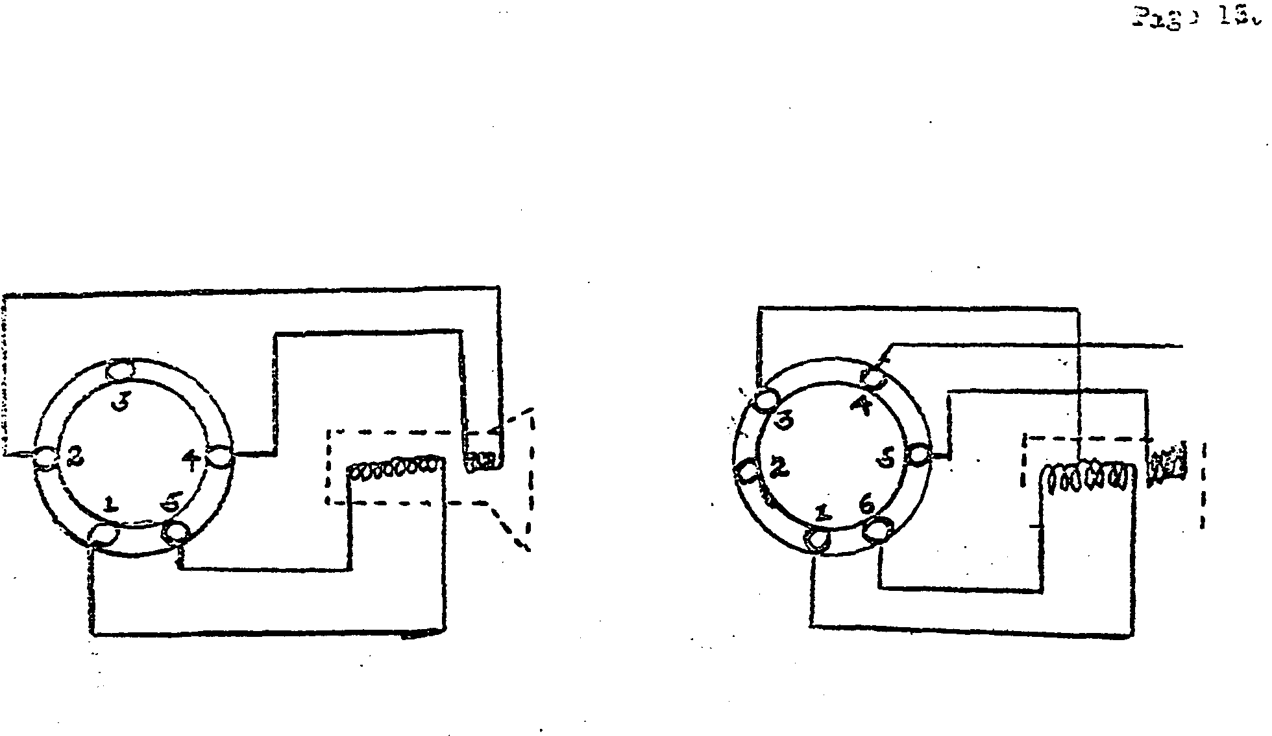SEEA.m". COIDlECTIONS

A
B B

. I

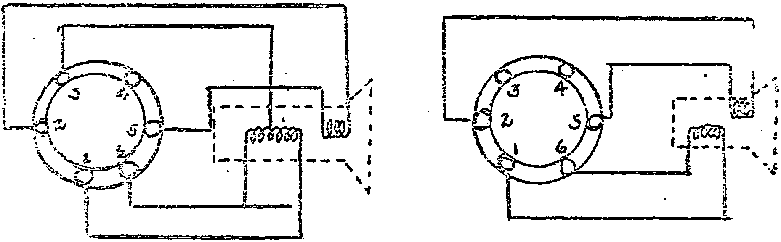B c

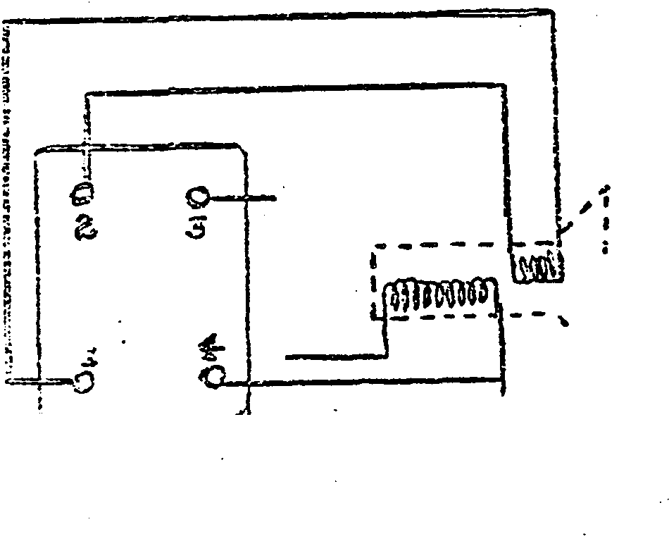

I I
I
.. I
.,

D

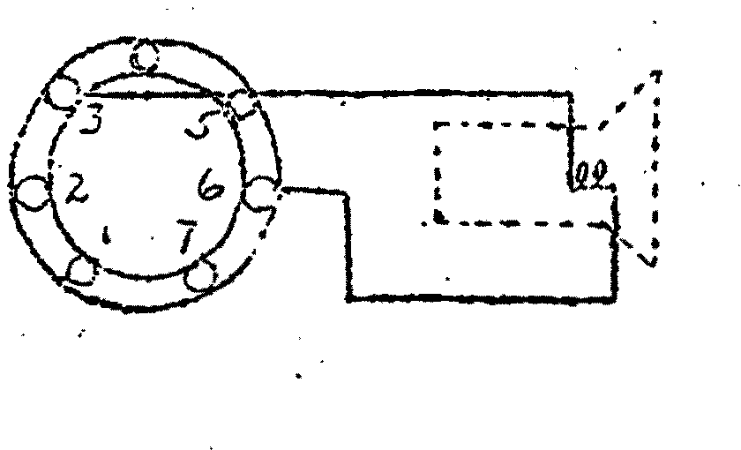

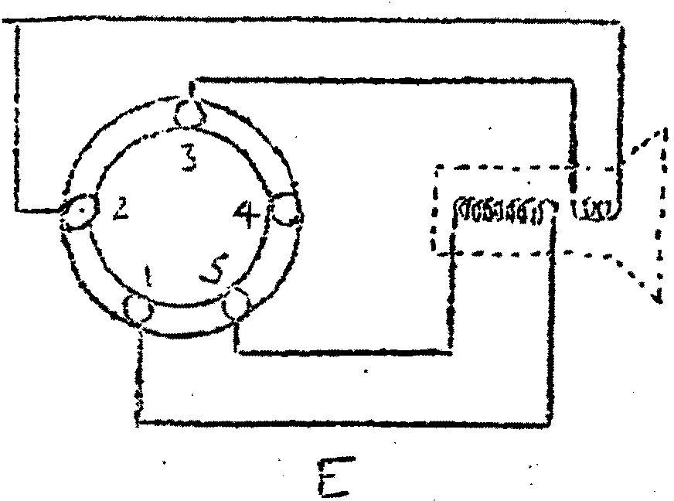 F

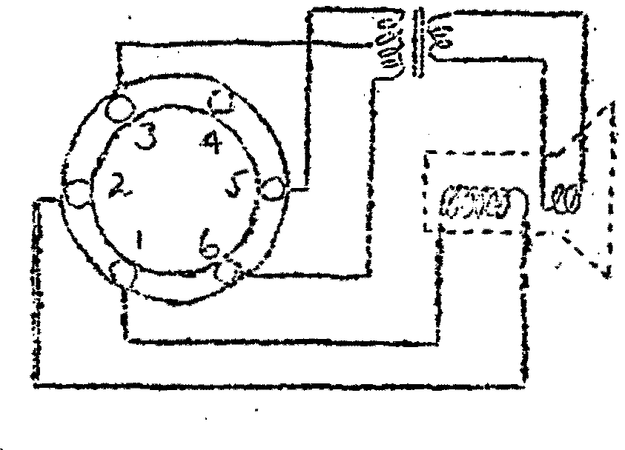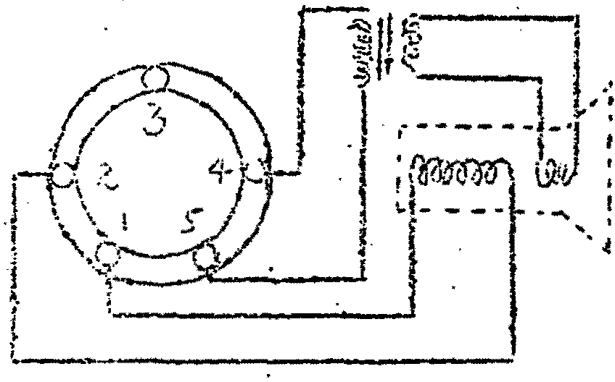
G- H

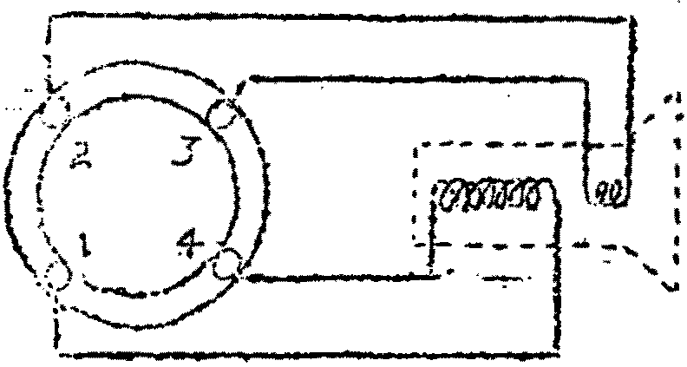

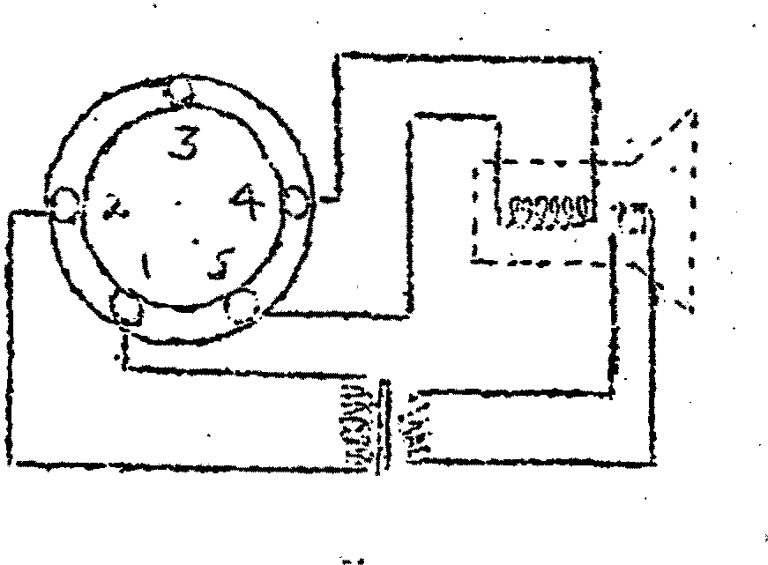J.
T
.. r

EXTP.A SPB.!ll\ER 'PLUG WIRING

·K

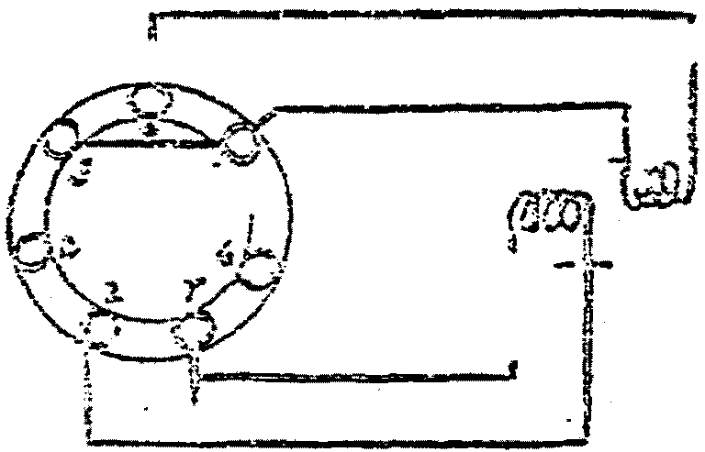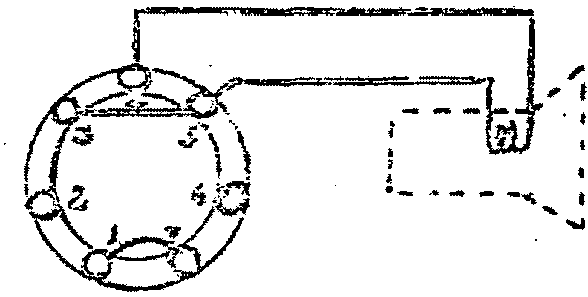. - - - r.;, - "
')

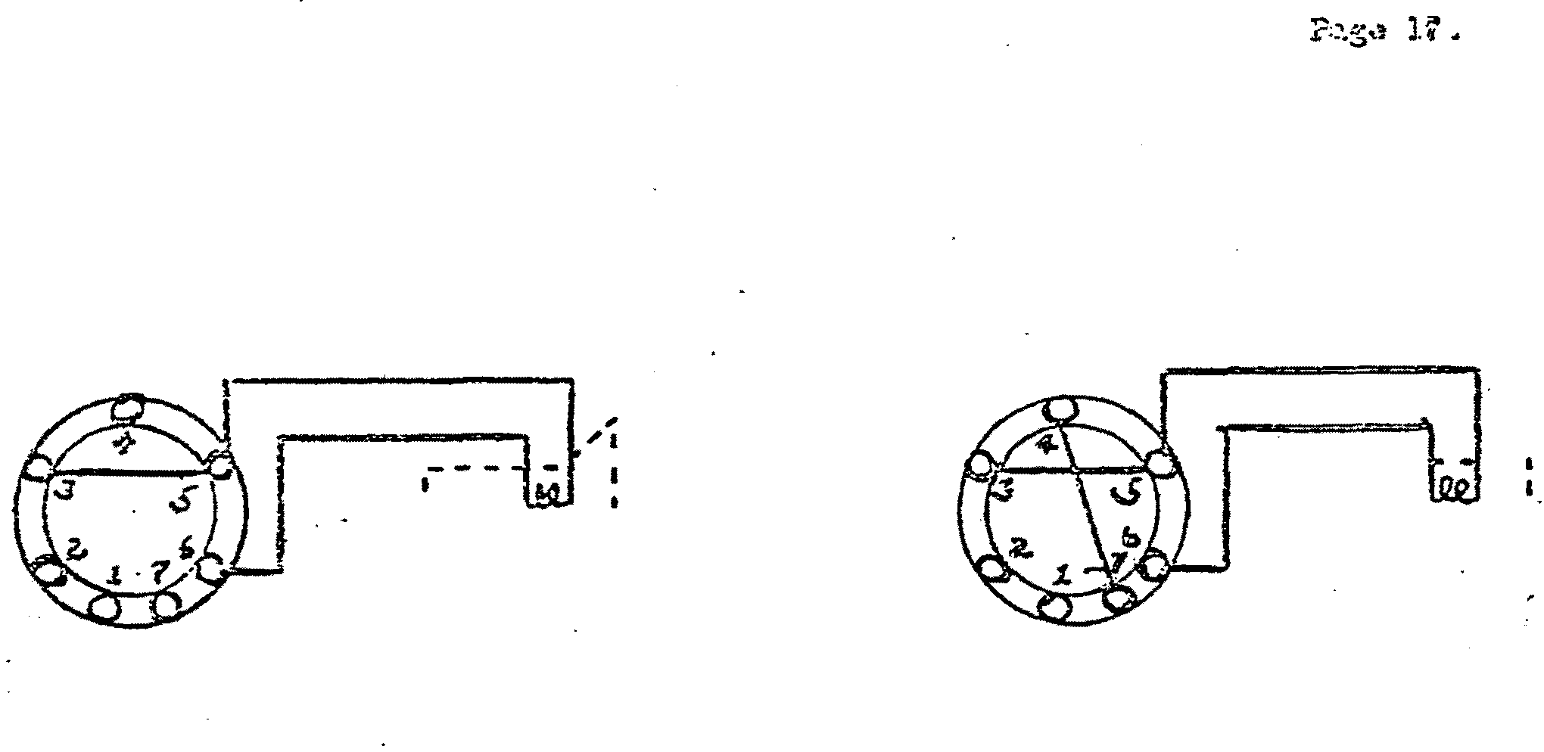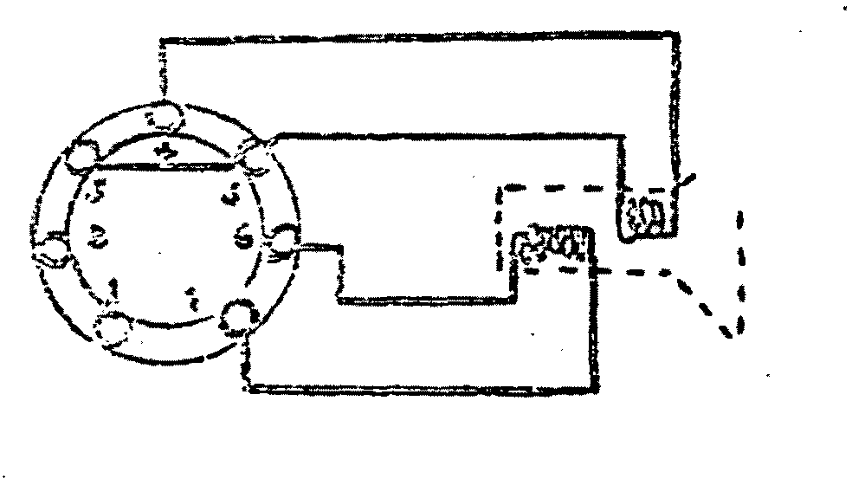:·1.·- - -\, '1 ·

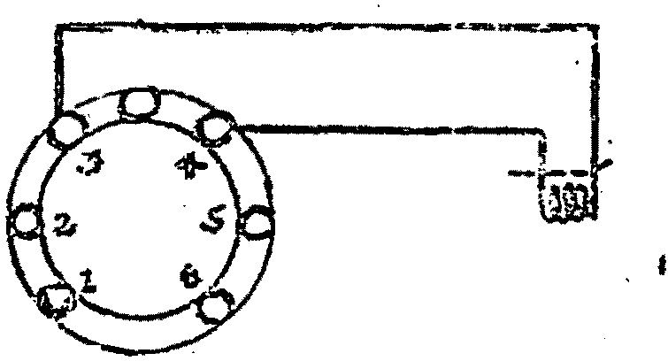- - "" I

DUMMY PtUG CONNECTIONS

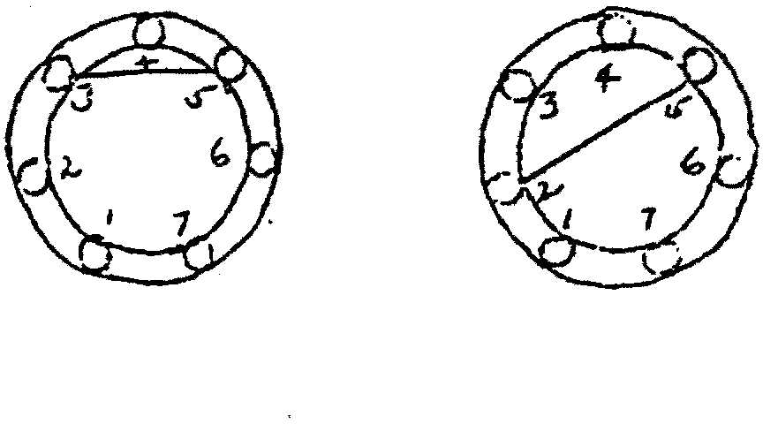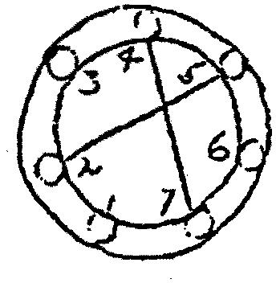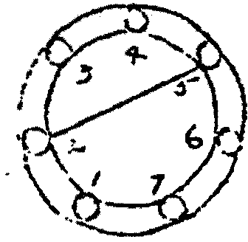

1 z 3 4
.Paza :.i:!
.

SERVICE
MANUAL

S ERVICE MANUAL

N o . 3

SEE BURG

RE MOTE CONTROL SYSTEMS

1. WALL-0- MATIC WI RELESS REMOTE CONTROL SYSTEM
2. DELUXE SELECT-0- MATIC 3 WIRE REMOTE CONTROL SYSTEM
3. SELECT- 0-MATIC WI RED REMOTE CONTROL SYSTEM
/

as applied to

1 94. 1 SE EB URG SYMP HONOLAS

( S EE BACK COV ER FOR INDEX)

J. P. SEE BURG CORPO R ATI ON
15 00. D AYTON STR EET • C H I C A G 0, U. S. A .

F 9939 Printed in U. S. A.

O I A G R AMS FOR S E E B U R G RE MOTE CO N T ROL SYST E MS

1 9 ' + 1 R . C ; S Y MPHONOLA S :
F I G. I - Cab i n et W i r i n g D i ag r a m fo r RC-8800 an d RC ... 980 0 . .
.
.
F I G . 2 - Cab i n e t W i r i n g D i a g r a m fo r RC-78 50 . . •
F I G . 3 - Ca b i n et W i r i n g D i ag r am fo r TRC- 1 S p e c i a l . • . . . •
•
PAGE

2 & 3
It & 5
6

F I G . It - Ca b i n e t W i r i n q D i agr a m fo r RC - 1 Sp e c i a l , •
F I G . | 5 | -
F I G . | 6 | -
F I G . | 7 | -

. . . .
. . . 7

S c hem at i G D i ag r a m of Typ e MCS25 - I M a s t e r Co n t r o l S t a t i o n S c h e m a t i C ' :D i a g r a m of Typ e MCS25 - 5 M a s t e r Co n t r o l S t a t i o n . . Step S w i t c h an d Rei ay A s s e m b l y ( 1 1 5 0 1 2 8 ) . . • . . . . .

WA L L -0-MAT I C W I R E L E S S REM OTE CONTROL SYS TE M :
F I G . 8 - S c h e m a t i c D i a g r a m of Typ e WS- 2Z Wal l -0 -M at i c { 5 ¢ ') , • • • , •
F I G . 9 S c h e m a t i c D i ag ra m of Typ e WS- I O Z Wa l l - 0-M a t i c ( 5 ¢ - 1 0¢ - 2 5 € ) .
F I G . I O Schema t i c D i agra m of Typ e WB- 5Z B a r.- 0-M at i c ( 5 t ) • • • •
F I G . I I S c h e m a t i c D i ag r a m of Typ e WB- I Z B a r� O -Ma t i c ( 5 ¢- I 0 ¢-25J } • •
F I G . I 2 S c hema t i c D i ag r a m of Typ e SR-'t S e l e c t i o n Rece i v e r • • , , , ,
F I G . I 3 B l oc k W i r i n g D i a g r a m o f Typ e S R -4 S e l ect i o n Rece i v er i n
Mo del s 7800, 785 0 , 8 8 0 0 and 9800 • • , • • • • • • • • • •

D E L U X E S E L EC T- 0 -M �T I C 3 WI R E REMOTE CO N T ROL S Y STE M :
F I G. I 4 - S c h e m a t i c D i agra m o f Typ e D S 20 - I Z D e l u x e S e l e c t - 0-M at i c ( 5 ¢ }
F I G . l 5 - S c h e m a t i c D i ag r a m o f Typ e D S 2 0- I O Z D e l u x e Sel e c t-0 -Mat i c
( 5 ¢ - 1 0 ¢-2 5¢ ) • • � • • • • • • • • • • • • ·• • • • • • • •
F I G . I 6 - S c h e m a t i c D i ag r a m of Typ e D S B - I Z B a r-0 -M at i c ( 5 ¢ - 1 0¢-2 5¢ ) • •
F I G . I 7 - S c h e m a t i c D i ag ra m of Typ e S S 20- I S t e p Sel ec to r • • • • , ·� .
F I G . I 8 - S t e p S w i t c h a n d Re l a y A s s e m b l y ( # 50 1 '+ 2 ) • • • • • • • •
F l G . 1 9 - S c h e m a t i c Di agra m of Typ e P S 6- I Z Power S u p p I y, • , , • , • ,
F I G . 2 0 - B l o c k W i r i n g D i ag r a m of Typ e S S 20- I Step S e l e c t o r i n
Mod e l s 7800 , 78 5 0 , 8800 an d 980 0 • • • • • • • , • • • • •
8 & 9
1 2 & 1 3
1 6

1 7
1 8
1 9
2 0
2 2

24

25
2b
27
28
29

30

S E L ECT -0 -MAT I C WI R E D R E MOTE CONT ROL SY ST EM :
F I G . 2 1 - S c h e m a t i c D i ag r a m of Typ e S 2 0- I Z S e l ect-0 - M a t i c.
F I G . 2 2 - S c h e m a t i c D i ag r a m of Typ e WA- I Z W i r e d Ad ap to r , •
F I G . 2 3 - · sch e m a t i c D i ag r a m of T ype PS 1 2 - 3 Z Pow e r S u p p l y • •
F i G . 2 4 - B l ock W i r i n g D i a g r a m o f Ty p e WA- I Z W i r e d Ada p to r i n
M o d e l s 78 00, 7850, 8 8 0 0 an d 9800 • • , •

3 1
• (J •• 3 2
3 3

34

W I RELESS R E MOT E SOUND S Y STE M :
F I G . 2 5 - S c h e m a t i c D i a g r a m of Typ e T- 3Z T r a n s m i t t e r • • • ,
F I G . 2 6 - B l o c k W i r i n g D i ag r a m o f T y p e T- 3 Z Tr an sm i t t e r i n Model s
780 0 , 7850, 880 0 an d 9800 • • • , , • • • • • • • • • • 3 6
F J G . 2 7 - B l o c k W i r i n g D i ag r a m o f Typ e T- 3 Z T r a n s m i t t e r i n Mo del s
RC -78 50, RC -880 0 , and RC - 9 800, • • • , • • • • • , • • . '
37
F I G . 2 8 - S c hemat i c D i a g r a m of Typ e RR6-2Z Remo te Rec e i ver • • • • 3 8

M I S C E LLAN E O U S :
F I G . 2 9 - B l ock W i r i n g D i agra m o f Typ e C- 5Z Remo t e S e l ect i o n Ca n cel
K i t i n 1 9 ' + 1 S y m p h ono l a s • • • , , • , • • • , • • • • • • •
S c h e m a t i c D i a g r a m of Typ e VC - I Z R e mo t e Vo l u m e Co n t r o l and
S e l ect i o n Ca n c e l K i t i n 1 9 4 1 M a s t e r Con t r o l S t a t i o n s • •

N 0 T I C E

8 & 1 2

We res erve t h e r i g h t to make ·c ha ng es and im pro ve me n t s i n our produc ts, whenever we de em neces sa ry, w t t h o u t no t i ce and w t t h o� t re t r o a c t i v e ac t i o n .

Pr i c e s· t n Parts L i s t are p e r u n i t unl ess o t herwise sp ec t fte d and are subj ect to ch ang e w i t h out no t t c e .

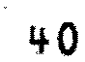

ITEM PART NO. DESCRIPTION

1 F-1569 - 16 Ft . Line Cord.
NO.REQ.

1
PRICE

$

PRONG PLUG

2 F-7867 - Triple Outlet •
5 �1CS25-5 - Master Control Station .(for Model 8800
only) • • • • • • • • • • • • • • • •
MCS25-l - Master Control St.H tion (for Model 9800

- 1511 Electrodynamic Speaker (for Model
1 .15

1 76.50

MAIN

only) . . . . . . .
. .
. . . . . . .
1 76.50

4 F-9024 - 15" Electrodynamic Speaker (for Model

F-9824
8800 only) . .

9800 only ) • • •
. . . . .
. . . .
11.00

1 16.50

STEP

5 F-6624-A - Tone Arm Ass embly
6 F-6005-A - Pickup Shorting Switch .
7 F-7529 - Shielded Input Lead and Plug.
8 SD20-7Z - Solenoid Drum Ass embly .
9 F-7415 - 4 Prong Plug .
10 11157 - Selec tion Cane el Swi tch
11 F-5205 - Motor Carryover Switch.
12 F-8827 - 6 Prong Plug.
15 F-6001 - Coin Switch •
14 12020 - 27 Prong Plug •
15 12021 - 27 Wire Cable •
16 12026 - 27 Prong Female Plug.
17 RI>-6Z - Relay Box • . . . . . .
18 SA-6Z - Electrical Selector Switch Assembly
F-1090 - Symphonola Motor (110 V. 60 Cycle ) .
20 F-7815 - Lighting Transformer.
21 F-8882 - Cylinder Motor.
22 F-7814 - Light Socket.
F-7817 - #81 Mazda Lamps •
24 F-7810 - Light Socket.
F-7816 - #87 Mazda Lamps •
26 F-8972 - Service Light Switch .
27 F-8896 - 2 Prong Polarized Plug.
28 12015 - 5 Prong Plug.
29 12001 - 5 Wire Cable.
1
1
1
1
1
1
1
1
5
1
1
1
1
1
1
1
1
28
55
7
2
1
1
2 per ft.
8. 00

.65
.15
25.00
.20
.25

.20
.10
1.00
1.50
1.00
12.50
15.00
17 .00
5.25
5.50
.10
.10
.10
.15
.25

.50
.06

® @ {

SYMPHONO LA LINE
CORD
CD

UPPER PI LASTER
LIGHTS

SPEAKER

£. PRONG PLUG

7 PRONG
PLUG

2 PRONG
8
8

PRONG PLUG

SWITCH

0
MASTER CONTROL STATION

J.t.CK

MOTOR FUSE

8 8
®T @T

®T

67�43
0

87544
0

0
SHIELDED PICKUP LEAD

5 PR.Ot-1-G PLUG

TONE ARM ®

PI CKU P @
SHORTING SWITCH

@@
®® {

I ' SELE CT OR

2
POL.t.RIZEO PLUG

@
27 PRONG PLUG

iOLENOID DRUM
®

@ @
DO ME LIGHTS

@
LIGHTING TRANSFOR MER

@ @
SIDE LIG HTS

F I G . CAB I N ET WI RI N G D I AG RA M FOR RC-8800 AN D RC -980 0

REL AY

6 P RONG PLVW

(@) SELECTION CANCEL SWIT CH

� PR

27 PRONG PLUG

@
G. PRONG PLUG
@@
LOWER PILAS T ER LIGHTS
®
CYLINDE R

@@
LOWER
PIL ASTER LIGHTS

®

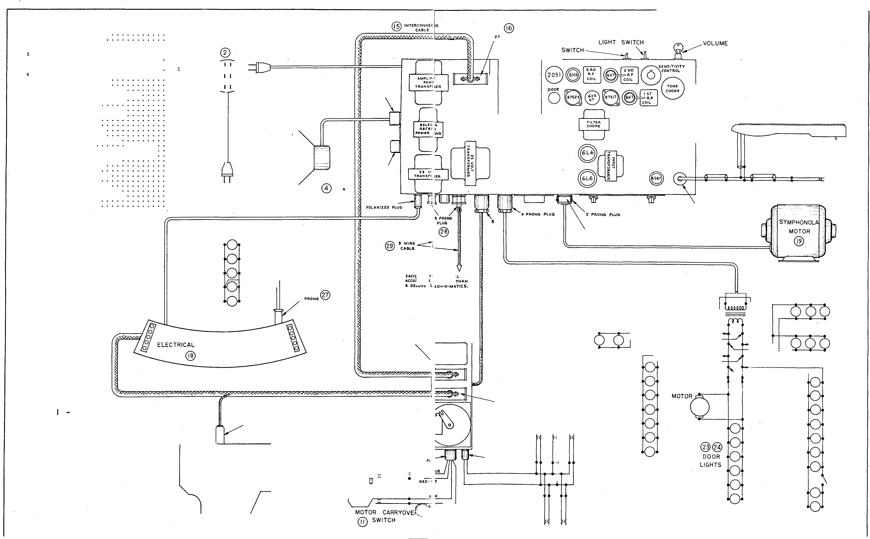BO X
@

2
ORANGE
CO IN ®
SWITC HES

3

@@
SE RV ICE LIGHTS
SERVICE LI GHT SWITCH

FI G. 2 - CA B I N E T WI RI N G D I AG RAM FOR RC -785 0

®
@ INT ERCONNECTING CA!!ILE

PRONG PLUG
@

MAIN

VOLUME CONTROL

ITEM

1
2
5
4
5
6
7
8
9
10
11
PART NO. DESCRIPTION

F-1369 - 16 Ft. Line Cord. F-7867 - Triple OUtlet •
MCS25-5 - Master Control Station. F-9024 - 15 • Dynamic Speaker •
F-6624-A - Tone Arm Assembl,Y •
F-6005-A - Pickup Shorting Switch.
F-7411 - Shielded Pickup Lead and Plug
SD20-7 Z - Solenoid Drum Assembly. F-7415 - 4 Prong Plug.
ll137 - Selection Cancel Switch
F-5203 - Motor Carryover Switch.
NO. REQ.

1
1
1
1
1
1
1
1
1
1
1
PRICE
e .8s
.15
76.50
11.00
8 .00
.15 SYM P HONOLA
.65
23.00 LINE
.:w CORD
.25
CD
. 55

I PRONG PLUG

STEP SWITCH

®

OIOOE JACK
0

87 5.4!1
8 8 0

TONE ARM ®

12 F-8827 - 6 Prong Plug.
13 F-6001-A - Coin Switch •
14 12020 - 27 Prong Plug •
15 12021 - 27 Wire Cable •
16 12026 - 27 Prong Female Plug .
17 ES-5 - Electrical Selector AS�;iernbl.y . • • •
18 F-1090 - Symphonola Motor (110 V. 60 Cycle ) .
F-7842 - 2 Prong Receptacle.
20 F-7813 - Lighting Transformer.
21 F-7814 - Light Socket.
22 F-7817 - #81 Mazda Lamp.
25 F-7810 - Light Socket.
24 F-7815 - Light Socket.
25 F-7816 - #87 Mazda Lamp .
26 12015 - � Prong Plug .
27 12001 - 5 Wire Cable.
1
5
1
1
1
1
1
1
1
21
24
5
4
4
2 per ft.
.20
.10
1.00
1.50
1.00
27.50
17 .00
.15
5.25
.10
.10
.10
.15
.15
.50
.06

7 PR.ONG PLUG

@
! WIR,E CABLE

8
PRONG
PLUG

MAST ER CONTROL STATION

®T

MOTOR FUSE

87544
®T 0

G)

, PRONG PLU,_

PICKUP ®
SHORTING SWITCH

@
ELECTRICAL SE LECTOR
2_ PR�NG RECEPTAC LE @

SOL ENOl
DRUM
@

@
LIG HTING TRANSFORMER

@
27 PQONG

® SE LECTION CANCEL SW ITCH

QD MOTOR CARRYOVER SWITCH

ORANG !- &l.UE

RED· I>LUE

!>LACK

SLACK - YELLOW

COIN ®
SWITCHES
@@
FR ONT LIGHT S

@@
BOTT OM LIG HTS

@@
FR ONT LIGH TS

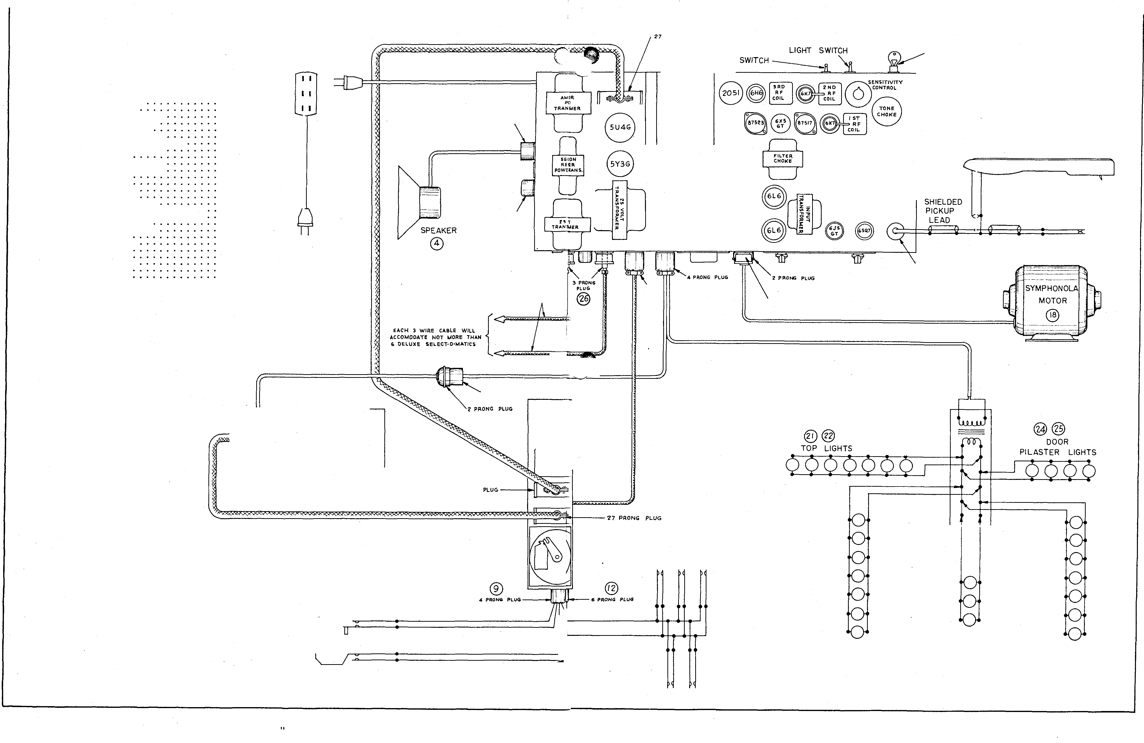

5

FI G 3 CA B I N E T WI R I N G D I AGR A M FOR TRC- 1 SPE C I A L

® '"'Tfllt.COJ•UH.CTIN,_ CA&Lt 2.7 PRON�
®
MAIN

VOLU1.1E CONTROL

@

SYMPHONOLA LINE
CORD
0

I� PART 10. DESCRIPTION

1 !'-1�9 - 16 Ft. Line Cord • • • ,
2 !'-7869 - Triple OuUot• • • , , ,
� K:S25-5 - Master Control Station •
4 !'-990� - � Speaker Field lleeiotor ,
5 F-0068 - Tone Arm ABeemblT (Old Scyle) ,
6 r-�204 - Pickup Shortiog Sw1tcb • • •
7 F-7411 - Shielded Input Lead and Plug
8 SD20-7Z - Solenoid Jlnuo, , , , , ,
9 F-741� - 4 Proog Plug • • • • , ,
10 11.137 - Selection Cancel Switch.
11 F-S20S - Motor Ca.rr.y-Over Switch.
12 12020 - Z7 Prong Plug , , , , ,
1�
12021 - 27 Wire Cable . • • • •
12026 - Z'T Prong Female Plug •
15 F-1090 - 110 V, 60 Cycle Motor.
16 12015 - � Prong Plug , , , , ,
17 12001 - S Wire Cable • • • • • .per ft.
18 14.121 - Cancel Solenoid 8.Dd Plunger.
19 12105 - Cancel Button . . . . •
20 12.100 - Cancel Button HoWling.
21 T-SZ - SoWld TransJI\l tter • • • • • •

@ SELECTION CANCEL SWITCH
PRICE
• ,85
.15
76.50
1.75
8.00
.lS
,65
2�.00
.20
.25
.�5
1.00
1.50
1.00
17.00
.ro
.06
1.40
.so
.25
17.50

MOTOR
@
[ACH S Wlft[ CA8Lf. WILL ACCOI'tOOAtE NOT r101'1t. THA.II Cio O'fLUXE SfLfCT-0-I'tATIC:lo

lifO• !ILUf

&LAG I<

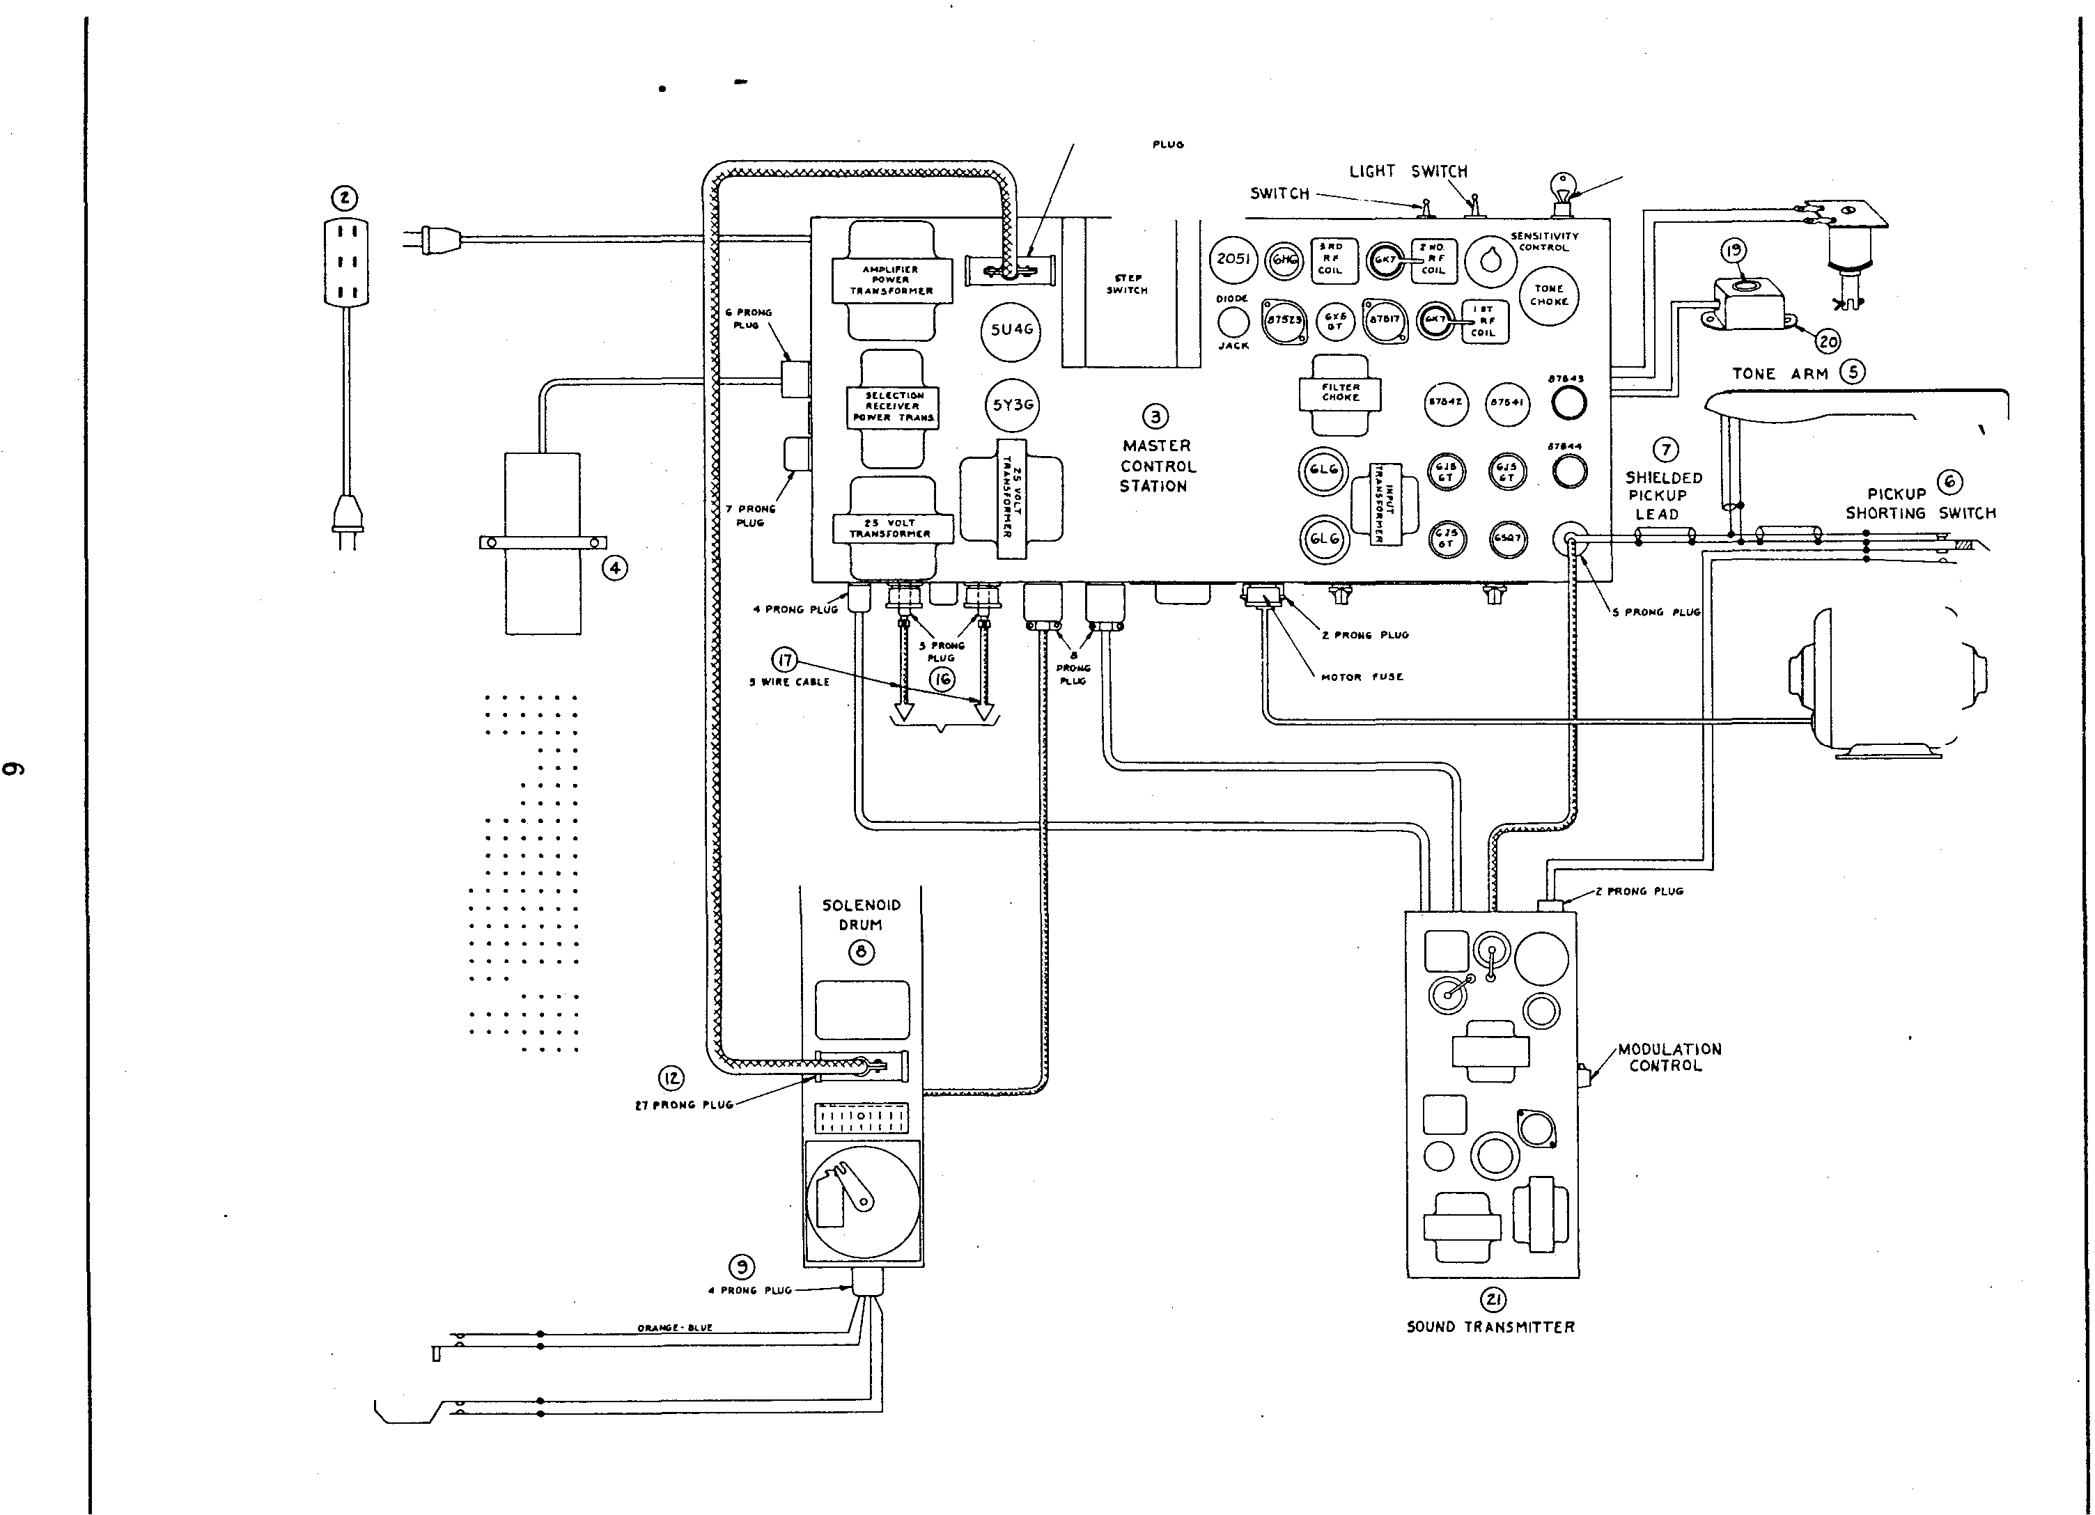@ MOTOR CARRYO VER SWITCH

ILACK· 'f[LLOW

@ INTE RCONNECTING CABLE

@
27 PRONG PLUG

MAIN

CONTROL

I I

SYMPHONOLA LINE
CORD
CD

PLUG\

, ,.,.0,...

STEP SW ITCH

0
MASTER CONTROL STATION

8 8 0
T ®T 0

ARM ®

PICKUP 0

......
SHORTING SWITCH

5 PRONG PLUG

PRONG PLUG

IACit I Willi CA.LI: •ILL ACCIO•ooa·ra IlliCIT 11011 1! TMIII
I DI.LUXI. II.LIC T-0-II&TICI

ITEM PART NO. DESCRIPTION

PRICE

@) SELECTION CANCEL SWITCH

SOLENOID DRUM
@)

Z?' '"0 111 1 IOCICIT

MOTOR

1 F-1569 - 16 Ft. Line Cord.
2 F-7867 - Triple Outlet •
3 MCS25-5 - Master Control Station.
4 F-9905 - Dumnl)' Speaker Field
Resistor. . .
5 F-6068 - Tone Arm Ass embly (Old
Style ) . . . . .
6 F-6005-A - Pickup Shorting Switch .
7 F-7411 - Shielded Input Lead and
Plug . . .
8 SD20-7 Z - Solenoid Drum • .
9 F-7413 - 4 Prong Plug. . .
10 11137 - Selection Cancel Switch
11 F-5205 - Motor Carryover Switch.
12 12020 - 27 Prong Plug •
13 12021 - 27 Wire Cable •
14 12026 - 27 Prong Female Plug .
15 F-1090 - 110 Volt 60 Cycle Motor
16 12015 - 3 Prong Plug . .
17 12001 - 3 Wire Cable. . .per ft.
18 14121 - Cancel Solenoid and
Plunger • . .
19 12105 - Cancel Button •
20 12100 - Cancel Button Housing

$ .85
.15
76 .50

1.75

8 .00
.15

.65
25.00
.20
.2 5

1.00
1.50
1.00
17 .00
.50
.06

1.40
.50
.2 5

ILAC:K- YILLOW
MOTOR CARRY OVER
F I G. �
CAB I N E T WI R I N G D I AG RA M FO R RC- 1 SPE C I A L

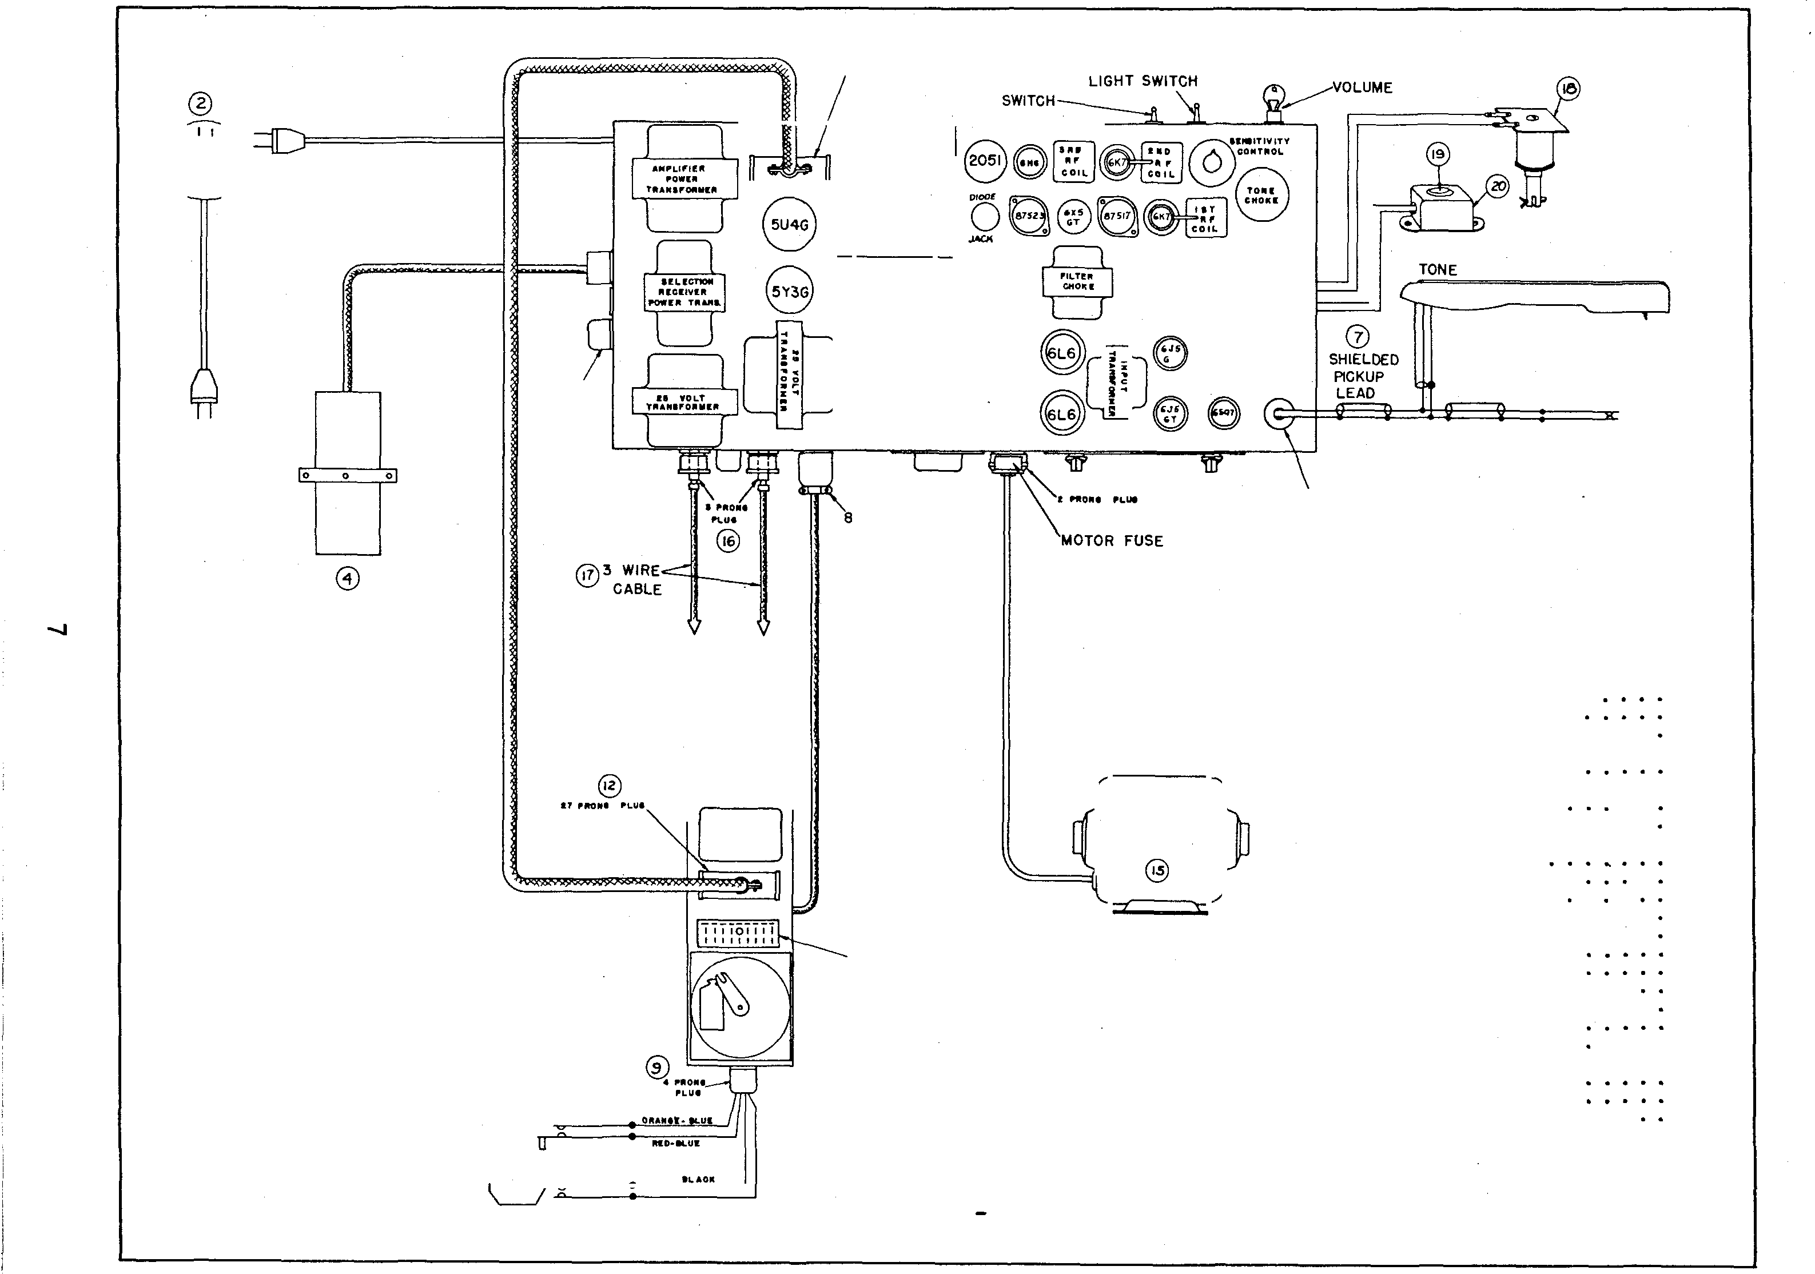@ SWITCH

F I G . 7 - ST EP SWI TC H AN D RELAY AS S E MBL Y ( # 5 0 1 2 8)

ITEM PART NO . DESCRIPTION NO. REQ . PRI CE

A-TO P VI EW

0PJ!'RAIIN6
011/

1 MO'T'ION l.IM11"'1N6 1'90./VP- I
--- --4
1 50128 - Step Switch
As s embly • • 1

.FTEPli"EUIY151NOI"'t'-"A 1"'1� CONTACl" ;:q rSCi05EC ANC ORNt'CI't:Wifl1rt:l'i_..Pt/U�· -1"'/'ii.SSI!NCJA PI:ILSAT/N6 iJ;,f'I!CTa1'PA'l'WTJ?f�-?-'T.'YEM:><.CA'IIle...,YAIYCBYY/RTWO"' Tl'i£L.� C"OPP!l'l'i' .5t. VI5.S Tl'it!'�MATVNrf!-/fHt't. C JT£ACVL. Y IN.l¥-R/1\'t!J Tl'il!!'\!'�77'7'.1!'/MA/L. Jif'J'AKr'C"a-YhV" 7"1)'�H. ­
WHEN THI!' l'i0L..CR'£L.t'IY/St'/YI!/i'G/.<'.1!'0, CO/VTflCT ·c ./S
C"L.OI5i!'O 7'r:JENeRI51ZET.!TeRI!<.EI'95i!' �U?>;I'IWO �r
"8 "/S�,Y..:CO.- T..V<5 W-?-'lf'NC�cr •c •;st:'ZOS£0n:>
i!EWEI'i'GIZE 77'TERi!'<.Efl!!rE .R£'L.t'9Y, Cl>VT>'f'CnF "];)" <f ·e:·
.-fREC"t.()Si't:} I9NO R£MI"l'I/VINT#I.S P051TIO/VR6JCO/VG1'95
TH.f'"TOL.O .PEL.I'9YISEMI!'RGIZEO BYTHE/MPVL 5E5
Cll"1'hVG TH�G-"1: · THif'.!J"O<.EIV0/05 OIV7"HE SC¥£/V0/0
OR'VM C?:IM�<f"T<f"TN£/RCI.ft:"V/Tny�,yC'O¥J'i"TCT.5"
•a ·� ·E :-

IT!f 15

I IS I TO <'!'IV.I!'R/5/Z'&' Th'tf' 6EL.tf'Cr/ON !?OL..f'N0/0.- CONn-JeT
5� 77Mif' 1/VTERY..L.,

$10 . 5 0

J
I D I

'e •OIVT"TI!' Rtf'L...I!'I'9!F.I!" R.f'L..I'9Y/5 0�¥..1!'0AN/¥Sn9¥T
<f"R 77£7 /M'A:FL. 5.:!""'*".!F&!'<!'"#Rt!'C.I!"IY..I!'OBYT/7'4'­

COII/TfiCTOR fiRM

L ___ _ _ _ _ _ _
ArT
.r,:t.t:CTO"i" JO.t.l!'-w:::>/0.-
l'vrJTEt- T-'TE1"'/�T�/NAY.f.SI!'!1 1WL.L. 4'.1!'/,Y£,&",&"£C77�
7P/WR£fn'CT 7?::> 6.f'CVR/� .S"EL...i!'CT/OIVf1'9NC ..fnW/41>
f.IPPi:flYS .OVGTO.:XT�N£<¥/S/M'-"'1:/L.!!f.l!'f 'THA TMA Y 8.1!'
.SE-TfP.I OIVT"fE-t./N.f'.-

PI"'Wt. 5PRINIS

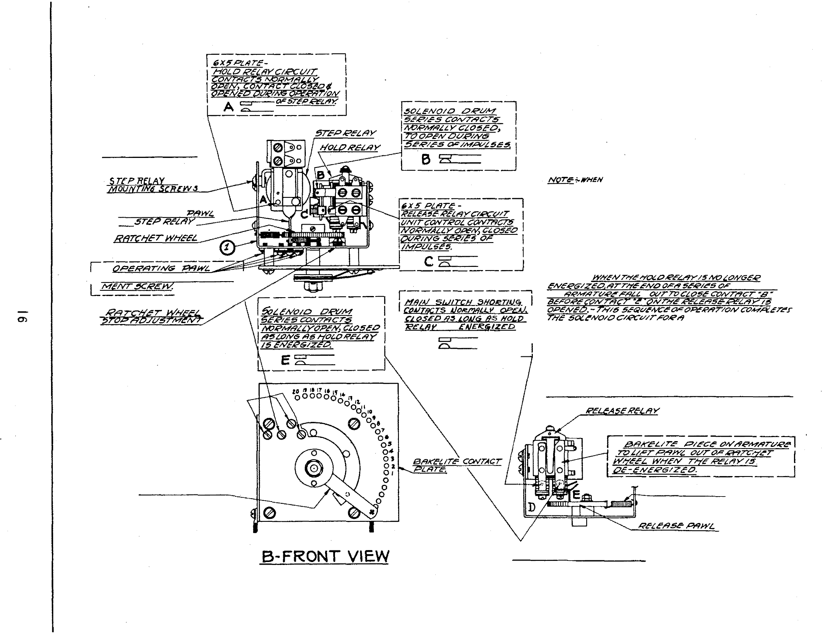

G- BOTTO M VlE.W

F I G. 8 SC H EMA TI C D I AG RAM OF TYP E WS - 2Z WALL - O �M A T I C { 5 ¢)

T'H10:. �•.I'UitANGiE.MEHT !�OTO
:'!.eLE.CT!OH!\ �£� e>A.R !S. l1�l.O DO'V'(H C'YCL.t. OF OPERA-

l!U, v£- .VHtTE

1't£P ·WHJTF
t'dNriiCTM ALH JMI'JWH
/N �DI"!CLIITNY¥ �'TNK

(;REEH

IJP£NS 8.l'F()�£ MOTai' SWITCH.
AIVO Ct.OS£S AFr££' 1"10TCR.S'iVITC/'1

ITEi�

Rl

R2
PART NO, DESCRIPTION PRICE ITZ.'1 PtcHT NO.

RESt ST ORS C2 85008
82438 - 151000 Ohms 1/2 C5 87518
Watt 10% • . . t .07
82706 591000 Ohms l Watt C4 8601:5
10% . . . . . . .10

CONDEN SERS

.os Mfd . 900 v.
DESCRIPTION PRICE ITEM PART NO.

.0005 Mfd, Mica N5 10961
Condenser. . . . . J!O M6 15045
12 M.fd . 250 v. -1/fl 15089
Izy-tic. . . • 55
.05 f'tfd . 400 v. M8 15090
Tub: Condenser .10
M9 10242
MlO 15005
M l SCELLAN EOU S M1l 15141
DESCRIPTION

- Main Switch.
- Motor Assembly
Selector Switch
Right •
Selector Switch
Left •
- Lnmps Mazda #51 .
Selector Plate
Assembly • . . Coin Relay Ass embly
PRICE

.:55
5. 00

2. 25

2.25
.08

.75
1.40

ClB
Tubular Con-

.os Mfd . 900 v.
·l

.35 M2 821261
M12 13lll
Shorting Switch.
.15

ClA
denser • . r.u 15129
Oscillator
Coil . 1.25
13ll0
Motor
Switch • • •
. 20

86059
Tubular Con-
M5 14087
R.F. Choke • .15
Coin Switch. .45

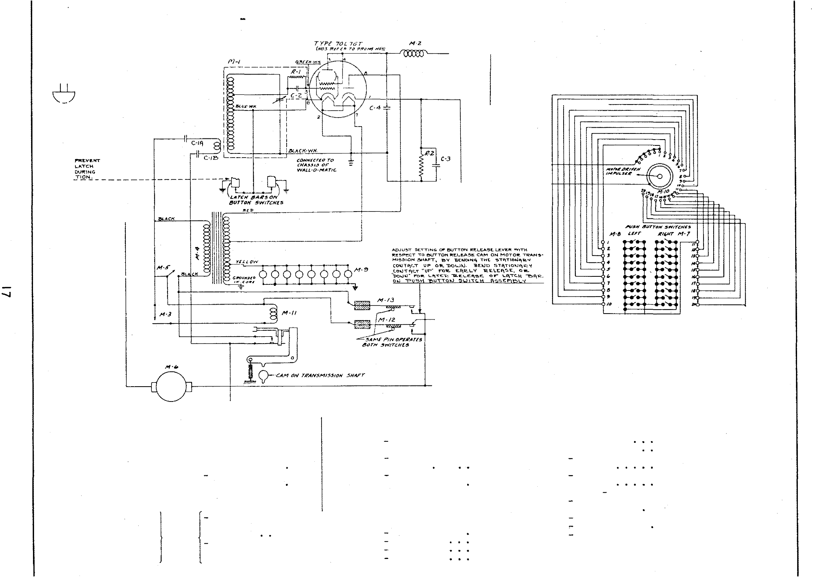denser • • • • • J I M4 15056
Transformer . 1. 35

F I G. 9 SC H E MA TI C DI AG RAM OF TYP E W S - I O Z WAL L-0 -MA T I C ( 5 ¢- 1 0 ¢- 25¢ )

M-2

LATCH BARS ON SELECTOR SWITCHES

M·20A
00 M·20B M·20C

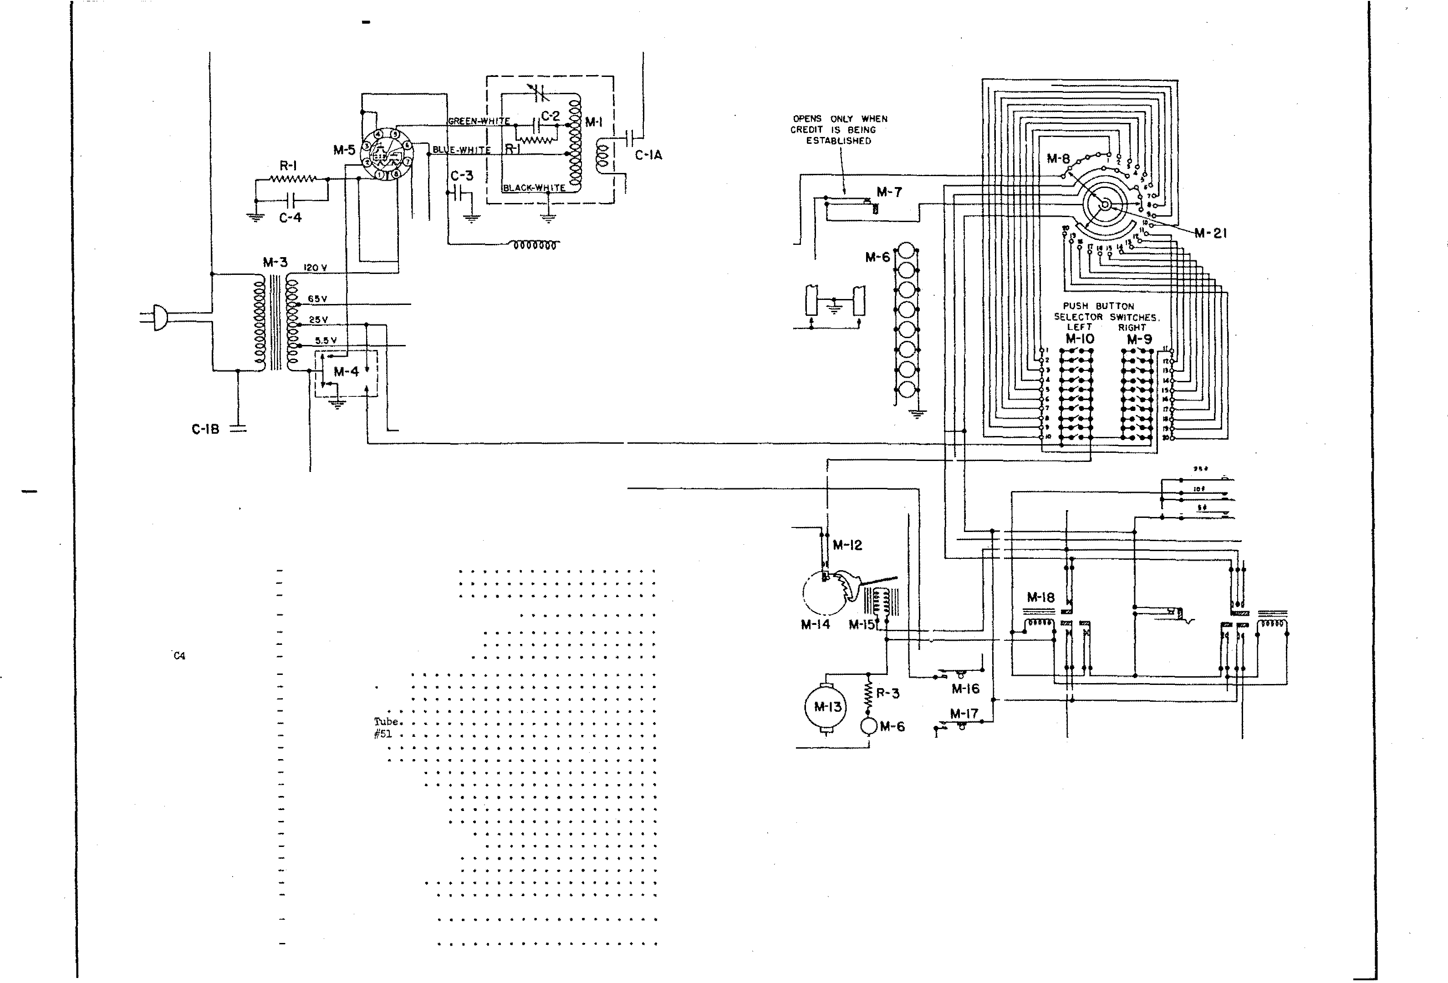
ITJ:JI PART NO.

lU 62119
R2 62700
!US 6104$ ClA
}
66059
ClB
C2 85008
C5 66015
87516
Ml 13129
M2 S--21261
M3 13526
M4 15536
!115
M6 10242
w 15566
M8 15548
M9 135011
MlO 13504
Kll 15368
Ml2 13561
Ml3 15358
Ml4 15466A Ml5 F-5851
�116 13110
Ml7 15110
MlB
}
1:1577
Ml9 13378
NrGA
MZOB 13524
M20C
M21 L\547

DESCRIPTION
15, 000 Ohm 20% 1/2 Watt •
39, 000 Ohm 10% 1 Watt • •
135 Olu':l 1(1,1; 5 Watt. . . .
Dual .OS Mfd. 900 V. Tub. Condenser
.0005 Mfd. Mica Condenser • •
.OS N!d. Tub. Condenser 400 V
12 Mfd. 250 V. ElectroJ..ytic
Oscillator Coil • R.F. Choke. . . Power Transformer Main Switch •
Type 70L7GT Lamps Mazda
ll+ Switcll • • Selector Disc Selector Switch R ..l! Selector Switch L.H
Relay n:Drop Out" Svdtch t4otor Switch Assembly •
.Motor Assembly .. .. .. .. •
Ratchet ll'heel Asse:nbl,y . • • Credit Magnet Coils (1 Pair) . Shorting Switch .. .. •
;t.1o tor Garry-Over Switch •
10¢ Coin Rala,y . • •
25¢ Coin Relay . • • • Coin Switcb. Assembly.. Contact Arm Assembly .

PRICE
$ .07
.10
.20

.20
.10
.::s
1.25

2.00
.45
1. Sl
.08
.25
.75
2. 25
2.25
.. 50
.25 s.oo
.60
1.00
.20
.20
1.90
1.ss

1.25

M·l l

OP!HS AT AIOVT 1ft CYCU

M·l9

F I G . 10
SCH E MA T I C D I AGRAM OF TYP E WB - 5 Z B A R -0-MAT I C { 5 ¢ )

....,1

ITE.� PI<RT liO.

DESCRIPTIO�

PRICE ITEM PART NO.
'601" Q'l"lt)f flj1' t.fiD ... ,.
011o1a U'll'tll.U'ttCI"* W
DESCRIPTION ""T� 'llltjr'T

Ml. 13294 -
M2 15295 -

Power Transformer. Oscllls:tor Coil Assembly

$2.00
1.25

l.U6 13538
M17 14087

- !<lain Switch Off-On.
- Coin Swite:h •

M3 13297 -
M4 13:184
�15 13296 -
Socket (15 Contact ) , Plug (13 Con teet) .
R.F. Choke • . .
.20 IUS 10242
M19
- G.E. f.w.ps #Sl.
- Latch Bar Switches ..

M6 13538 -
!lr7 J'-5851 -
M8 15466-A
N9 15361 -
Motor. . . . . . . . . . . . . . .. Credit Megnet Coils (1 Pair) Credit !\atenet \ihee1 Assembly . Meter Switch • •
s.oo
1.00
.so
.25
Rl 82706
R2 82438
- �9,000 Or.!'l Resistor l Watt • • .10
15 ,000 Ohm Resistor 1/2 Watt
(In Oscillatcr Coil Assembly) .07

Ml.O 15110 -
Switch • •
. . .
.20
Cl 85008
- Mica Conden ser -.0005 Hfd.. .20

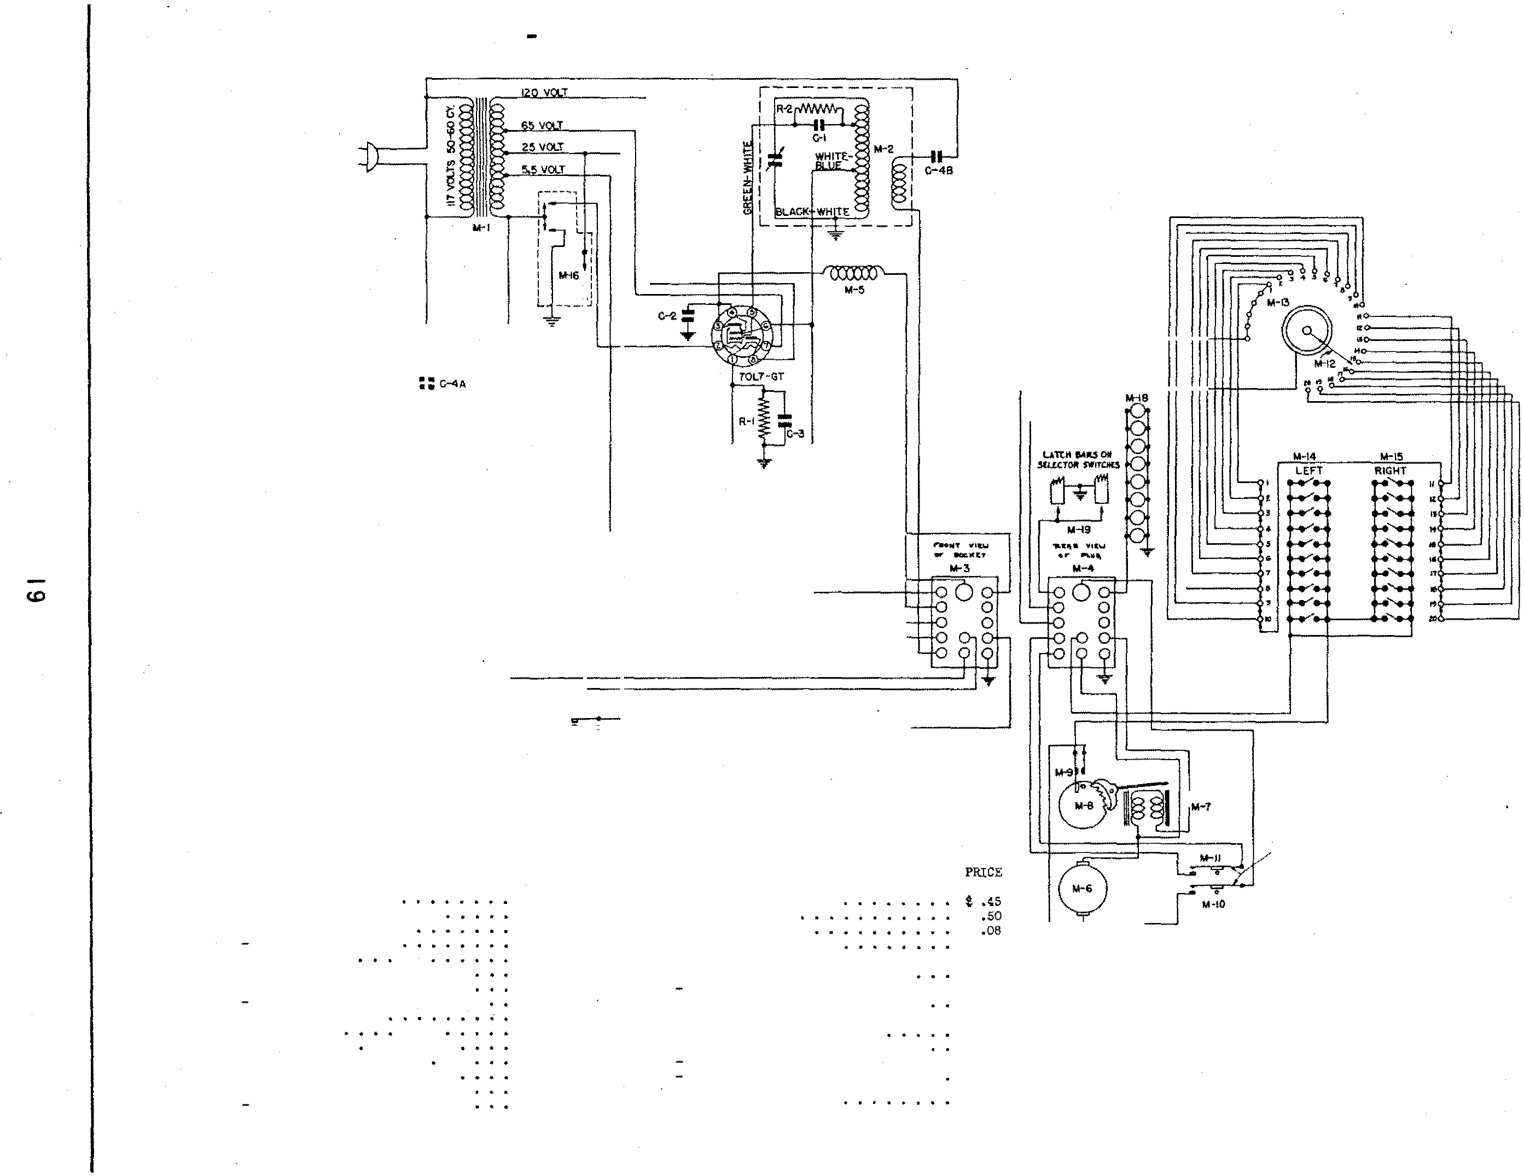Ml.l 1:1110 -
M12 13347 -
Ml.o 13005 -
1/[1.4 13531 -
M15 15350
Switch , . . . . . .. . .. Contact A.rm Assembly •
Selectcr Disc Ass embly • • Selectcr Switch Assembly L.H Selector Sliitch Assembly R.H
.20
1.00
.75
2.40
2.40

C2 8601:1
co 87518
}
C4A
86059
c4B
(In Oscillator Coil Ass embly) .20
Tubular Condenser -.05 Mfd .. 400 Volt .10
Elect. Condenser 12 l'.fd. 250 Volt .�5
- Dual .05 Condenser.
. 35

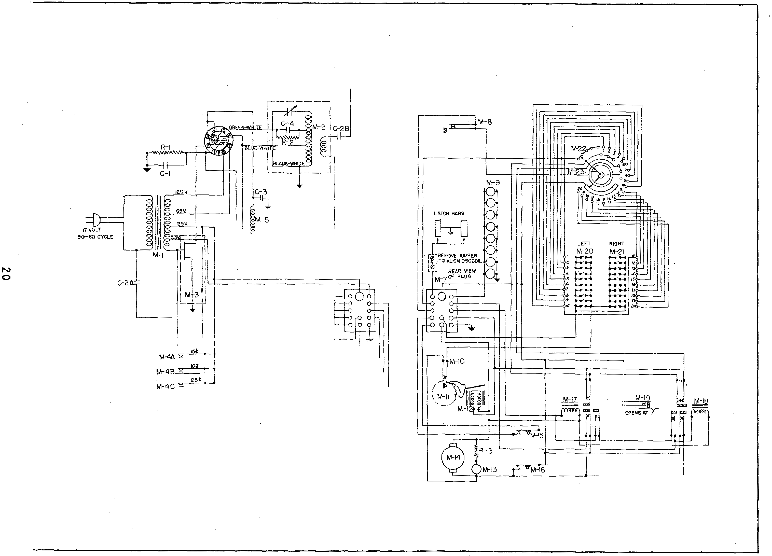

F I G . I I - SCH EMAT I C D I AG R A M OF TY P E WB - I Z B A R - 0 - M A T I C ( 5 ¢- 1 0 ¢ - 2 5¢ )

OPENS ONLY WHEN CREDIT IS BEING ESTABLISHED

FRONT Vt€W Of SOCKET
M-6

l 3
GYCLE OF MOTOR
SHAFT

F I G . I I - SCH EMATI C D I AG RAM OF TYP E WB - IZ BA R-0-MATI C { 5 ¢ - 1 0 ¢-2 5¢ )

I TEJV! PART NO . DESCRIPTION PRICE

Nl 1 5294 Power Tran sformer . • . . . . . . . $ 2. 00
1-12 15295 Os cillator Coil As se mbly . . . . . . 1 . 2 5
}
M5 15558 Switch . . . . . . • . . . . . . . . • . . . 45
M4A
M4B 13298 Coin Swi tch Ass embly . 1 . 25
M4C
13296 R.F. Choke . . . . • . . . . . . . 25
M6 13 297 Sock et (15 Contact ) . . . . . . 20
M7 13 384 Plug (1 3 Contact) . . . . . . .
M8 13366 Switch B+ Circuit . . . . . . . . . . . . . . 25
M9 10242 Lamp s G.E. #51 . . . . 08
.MlO 13 361 Motor Switch . . . . . 2 5
Mll 13355 Credi t Ratchet vJheel . . . . . . . . . eo
JI<U2 F-3851 Cred it Magnet Coils (1 Pair) . . l.OO Ml3 10242 Lamp G.E. #51 ( nwai t 11 Light) . . . . 08
Ml4 13338 �·1otor. . . . . . . . . . . . . . . . . 5 . 00
Ml5 13110 Switch . . . . . . . . . . . . . . . . . 20
Ml6 13110 Switch . . . . . . . . . 20
Ml7 13 377 Relay (10¢ Credit) . . . . . . . . . 1. 90
Ml8 13378 Relay ( 25¢ Credit ) . . . . . . . . . . . 1 . 95
Ml9 13 368 Relay Switch . . . . . . . . . . • . :::a
M20 13351 Sele ctor Switch Ass embly L.H . . . . . 2. 4 0
M21 13330 Selector Switch Ass embly R.H . . . . . 2 . 4.0
1-122 15 548 Sele ctor Di sc Assembly . . 7 5
M25 15547 Conta ct Arm Ass embly . . . . • . 1. 00

Cl 87518 12 J';'tfd . 250 v. Electrolytic Condenser . . . �5
}
C2A
C2B 86 059 Dual . 05 Hfd . 400 V. Condenser • . . . . .:3 5
C5 86015 .o 5 rJffd . 400 Volt Condenser . • . . . . . . . . . 10
C4 8 5008 Mi ca Condenser .0 05 T>'lfd . (In Osc illator Coil
Ass embly) . . . . . . . . . • . . . . . . . . . 20

Rl 82706 Re sistor 59, 000 Ohm 1 Watt • . . . . . . . . . . 10
R2 82458 Re si stor 15,000 Ohm 1/ 2 Watt ( In Osci lla tor
Coil Ass embly ) . . . . . . . . . . . 07
RB 81045 Re sistor 155 Ohm Wire Wound . . . . . . . . . . . 20

2 1

F I G . 1 2
SCH E MA T I C DI AG RAM OF TY PE SR- � SELE C TI ON RE CEI VE R

ITDI PART NO.

Rl 82426 -
-
R2 82426
R1l 82450 -
-
82468
R5 11�15
-
R6 11�92 -
R7 108��
R6 82108
DESCRIPTION
1500 Ohm 1/2 Watt ;t 10%.
1500 Ohm 1/2 Watt ± lCJ%.
150,000 Ohm 1/2 Watt ± 10% •
4.7 f!eg. Ohm 1/2 Watt ;t 10% .
40,(X)Q Ohm Variable Sensitivity
Control. . . . . . . . . .
.
Candohm 790-132-132 Ohms .± 10%
Candohm 5200-4000 Ohms + 10%
220 Ohm 1/2 Watt ± 20% \wire
PRICE
$ .07

.07

.75
.25

C-IA

R9 82442 -
/ % .07

ClA }
ClB 86061 {:
86008 -
C2 - 86008 -
C4 86013 -
86009 -
C6 8601� -
-
C7 86008 -
C8 8600�
Wound) . . . . . . . . .
33,000 Ohm 1 2 Watt .±. 10 .
.OS Mfd . 600 Volt Tub . Condenser
)
.OS Mfd . 600 Volt Tub. Condenser :
.1 Mfd . 200 Volt 'fub. Condenser.
.1 Mfd. 200 Volt 'fub. Condenser.
.05 Mfd . 400 Volt Tub. Condenser
.05 M.fd. 200 Volt Tub. Condenser
.OS M.fd. 400 Volt 'fub. Condenser
.1 M.fd. 200 Volt Tub . Condenser.
.1 M.fd. 400 Volt Tub . Condenser.
.07

.25
.10
.10
.10
.10
.10
.10
.10
, ------- �� ------�

N C9 87521 -
10 Mfd.
50 Volt Electrolytic

N
-
ClO 86015 -
Condenser.
.01 M.fd. 600 Volt 'fub. Condenser

.10

Cll 11076
S.C Mfd .
�00
Volt Paper Condenser.
1. 25

Cl2A}
87517 r
Cl2B
Cl5 8752� -
20.0 Mfd . 450 Volt :Electrolytic
Condenser.
:}
20.0 Mfd. 450 Volt Electrolytic
.
Condenser. . . .
Hfd. 450 Volt EJ.ec trolytic
15.0

.65

CH 86062 -
Condenser.
Mfd . 400 Volt Tubular Condenser
.45

Cl5 87529 -
.5
10.0
Hfd.
300
Volt Non-polarized
.25

Ml W202 -
1�2 W20� - M5 30204
-
-
M4 1084� M5 lll88
146 12224- -
M7 50142 - M8 12022 -
-
M9 10840
MlO 12185 -
M1l 11401 -
--
Ml2 F-1�69 -
Mlo 10841
-
M14 10841
MlS 11474
Condenser.
1st R.F. ( Input) Transformer •
2nd R.F. ( Interstate) Transformer.
�rd R.F. (Diode) Tro.nsformer
R.F. Choke .
Jack . � . . . � . . .
1/2 Amp. Solenoid Fuse
Stepswitch Assembly .
27 Prong P.1ale Socket
Filter Choke •
Power Transformer.
2 Prong Receptacle
Line Cord. R.F. Choke • R.F. Choke . Line Cord.
.40

.75
.85
.75
.25
.<5
.15
10.50
1.00
.EO
2.75
.20

.55
.<5
.15

,...

Ml6 12004 -
9 Prong
Plug
.25

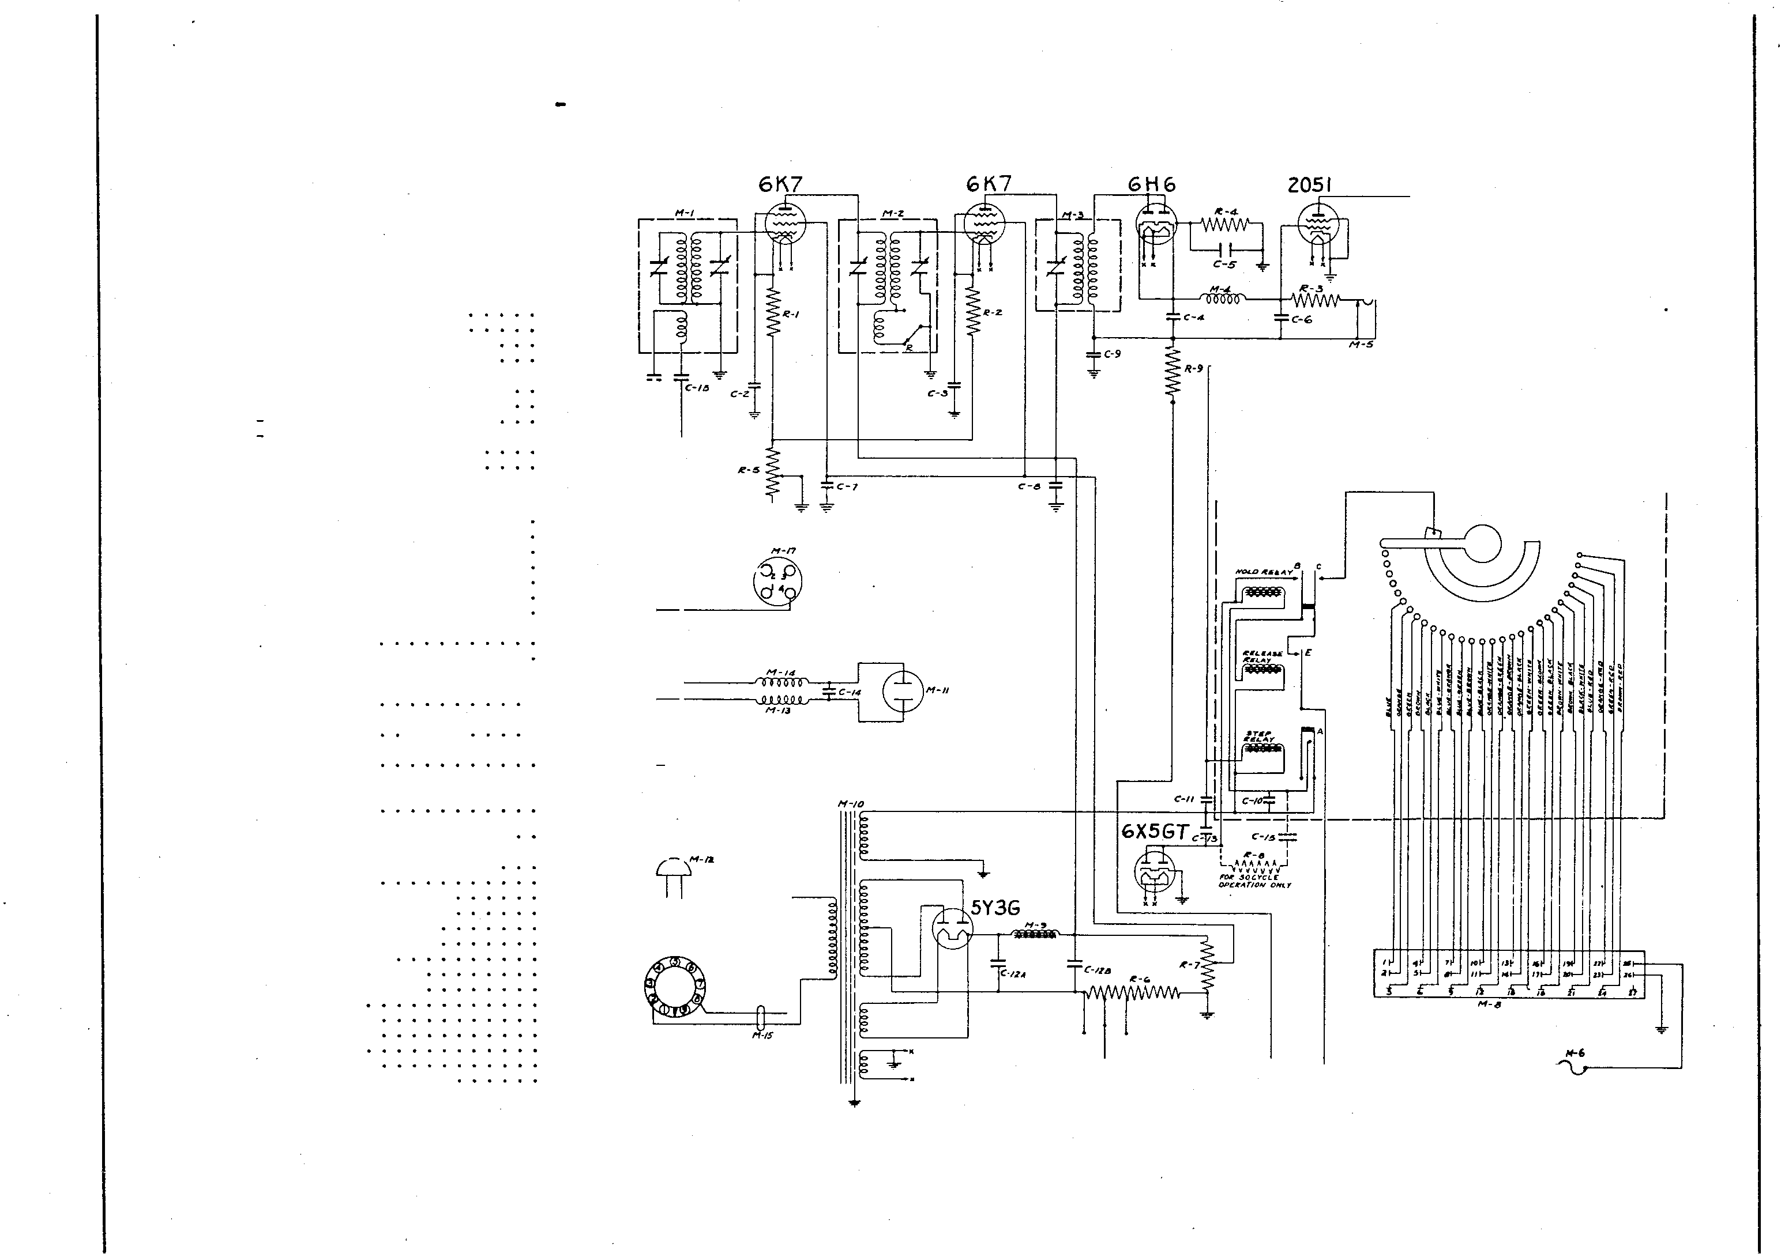f117 12m2 -
Small 4 Contact Socket
.15

F I G .
1 3 B L O C K
W I R I N G
D I AG R A M 0 F
TYP E S R - 4 SE L EC T I O N
R E C E I V E R

I N MOD E L S
78 00 , 7 8 5 0 ,
88 00 , AN D 98 00

0

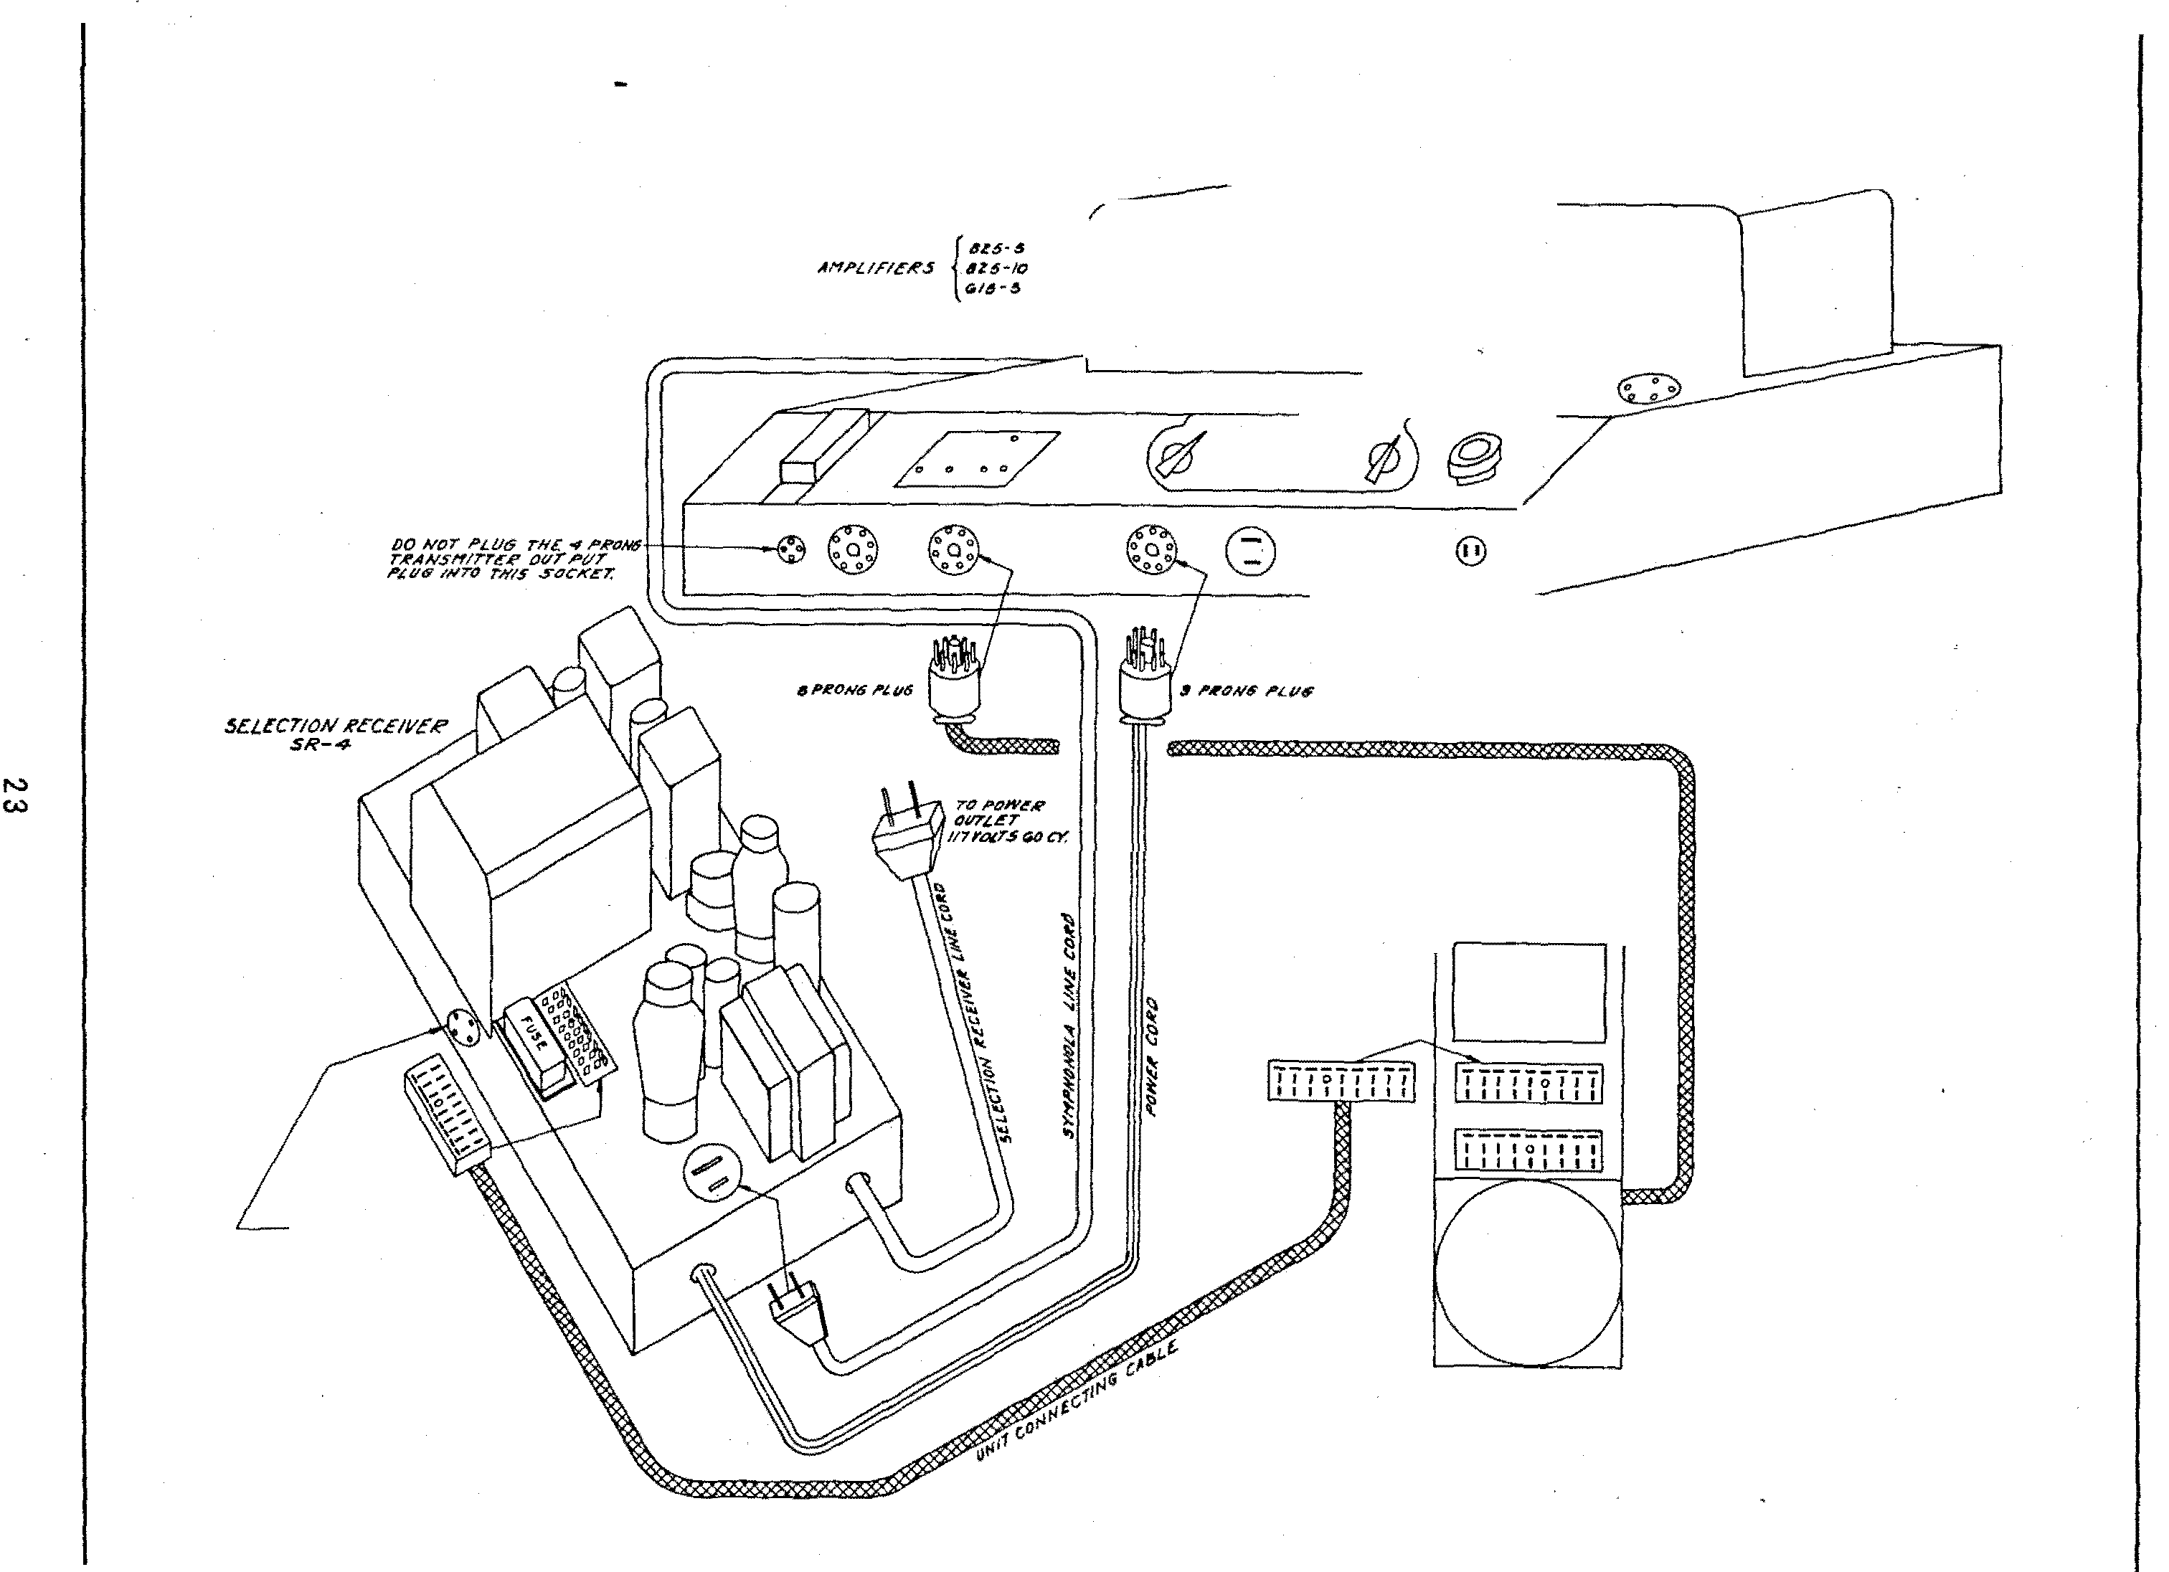

WH�N A 1'RAJVS/"111'T'l'R T·3l.
1.1 VSI!O T'HE of- /".('{)H$ /'L Va tiN T'#i! OUTPVT CORO Cl' THI! T'lt'A#SNIT"ri!R /"lUSTIJE !NSI!QI!O
/IV TN/.S _, CONr.Acr SOC,II('4"7:
I>{) NOT l't.V.S T'HI! "rAANSI'fl "rTI!A'
ovri"VT Cot('o tNTt1 T>YI! ,iH/'<.ti'I�J! IVHI!N US�P Wi n.'4 SI!£1!CTN7N IUCI!IVI!A 411!•-1-,
$DU!NDIO 0/t'V/1 $0ZD-7Z.

F l G . P t - SCH EMA T I C D l AG RAM OF TYP E D S 20- I Z
D E L U X E S E L ECT- 0 - M A T t C ( 5 ¢ )

LATCH BARS
ON BUT TON SWITCH£ /!!
CON TAC TOR ARM SHOWN
IN NON·OPERATING POSITION

M·l
BUTTON

i>JN

M·Z.

ON TRANSMISSION SHAf'T

IT EJV1 PART NO . DESCRIP'riON NO.
PRICE

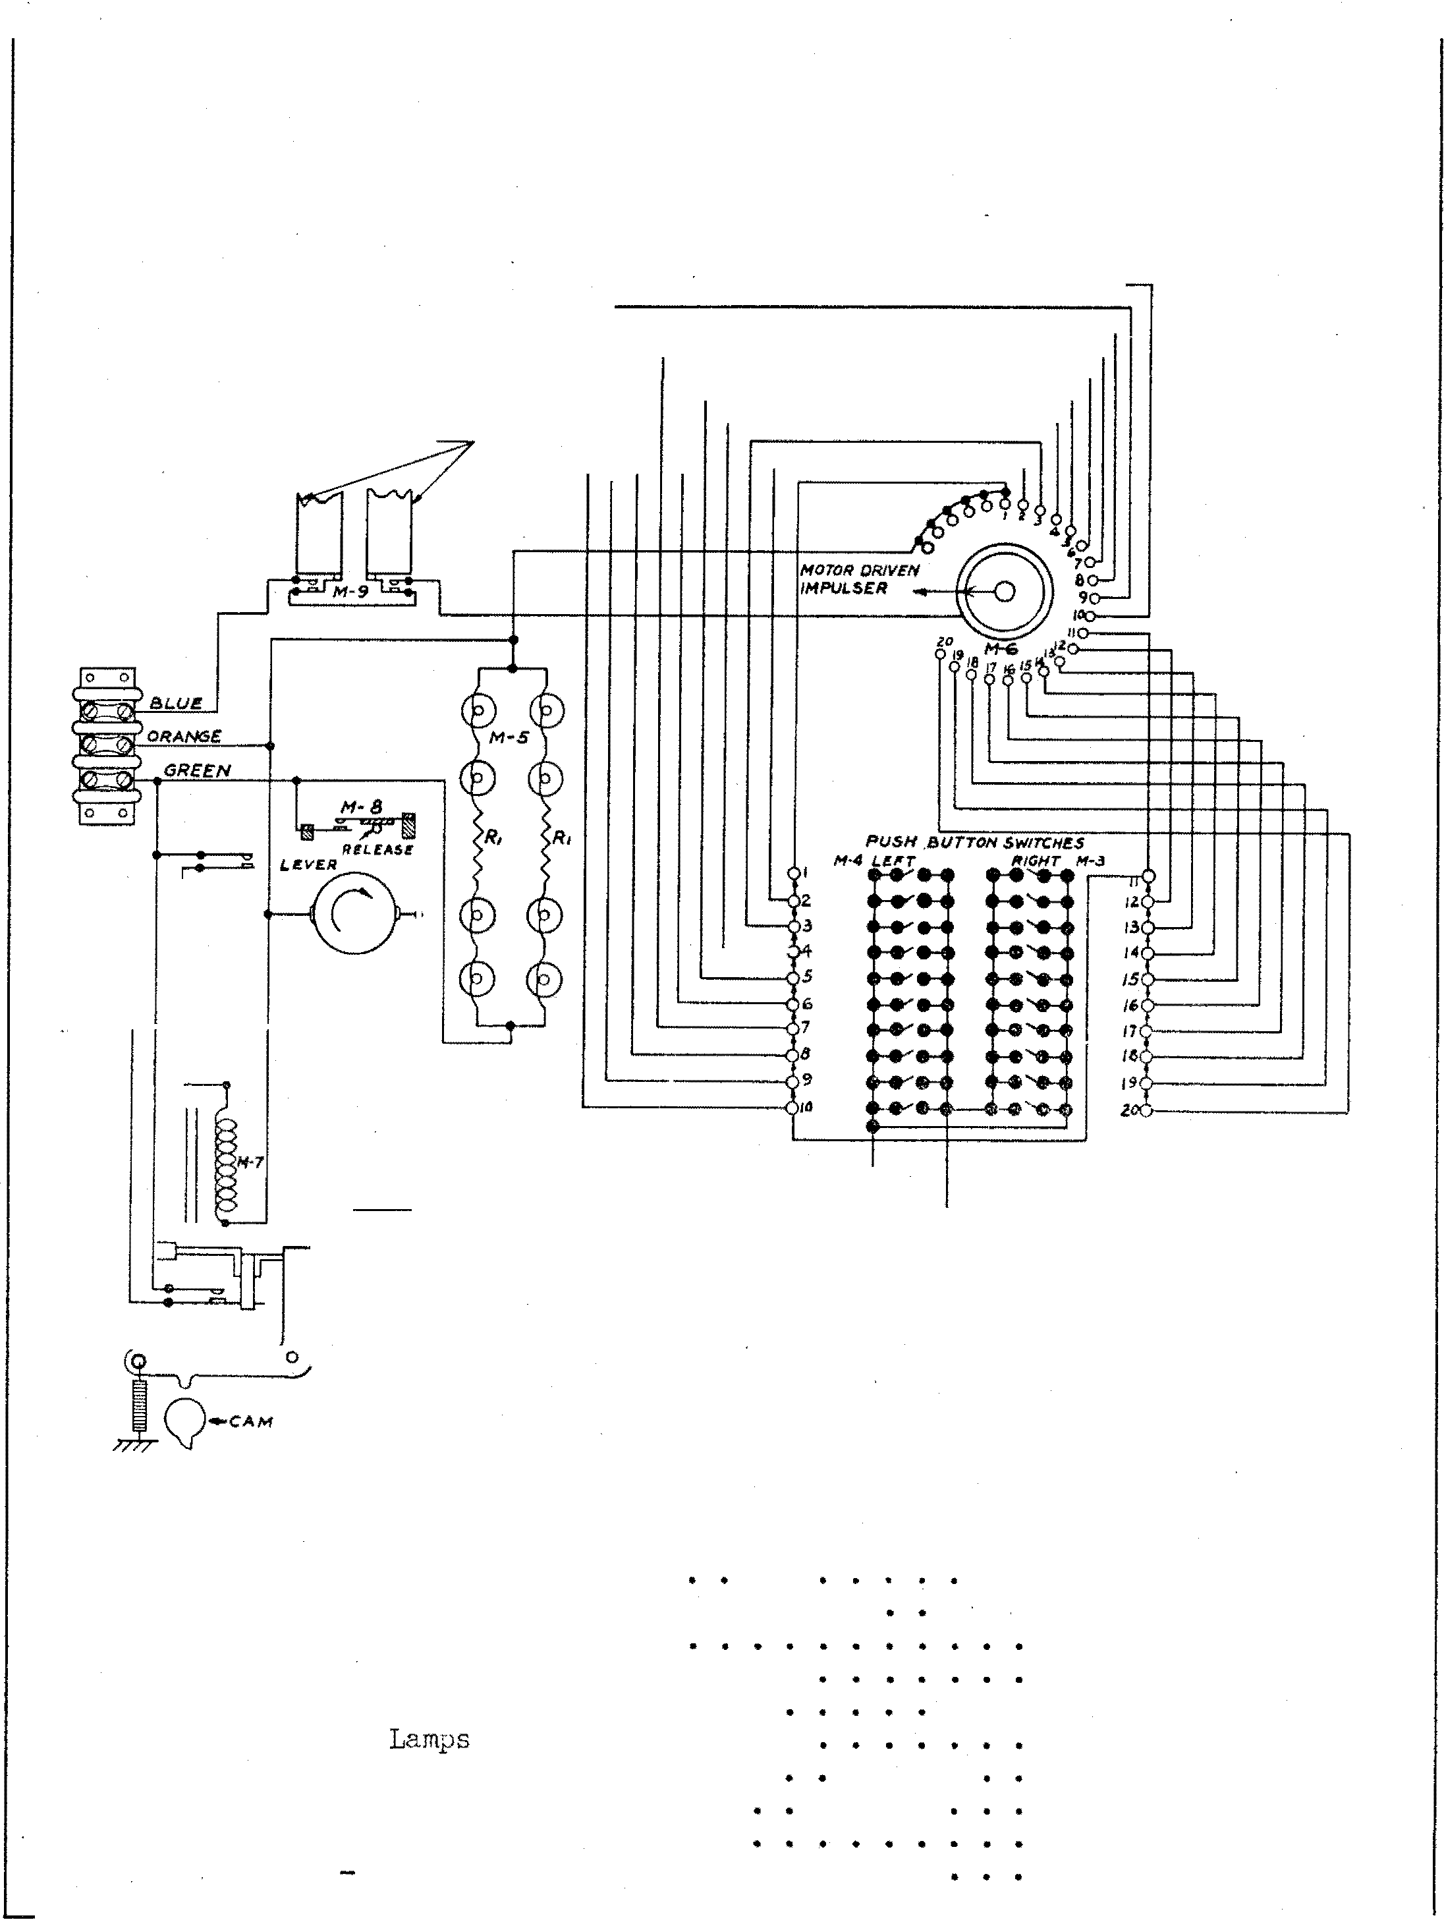
Rl 82718 - 22 Ohm 20% 1 Wa tt • . . • 1 $ .15
I'll 15040 - Coin Switch . . . • • . . . . . . • 1 .45
fll2 14108 - �1o tor As s embly . . 1 5. 00
N3 14109 - Selector Switch (R. H.) . . 1 2. 25 f·14 14110 - Selector Switch (L.H. ) . . . . 1 2 . 25 r-15 10242 - #51 Mazda . . . . . 8 . 08 i'l6 13848 - Selector Di sc Ass embly . . . . . 1
.75
H7 14103 - Coin Relay As sembly . . . . . 1 1 . 25
NS 13110 - Jli[otor Switch . . . . . 1 . 20
JVl9 11 0pen 11 Switch (on M-3 a:nd M-4) . .

F I G . I 5 SCH EM A T I C D I AG R A M O F TY P E D S 20- I O Z D E LU X E S E L ECT-0-M A T I C ( 5 ¢ - 1 0¢- 25¢ )

OPENS ONLY WHEN CRE DIT IS BEING
M-3
M-7

w
"' z w z UJ
;;;> <I w
_ , a : a::
M-1
LATCH BARS

M-6

PUS� BUTTON
SELECTOR SWITCH
M-9 M-tO

L E F T RI G H T

SWITCHES CLOSED ON LY WHEN LATCH BA R IS
II
RELE ASED 13
SWI TC HE S ARE PA RT OF 14
PUS� BUTT O N SE LE CTOR R-1
S W I TCH AS S E MBL I E S
16

M2A-5(J';

M28-10¢ M2C·25�

COIN SWITCHES

CREDITS ARE ON
WHEEL

M-I l
OPENS AT
y3CYCLE

Kl.P2A } Hlo5

ermi.nal Strip.. • . . . . . . . . . . � .. . .
RATCH£

M-18

1\26
>!ZC
15524
�oL"l Switch • • ,. . . . . . . . . � . . . . .

1.25
M-15
M-18

M3
>14
MS
M6
15566 - swi tcb J3.l. Ci:rcuit. • • • • .. • • • • • • • • •
- Switch (on Sii!lector Sd teh Assembl;Y' } . • ,. � •
s'witeh (on Selector Sltit.ch Assembly) . . . . . .
10240 [kllliJS C.E:. #51� • • • • • • • • • � • • • • 0
.25

.OS

M9 �4141 - ''
>112

1<!7
l34�7 - selector Disc A.ss embl;r� • • � ,. • • • � • • •
-
,75

�jj
l414a - rGOnt.act
Arm Assembly. . . .. . .. . • • • • • •
1.00

�lector Swit.ch Atu>embly L.!:l. ,. • • • • • • •
2.40

Kl.O
Hl42
Sdec tor Swi l;.ch Assembly R.H. � •
� • • • • •
2 .40
M-17

>Ill
15368
Relay Switch� . . . . . . . . . . ... ... . . . . . .
- \,
·""

IUS
15561 "" tor Switch • • • • • • • 4 • • • • • • � • •
10242 Lamp G.E. #Sl ("We.it" Light) . . . . . . . . � • •
-
.06
.60
CA!i!RY-OVER
SWITCH

Kl.4
>US Kl8
15555
F-5651
1:33!8
�redlt Ratc.b(;t Wheel. � . . . � • • ,. • • • • •
- Cudit Magnet. Coils {1 Fair) • • • • • • • • •
�tor • • • • • • • • • • � • • • .. " " • • ..
1.00

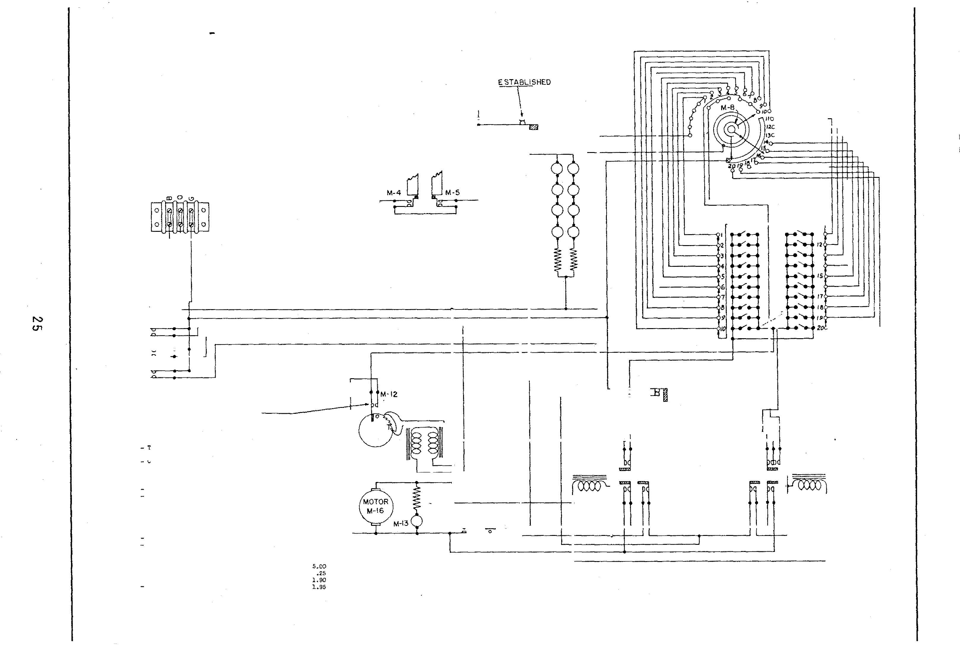Kl7
Kl8
Kl9
Rl. R2
Rll
1�110 - S•itcn . . . . . . . . . . . . . . . . . . . . .
15577 - RelAy (10; Credits) • • , • • • • , • • , • ,
1�378 Relay (25¢ Ctedits ) • • • • • • • • • • • • •
62718 - Res:istor ::!2 OhJ!I l Watt• . . . . . . . . . . . . .
82718 - Resistor 22 ()h}1t 1 Watt. . . . . . . . . . . . .
81045 - Resistor 1;')5 Ohm Wire Wound • • • • • • • • •

,07

OPENS ONLY WHEN CREOIT IS BE ING

F I G . 1 6

TYP E D S B- I Z
S C H E MA T I C D I AG R A M O F
B A R -0 -MA T I C { 5 ¢ - 1 0 ¢ - 2 5 ¢ )

LATC H BARS ON SELECTOR
SWITCHES
0 0

M -7

M-8

M·IB

FRONT VIEW M-1 OF SOCKET
M-3

0
0 0
0 0
REAR OF P

M -4
0
0
0 0
0 0

R-1 R-2

M-20 M-21
LEFT

M-9

M-15

IT11< PART NO. Ml'A }

M-2 M·2B M -2 C
5< 10¢ 25�

COIN SWITCHES

PIUCE
M -I l

M-1 0

�C YCLE

M·l6 M-17

.0.

M2B
M3C

M4
M5

M6
H'l
M8
�9
KlO Jill Kl2
MU Ml4
MlS Ml£
10.8

>20
M21
14235 - Ter11\1n,.'1.1 Strip ASSI!liTibly� �

13298 - Coin Sw itch Astembly •

13297 - Socket (13 Contact) • •
13384 - Plug (13 Contact) • • • • • �
- Switch (on Sehctor Switch Assembly ) •
;;.
S\'litch (o:a Selector Switch Assembly) •
13366 S•i tch ( ) . • • • • • • • • •
10242 LB.mJ>s (G.E. #51) • • • • • • •
13:361 - Motor Switch • • , • • • • • • • • • • F- �1.151 - Credit Kagnet Co Us (1 Pair) • • • • • lM66 Credi t. Ratchet "beel • • • • • • • • •
13338 MotQr . • • • • • . * • • • • • • • • • • • •
10242 - Lal"-P G.E. #51 (""'dt11 Light) • • • • _. •
15110 - Carz.y-Over S"itch . • • • • • • • �
15368 - Belay Switcb • ,. • • • •
13377 Relay 10¢ Credit • � • •
1��78 iiele.y 25¢ Credit • • • •
13348 - .Selector Oiec Assel'lbly •
13347 - Contact Arm l'ISS e:"'.bly • •
13��1 - Selec tor S"iteh As.sernbly L.H •
���(';() .., Selec tor Switch Assenbly R.li • • � . . .
r
$ .25

1.25

.20
.lS

.25
.oo
1.00

.20
.so LOO l.95
.75
LOO
2.<0
2.40
R 3
2

M-13

M-14

R SWITCH
RE LAY RE LAY

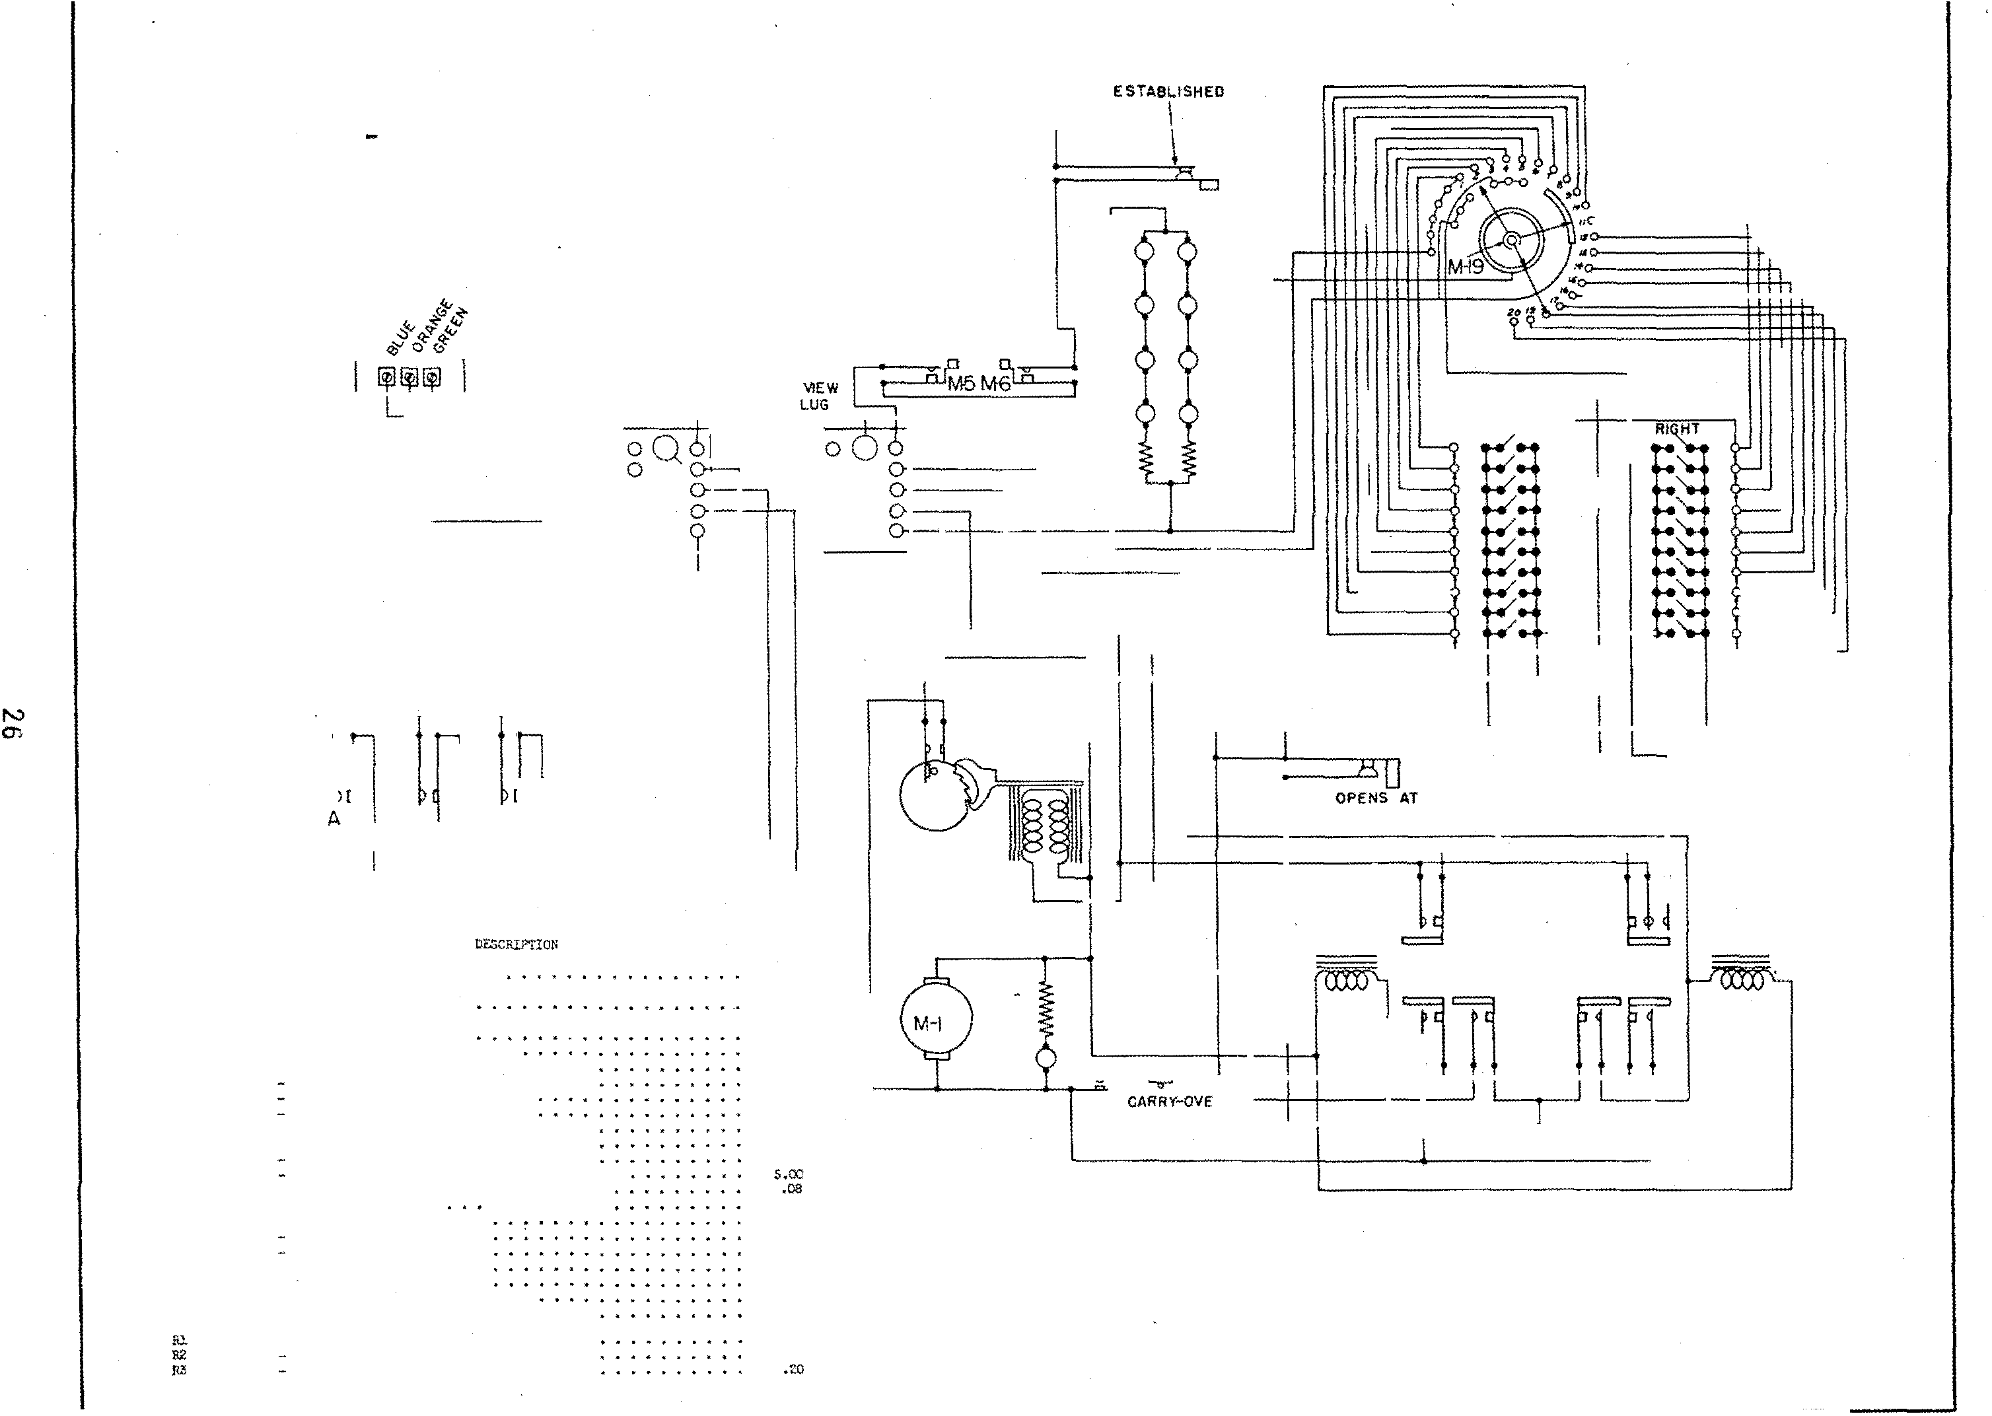82118
62718
81043
- Resistor 22. Oh\'1'5 1 .,·a tt • • � • • • • • Rssia.tor 22 Ohms 1 '•intt • • � .. . . • • Re::�i:stA!r US Ohms 5 Watt irli e Wound• •
.07
.07

F I G . 1 7 - S C H E M A T I C D I A G R A M OF TYPE S S 2 0 - I ST EP SE L E CT O R

R- 3

r - - - - - - -
1 HOL D RELAY

STEP RELAY

--, I
I I
I
I
I

-

� M[ij· 1 0
r-- - - - -- -- - - -,
1
� I 3 I
I I
I I I I
M- Il
:
- : TO NOT MORE THAN 6
:
1 DELUXE SELEC T- 0- 1
L -M��C� _ _ _ _ _ J

ITEM PART NO.
DESCRIPTION

PAPER COMDEMSERS
PRICE ITEM PART NO. DESCRIPTION PRICE
R4A } 12007 {- 500 Ohms Wire Wound 10%

C1 86015 - ,05 Mfd, 400 Volts , •

$ .10

R4 B
• •
- 4750 Ohms Wire Wound 10% •
:} $ . 45

C2 11076 - 5 ��d. 300 Volts • , • • • •
C3 86015 - .01 Mfd. 600 Volts • • • • •
1. 25 Ml SCELLAHEOUS
.10

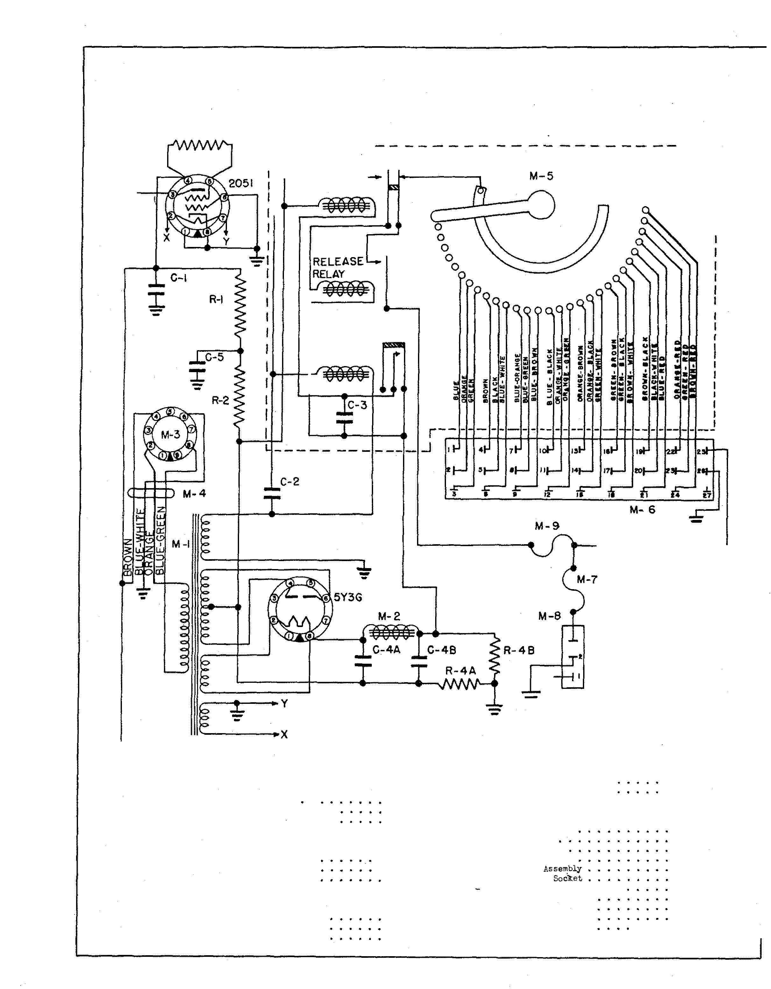
ElECTROL YTIC COHD£HSERS
} {-

G4A 20 ��d . 450 Volts Dry, , C4B 87Sl7 - 20 Mfd , 450 Volts Dry . , C5 87521 - 10 l·�d . 50 Volts Dry • •

RESI STO RS
Rl 82442 - 33,000 Ohms 1/2 Wa tt 10% ,
R2 82442 - 55,000 Ohms 1/2 Watt 10% •
R5 82454 - 330,000 Ohms 1/2 Watt 10%.
�11
M2 t-13
M4
:} ,2 5 )'16
M7
M8
M9

• 07 MlO
.07 Mll
.07

27
12002 - Power Tran sformer.
10840 - Filter Choke •
12004 - 9 Prong Plug • ,
12005 - Power Cable. • • •
50142 - Step Switch
12022 - 27 Prong �lale
14175 2. 5 Amp. Non-tamperable Fuse
12006 - 5 Prong Socket , • • •
12224 - 1/2 Amp . Solenoid Fuse
12015 - 5 Prong Plug • • • • •
12001 - 5 �ire Cable • • • • •
2. 25
. Eo
.25
. -�5 lO.EO
1. 00
.25
.15
.15
.30
.per ft. ,06

F I G . 1 8 ST EP SW I T CH AN D R E L AY ASSE MBL Y ( # 50 1 �2)

ITEH PART NO . DESCRIPTION NO . REQ. PRICE

A-TO P VI EW
1 50142 - Step Switch
Ass embly . 1

NOT!i" f!.!f'HEIV .fTEPR£t,<?Y15/IVOPEirA'r!ON_, CONTAC'T � /SCi05Et:J
ANO OPENEPR:>"?&I"'CH/HPVt>&'. - THISSENO.fA Prlt.A.S TIN/5
Wli'ECTC"VRRt"NrT?iRWGHTJ'fE1"/0Lt:JR.<!.:/IY4N08Y WRTVEO!'=
TH£i:.AH'f!N!f C"OPPI/'R 5/:.VGS THEARMAT(/i!f'/.f' HEt. O J'rEAO/t. Y
INav'RINCI /HeA!'RA:>O THeIMP</t. .J'EJ'ARI/' C&I¥1/VG T"t'ROVGI'f.­
WHEN THI:' Hot. OR.<!LI"'Y/SEIVERGIZI:'P; CO-'V/fiCT "C ?!i
Clf.05E.0 71:Uf'NER61ZE 7"ijERJ!t.Et95C' �L19Y;n>Y.O �T "8 '/5�N&'D.- T"7V5_, W"fi/'NCO>'V7i"TCT "C 'IS CLOSC'O 7'1:>
eNERGIZe 7"-'TcR&-LcR5E RelfiY, CO¥TRC� "£: '
t'fRJ!!Ci.OSJ!O! RNCJRJ!Mfl/,Y/NTHI$ P051TIONt95LON5t9S
7"'!E "'OLCJ Rlf!LRV /5 £1VJ!R51Zif!.O 8YT-'TEIMPVL ScS
C0'1'1N6 THROVG-7'. · THE .!Ot.E/VOI05 OIVT":f'E .50.::EN'010

$10 .5 0

1 MOTION t.IMIT/Iv'tf? t'90./V6T- I
ORVM
C/7M.PLt!'T&'/-':f'EIR C/.fl;"t/1/ /-7'Rt7VGij
C'OIVTr>'C73"

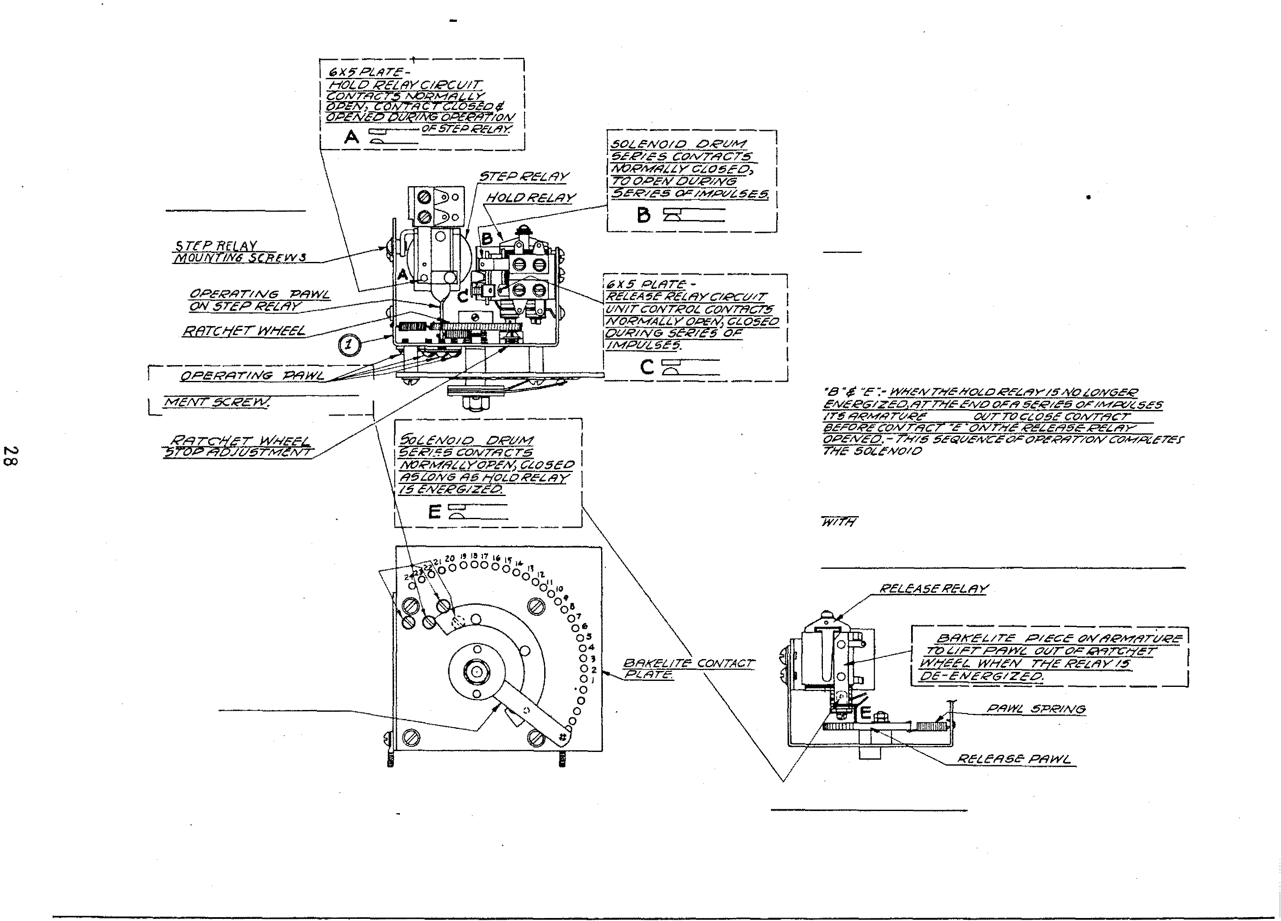
-- --------

CONTr'iCTOR fiRM

B- FRONT VI E.W

��"�-t.L5 ·a ·
15
CIRCVIT�ORr>' S,I;IO,f"'T 77A?'E1/VJ&RJ//ft:.
70 t!'NeR<71ZE /HC: 5t!'t.ECTIO'N !X?Ltf!VOIO.- co,-vrr»CT
"E "ONTHc RELE/fS.E REt:./fV/.5 OPeiVEO AIV/..YSTRNT
AI'7ER /HE /MPVI. !iE r,'t9S &:t!'IYR!:Ctf/1/cO BV T"7E
.Y&U'CTOii? JOt.E4'0/0, -
/VO/t!'.;. T,.t!'., �/-f¥TP/H!"/MA:L:I :fcS IY/L.f. <!I&'/M:r�C.T7Ye
,p,yp,:cT /0 9t!'CVR/..YG feLt!'CT.fOfV.Jt9NI:> .JTORING
VPPt.l'iY.5 OV!l 7l?E¥' TR19NEOV.5/MPVt.!!!C'.f' THA TMA Y 8C"
5.:'-/VPO.NT-"'C'L/N.f'.-

G- BOTTO M VIE.W

F I G . 1 9 - S C H E MA TI C D I AG R AM OF TYP E P S 6 - I Z POWER SU P P L Y

r-- - -
1
-- ---- - - 1

!
I
l
I

r 50 ·(;D
I CYCLE!i

YELLOW
M· 6 I
I
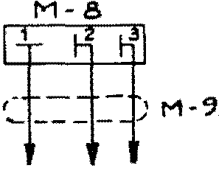.I

I

I
I
1

L _ ---

&LAC K· REI) GRUN

M·.5
I
I
I
I
I
I
I
l
I
J
_ _ __ _ _ _!

TO NOT MORE THAN
6 DELUXE SElEC.T-0-MATICS

ITEM
PART NO .
DESCRIPTION
NO . REQ . PRI CE

l 12004
•
9 Prong Plug
• . . . • . • . . . • . •
1 $ . 25

2 12005
5 | 84244 | Socket for Power to Step | Selector . | . | . • | • . | 1 | . 10
4 | 11213 | Power Trans former . • • . | . . . . • | . |  |  | 1 | 2. 75

.
Power Cable .
• . . •

• . .
. . •
1 . 55

5 81006
6 1417 3
1000 Ohm 5 Watts 10% Wire Wound Re si st or 1
2.5 Amp . Non-tamperable Fus e . . . . . . . • 1

7 12006
Socket for 6 DeLuxe Selec t-0-Matic s . •
• • .
1 . 15

8 12015
•
Plug for 5 Wire Cable . .
• • . . . . • .
1 . 30

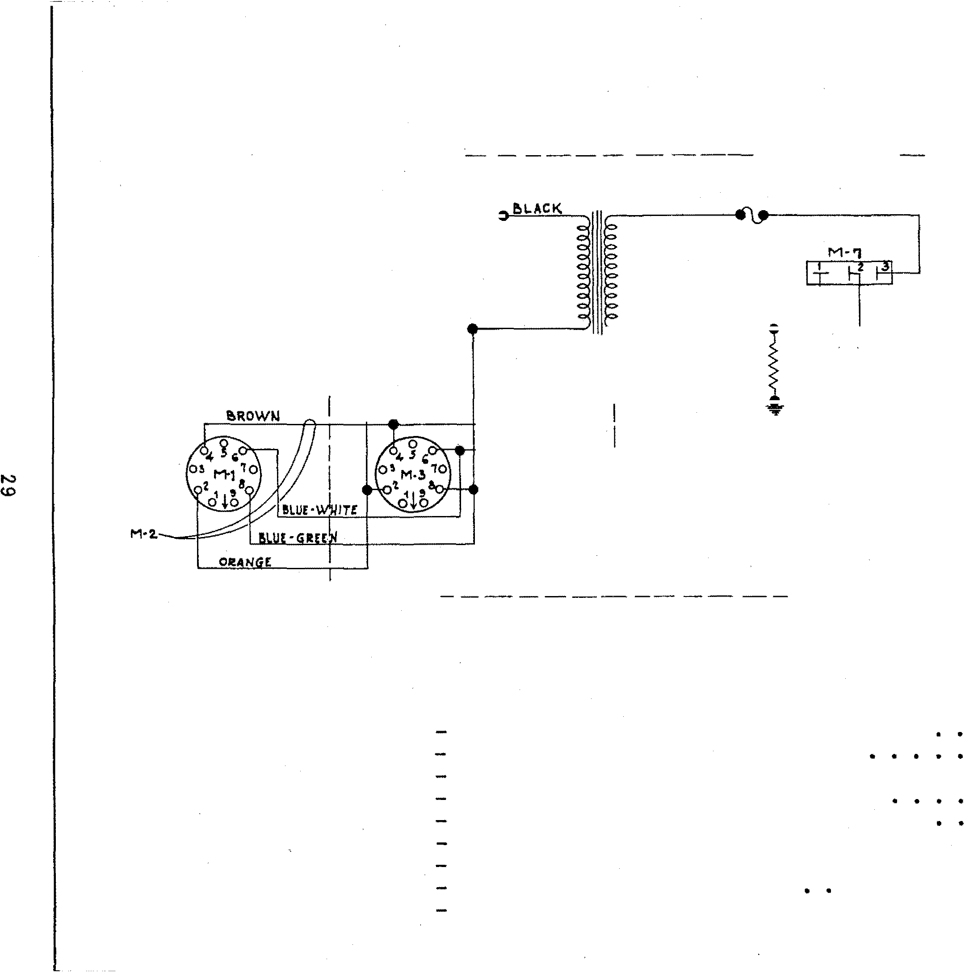9 12001
3 Wire Cable • . . . • .
. . . . • . . . • per ft. . 06

F I G . 20 - BL OCK WI RI N G D I AG R A M OF TYP E SS2 0- 1 ST EP S E LEC TO R
I N MO D E LS 7800 , 7850, 88 0 0 , AN D 980 0

AMPLJFJER 825-5
825-10
61 5- 3

SOLENOlD DRU TYPE S020-7Z

UNIT CONNECT ING CABLE

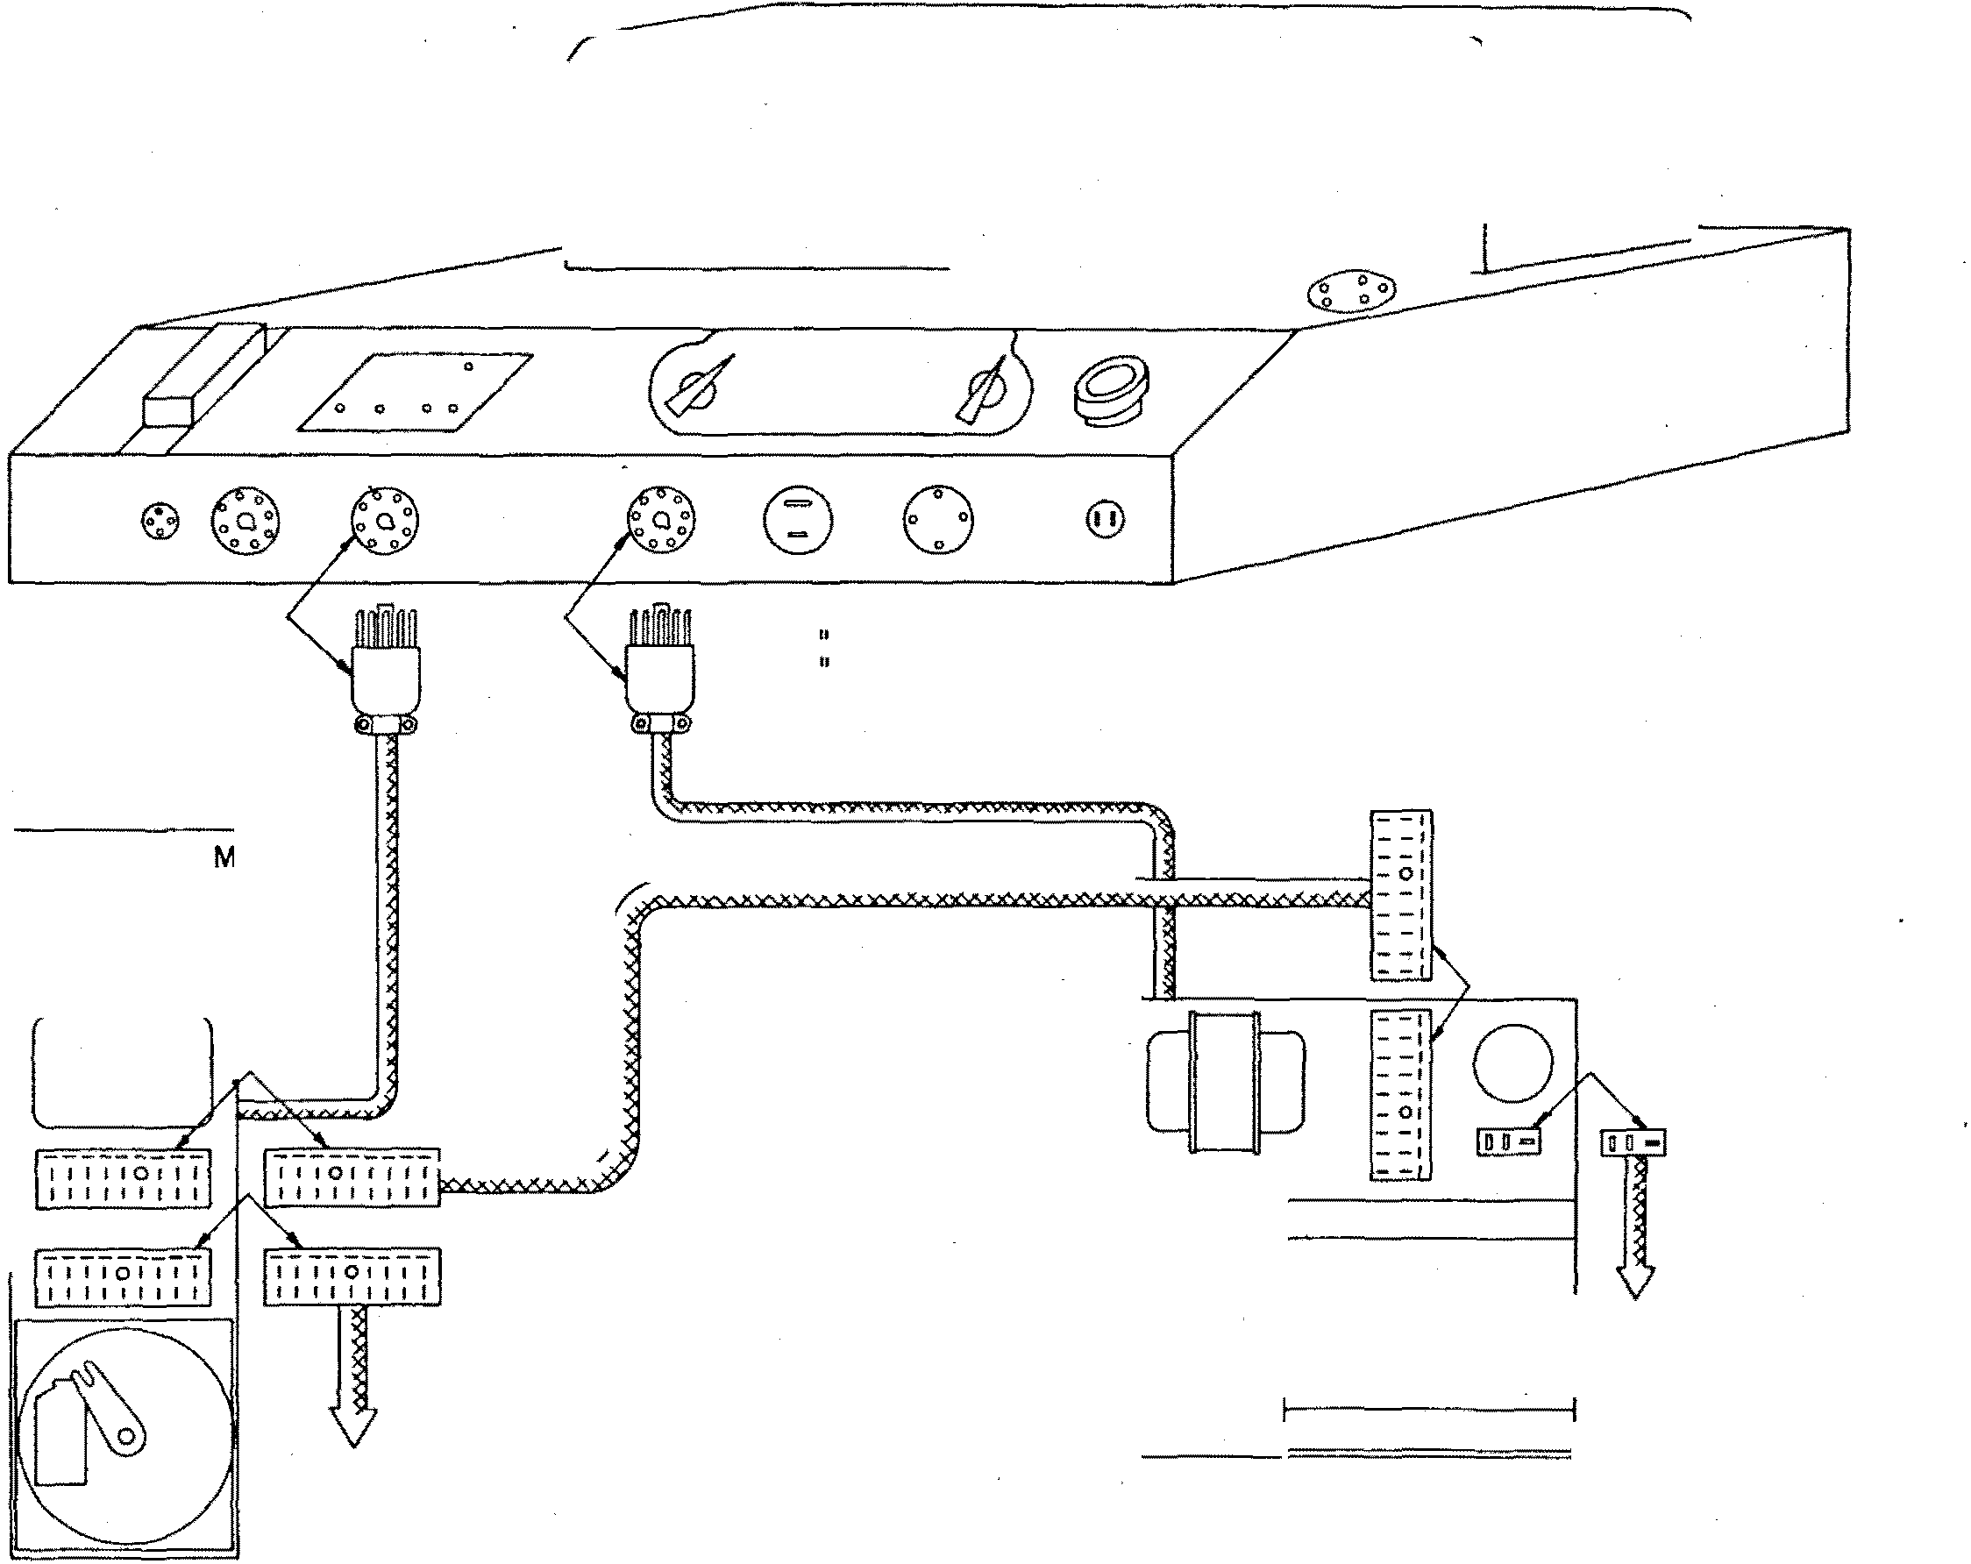

TO ELECTRICAL SELE CTOR
0
0
0
STEP SELECTOR TYPE SS20-I

TO NOT MORE THAN 6 DELUXE SELECT-0- MATICS

F I G . 2 I
S C H E M A T I C D I AG R A M O F TYP E S2 0- I Z SE L E C T - 0 - M A T I C

G)

®

®

CD I
®

21 0

22 0
4 2.30

:.:

z : z "'

- - - - - -
l

I' I

"' 0:.:
"z "' 0 " "' z z

ill I

" CD ID
zI
1- <(
: a!
" . L
. "'
" <( 0 " ' c -
I 0
a:: ac a c x
CD Cl> 0 "
®
z
0
I
l
N OT E:

0 ll ... . Il:1: <C;
• • z l
.!, �
I I :.:
Ill "' "

c 0 ::) ::) "' "' c 0
< I : )
WHEN SELEC TOR sw ITCH IS

....1 a: a: a: r ca::
a: a: ....1 ....1 ....1 ....1 ....1 a: a: a: ....1

1 1 > 0 0 0 CD CD Ill CD Ill 1111 Ul 0 111
- - - INT ER RUPTER WHEE L
J SET BETWEEN T WO
IS ON
SELECT IONS

·l� 2� 0
21

17 1 3 9
SELECTOR

3
SWITCH SHAFT
THIS SWI TCH WIL L
BE o·PEN

0 0 0
28 2. 4 22

20 18 18 14 12
® ITEM
4 1
2
3
4
PART NO .

14047
14087
12224
14086
DESCRIPTION

- Selector Switch only (See Item 7 or 8).
- Com Swl. tch , , • • , • • • • • • • • •
l/2 Amp . Solenoid Fuse • • • • • • • • • • • ,
- Interrupter Switch Ass embly only (See Item 7 or 8) • • • • • • • • • • • • • • • •
PRICE

$ 1.00
.50
.15
• 75

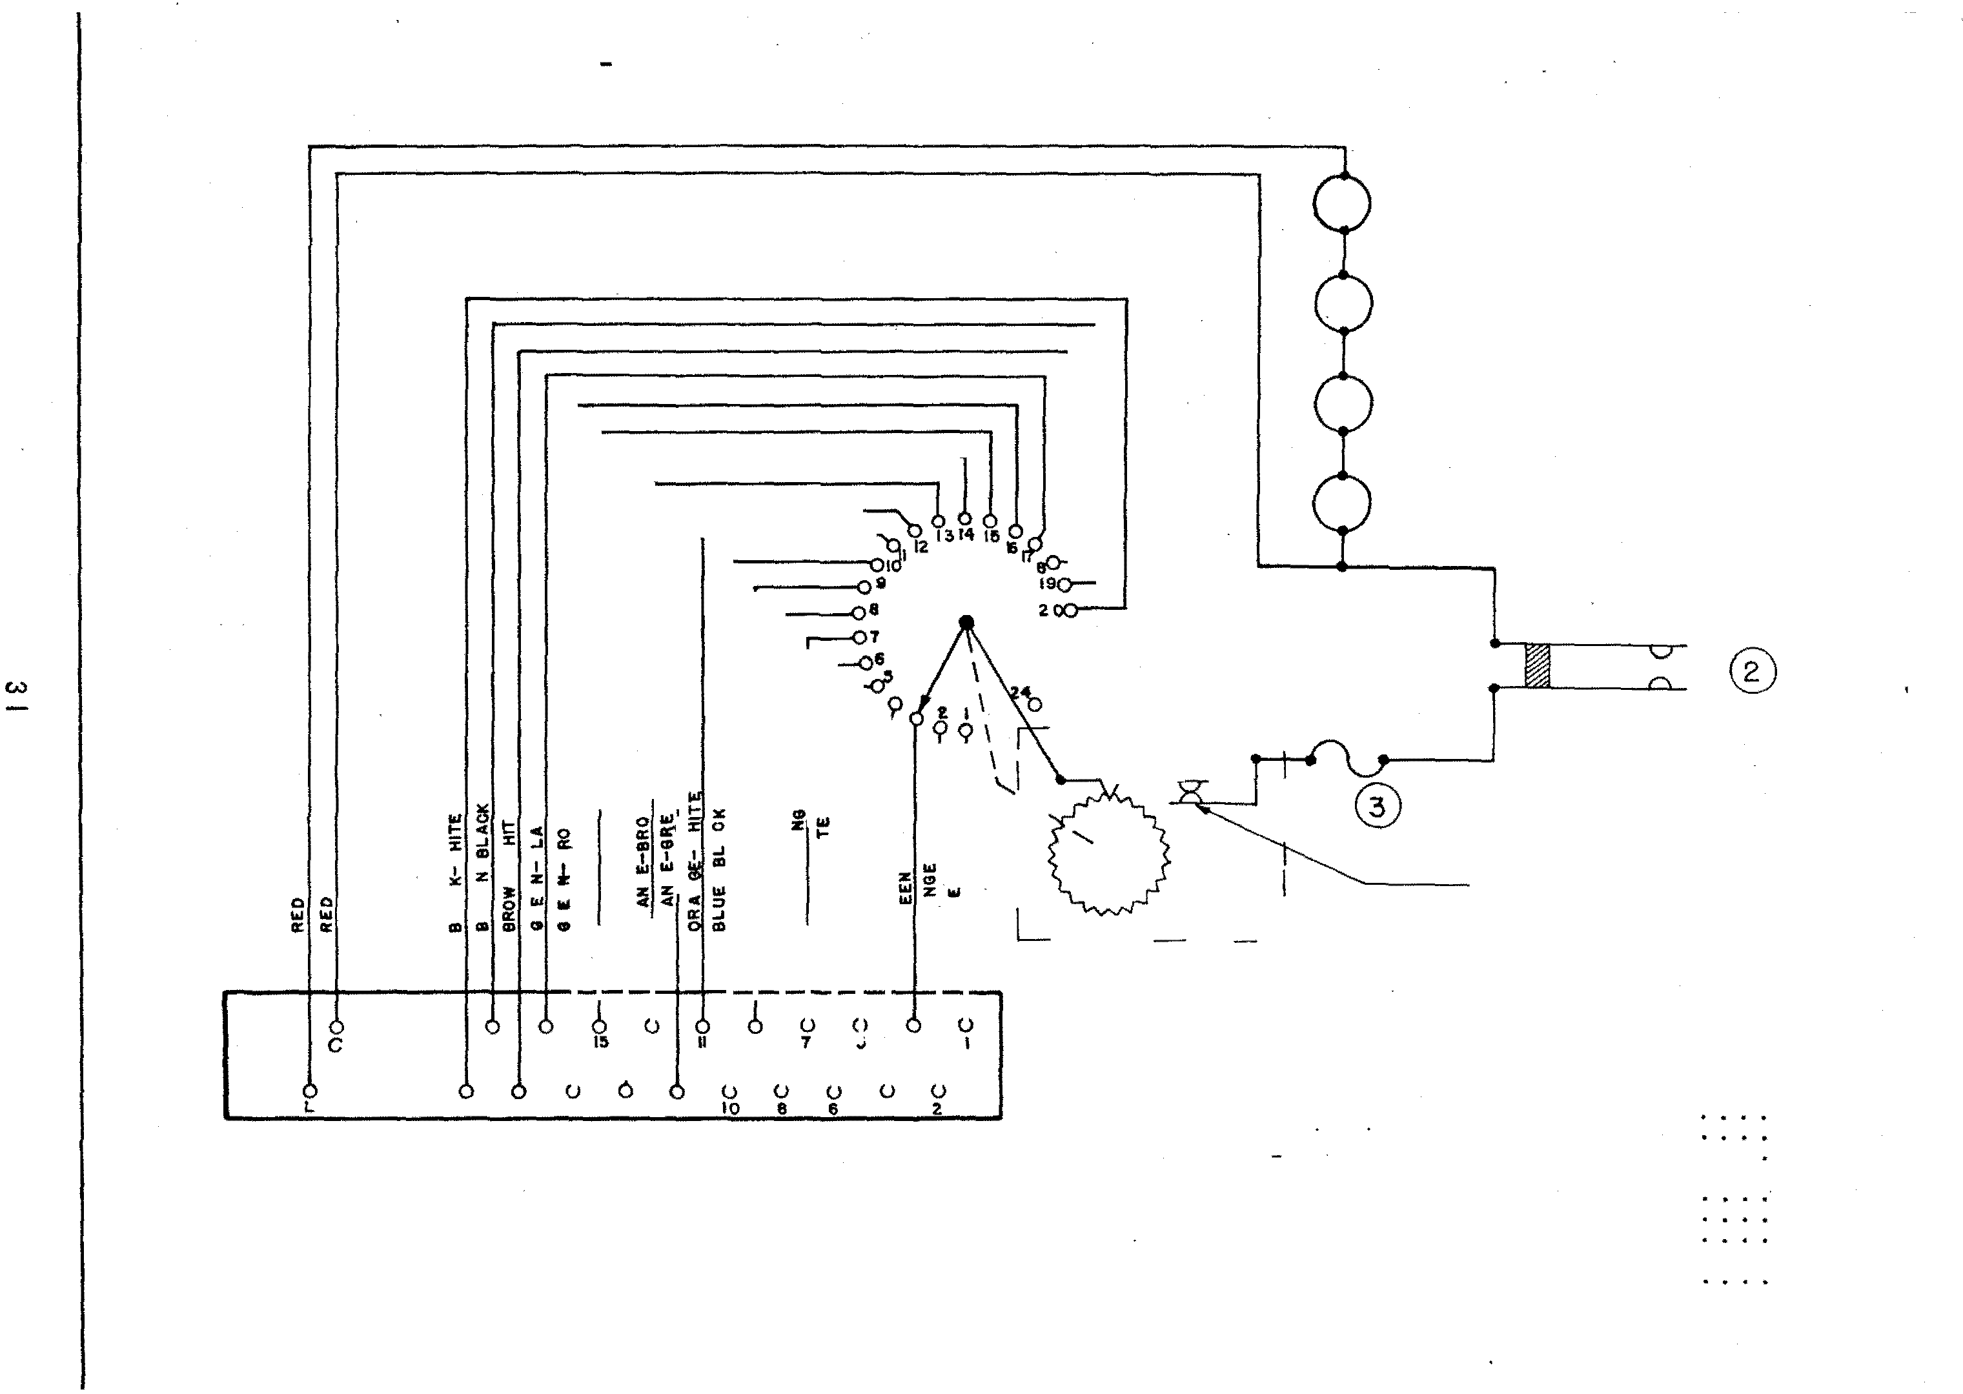5 10242 - #51 Mazda lamp . • • • • • • • • • • • •
6 14072-A - Terminal Strip Ass embly • • • • • • • •
7 14145-A - Selector Switch Ass embly complete with
Interrupter Switch • • • • • • • • • •
8 14146-A - Selector and Interrupter Switch complete wired to Terminal Strip , • , , • , • • • • • • • •
.08 -
.40

2.50

FI G . 2 2 - SCH E MA TI C D I AG RAM OF TYP E WA- I Z WI RE D ADA PTO R

r-- - -- - - ----- --- -- - - 1

M . 1 M Z M ' Z . I
I
3

I
I
I
I
I
I
I
I - - I

I

- - I
� I

I

I

- - I
I

I

- - I

I 15 '"
I
I
I Z7 r, I n

I
117

L - - - - -- - - - - - -
M· 5
- - - -
_j

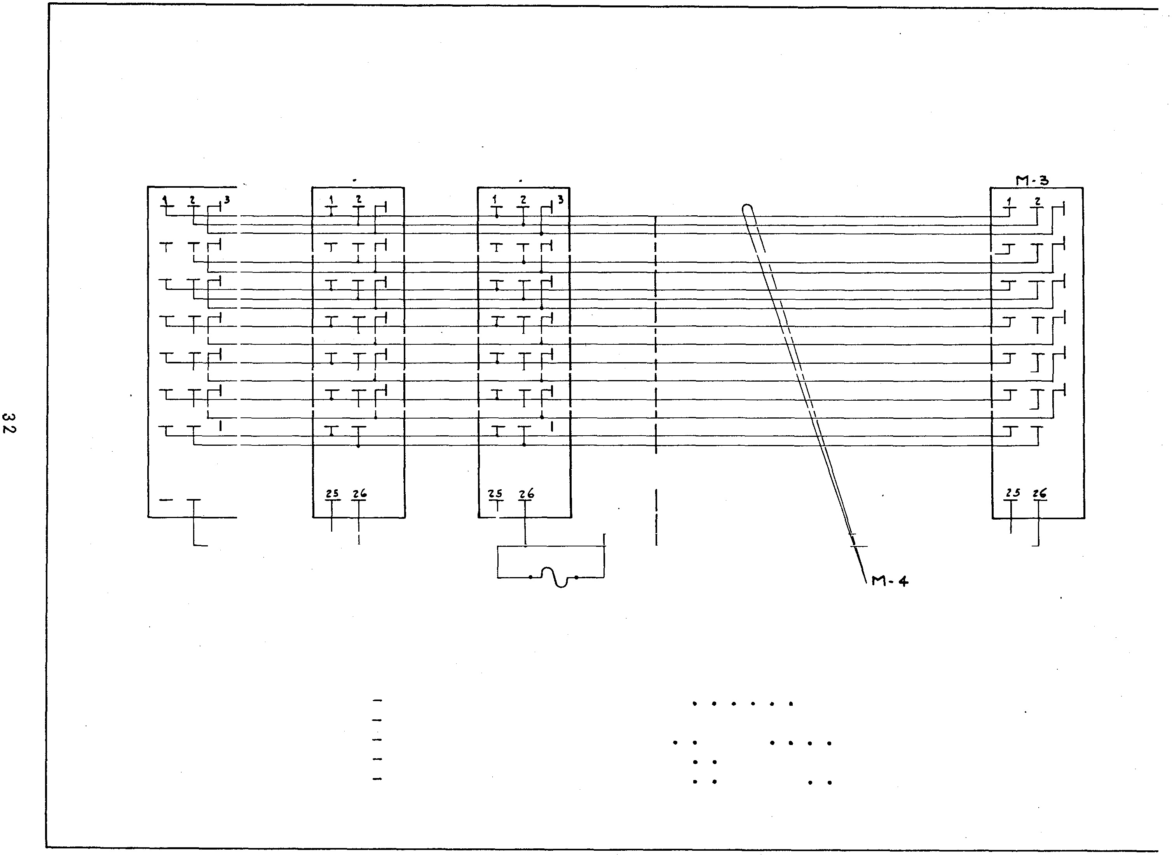I TEM PART NO . DESCRIPTION

1 12017 27 Prong So cket - Special. .
27 Prong Socket . . . . . . .
2 | 11202
3 | 12020
4 | 14213
5 | 14173

27 Prong Plug . . . . . . .
Selection and Power Cable . .
2.5 Amp . Non-tamperable Fuse
NO . USED

. . 1
. . . . . . . . 2
. . . 1
. . . . . . 1
. . . . 1
PRICE

$ 1. 00
1. 00
1. 00
1.5 0
.2 5

I I

\

- - I
I

- - I

, t,
I
- - I
I

\
- - I

I

FI G . 23 - SCH E MA T I C D I AGR A M OF
TYPE PS I 2- 3Z POWE R SU PP LY

ITEM
PART NO .
DESCRIPTION
NO REQ . PRICE

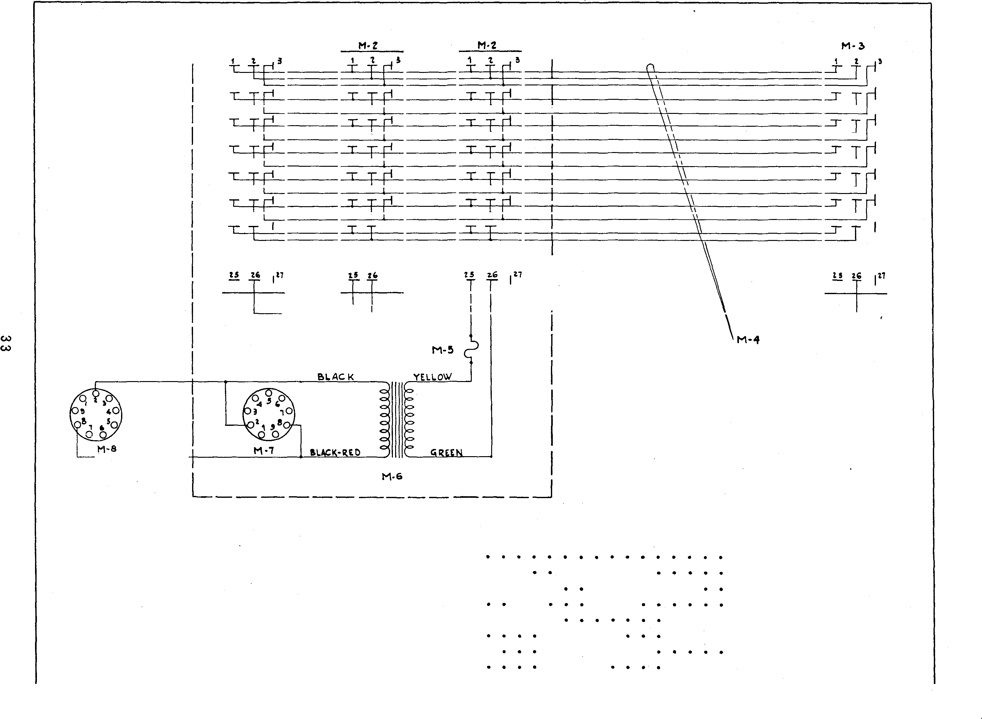1 12017 -
2 11202 -
5 12020 -
4 14213 -
5 1417 3 -
6 11213 -
7 84244 -
8 12004 -
27 Prong Socket - Special .
27 Prong Socket . . • . . . . . .
27 Prong Plug . . . . . • . . . . .
Selection and Power Cable . . .
2. 5 Amp . Non-tamperable Fu se . . .
Power Transformer . . . . .
9 Prong Socket . . . . . . .
9 Prone Plug . . . . . . .

. .
.

.
. . .
. . .
. . .
1 $1 .00
. . . . 2 1. 00
. . . . . . . 1 1. 00
. . . 1 1.5 0
. . . . 1 .2 5
. . . . . . 1 2 . 75
. . . . 1 .10
. . . . . 1 .2 5

F I G . 24- B L OC K W I R I NG D I A GR A M OF TYP E WA- I Z WI RED A D APTOR
AN D 980 0
78 5 0 , 8800,
I N MO DELS 780 0 ,

SD 'C0 -7i

To !!> CONT.,CT 50C.KCT OIJ
'l>'if"\f'HOI',IOU\ 1\I"'I='Lif"IE'R.

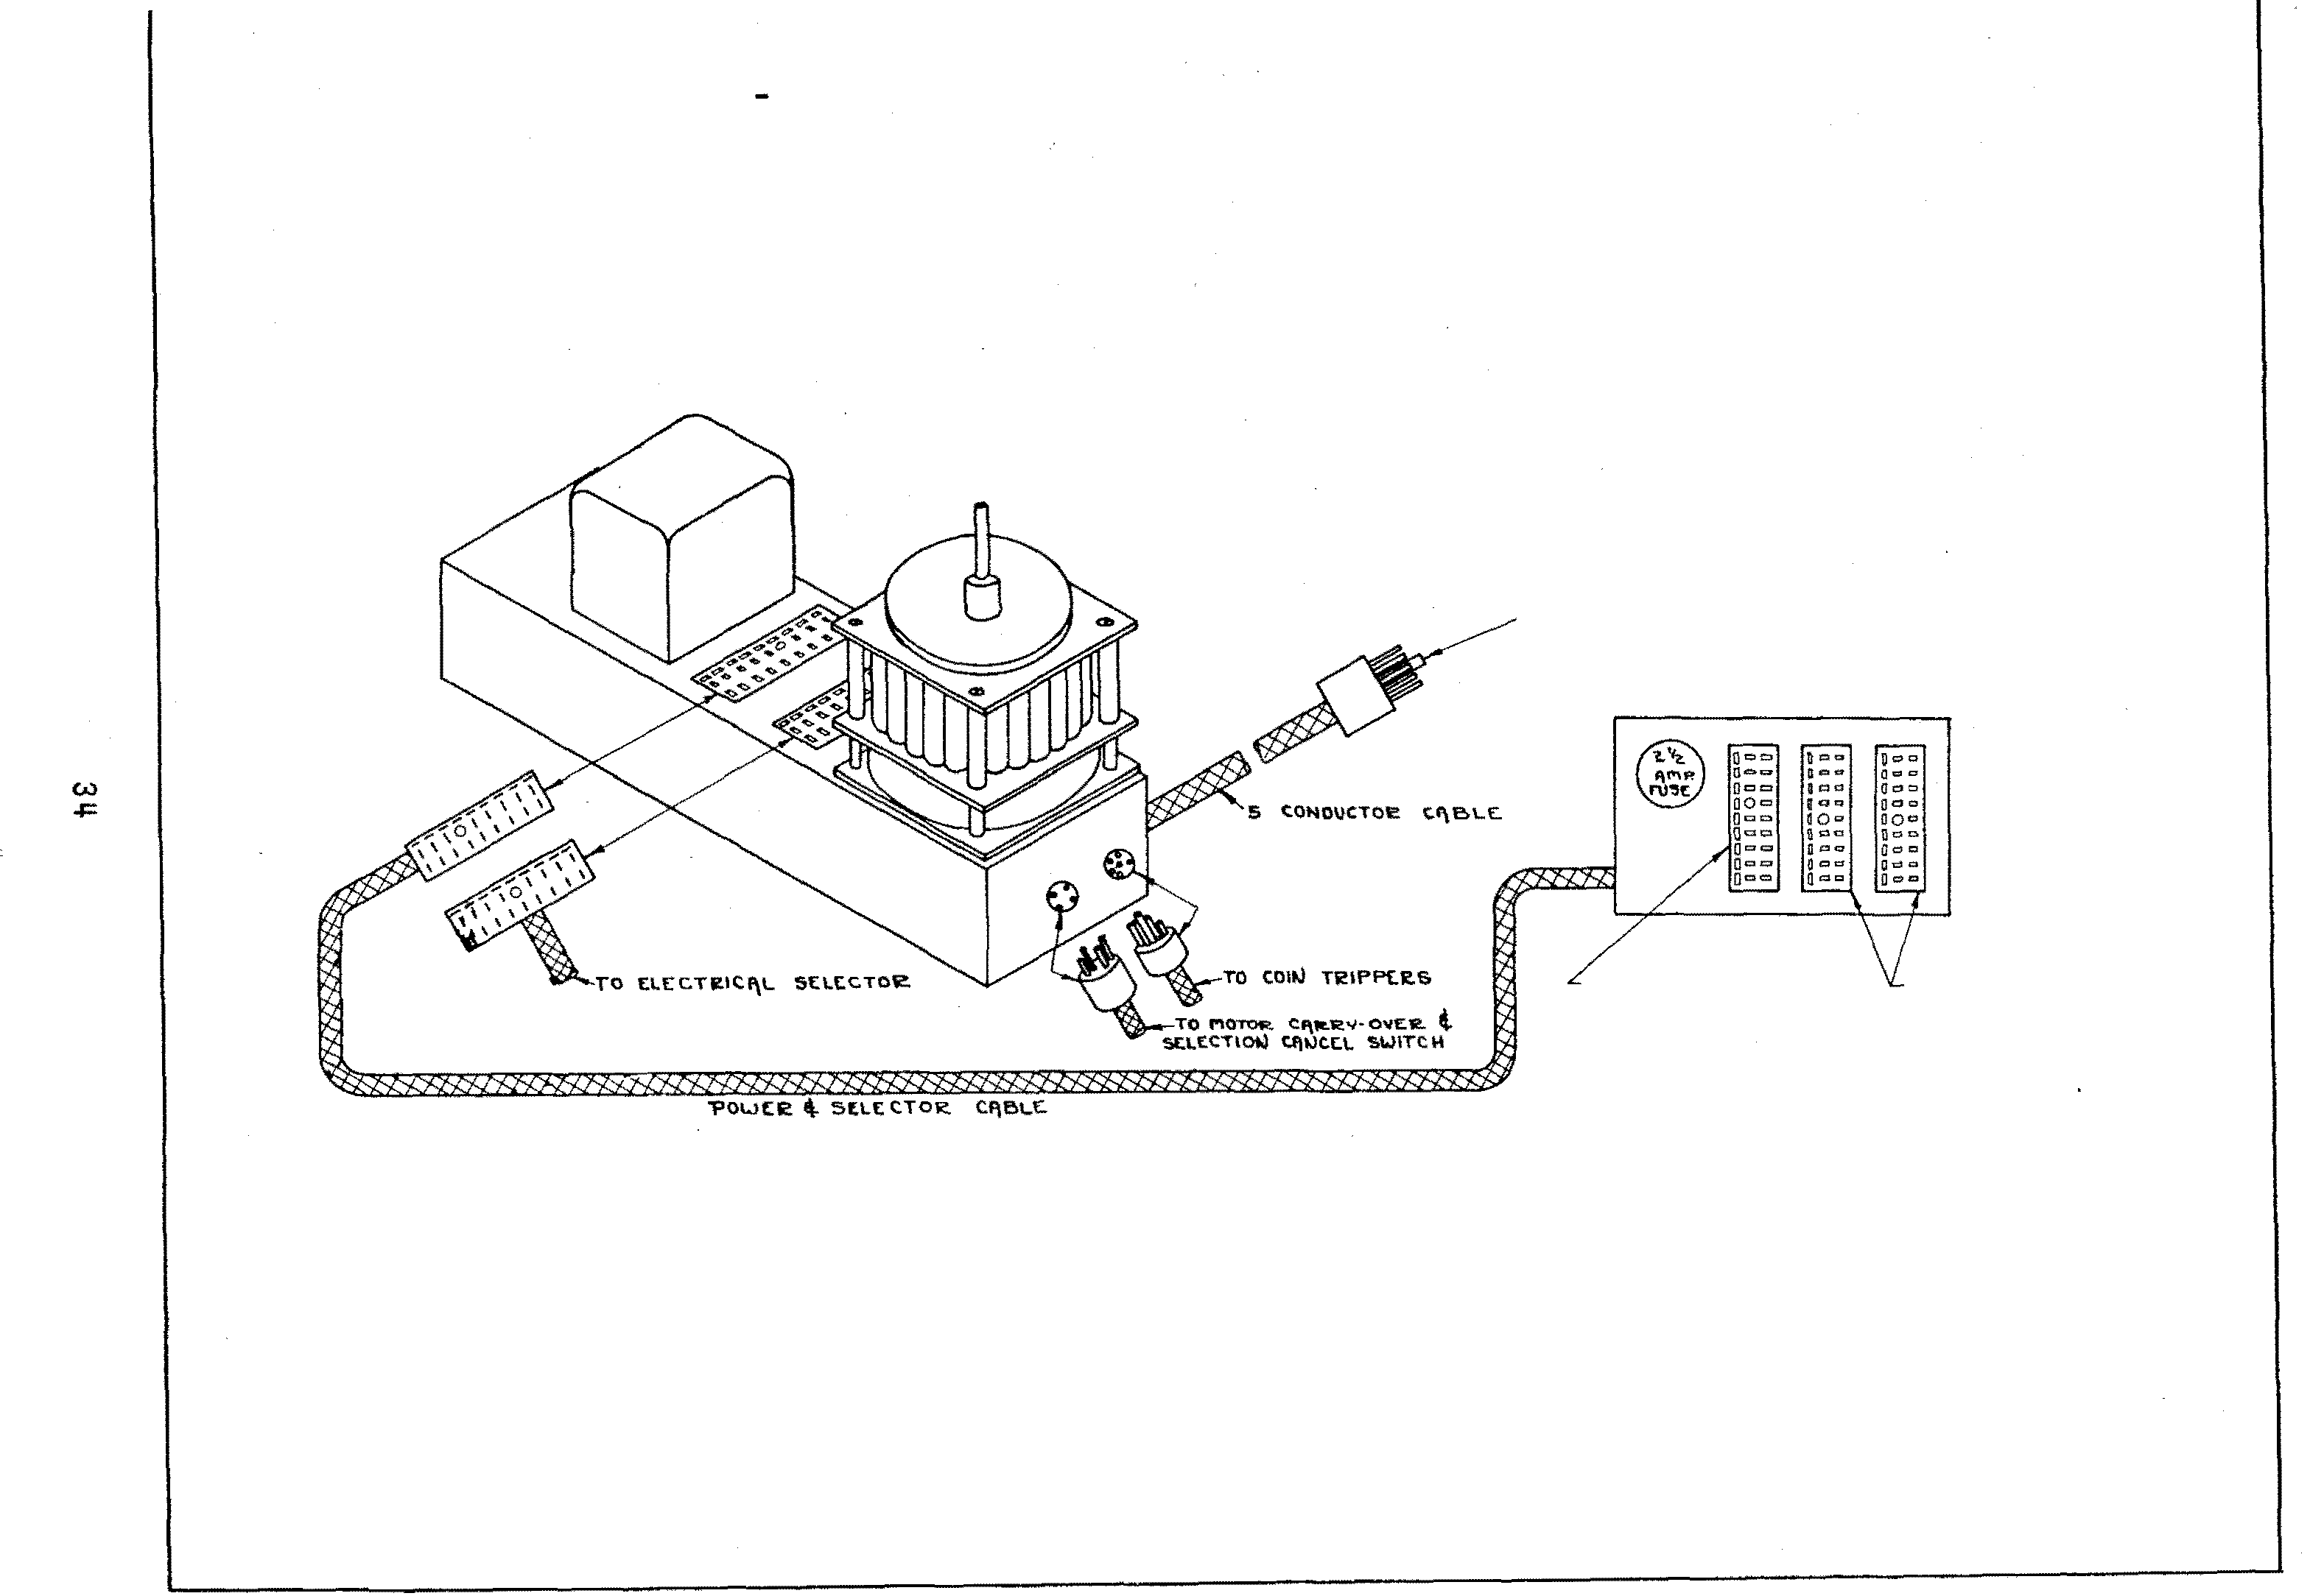IJHEtJ 'POWER SllPPLY PS I<!.-'3 � IS. USED­
Pl.U� IT's POI.JEI<!. ti
":loE l.E<:TO!t. C. I\ &L�
l t..lTO TI HS S.=K l::T
CI\8Lt:'5 f'e.OM IJOT 1'\0IU: THI\'-l
I� 'SEI.ECT-0-Mil HC!>
'Pl.Uq !!.lTO THESL
SOC KETS

F I G . 2 5 SC H EMA TI C D I AG R A M OF TY PE T- 3Z TR AN S M I T T E R

6 J�GT

/18

w
<..TI

C8 <:! 9A
HIZ

- - _,

C!J.B

M/0

!TL)f. PART NO. DESCRIPTION PRICE ITDf PART No. DESCRIPTION

PRICE ITEJ'of PART NO- DESCRIPTION

V C/0

PRICE

RES! STORS

R1 11010 - 2501IJOO Ohm Variable Modu- l�ttion Control. • • . •
R2 82427 - 1000 Ohm 1/2 Watt z lQ% •
R3 82444 - 47 ,<XX> Ohm 1/2 Watt .:t 10% •
R4 82421 - 560 Ohm 1/2 Watt ±. 1()% • • •
R5 82441 - 2710CQ Ohm 1/2 Watt ;:: 10% ,
C2 86026 - .015 Mid. 400 v. Tubule.r. C5 86013 - ,05 M.fd. 400 V. Tubular
C4 8501:5 - .0005 M.td . (500 Mm.f.) Mica
.75 10% . • • • • • • •
.07 C5 85006 - .001 (1000 Mmf.) 10% • • • •
) {- • • }
.07 C6 85006 - .001 Mfd . (1000 Mmf. ) 10% •
.07 C7A .20 Mfd . 600 V. Tubular
BG060
,07 C7B - . 20 M.fd, 600 V. Tubular • •
$ .10 M3
.10 M4
M5
.20 M6
.20 H1
.20 MB M9
.40
.30148 - O.scilla tor Coil As5embly.
30179 - Output Coil Assembly .
11012 - R. F. Choke.
11022 - Po'!ll'er Transformer •
11007 - Filter Choke.
11469 - Input Lead.
1202� - Input Adapter Plug and
Socket Assem.bly

$ .75
1.00
.35
2.25
1.25
.l\0

R6 82444 - 47,000 Ohm l/2 Watt ± 10% •
R7 8.2444 - 471000 Ohm l/2 Watt ± lQ% •
RB 82436 - 10,000 OhJ'II 1/2 Watt ± 10% •
-
R9 11008 Ce.ndohm 1900-8 333. Ohms .
•07 CB 87519 - 20 M.fd. 450 V. �ic . •
) {-
,07 C9A 20 Mfd. 450 V. Lytic. ·)
.07 C9B 87520 - W M.fd. 500 v. �!c . •
.SO ClO 87521 - 10 Mfd. 50 V. Lytic •
.SO MlO 12028 - 8 Prong Plug •
M1l 12126 - Power Cord.
1.00 Ml2 ll758 - 4 Prong Plug.
...25 Kl3 12126 - Output Cord

.20
.25
.25
.20

RlO 11009 - Candotun 700 Ohms.
COMDEMSERS
cuj {- 20 r«d. 25 v. L,ytic •
.10
.20

Mi SCELLAHEOUS
l-0.. ll072 - Bass Choke Assembly •
•
Kl4 12027 - 2 Prong Socket. Ml5 F-3205 - 2 Prong Plug.
Kl6 F-�024 - Pit:lrup Shorting Switch.
.10

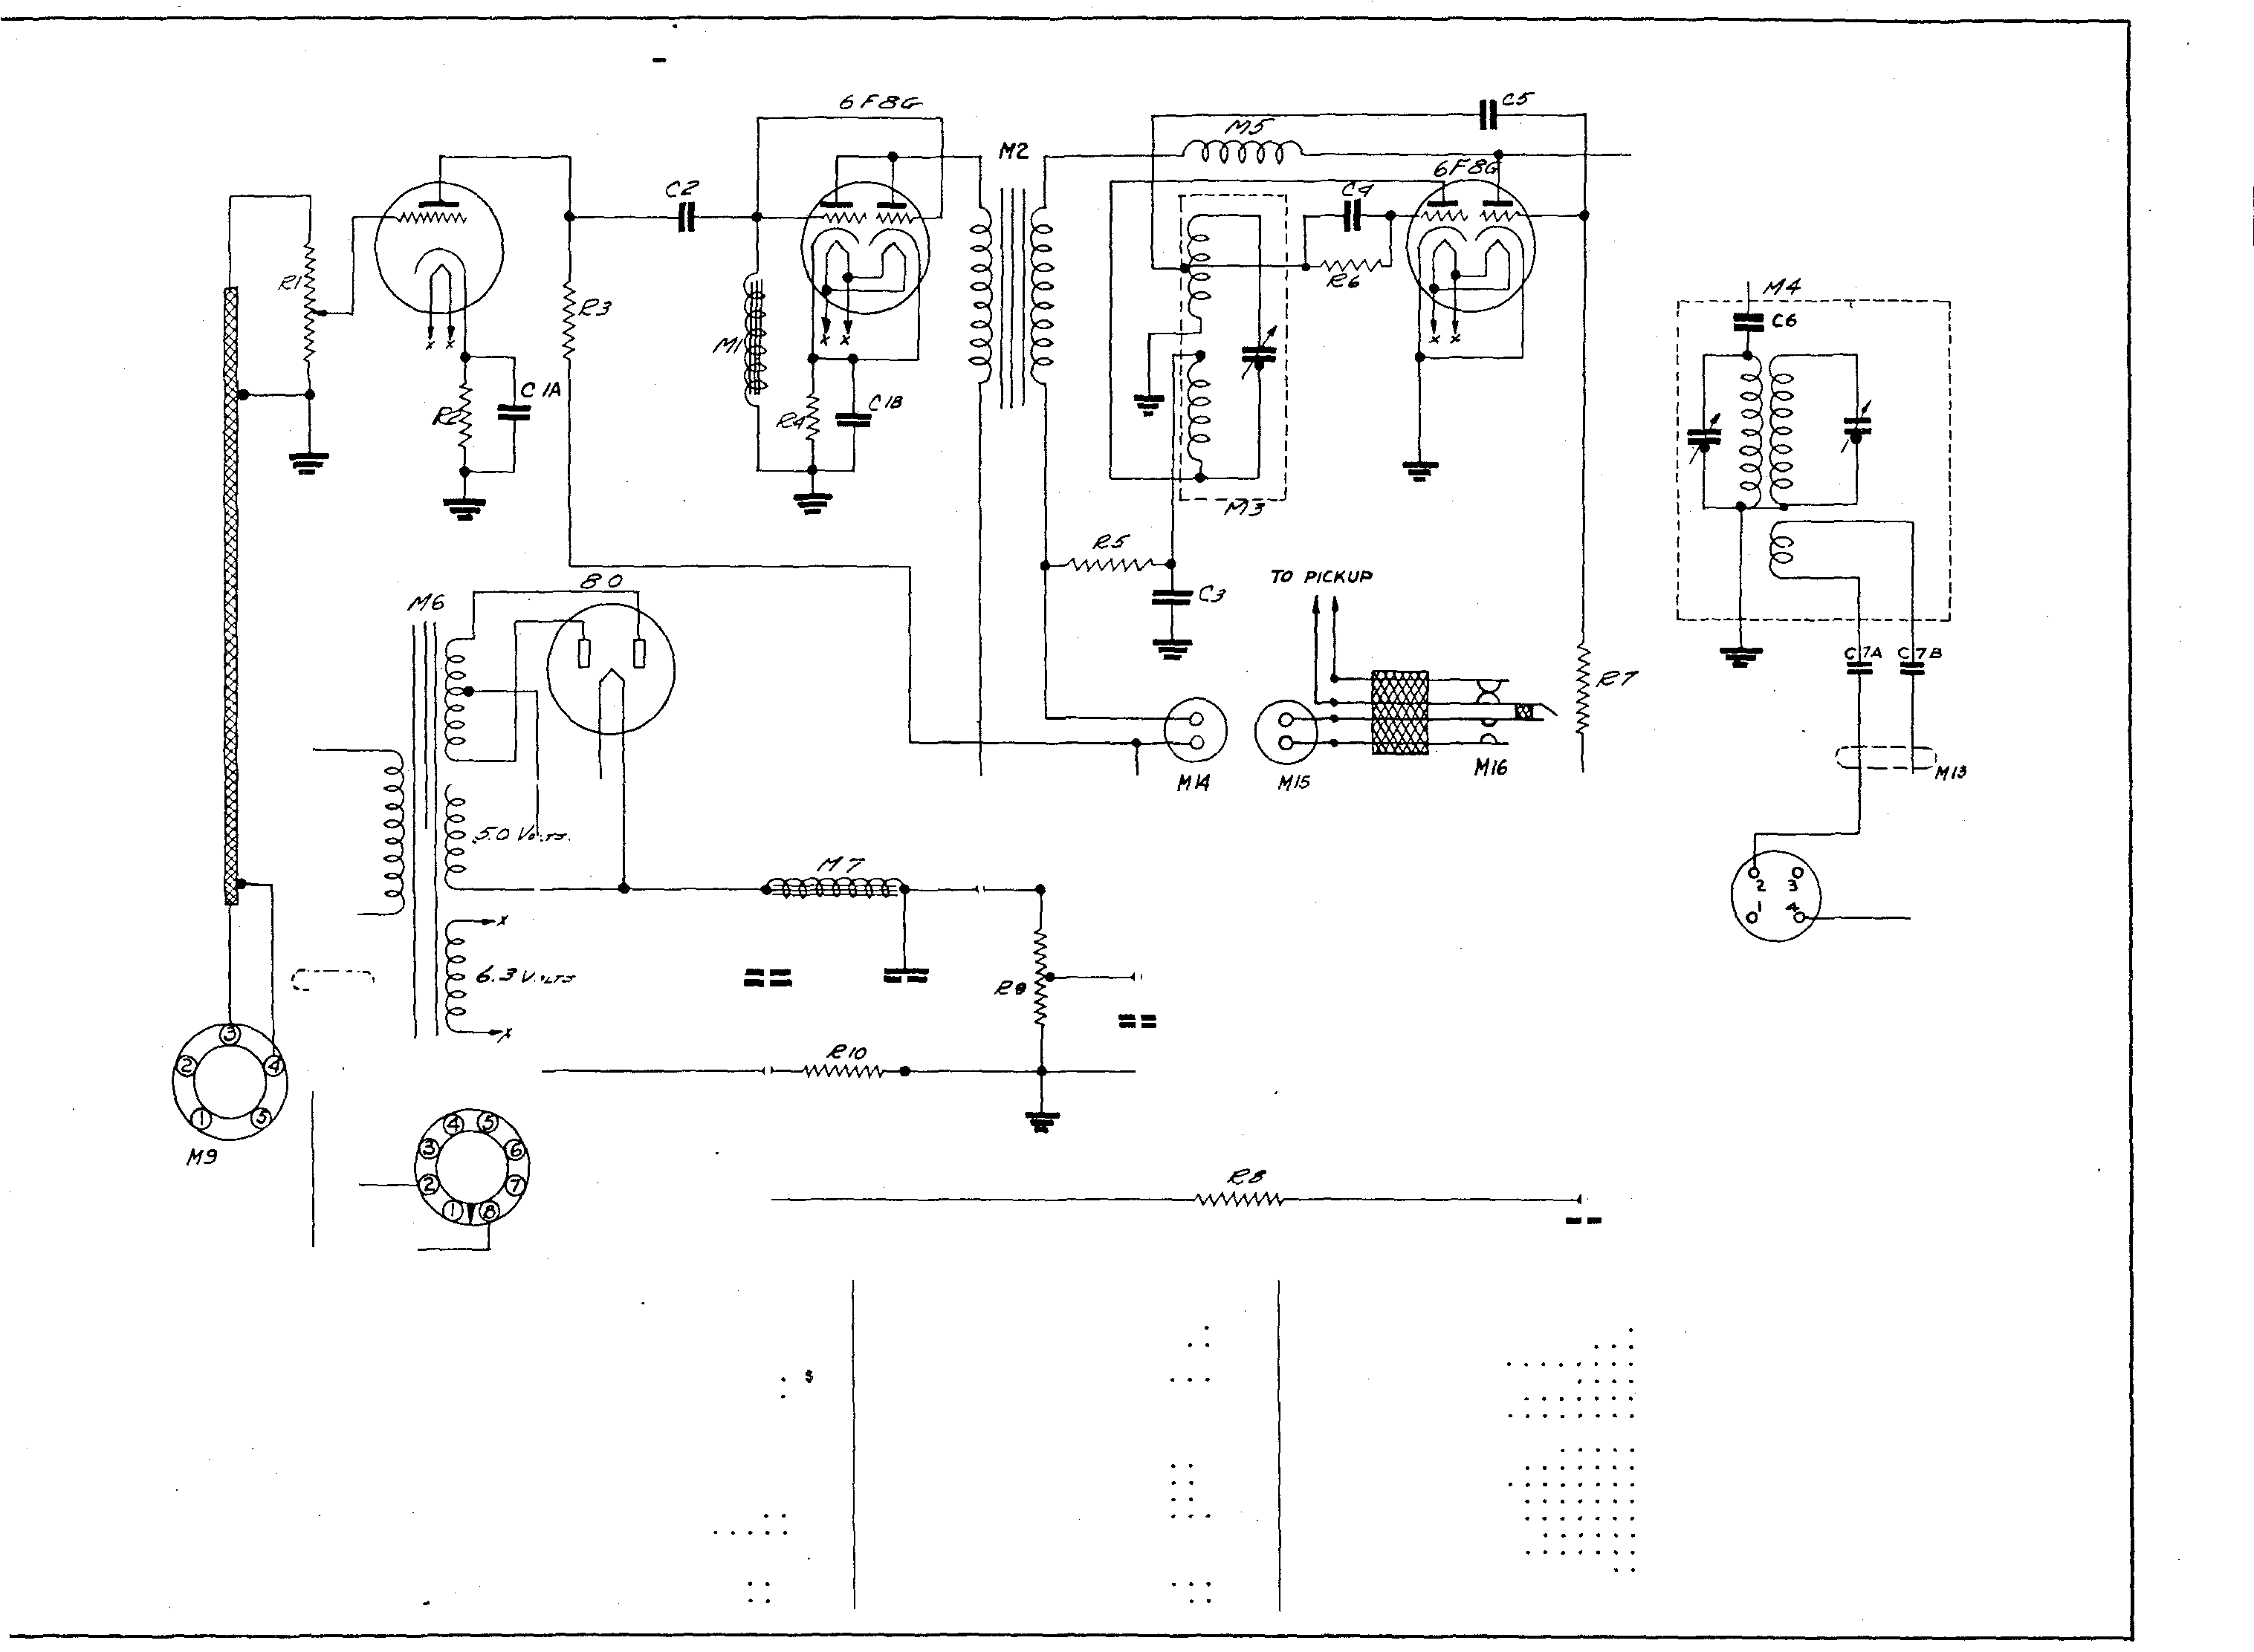C!D 87512 - 20 !<ifd. 25 V. Lytic • :}
•75 M2 ll006 - Modulation Transformer.

FI G. 26 - BLO CK WI RI N G D I AG RAM OF TYP E T- 3Z TRAN S M I TTER
I N MO D E L S 7800, 78 5 0, 880 0 , AN D 98 00

T• •r"' I'H•tloL4
1"1 4l.IC,UP

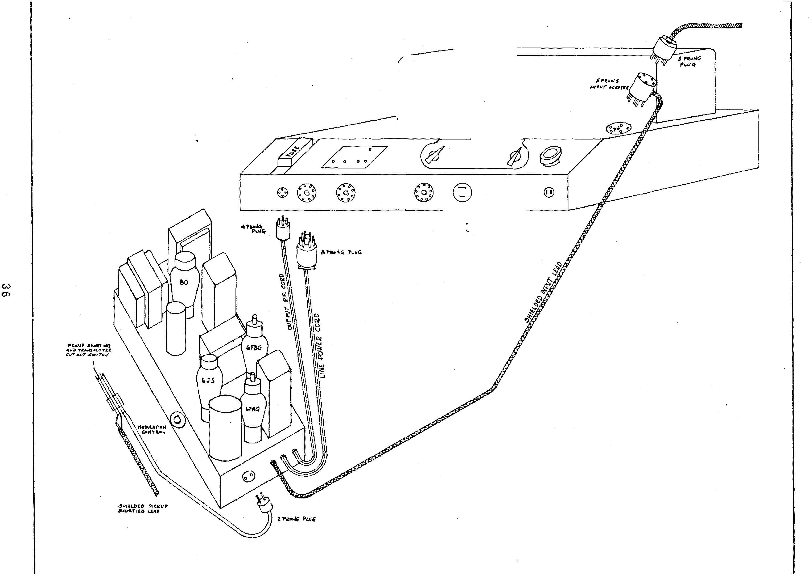

TI.AIISMITTER T·.:n
0

AMPUFIE/2 .&f.5 •5
I!J7.5•10 bl.5· 3

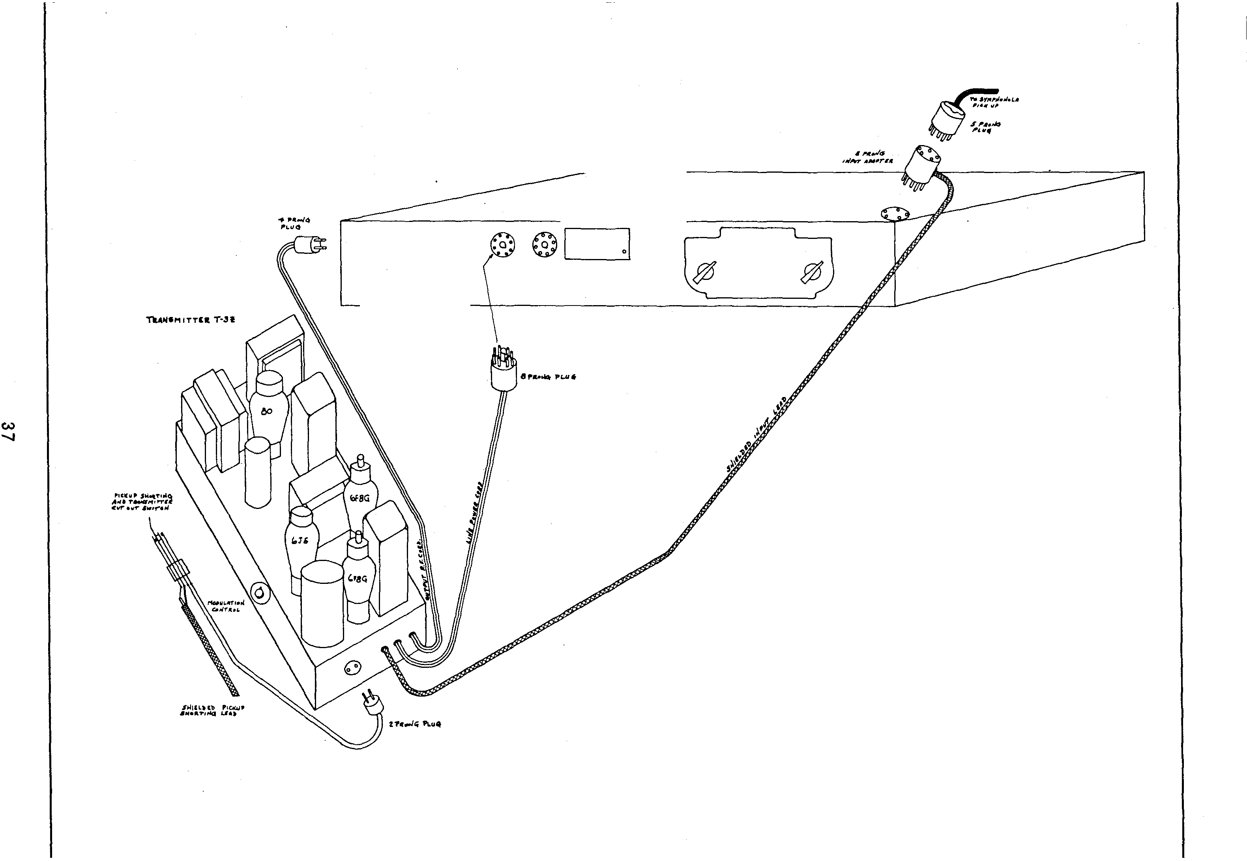
FI G. 27 - BLOC K WI R I N G D I AG R A M OF TYP E T- 3Z TR AN S M I T TER I N MODE L S R C - 7850, R C -88 00 , AN D RC-9800

o 0 0 . . : o

,1/f.TI� C1ulr�oL $7"1f/JoJ P'ICS fl·l
f"'CS J.I·J

c-�

C·/0
1'1·8
r- ---- ------ ------- - - - --,
: :
I I
1 I
I I I I

w
00

/1·10

F I G. 2 8

SC H EMA T I C DI AG R A M OF TY PE RR 6-2 Z R E MOTE RE C EI VE R

IT:EJ.i PART NO. DESCRIPTION PRICE ITEM PART NO. DESCRIPTION PRICE ITEM PART NO. DESCRIPTION PRICE
RESI STORS co 86038 - .cos M.fd. 600 Volt Tub • • $ .10 C23 86032 - .2 M.fd. 400 Volt Tubular • $ .10
C4 86009 - .OS Mfd. 200 Vol t. .10 C24 875:59 - 100 Hfd. 50 Volt Electro-
R1 824.17 - 270 Ohm 1/2 \o.'a tt .!. 10% • • $ • 07 C5 86009 - ,05 M.fd . 200 Volt Tubular. .10 zytic • .35
R2 82706 - 39,000 Ohm l Watt ;t 10'1,, .10 C6 86013 - . as M.fd. 400 Volt Tubular. .10
R3 82444 - 47,000 Ohm 1 Watt ;t 1()%. .10 C7 86017 - .2 M.fd . 200 Volt Tubular • .10 M I SCELLAHEOUS
82460 - 1 Meg. Ohm 1 Ws. tt .±. 10%. .10 C8 86009 - .as M.fd . 200 Volt Tubular. .10
R.5 82460 - 1 Meg. Ohm. 1 watt .± 10% • ;10 C9 8601� - .05 M.fd . 400 Volt Tubula.r. .10 Ml 50183 - 1st R. F. Coil and Shield
Rti 824.17 - 270 Ohm l Wntt .±. 10% • .10 C10 86003 - .1 M.fd. 400 Volt Tubular .10 Assembly •
R7 82445 - 56, 000 Ohm 1 Watt .±. 10%. .10 Cll 85017 - .003 M.fd . Mica • .20 M2. 30184 - 2nd R.F. Coil and Shield
RB 82460 - l Meg. Ohm 1 Watt ± 10%. .10 C12 85000 - .0001 M.fd. Mica. .10 Assembly •

R9 11152 - 250,000 Ohm VolW!Ie Control
C13 85000 - .0001 M.fd. Mica. .10 M3 30185 - 3rd R.F. Coil and Shield

RlO 82440 - 22,000 Ohm 1/2 Watt z 10%. .07 C14 86031 - .02 M.fd. 400 Volt Tubular. .10 Assembly • .75
.75

R11 82460 - l M!;!g. Ohm 1/2 Watt z 10% .
Cl5 86000 - .01 M.fd. 400 Volt Tubular. .10 M4 lll88 - Jack • -�5

R12 82442 - 33 ,000 Ohm 1/2 Watt � 10%. .07 C16 85010 - .0015 f·tfd . Mica . .20 M5 11400 - Audio Input Choke. 1.00
R13 11406 - 1 Meg. Ohm Tone Control. • 50 C17 86000 - .01 1-lfd. 400 Volt TubulEr • .10 H6 11403 - Relay and Bracket. 2.00
R14 82444. - 47,000 Ohm 1/2 Watt ;t. lQ%. .07 C18 85010 - .0015 M.fd. Mica. .20 H7 84201 - Speaker Socket • .10

R15 ll�98 - 155 Ohm Candohm.
C19 85010 - .0015 M.fd . Mica. .20 M8 11399 - 12" Speaker. 6.00

R16 11402 - 105 Ohm Candohm. . 20 C20 87534 - 50 Mfd • .350 Volt Electro- M9 ll409 - Near-Far Switch. .15

{- lytic • • • • • •
.65 Ml.O F-1369 - Line Cord and Plug Assem-

CONDENSERS C2 �} EJ.ec trolytic • •
J Ml1 ll443 - Off-On S·d tch and Lead

30 Mfd. 350 Volt bly . .as

CZlB
87533

- 30 Mfd. 350 Volt
.75

Assembly •

C1 86045 - .1 Mfd. 600 Volt Tubular .10 Elec trolytic • • Ml2 11401 - Two Prone Receptacle .20
C2 86045 - .1 M.fd. 600 Volt Tubular .10 C22 87535 - 200 M.fd. 25 Volt Ml3 11597 - Pol!'er Transformer. 3.25
.<0

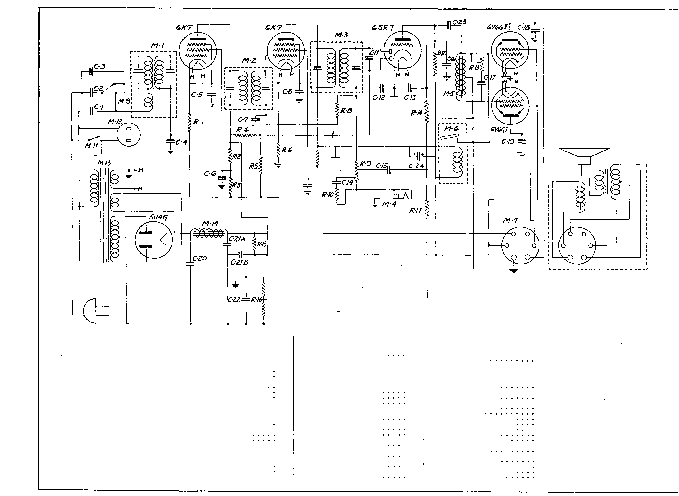Electrolytic •
Ml4 ll396 - Filter Choke • 1.25

F I G . 29 - BL O C K WI R I N G DI AG RAM OF TY P E C- 5 Z R E MOTE SEL EC T I O N CAN C E L K I T I N 1 9 ' + 1 SY MP HONO LA S

I
AMP LIF IER I
OR
MAS TER CO NTROL
STAT ION I
I
I
BLACK RED

BL ACK

8 PRONG

M-2.

ZIP CORD

SPL ICE TO BE SOLD ERED 4 TA PED

ITEM PART NO .
DESCRIPTION
PRICE

Ml | 14121 | - Cancel | Sol enoid and | Plunger • • • • • . . | . $ 1. 40
M2 | 12105 | - Canc el | But ton • • • | • • • • . . . . | . | . 50

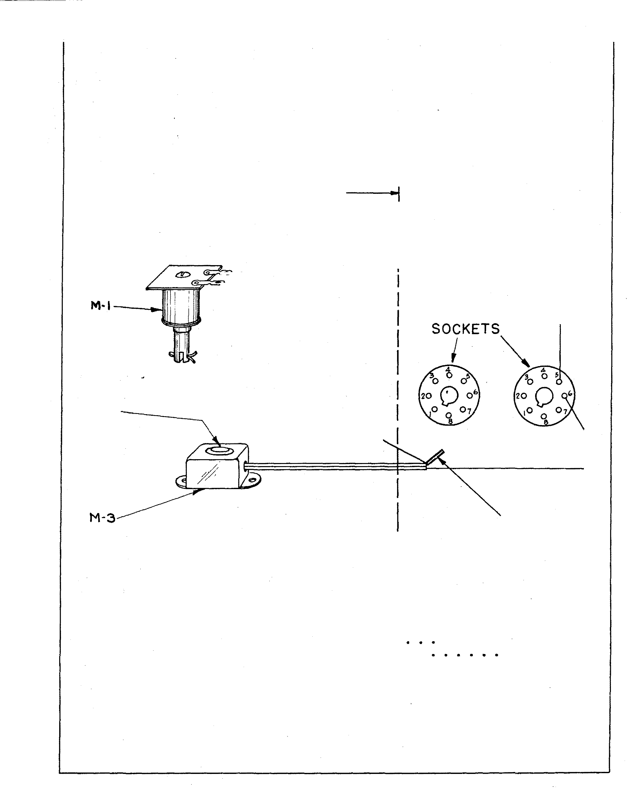fJ[5 12100 -
Cancel Button Housing • • • • •

39
. 2 5

SERVICE
MANUAL

51 - IO IOY

T '20V

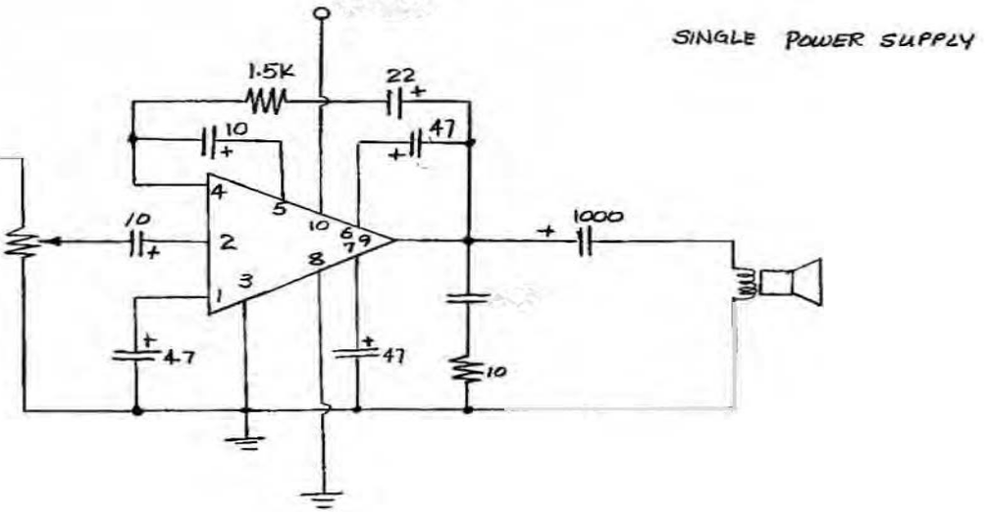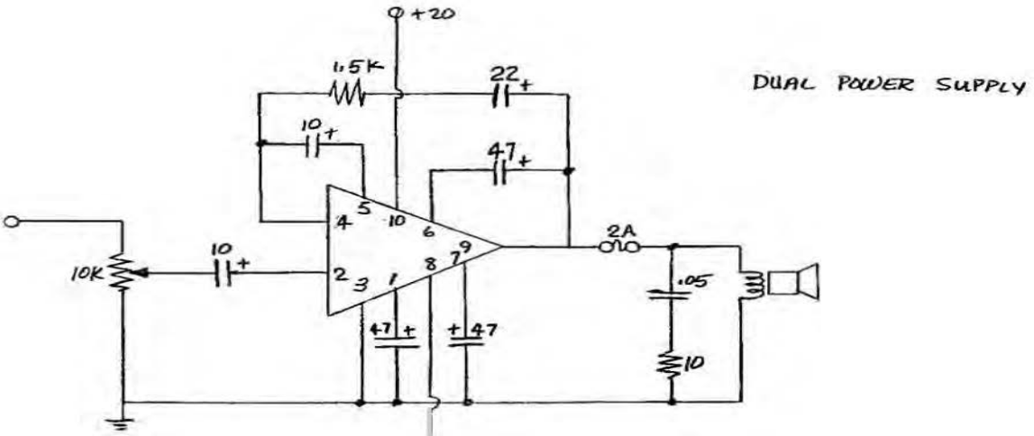

IO#t..

.os

Sl- lOIDY

INSTRUCTIONS FOR ASS�ING A BASIC 10 WATT (RMS) SIHGl.E C*NNEL
OR STEREO SOUND SYSTEM

AUOIO SIGil� FROio! PRE.OIIP, Tl.llll TAOU:. TAI't lllCOIUII.
.-ADIO, (tc.

CHI
@J[i]

(;4, C5, C,,CT.
ct,ca, Rl. RZ.
Sli,Cil
.
OUf'UT Tll l

1
,-- - - - - - - - - - - - - - - - - - - - -
POWER SUPPLY
TYPICAL LAVOUT ISTI!AfOI

Ill 'lOUIE CCIIliiOL

C4,C5,C6",CT,
8
ce,ct,III,Rl,

OUTPUT t
lSI

CtU
CIO AMPt

110 VAC

I I 1 1_

c•· "·''·C'7,

- - - - - - - - -- - - - -I�""1I- :_, - - -- - - -.J
·-·
I I I ... ! ,OWf:l! TO

CI, C.t,

1!1,1\2,

OUTPUT I

IIOT(S SILICON 'II£AS£ IIU!.T 8£ API'UED 8£TWtol
.lHO -lNG PLAT£ OF tfY8RIO AIOIPUflER
TIGHT!!!, 2 110\.IHTlloG SCREWS F'IMot.T.
�EEP All WilliNG AS SIIOIIT· AS POS518Lf
I '--,; CH.A�!O(_L 1
I ( ST(I!£01
CHASSIS I
I L-- .
L -- �PIANI<lL 3&4 t®AOI
at,Sll
l$1

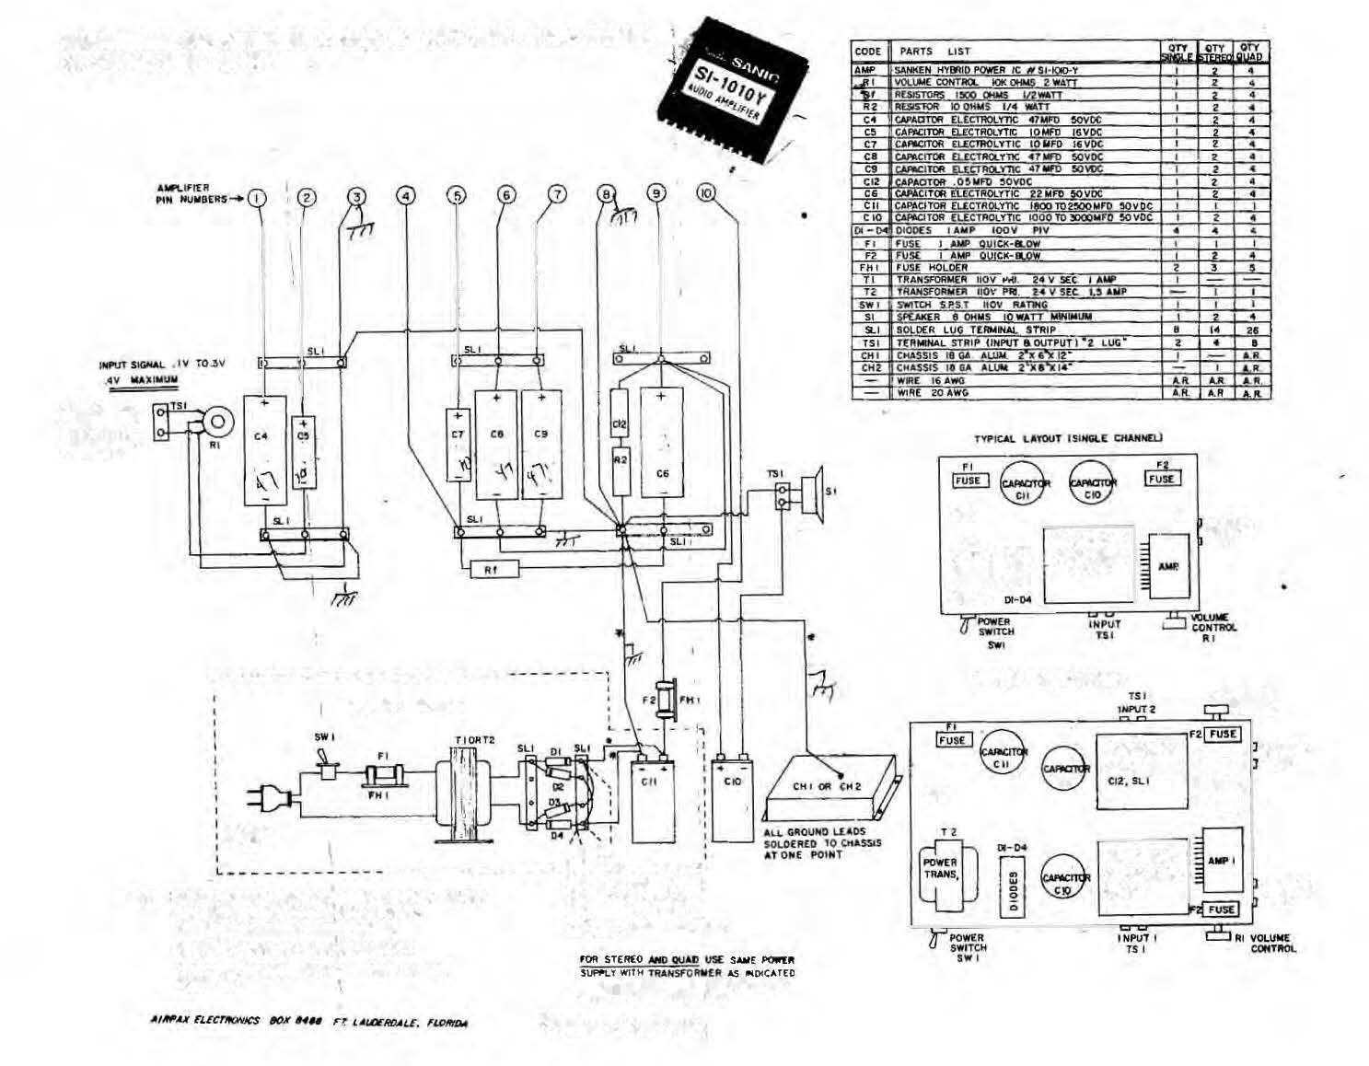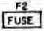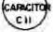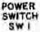;'::� �l WilliNG CA�[f\JL�V IKIOR( !UMNIIoG

:=�::'���� ��;'\1��

• OOIOIES 16 AWG WIRE

.lS

1.3
-
I " .
l. 4-7, '0 . -

1 tz.oo 11 tl

, · ·....
.....

ELECTRICAL CHARACTERISTICS

Ch..,e.eter•tt•c_
SI·IOIOG
S1·1020G SH030G St-10100

- -.

M.nun.u:rr rau l'owcr

a....... ......

S.opl) v.,....

s...,ly
.•

s\11>vb c��,.,._M t•'ft.)

ProI('(ti'tlct F'u.o.1n•

I�Kt"' VO!u.,.

JOW

8 ok..

34V or U7V
45V •• z u.s\' U.SOA
lA (Mel illo•

o.S!-r m-..

0.30\' tn

' .,,....

..&t".or =n'l SfV •• �21V 66V or :t.JSV

S$V or t2.SV 60V or -:.JOV t;0\1 or �«<V UA
lA (/".Jick Olow t,S..\ Qu1d DJv\11 lA Qui-l'k f}Jf)\1.

I).S"•c IN.'- Q.S',�;

O.d\' \)'0. 0.52\' .,•• 0.10\" •r<>

·-. ..-�,:,D�� �

�Cl' JJCOJio'

' ,.�, h' 'Si lOloG

MOJfli.Ynl ,,.,.,, Valtoe<(:>o)

lflput lettted""�··- ...., ..

IOV

30d8 ,,••

ifV.OOO otwp I

JOOfl typ. SOdB <Tr> �OdB '""'
Yll· 40,oo./nh10s <rr>- 40.000 O�il1t \V'D1 iO,()OO ohms 1't'p,

6. Sf'Ll'T' POWER SUPPLY
.· .. ..
lmP.donc<

t...o..o c-.u�...
(P.•IIV)
O.Z ollm It•·

O.II:IA 111'>
Q,2 •h:o ,,.� 0.1 •""' �til- 0.2 ohm lf'll

1,� .,,. �IIOA tl"" 1.� .,..

t...d o....., lo-ol

t.5ZA '""

·��� ·�

7.110.< ,,..

t.: IQ

Oootout \lolttcc (rmA)
Sicnol to �olu Ralr�

!!OdR tro

12 7\1 .,.... 160V IYJ.

Wdll t>o 90r1B \l�

liCIT

JdlinJ Curr,nl

W.A

It•·

2flo.A typ. 20m!\ till- 2.()m,;. typ.

....,

);•• t.o_
Ftf'!llutney Ru..ac (1'.= 11'1·)

Powu S.cdwidt� I -3dBI
201h ,. 100\11•

201\r to 20Ub
201b lo lOOk& 20HI to IOQ).H' 20H• to IOO�llt

20Rt to �If-• �ato �l, 20M, ta DHt

0£Jerttillf TCWt.,tnturt-

StOl'<\P ie.mr>c-fltfll'#

Oviltqn Prf>t •C"liOI1
- HI'C to + 71fC -2CI'C •• �ao'C -2Q"C t.o �MC
·�$"C t• �5·c -JII'C to +!DO•t.:

--- ('_tJrrtn1 'hnif("' C'\trrftnl H.mlll!ltf

··�

l �t hi' S1tlC10C

k, ::S ohms

. .�· -'\•

/ ' 3. '3

IOV

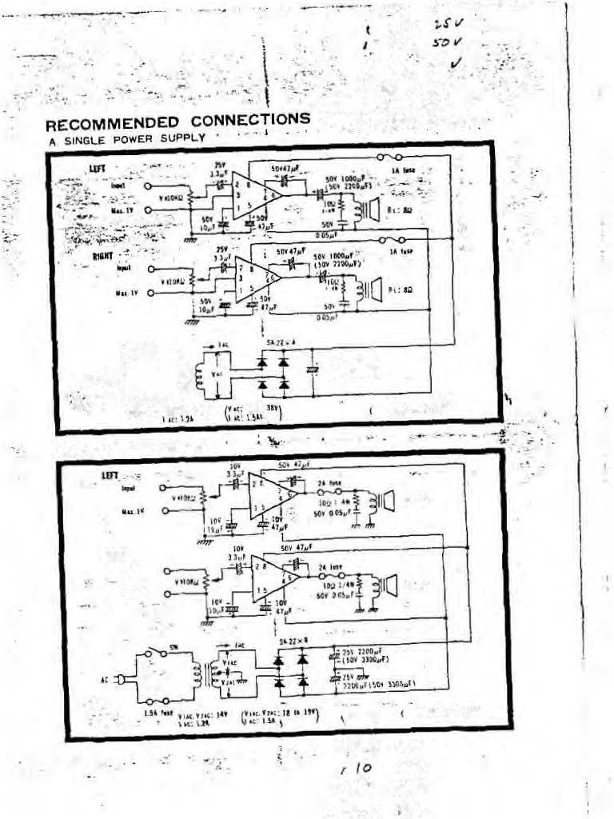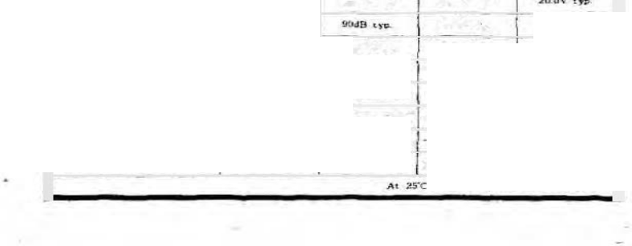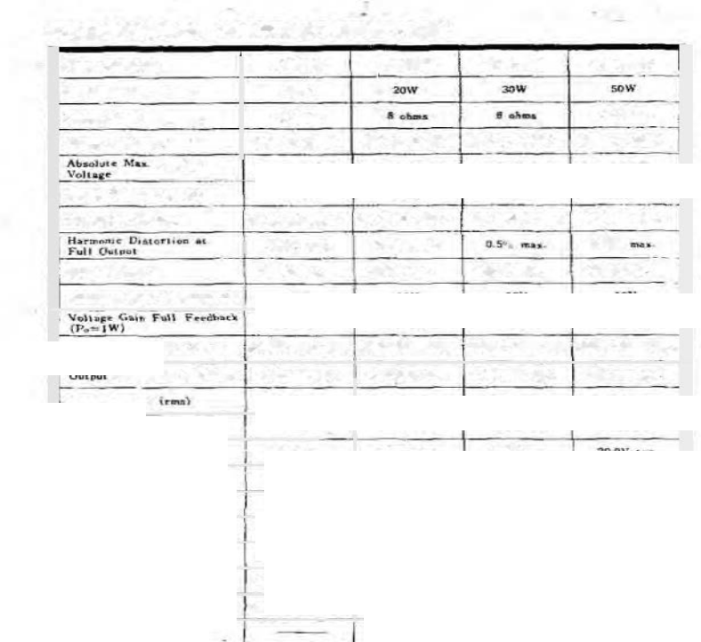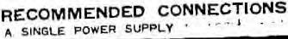-:.. 4 7 �-� v
�---···· -· - · -- -·--:--
. : ('(} 1 . � v
: ·

RECOMMENDED
A. SINGLE POWER SUPPLY

'""''

.
1 I t'lv· '• • 'I
(SI·lOlOG & Si-lOooG�

IA1illw

lit!IJ,l

'·;.

Ill.!�

!o- .Uv 1N•)j.(f
(I!Y mOufl

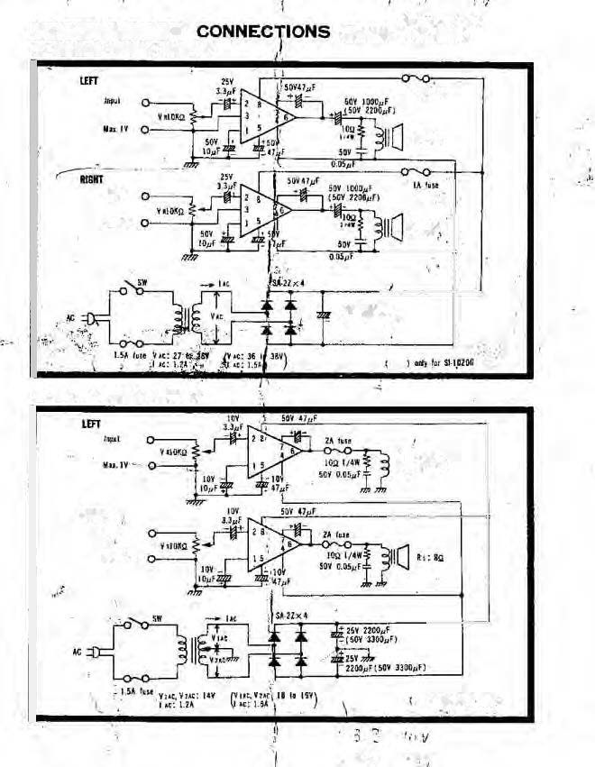

B.S�IT POWER SUPPLY

110 '" Ill

liGHT I�pill

jfaa.l't

I ,,., '" !l tulOS

. '

ELECTRICAL CHARACTER�TICS
Cher'acterls.tic SI·IOIOG ��H020<i SH030G SHO�OG (
Muimutn rn•s Pawu IQW 20\V 3DW sow

Oot_pul Lo&d a' ohm• 1' 8 �.Jlms 6 ohms 8 olu�>£
._.
SlilPPIY Volt•se JAV <>•. ±17V 41t:· 'or ±23V 54V or ±27V 66V or 1:JJV
··----

Voltaae
4SV or ±22.SV

: 1 : 2 5 V
6DV or ±JDV !!OV or ±40V

SuJ)l)ly Currtal bve.) 1J.SOA ; 0.721\ 0.66A LlA
Protectivt Fusio� lA Quie� Blow JA Cl lek Blow l.SA Q.uck Blow 2A Q11i<k ,Blow

Hai-moni� L>�tlorti� at 0.5% ..... .....
0,5% mAJ:.

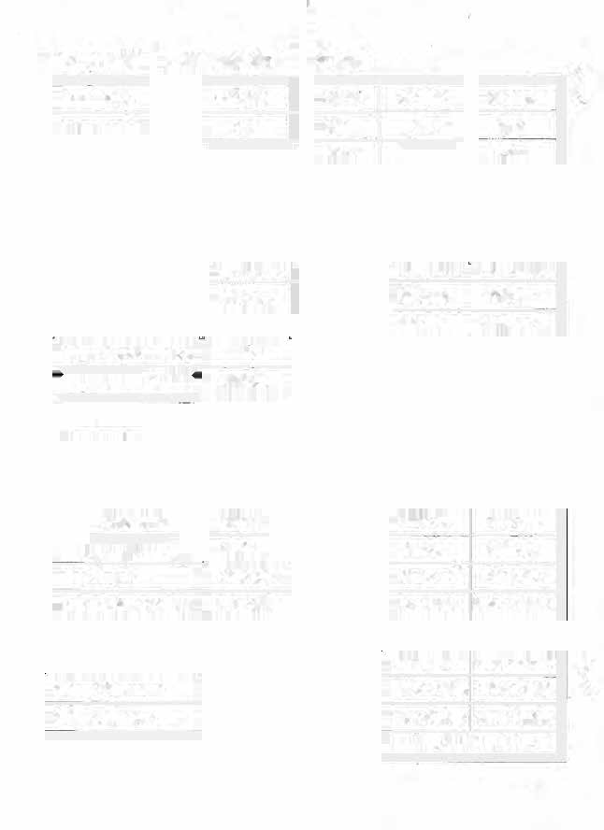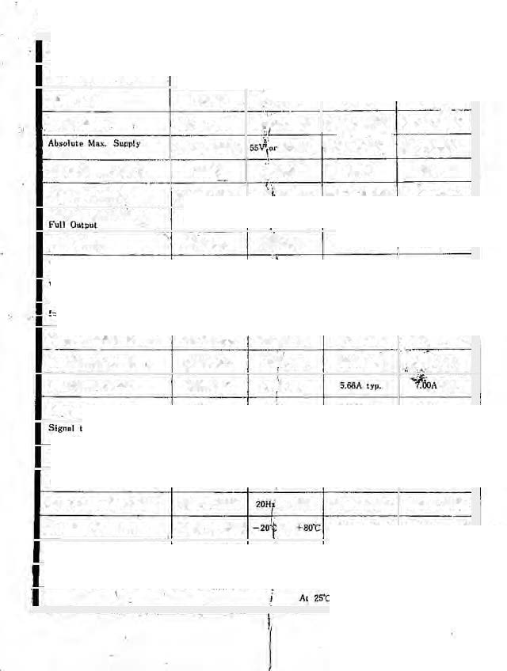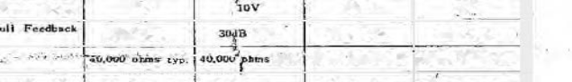lnl)ot Voll1ge O.JOV tYJl. o.qv •r•· I>.S2V tyo. 0.70V cyo.
t.tnimom Input Vollace(p-Q) lOV lOY · IOV

!P.=IW) 30dB tyo. iY1J. 30d8 tyo, 30d8 ,,._
(.v�t- 4Q,OOO olvU' •>i>- r40,ootl 6i..• t)'P. Outpt,�l Impedance (Po=lW) 0.2 ohm t1o. 0.2 ��.. ,,•• 0.2 oJ\m tJ'P. 0.2 �htn ·l)�
.
...
Load Current {nul 0.89A typ. l.SSA tYJ>• 2.00A tJP. ·2.50A 11•·

Lc,.d C"rrc.nl {p·p) 2.52A typ. 4.45t\ typ. tyo.
"Output Volt..< (rr..) 8.9V typ. typ. J6.0V typ. zo.ov typ.

(Input Shorted) 90dB cyp. 90 n typ. 90dB ryp. !Ml<IB '»· IdUna CurrtrJt 20mA typ, typ. 20mA typ, 20mA typ. FrC'q!v.eneJ Range- fP•=1W) 20Hz to 100kHz 20Hz \o IOOklh 2011< to IOOHt.r 20Hz to IOOI<Hr
Power Band11idth (-JdB) 20Hr. to 20kHz to 20kH• 20Hz to 20ktb :WHz to 20kHz

• Oper•tins Ttmpf!'ratur·e -1o·c co +7<rc to -zo·c to -�;so·c -20'(: to +80'C
Stllr"'e- Tem�nture -2s·c to us•c -30:� to + IOO'C -3<J'C to HOO'C -30'C to +1oo·c (
Buill•in ProtediGn ---- .:urrent lilnitiac curnnt Umili"n«

SC &� C E �'" A TDC DH A C.j RAM TRM -408

.. ....
"'' '
1 \ '11·..
' ....__.

. ..

, .. I
�·
,..
-�· (.!\: ...
�· -�·. r, ;11
�· �:
-·

'" .......... r·

BASS
lOD I(

OUT

50pF/25V
J
20 to 36 V

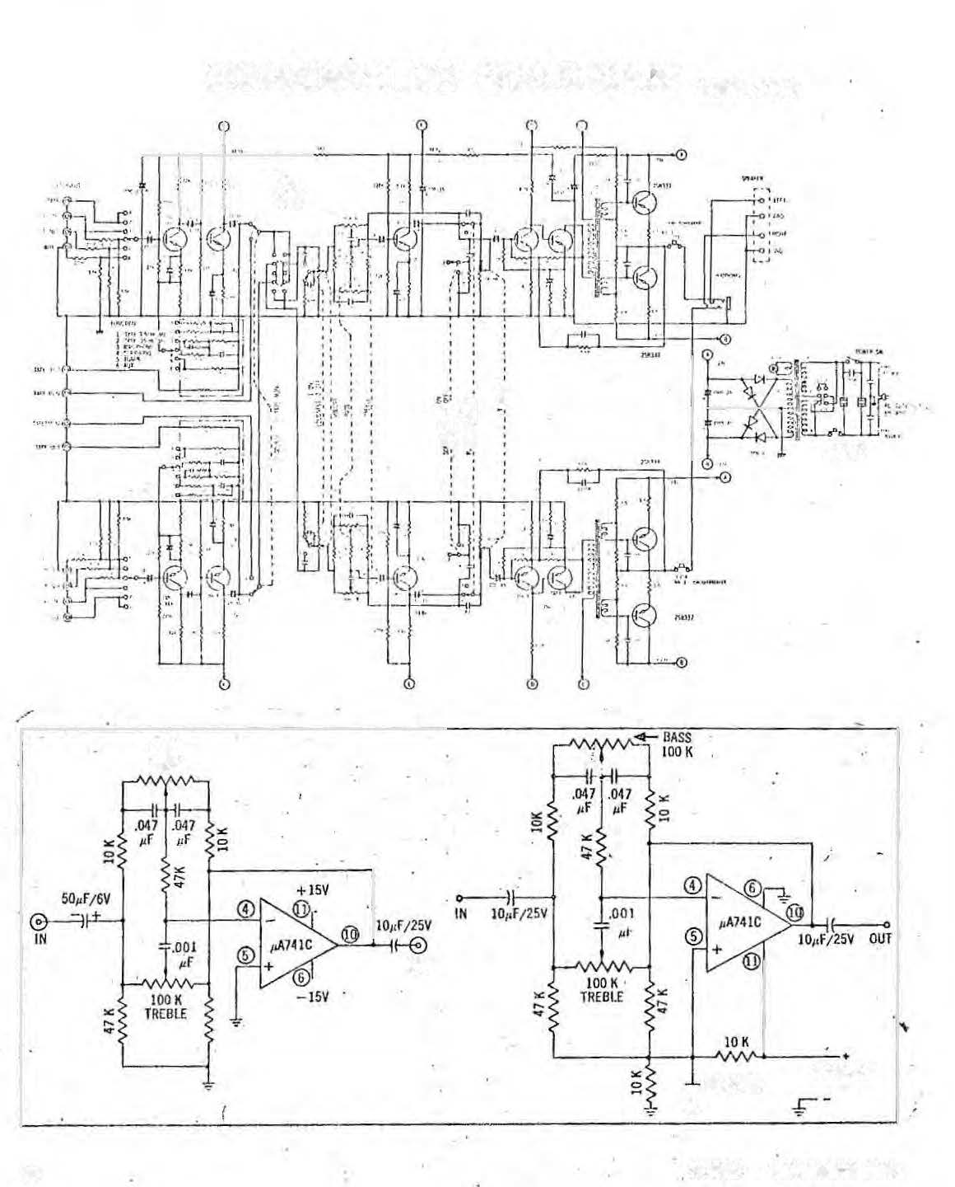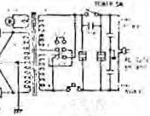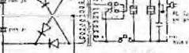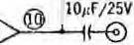

32 AUDJO • NOVEMBrR 1969

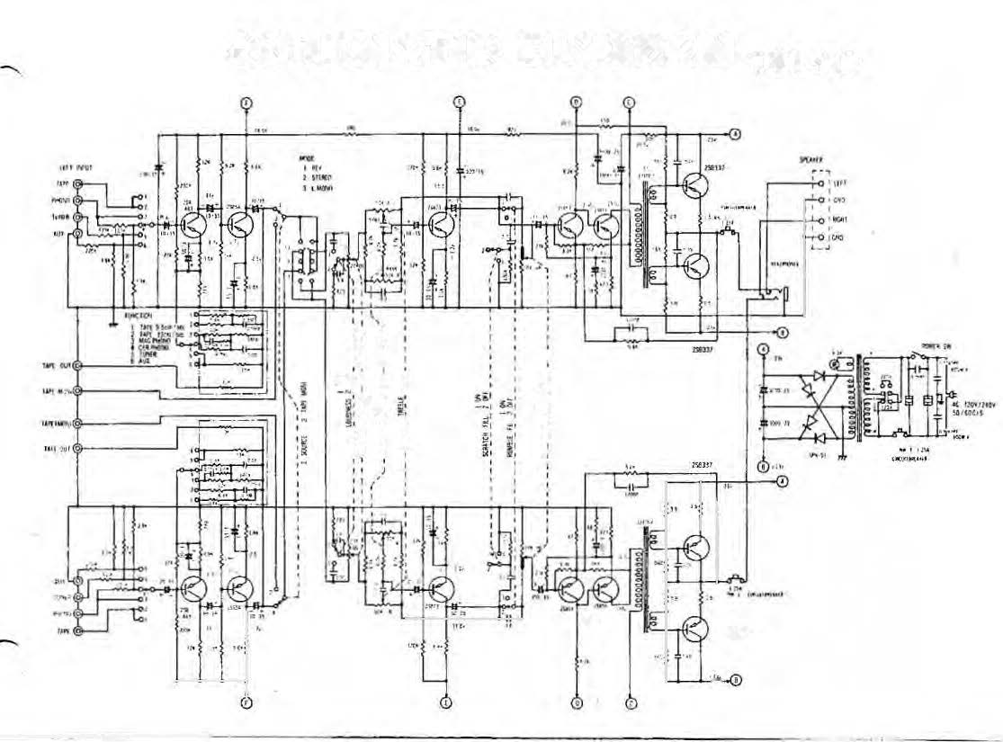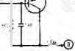SC H E M ATIC DI AG RAM TRM -408

' ' '
'I I. I.
' . . •
I
�': I ! : -·
:1 : !:
&,
,f �.
1 I I •
'
I . I I
' • t I '
I
I I

t+••

-·

