SERVICE MANUAL

SEEBURG SYMPHONOLA

19391\IODELS
CLASSIC-VOGUE MAYFAIR-PLAZA-CASINO

•

.J. P. SEEBURG CORPORATION

FORE WO HD

This manual has been prepared to assist the service engineer in making any adjustments and repairs that may be necessary on 1939 Seeburg Symphonolas.
In preparing this manual every effort was made to present the material in as simple a form as possible. Wherever practical, the steps in a particular operation. are set forth in numbered paragraphs.
Seeburg maintains a nation-wide organization of field engineers to instruct and cooperate with your ser­ vice department. You will find these men up to date on all information pertaining to service. In addition, we maintain a home service department at the factory to
help you and to furnish you with any technical or ser­ vice information that you may desire.
When requesting information by wire or letter relative to the Symphonola, please give Model and Serial Number. Also please give a full description of the problem at hand so that we may be better able to serve you.

TABLE OF CONTENTS

To Prepare Instrument for Operation Operation and Maintenance • . • • •

. .
. . . .
.
. . . . . . . . .
PAG
5
7

Motor • • • • • • • • • • • • • . . . . . . . . .
Motor Fuse Blows • • • • • • • . • • • • • • • • • • • Meehanism Fai 1 s to Respond When Coin is Inserted • • • Magazine Relay Does Not Respond to Coin • • • • • • • Turntable Fails to Rise to Playing Position • • • • • Too Few Plays for the Amount of Coins Inserted • • • • Too Many Plays for the Amount of Coins Inserted • • • Coin Switch Assembly • • • • • • • • • • • • • • • • • Needle Does Not Enter Record Groove Properly • • • • • Changing Mechanism not Set in Operation at the End
of Record Play. . . . . . . . . . . . .. . . . . . . Turntable Does Not Rotate When in Playing Position • • Record Coming up to Playing Position and Returning
Without Being Played. • • • • • • • • • • • • •
Tone Arm Weight Adjustments • • • • • • • • • • • • • Continues to Repeat Same Selection • • • • • • • • • • Selector Pul I ing Out Two or More Trays at One Time • • Record Trays Cannot be Returned to Their Normal
Position After Changing Records • • • • • • Sound Equipment • . • • • • • • • • • • • • • • • • • Sound Equipment Apparently Dead • • • • • • • • • • • Faulty Tone Quality • • • • • • • • • • • • • • • • • Instructions for Installation of Extra Speaker and
Volume Control Unit • • • • • • • • • • • • • • Junction Terminal Box • • • • • • • • • • • • • • • • Light Fuse B 1 ows • • • • • • • • • • • • • • • • • • • Record Playing Indicator Dial • • • • • • • • • • • •

Symphonola Chassis, Plate No. I • • • • • • • Symphonola Chassis, Plate No. 2 • • • • • • • • • • • Symphonola Chassis, Plate No. 3 • • , • • • • • • • • Symphonola Chassis, Plate Ho. ij • • • • • • • . • • • Coin Switch Assembly, Plate No. 5 • • • • • • • • • •

(Table of Contents conttnued on next pa�e)
7
9
I 0 10
10
I I I 2
I 3

13

I ij I5

16
16
I 7 I 8

21
2 I
23
23

2ij 25
26
27

28,2
30,3
32,3
3ij,3� 36,37

Symphonola Cabinet Wiring I I S Vo It, 60 Cycle. I I Symphonola Cabinet Wiring I I S Vol t, D I c I I I I I
Symphonola Cabinet Wiring
32 Vo It, D. C. . I I .
Symphonola Cabinet Wiring I I S Volt, 60 Cycle. I . Symphonola Cabinet Wiring I I S , DI c. I . I I . I I
Symphonola Cabinet Wiring
32 Volt, DI c. I I I . I
Symphonola Cabinet Wiring

Diagram - Mode I I I I I I I I I
Diagram - Mode I
I I I I I . I I
Diagram - Model
. . I I I . . I
Diagram - Mode I I I I I I I I .
Diagram - Model I I I I . I I I
Diagram - Model
I . I I I I I I
Diagram - Mode I

Mayfair
I I I I
Mayfair
. I I I I I
Mayfair
I I I I . I
Plaza
I I I I I .
Plaza
I I I I I I
Plaza
. • I I I I
Casino
PAGE

39

40

4I

�2

�3

I IS Volt, 60 Cycle. • •
I I I I I . I . I I I I �4

Symphonola Cabinet Wiring Diagram - Model Casino

llS Volt, D. C.. • • • •
I I I I I . I I I I I I I I 4S

Symphonol a Cabinet Wiring Diagram - Mode I Casino

32 Volt, D.C. • • • • •
. I . I I I I I I I I I I I 46

Symphonola Cabinet Wiring Diagram - Mode I Classic

llS Volt, 60 Cycle. • •
I I I I I I I I . I • I 47

Symphonola Cabinet Wiring Diagram - Model Classic

I IS Volt, D.C.. • • • •
I . I . . . I I I I I I �8

Symphonola Cabinet Wiring Diagram - Model Classic

32 Volt, D.C. • • • • •
I . . I I I I I I I I . I I 49

Symphonol a Cabinet Wiring Diagram - Mode I Vogue

llS Volt, 60 Cycle. • •
I I I I I I I I I I I I I . SO

Symphonola Cabinet Wiring Diagram - Mode I Vogue

llS Volt, D.C.. • • • •
I I I I I I I I I I I I t I SI

Symphonola Cabinet Wiring Diagram - Model Vogue

32 Volt, D.C. • • • • •
Amp Iifier Wiring Diagram Used | Symphonola | - | Model
M ayfair, Type 820C-2 • • • • | • , • • , • • | • | • • • | • | S3
Ampl ifier Wiring Diagram Used | in Symphonola | - | Model
Mayfair, Type 830-1-Z • • • | • t • • • • • | I | t • • | • | s�

I I I I I . I • . • I . I I S2

Amplifier Wiring Diagram Used Plaza, Type 720C-2· • • • • AmpI ifier Wiri�g Diagram Used Plaza, Type 72S-1-Z • • • •

in Symphonola - Model
SS
• • • • • • • • • • • •
in Symphonola - Model
. . . . . . . . . . . . S6

Amplifier Wiring Diagram Used in Symphonola - Model
Casino, Type 62S-1-Z. • • • • • • • • • • • • • • • S7

TO PREPARE INSTRUMENT FOR OPERATION

UNPACKI NG: We advise that the packing case be carefully examined before unboxing instrument, and should there be any indication of concealed damages, the transportation company should be notified.
(I} Remove the screws holding the front of the packing case, to

the sides.

(2} Carefully remove instrument from packing box.
(3) Open doors in back by means of the keys which are wrapped and fastened to the coin slot.
(4} Remove the fastening from tone arm to tone arm post bracket.
( 5) Remove shipping block holding record trays, and shipping brace and wooden block which hold the motor rigidly for transportation purposes. It is advisable t� keep these braces in the bottom of the instrument and use them again when transporting the machine.
(6} Remove four wing nuts in each corner of the chassis.

MOTE: Wing nuts should be removed so that the chassis may be resiliently suspended in the spring mounting. This is absolutely essential in order that the best tone quality may be obtained. When instrument is again to be moved, these wing nuts shbuld be replaced and tightened down so that they hold the chassis rigidly.
NEEDLE: The Symphonola Pickup is designed to use any standard phonograph needle, however, we recommend the type supplied with the instrument. The needle should be installed having the flat part of the needle aligned parallel to the grooves in the record.

5

SERVICE MANUAL FOR 1939 MODELS

CURRENT SUPPLY FOR I NSTRUMENT: On the back of each instrument will be found a name plate which gives the type of current upon which the instrument is designed to operate. If in doubt as to whether or not the type of current at the location is correct, look at the house watt hour meter or call the local power com­ pany for this information.

I NSTRUC TI ONS FOR I NSTALL I NG RECORDS: A set of record support discs will be found fastened inside of cabinet. One disc should be used as a support underneath each record. It is not necessary to remove the record support discs from the trays when records are being changed, but it is important to make certain that both the discs and records are centered properly in the record trays.
When installing or replacing the records in the instrument, it is best to install or replace the record in No. 20 tray first. Install or change balance of records starting with No. 1 tray and work down thru stack of record trays until all the records are in their respective trays. As each record is put in its tray the title for that particular record should be put in its proper place in the program holder.
After all trays have been filled they must be returned to their original position by hand excepting No. 20 which should remain over turntable.

6

SERVICE MANUAL FOR 1939 MODELS

OPERATION & MAINTENANCE

APPEARANCE: It is important that the general upkeep and appear­ ance of the instrument be maintained. A careful selection of good quality records that fit in with the location should be made. Typwritten or printed title slips should be used at all times. This not only adds to the attractiveness of the instru­ ment, but increases its earnings.

LUBRICATION: Oil the gears occasionally using an automobile oil having a viscosity of 20. Oil all friction points,
such as the high speed transmission bearings and selector feed clutch plates on toothed rack. We recommend this oil inasmuch as the ordinary light sewing machine oil on the turntable shaft or transmission shaft or transmission bearings has not enough body to retain proper lubrication. The slide grooves may be oiled sparingly should the record carriers become binding or
sticky. If grease has been used in the slide grooves or 5rooves1 b�come gritty or 5urruny, the record carriers may bind. Same
should be washed thoroughly with a brush and a light grade of good quality lubricating oil. Wipe clean and re-oil sparing- ly. DO ::o':' USE VASELINP OR ANY GREASE IN THE SLIDE GROOVES AS IT WILL QUICKLY GUM UP CAUSING A HEAVY LOAD ON THE SELECTOR SLIDE PLATE.
MOTOR
The motor used to drive the mechanism is a 1/30 H.P. induc­ tion type .,:_ a starting winding and a starting winding switch. The starting winding switch automatically turns off
7

SERVICE MANUAL FOR 1939 MODELS

the current to the starting windings when the motor has attained the proper speed.
- Motor does not start: Blown or defective motor fuse. Check
motor fuse in Junction box. Make sure contacts in play magazine are closed and are making proper contact. A bind in mechanism may cause too heavy a load on motor and will not allow it to turn.
- Motor does not start until coupling is disconnected and
motor is spun with fingers: Cause of trouble in this case may be a defective starting winding switch or a burned out starting winding. By removing the end plate of the motor the starting winding switch is made accessible and can be cleaned with fine sand paper, then wiped with a clean cloth.
- Starting winding cuts in and out continuously: This is usually due to a bind in the chassis mechanism which allows
the motor to just barely come up to enough speed to open the starting winding switch - the motor speed is then im­ mediately reduced due to the heavy drag causing the starting switch to close again.
- Motor Base. No. 1840, Fig. 2: The motor is resiliently
mounted on steel springs in order to prevent vibration from the motor being transmitted through the chassis and reaching the pickup.
- Note: It is important that the two sides of the loop in
the spring No. 1841, Fig. 2, mounting do not touch each other where they cross. If they do vibration will be

8

SERVICE MANUAL FOR 1939 MODELS

transmitted into the chassis and interfere with the true reproduction of music.

MOTOR FUSE BLOWS
  - Replace with a 3 ampere fuse but before replacing, find what caused fuse to blow.
There are a number of reasons that will cause the motor fuse to blow. The most usual reason is the failure to re­ move all shipping blocks.
Hake Sure Instrument ts Completely Unblpcked:

(2) Bind in transmission gears No. 3054 and No. 1071, Fig. 1, causing overload on motor. Tight bearings in motor. This can be determined by loosening coupling No. 1083, Fig. 1 and turning motor with fingers. It should turn freely.
(3) Record trays may be jammed due to dirt or grit in the tray grooves. Neither vaseline nor grease should ever be used to lubricate the tray grooves as binding of the trays is almost certain to be the result. If grease has been used in the grooves, they can be cleaned by applying with a brush, a light grade of good quality lubricating oil.
(�) If instrument has been in a cold place over night, it should be allowed to warm up before the current is turned
on, otherwise the lubrication will be stiff causing a heavy drag on the motor which will often blow the fuse.

9

SERVICE MANUAL FOR 1939 MODELS

MECHANISM FAILS TO RESPOND WHEN COIN IS INSERTED

Corrective measures will be found under the following headings:
Page No. 9 Motor Fuse Blows

Page No. 7

Page No. 10

Page No. 10

Page No. 13
Motor

Magazine Relay Does Not Respond To Coin Turntable Fails to Rise to Playing Position Coin Switch Assembly

MAGAZINE RELAY DOES NOT RESPOND TO COIN
(I} Look for loose line cord connection at wall outlet.
(2) Make sure that Service Relay lamp in Ju nction Terminal Box is not burning. The play magazine is inoperative when service relay light is on.
Service relay lamp may be loose in its socket or may be burned out. If lamp is burned out, replace with a 120-V (60 W lamp) except in the case of 32 volt D.C. instrument
where a 32 volt - 25 watt lamp is required.

- Defective Magazine Relay Magnet No. 1537A, Fig. 2, broken wire or bad connections on magnet posts.
( 5) For other corrective measures, refer to "Coin Switch Assembly", page 13.

TURNTABLE FAILS TO RISE TO PLAYING POSITION
  - Insufficient or faulty lubrication on the turntable spindle bearings. Use SAE-10 oil. DO NOT USE a light sewing machine oil as it does not have the body required at this particular point.

10

SERVICE MANUAL FOR 1939 MODELS

- Foreign obstacles such as dust or grit entering turntable bearings.
- To remove dirt and foreign matter from turntable spindle No. 1011, Fig. 3: With turntable in uppermost position and the
motor cut off by means of turning off main switch in Junction Terminal Box, flood generously with oil, moving the turntable up and down with the fingers, and wipe off with a clean cl oth. Repeat this operation until the shaft and bearings are clean. Re-oil lightly with No. SAE 10 oil before leaving instrum
(ij) If turntable lift springs No. 1009,. Fig. 3 are too weak, replace with new springs from the factory.
- It is possible that turntable gears may be meshed too
tightly. There should be a slight play between the teeth of the turntable worm gear No. 1528-A and steel worm No. 1022, Fig. 1. Transmission casting No. 1040, Fig. 1 con­ taining the steel worm assembly can be moved away from the turntable worm gear No. 1528-A to allow about . 00511 play between the teeth of the gears.

TOO FEW PLAYS FOR THE AMOUNT OF COIN S IN SERTED
  - Coin Switches may not be making contact. Refer to "Coin STitch Assembly", page 13. Refer also to "Magazine Relay Does Not Respond to Coin", page 10.
(2) Magazi�e Ratchet Wheel No. 1525-A, Fig. 2 should be rotated
one notch for each stroke of the Magazine Ratchet Pawl No. 1532A when the Pawl is released by the Ratchet Pawl Release Block No. 1153.
II

SERVICE MANUAL FOR 1939 MODELS

If Ratchet Wheel should rotate two teeth for each stroke of the Pawl, this difficulty may be overcome by cutting about one eighth of an inch off the Magazine Ratchet Return Spring No. 1143, Fig. 2. This will strengthen the spring which
will resist the ease of rotation of Ratchet Wheel slightly.

TOO MANY PLAYS FOR THE AMOUNT OF COINS INSERTED
(I) It may be that one of the Coin Switches is making more than one contact, as the coin passes the Switch Lever. Refer to "Coin Switch Assembly Unit" page 13.
- Play Magazine Switch may not be cutting off. Checlr for
binds of any sort in switch lever, escapement lever, ratchet wheel, etc. The tooth of Escapement Lever No. 1512A, Fig.
2, should catch the tooth of Magazine Ratchet Wheel No. 1525A as the Magazine Ratchet Pawl No. l532A is released
from the corner of Pawl Release Block No. 1153. This should rotate the Ratchet Wheel one tooth for each cycle of the Cam Shaft.
The action of the Magazine Ratchet Pawl No. 1532A is caused by the rotation of the Cam Shaft, upon which it is mounted.
- The Escapement Lever should be free from binds and have
about 1 /64 inch clearance between teeth of Lever 1512A and the Ratchet Wheel No. 1525A as the Escapement Lever is moved to and from the Magazine Relay No. 1537A. Should the tooth of the Escapement lever not hold the Ratchet Wheel after
Ratchet Wheel has been rotated, same could be caused by a weak Escapement Lever Spring No. 1150. Spring may be

12

SERVICE MANUAL FOR 1939 MODELS

strengthened by cutting off two or three coils.

COIN SWITCH ASSEMBLY
  - As shown in Fig. 21 when a 25¢ coin enters the runway, it successively moves the levers of the coin switches Nos. 1,
2, 3, 4 and 5 downward, making a single contact for each lever moved. Each contact made should store a play in the Play Magazine.
- Fig. 20 is a front view of the Coin Switch Assembly showing
the 5¢ and 10¢ coin runway. When a 5¢ coin enters, it

travels down the right hand runway, moving the lever on #4 coin switch downward, making a single contact. This should store one play in the Play Magazine.
- When a 10¢ coin enters, it travels down the left hand run­ way, moving the levers of #1 and #5 coin switches downward,
making two c ontacts. This should store two plays in the Play Magazine.
(�) If coin switches fail to make proper contact, it is usually
because they have accumulated dirt or a film on the contact surfaces, which may be cleaned by using a dry cleaner, such as, carbon-tetrachloride. The best way to apply the clean­ er is to dip a small brush in the cleaner and wipe the contact surfaces several times with the brush being careful not to bend the blades of the switches too far, as this may bend them out of adjustment.

NEEDLE DOES �OT ENTER RECORD GROOVE PROPERLY
( I) As the turntable comes up with a record, the needle should contact the record about 3/32" from its edge. This should
13

SERVICE MANUAL FOR 1939 MODELS

be for an average record which will be found to be approx­ imately 9-7/811 in diameter. The adjustable support hook No. 1846, Fig. 3 that holds the tone arm in position, ras the turntable is being raised, may be adjusted so that the needle will rest in its proper position on the record.
If the needle stays in one position on the record and does not enter the playing groove, the cause may be a bind in the tone arm support rod No. 1121, Fig. 3, instrument being too far out of level. If there is any sort of a bind in
the tone arm support rod No. 1121, same should be traced down and remedied, as this will cause an improper repro­ duction of the music as well as excessive record wear.
(3) If the instrument is too far out of level, same should be
leveled up within reason. A tone arm booster spring No. 1124 is shown in Fig. 3. This may be adjusted if necessary to assist the movement of the needle toward the playing grooves of the record.
(�) If tone arm booster spring No. 1J24 is adjusted with too much tension, same may cause tone arm to skid across record, when the turntable rises to playing position.

CHANGING MECHANISM MOT SET IN OPERATION AT END OF RECORD PLAY
{I) If stop groove in record is worn out or damaged, destroy such a record and replace with a new one.
(2) If there is a bind in the tone arm support rod #1121, Fig. 3, it may seriously affect operation of the needle in the cutoff groove, causing it to skip over and not follow the groove. The bind should be remedied before attempting
any adjustments.

I�

SERVICE MANUAL FOR 1939 MODELS

Changing Mechanism should be set in operation when the needle enters the stop groove and has traveled to within a distance of 1-7/811 from the center of the turntable spindle. Should adjustments be necessary, refer to Fig. 10 and make adjustments with the adjusting screw No. 1085 until the proper setting has been made. Occasionally a record may be foun where the music has been recorded past the limits set for the cutoff mechanism. It is inadvisable to reset the mechanism to trip off for such a record.
( �) Transmission worm shaft No. 1044, Fig. 1, may be binding.
Sarn should slide back and forth freely. Steel worm
No. 1 071 and large worm gear No. 3054, Fig. 1, may mesh too tightly, causing shaft to bind slig�tly, or the flat spring No. 1075 may be too weak. Spring may be strengthened by removing and reforming the bend, taking care not to make the bend too sharp or the spring may break.
  - (5) If trip lever in rear of cabinet is binding in hole through
rear panel, it may cause pressure against the clutch re- taining yoke No. 1508A, Fig. 10, preventing yoke from engaging clutch retaining lever No. 1052. The trip lever
should work freely with rear panel installed.

TURNTABLE DOES NOT ROTATE WHEN IN P LAY ING PO SITION
( I) Turntable clutch No. 1014, Fig. 1, in the lower end of turn- table spindle should have a slight slippage to absorb the jar as it engages with the clutch pin situated underneath the turntable gear No. 1528A. If this clutch is too loose it will not drive the turntable. In this event, the clutch spring
I 5

SERVICE MANUAL FOR 1939 MODELS

No. 1815 should be replaced.

(2 ) Turntable clutch No. 1014, Fig. 1 should come in engagement with the pin un eath the turntable gear No. 1528A, Fig. 3. With turntable in raised position, the turntable elevating
cam No.1006 should be clear of cam roller No.1016, Fig. 3 , so that the turntable clutch will engage the clutch pin in turn­ table gear. If turntable elevating cam does not stop in cor­ rect playing position same can be s lightly adjusted by means of the adjusting screw on clutch release pawl No. 1077 mount­ ed on the turntable elevating cam 1006, shown in Fig. 1.

RECORD COMING UP TO PLAY ING POSITION AND RET URNING WITHOUT PLAYING

( I) This may be caused by the clutch retaining lever No. 1052, Fig. 10 slipping off the edge of clutch retaining yoke
No. 1508A at the points where they meet. Strengthening the yoke spring No. 1057 , Fig. 10 by removing four or five coils from the same should help overcome this condition.
- Make certain that the ratchet pawl No. 1056, Fig. 10, ( which becomes operative when the older type Victor records are used ) clears the saw teeth No. 1058, when the yoke drops
down and when the tone arm is directly over the notch of the tone arm post bracket No. 1846, Fig. 3.
TONE ARM W EIGHT ADJUS TMEMTS
The weight of the tone arm at the needle with the needle just barely clearing the record should be about 3 .5 ounces. A small
tone arm weight scale will be furnished each dealer o.r service man on request which facilitates the weighing of the pickup and tone arm.

16

SERVICE MANUAL FOR 1939 MODELS

As shown in Fig. 19, the indicator pointer of the scale should be directly opposite the needle screw just as the needle is leaving the grooves of the record. If the tone arm is too heavy or too light, adjustment can be made by bending the flat spring underneath the tone arm upward or downward respectively.
If this weighing test is made while instrument is playing, it is easy to determine just when needle starts lifting out of the grooves. Note: It is best to make a weight test near the start of a record.

CONTINUES TO REPEAT SAME SELECTION
  - Selector mechanism should rotate freely with selector levers in non-selecting position. Same should be checked carefully for any binds. A bind in any part of ·the selector mechanism would cause the same to operate improperly.
- With selector levers in upward positions, the helix pins No. 1254, Fig. 18 should clear the stop tooth on the selector levers. If a selector lever tooth engaged one of the front helix pins No. 1254, the helix could not rotate
and would, therefore, repeat the same selection as often as this position of selector would be maintained. To eliminate this, the front helix No. 6062A, Fig. 18 should be lowered slightly until helix pins clear the stop teeth on the levers above. The stop pin, Fig. 18, that holds front helix up in position can be moved down slightly until helix pins clear the levers, when the levers are in their uppermost, or non­ selecting position. This should enable front helix pins to clear the teeth in the selector levers.

17

SERVICE MANUAL FOR 1939 MODELS

( 3) If no selection is made the rear helix No. 1583A Fig. 3 must rotate 21/20 of a revolution for each complete cycle of the
cam shaft. This will enable the selector to advance one number, and bring out a new record, each time the instru­ ment is played without selecting.
By marking the sprocket No. 1221, Fig. 11, with a pencil at the last position of the roller No. 1822 and watching the rotation of sprocket with mechanism in opera­ tion, the amount of rotation may be determined. Proper adjustment of same can be made by means of adjustment
screw in segment gear No. 1807, Fig. 3, that controls the amount of travel of the segment gear. The amount of travel of this segment gear determines the amount of rotation of the selector helix - when no selection is made.

SELECTOR PULLING OUT TWO OR MORE TRAYS AT OME TIME
  - When a selection is made one tray only should be pulled out at a time. The trays are wi thdrawn by means of the selector slide pawls No. 1183, Fig. 8 (of which there are twenty).
One of these becomes engaged to a lug on a tray No. 1110, when one of the rollers No. 1223 of helix No. 1583A push against the selector slide pawl spring No. 1184, thereby moving the pawl No. 1183 inward, as shown in Fig. 8.
The selector pawls No. 1183, Fig. 8, are urged inward at all times by the action of the selector pawl springs
No. 1184. But when the selector slide No. 1180 is in posi­ tion with the selector pawls opposite the lugs as shown in Figure 6, then the action of the selector pawl lift springs
18

SERVICE MANUAL FOR 1939 MODELS

stud No. 1222, Fig.3, slightly upward or downward until the proper alignment of the roller with the selector pawl spring is attained.
(2) The selector pawl lift spring No. 1113 shown in Fig. 8,
should be strong enough to overcome the pressure of the se­ lector pawl spring No. 1184, Fig. 8, expecting when the roller No. 1223 of the selector helix gives the added pres­ sure to selector pawl spring No. 1184. If the selector pawl lift spring No. 1113 is not strong enough, it may be strengthened by bending outward slightly, or the same result may be obtained by weakening the opposing or selector pawl spring No. 1184 slightly.
(3) Helix No. 1583A should stop after being rotated in such a position that the helix lock roller No. 1125, Fig. 11, rests in the recess of the sprocket No. 1221.
If the helix is stopping with lock roller No. 1822, resting on tooth of sprocket No. 1221, it may be that the segment gear No. 1807, Fig. 3 does not travel the prop�r distance. This may be corrected by carefully following these in�tructions:
See that all selector keys are in cancelled position.

In other words, that no selection is made. Then place roller No. 1822, Fig. 11, in one of the recesses of the sprocket No. 1221, put a pencil mark on sprocket at point where roller is in contact - then start �echanism in motion, and watch the rotation of the sprocket. It must turn 21/20 of a revolution, or one recess of the sprocket past the

20

SERVICE MANUAL FOR 1939 MODELS

No. 1113 should be strong enough to overcome the pressure of the selector pawl springs No. 1184 and prevent the selector pawls from becoming engaged to the lugs on the trays Fig. 6. That is, with the exception of that parti­ cular pawl which is pressed in through the action of the helix roller against the selector pawl spring No. 1184, Fig. 8.
The following added points should be carefully checked and adjusted if necessary:
The selector helix rollers No. 1223, Fig. 3, should be in line with the centers of the selector pawl springs
No. 1184. If out of line so that roller also engages the spring above or below the one selected it may depress two pawl springs causing two trays to be withdrawn. The se­ lector slide rail No. 1181, Fig. 3, may have moved downward slightly, or the helix No. l583A, Fig. 3 may have moved up or down. Before attempting to re-align the selector slide rail, be sure that this is necessary. Make certain that the selector slide pawls No. 1183, Fig. 3 are kept in alignment with the grooves in which the lugs of the trays move.
In re-aligning the helix, be sure that the proper mesh of the miter gears No. 1210, Fig. 7, is maintained, and that the timing of selector is not disturbed, or if so, properly retimed. If one or two rollers are out of line with the selector pawl springs, the adjustment of same can be greatly simplified by bending the helix roller mounting

I9

SERVICE MANUAL FOR 1939 MODELS

pencil mark, and lock roller No. 1822 must stop directly in this recession. The rotation of selector is controlled by the segment gear No. 1807, Fig. 3. If amount of rotation of the selector is not correct, adjustment can be made by ad­ vancing or retarding small adjusting screw (in segment gear No. 1807). This segment gear No. 1807 rotates the helix through the small driving gear No. 1809, Fig. 7, that is mounted on the selector shaft No. 1816 and upon which the miter gear No. 1210 is also mounted.

RECORD TRAY� CANNOT BE RETURNED TO THEIR NORMAL POSITION AFTER CHANGING RECORDS
Motor switch may open too late. To cut motor off earlier, the setscrew of Magazine Kicker Block No. 1513A, Fig 2 should be loosened slightly and No. 1513A should be tapped lightly with a light hammer in a clockwise direction. Block should not be moved more than about 1/16 of an inch at a time. The setscrew holding same should be well tightened before starting the mechanism.

SOUND EQUIPMENT
Pickup: The pickup is of special design and is built to match the other parts which make up the sound equipment. It is very rugged in design both mechanically and electrically and will stand wide changes in both temperature and humidity. The pickup is sealed and if it should at any time prove defective, return same to factory with seal unbroken. A very nominal charge is made for the repair or replacement of a pickup with its seal intact.

21

SERVICE MANUAL FOR 1939 MODELS

Volume Control: The volume control is located in the Junction Terminal Box and is so designed that the volume may be adjusted from off to full level with an even rate of increase. Should the control cause the volume to jump up at a rapid rate when turned and then go down again when turned slightly farther, the control is defective and should be replaced.

Amplif ier: The Amplifiers used in the models Mayfair, Plaza and Casino are the Models 830-lZ, 725-lZ and the 625-lZ respec­ tively. They are all designed to operate at any volum set by the control from very soft to full output without distortion or bad tone quality. All the amplifiers are equipped with Dual Tone compensators one of which is used for modifying the high frequency notes and the other for modifying the lower frequen­ cies or bass notes. Care should be used in adjusting these be­ cause by subduing either the high notes or the low notes to too great an extent, the tone quality and faithful reproduction of music will be greatly impaired.

Tubes: When installing or replacing tubes, special attention must be paid to the designated number on each tube. Each tube must be inserted in its proper tube socket having a correspond­ ing number, Failure to do so may result in a burned out tube filament or a blown amplifier fuse. Make certain that each tube is firmly pushed into its socket to make proper contact.

Speaker: The speaker used in each model Symphonola is designed and matched to operate with the other parts which make up the sound equipment for that particular instrument and is built to

22

SERVICE MANUAL FOR 1939 MODELS

withstand the full volume of the amplifier without injury. Care should be taken not to allow dirt to enter the speaker as this may cause a rattle or bad reproduction of music.

SOUND EQUIPMENT AP PARENTLY "DEAD"
Note whether the fuse in the amplifier is blown. If it is blown, replace with 3 ampere fuse, but before replacing test all tubes with a tube analyzer and tap the tubes with the fingers while they are being tested so that any shorts will be indicated. Make certain that there is a separation between the contact points of the pickup shorting switch No. 6005, Fig. 3, when in­ strument is in playing position as shown in Fig. 3. Check to
see if needle is making contact with record. With instrument on, turntable rotating, volume control on full, and pickup shorting switch in open position, remove the tube nearest socket marked
(Mic.). A loud click should be heard. If no click is heard
trouble could then be in amplifier which should be checked by a competent sound or radio repair man. If a loud click is heard when tube nearest socket marked (Mic. ) is removed, then the trouble may be in pickup shorting switch, pickup wires, or
pickup itself.

FAULTY TONE QUALITY
- Remove needle and check point under a good light. Sometimes a needle that has worn badly. will still play some records, but will fail to enter properly the more narrow grooves on others. A needle in this condition will cause poor qual­ ity reproduction and should, of course, be replaced.

23

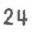SERVICE MANUAL FOR 1939 MODELS

- Make certain that the records are still in fairly good con- dition. This is very important, for the reproduction of music will still be poor if the record is badly worn, or defective, even though the entire sound equipment is _in per­ fect working order. A shorted or defective tube is often a cause of faulty tone quality.
- A loose connection at the pickup connection or the Junction
Terminal Box, or the terminal block on the chassis can af­ fect the tone quality.
(�) Check volume control by rotating same when a record is being
played. If sudden changes in volume are noticed, the cause may be dirt between the contact arm and resistor in the con­ trol, or a defective resistor. It is often possible to remove dirt or scale by rotating the control back and forth rapidly. If, after trying this, the control still causes sudden changes in volume, when it is rotated slowly, re- placing of control is advisable.

IN STRUCTION S FOR INSTALLATION OF EXTRA SPEAKER AHO SPEAKER VOLUME UNIT

To install the extra speaker, the seven-prong dummy plug in the left hand side of the amplifier (looking from rear of cabinet) is removed, and the plug attached to the cord of the
special speaker control unit is inserted in its place. The plug attached to the cord of the extra speaker is then inserted in either one of the two red sockets of the speaker control device. Two extra speakers may be operated at the same time from the unit if desired.

SERVICE MANUAL FOR 1939 MODEL

There are five positions on the switch of the control: The third, or center tap affords the same volume level on both the instrument speakers and the extra speaker. By turning the switch from the center tap in one direction, the volume increases in the extra speaker and decreases in the instrument speakers. By turn­
ing the switch in the opposite direction, the volume is reduced

in the extra speaker and increased in the instrument speakers.
The regular Instrument Voluae Control ts used to ;ouern the actual volume level destred.
The Speaker Control Unit is mounted on the inside of the extra speaker cabinet for packing purposes only and should be re­ moved and mounted inside the extra speaker cabinet on the left­ hand side about 611 from the bottom, flush with the back edge and with the extra speaker sockets facing upward. A 1-1/411 hole should then be drilled in the rear door and in the correct posi­
tion to allow the speaker control key to be accessible for adjustment.

JUNCTION TERMINAL BOX
The purpose of the junction terminal box is to route the current entering by way of the line cord to its proper channels. There is very little chance for any trouble occuring in the junction terminal box, with the possible exception of the main 1 switch, light switch, and volume control. It is not advisable
to try to repair any of these in case of a defect as they may be replaced at a nominal charge.
If, at any time, it is necessary to remove any of the wires from the terminals on the junction terminal box, make certain that they are replaced exactly as they were originally.

25

SERVICE MANUAL FOR 1939 MODELS

FUSES: There are two fuse receptacles in the junction terminal box. The upper one contains the light fuse and the lower one the motor fuse.
To remove a fuse from either fuse receptacle, it is neces- sary to unscrew the center section of the receptacle with a screw driver and pull the fuse out of this removed section.
NOTE: It is very important to replace a blown fuse with one of the correct value. At the bottom of this page is a table list- ing the ampere capacity of fuses used in each model Symphonola. LIGHT FUSE BLOWS:
  - Look for source of trouble before replacing fuse.
- A broken or defective socket may cause a fuse to blow.
- If lamps of greater wattage than those supplied with the
instrument are used they may cause the light fuse to blow on the models Mayfair, Plaza and Casino.
Light Motor
Model Fuse Fuse
115V-60 | Cycle | 1 | 3
115V-DC |  | 1 | 3
32V DC |  | 3 | 3
115V-25 | Cycle | 1 | 3
115V-60 | Cycle | 1 | 3
115V-DC |  | 1 | 3
32V-DC |  | 3 | 3
ll5V-25 | Cycle | 1 | 3
115V-60 | Cycle | 1 | 3
115V-DC |  | 1 | 3
32V-DC |  | 3 | 3
115V-25 | Cycle | 1 | 3
115V-60 | Cycle | 3 | 3
115V-DC |  | 3 | 3
32V-DC |  | 10 | 3
115V-25 | Cycle | 3 | 3
115V-60 | Cycle | 3 | 3
115V-DC |  | 3 | 3
32V-DC |  | 10 | 3
115V-25 | Cycle | 3 | 3
 | 26

Mayfair
II II II
Plaza
II II II
Casino
"
"
"

Classic
II II II
Vogue
II " II

SERVICE MANUAL FOR 1939 MODELS

RECORD PLAYING INDICATOR DIAL
(I) The "record playing" Indicator Dial is located just back of the cabinet escutcheon and is illuminated by the same lamps that illuminate the program holder. It is timed with the selector. Should the numbers appear off center or indicate
the wrong number being played dial may be retimed by select­ ing record No. 20 and stopping mechanism when record is in playing position. Remove the program holder, reset the
dial to correct position, tighten all screws and start motor.
(2) Indicator Dial should rotate freely. If there is a bind in
same, inspect carefully to see if it is rubbing on front of cabinet. A bind in Indicator Dial will affect the opera­ tion of the selector.

27

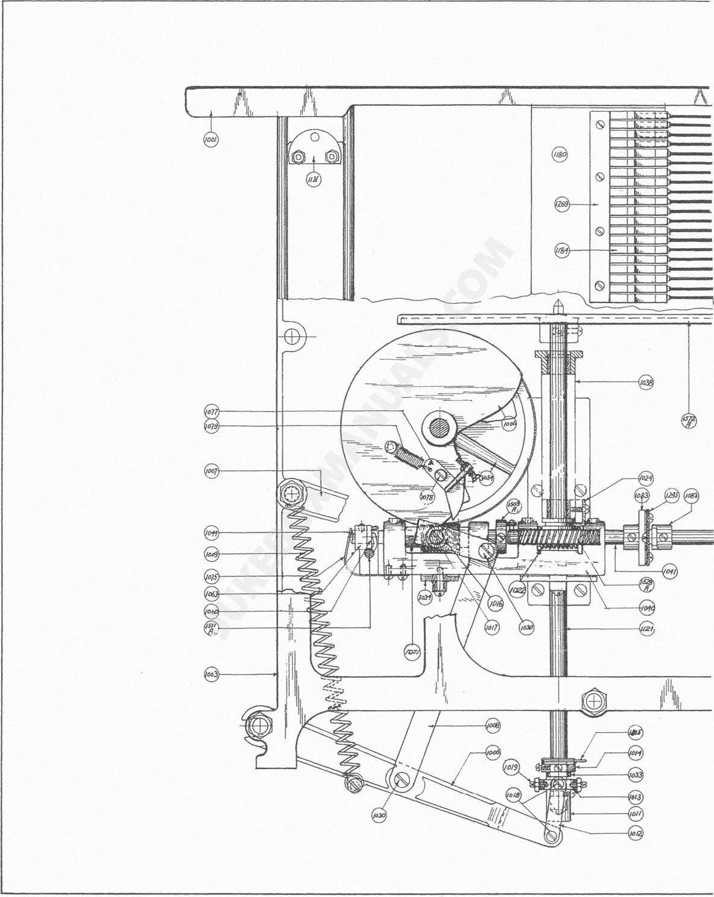

28

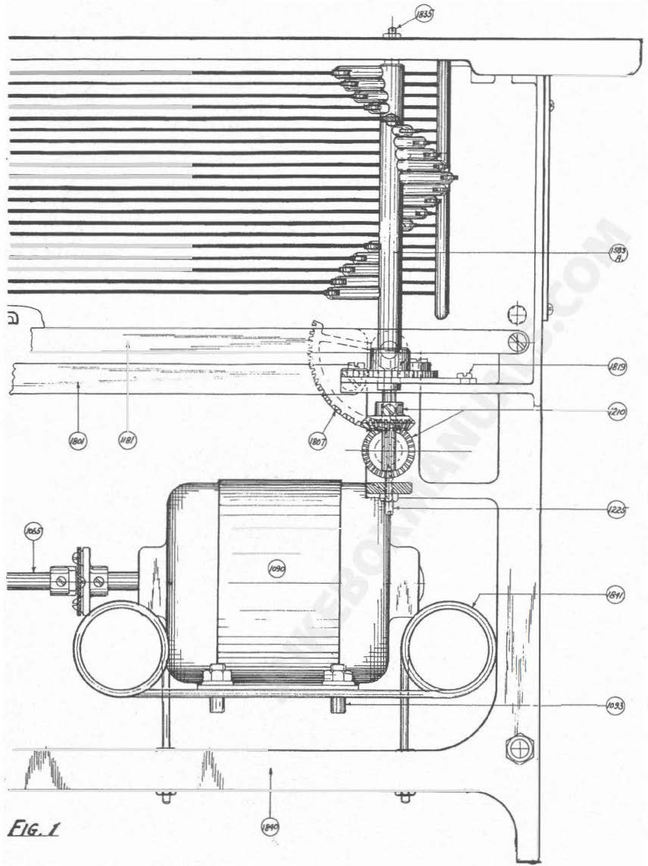

-
..�i;_� \

PLATE NO. 1

29

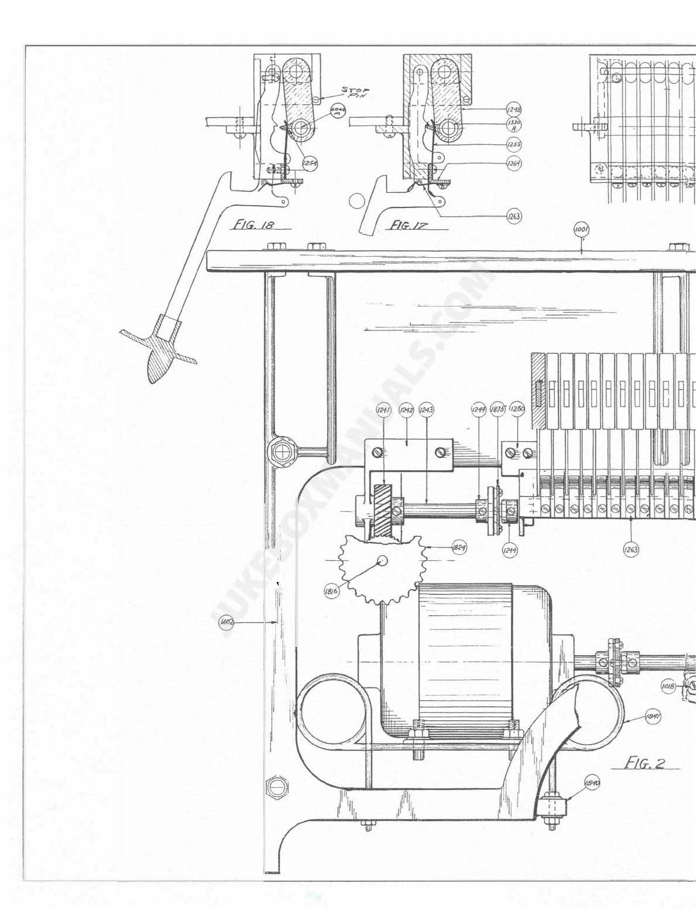

·I.':,,
I

I
II
I

30

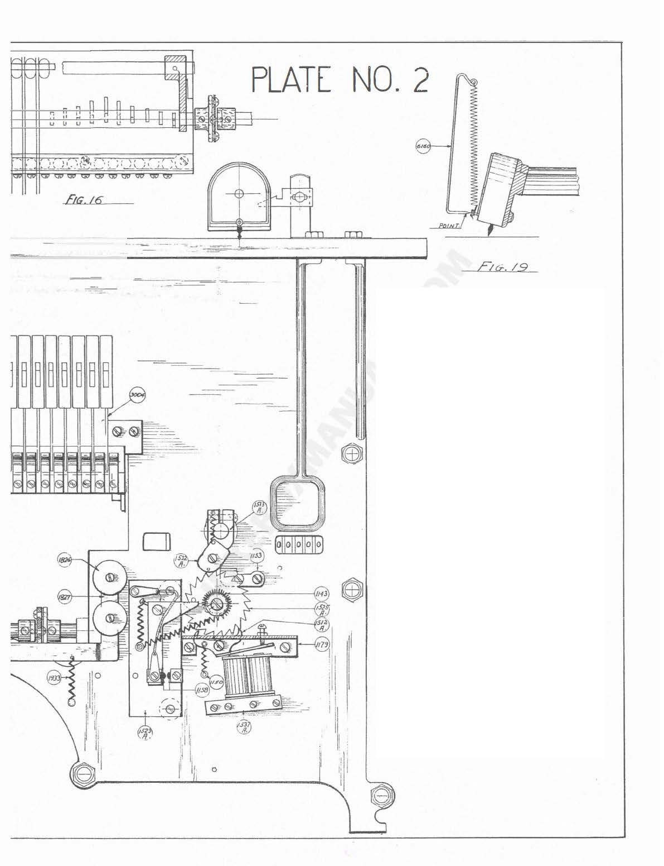

31

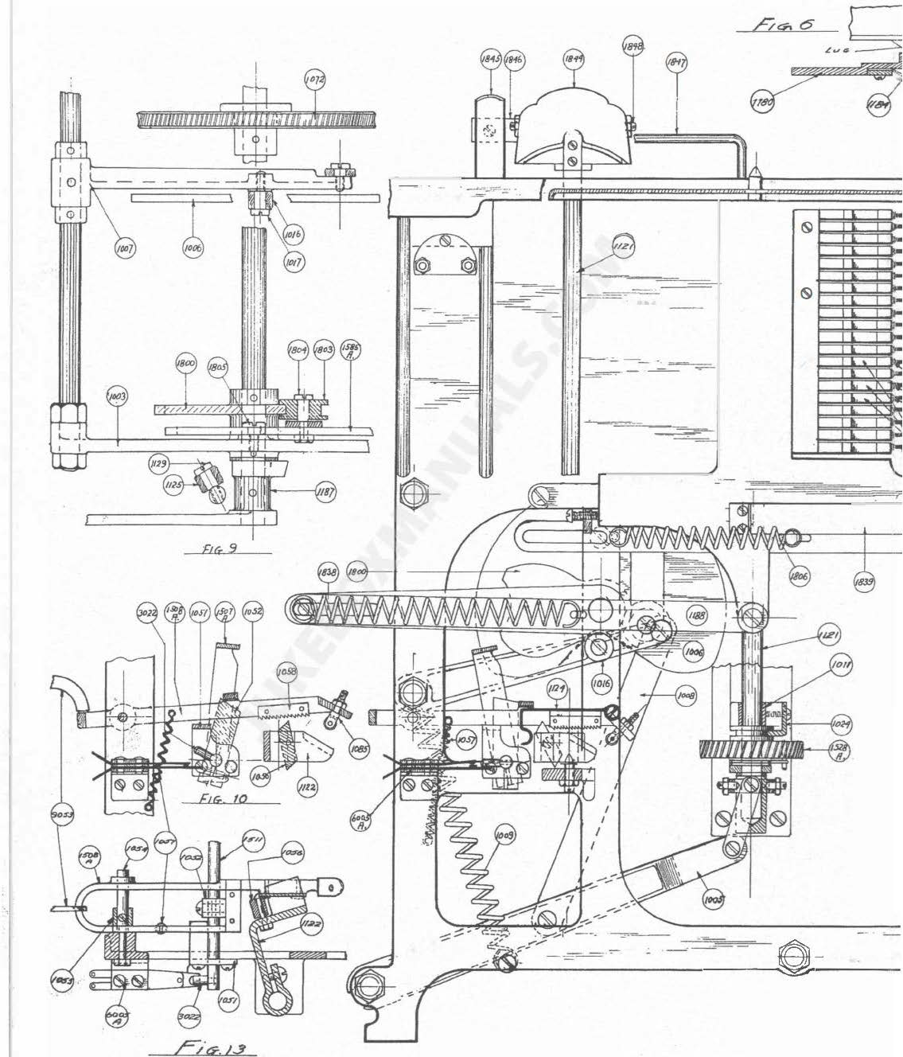

-.;:-- --

--=-
- --

@

@

---�-

. ..-- �

32

PLATE NO. 3

__])

33

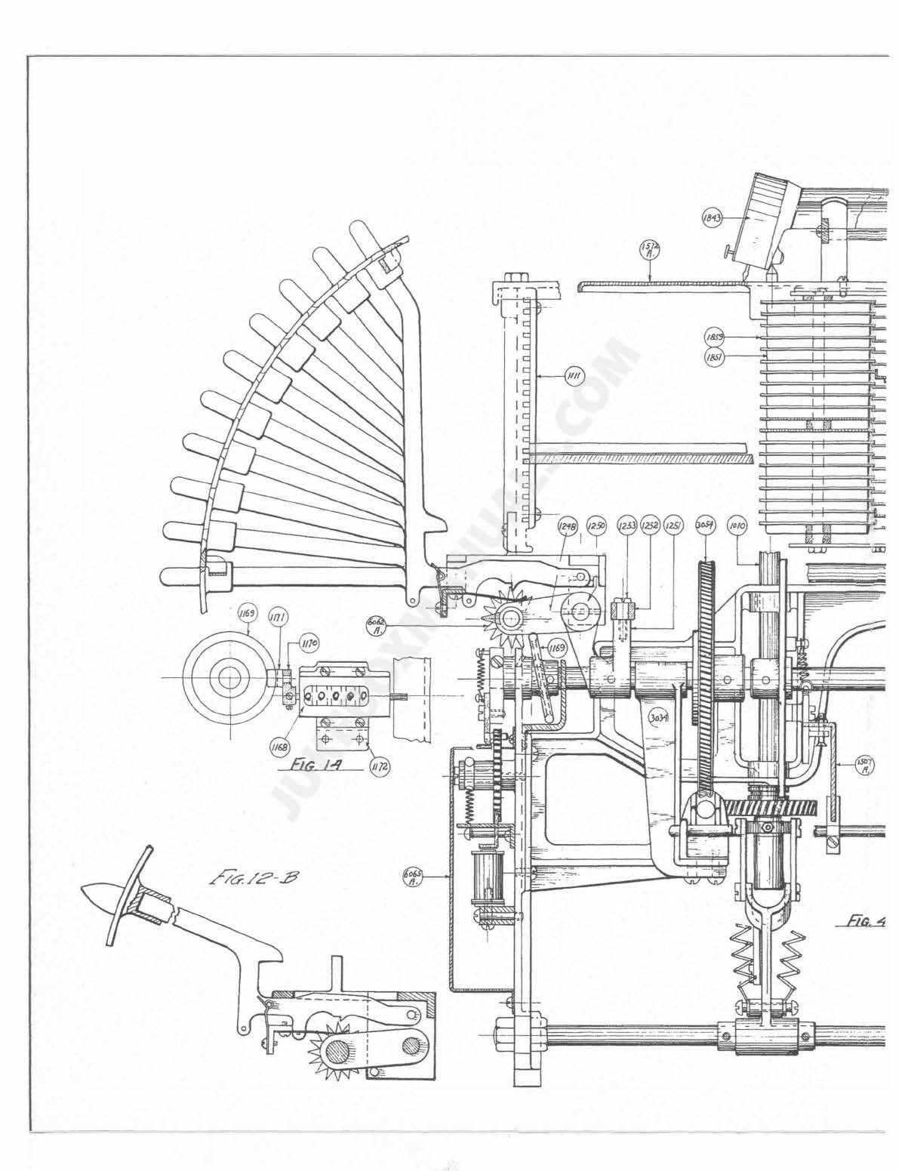

34

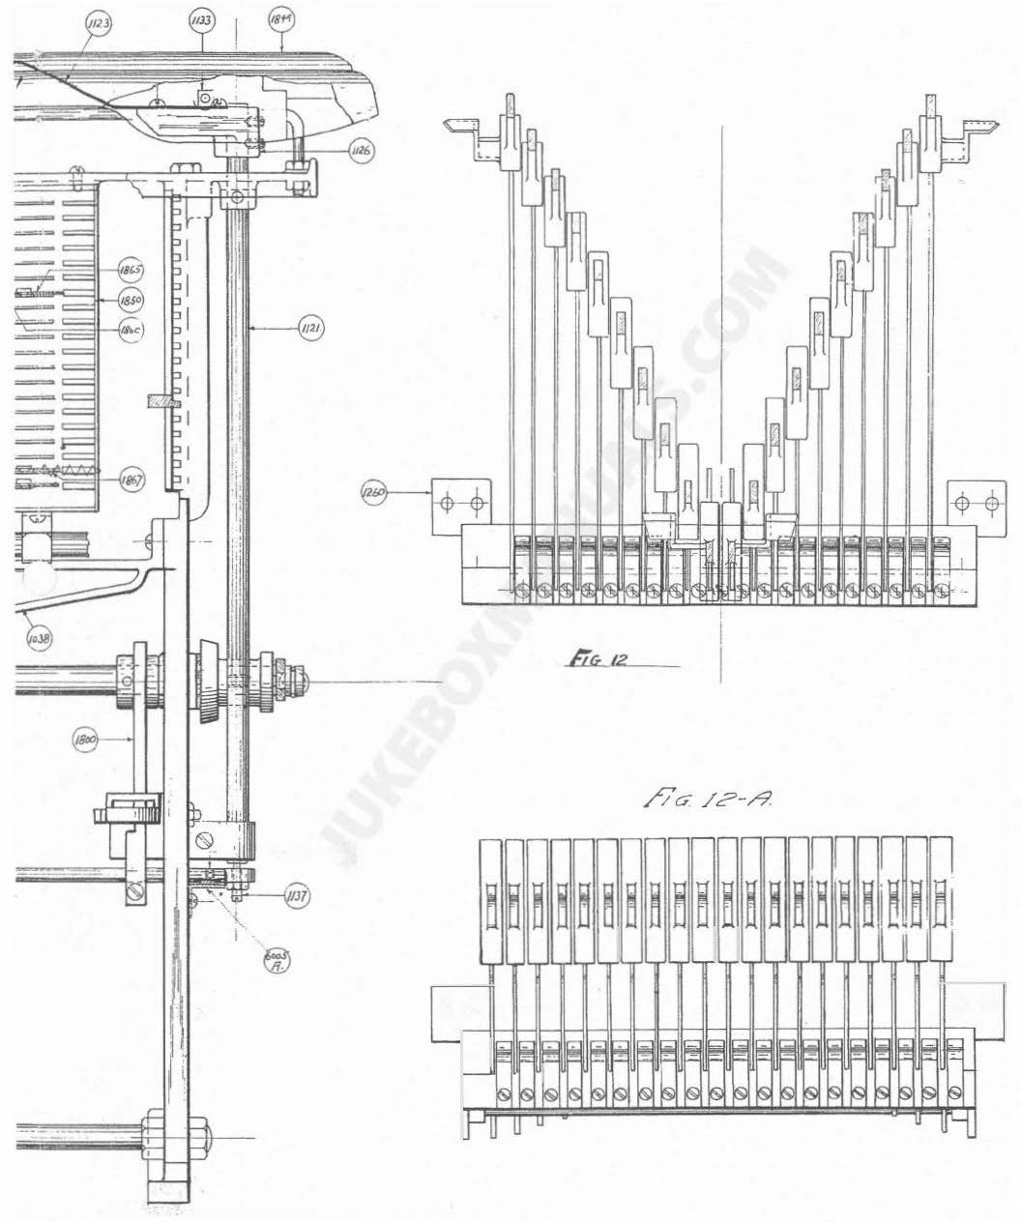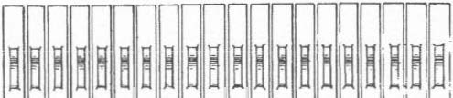PLATE NO. 4

--e

00 0 0

35

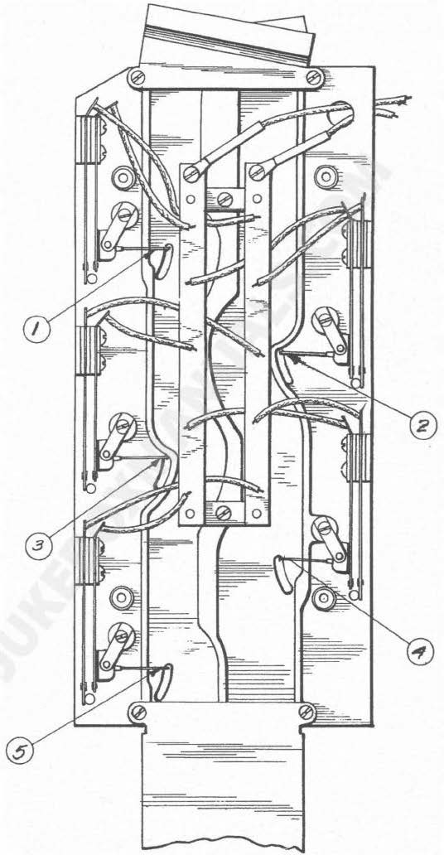

j=;c;.EO

USE CARBON TETRACHLORIDE TO CLEAN SILVER CONTACTS - APPLY WITH SMALL BRUSH.

36

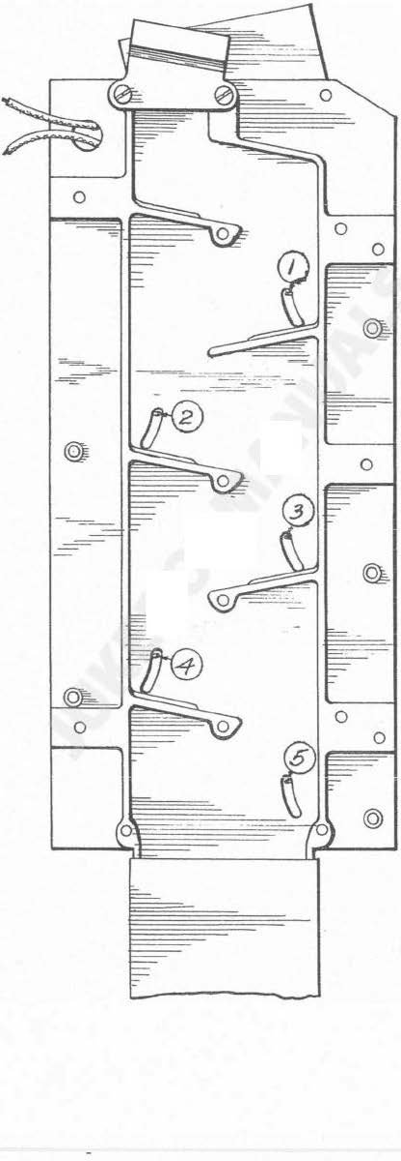PLATE NO. 5

hcr.2/

37

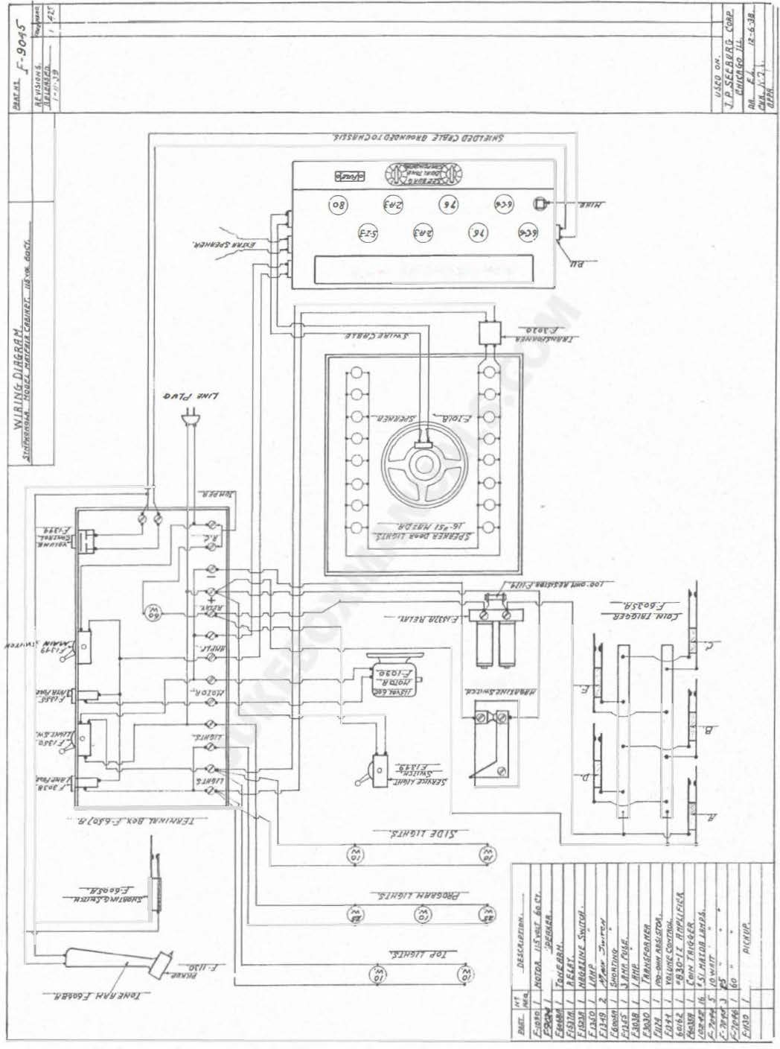

·.-;u11 r1-or11 .,
.7:9/09,-

-yur

38

fif) �
@ e 0 9
e 9
··evo9 ·'"' N?//l'TctH// o;;v -

'

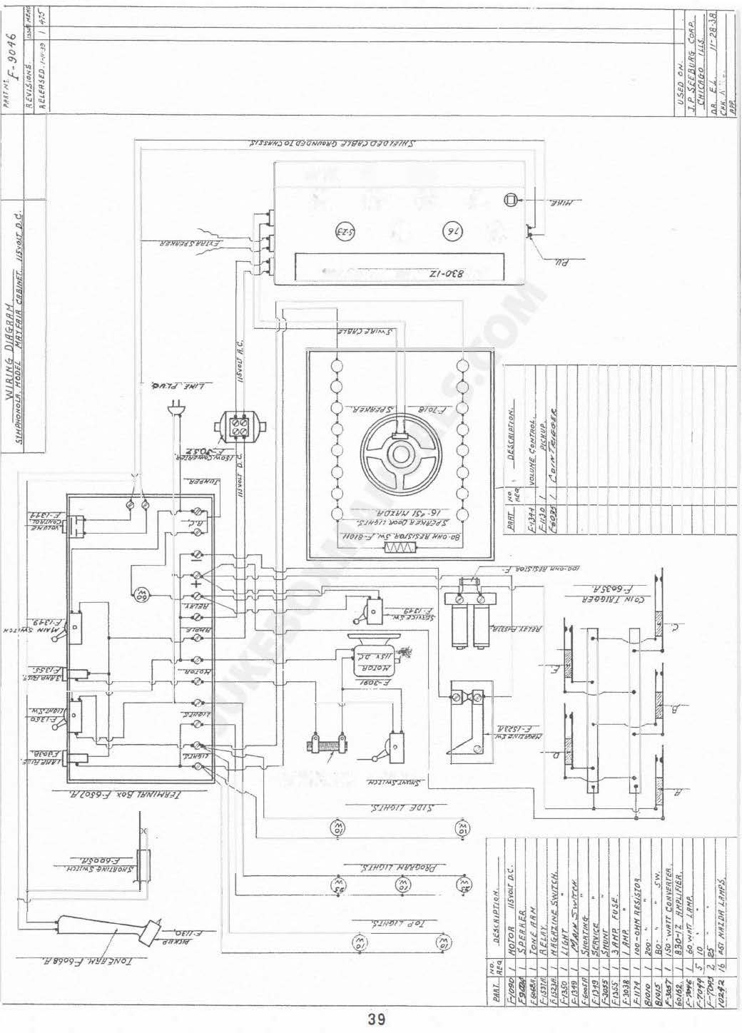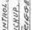�g·� -
�r.r/./A"t-o•ODC
SS'"<·3

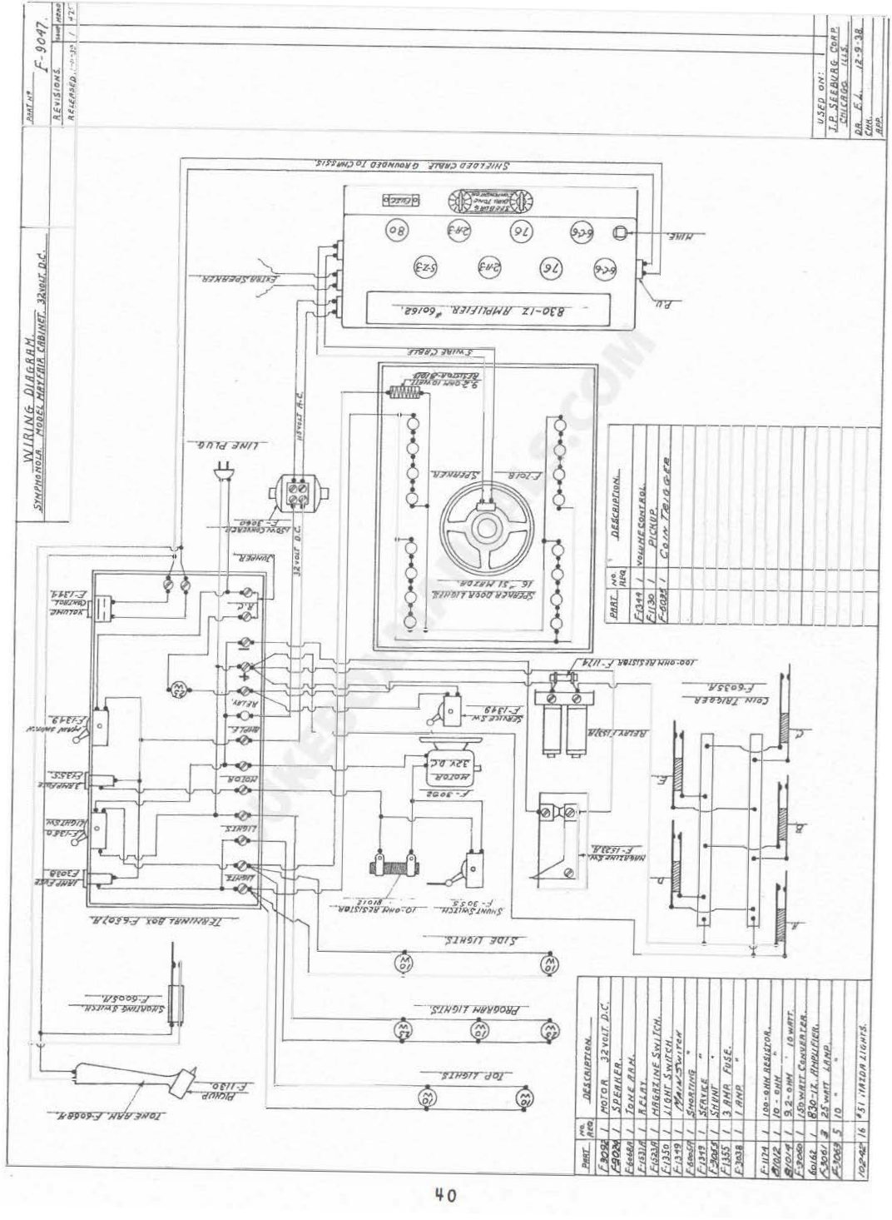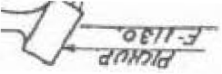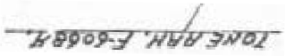

-

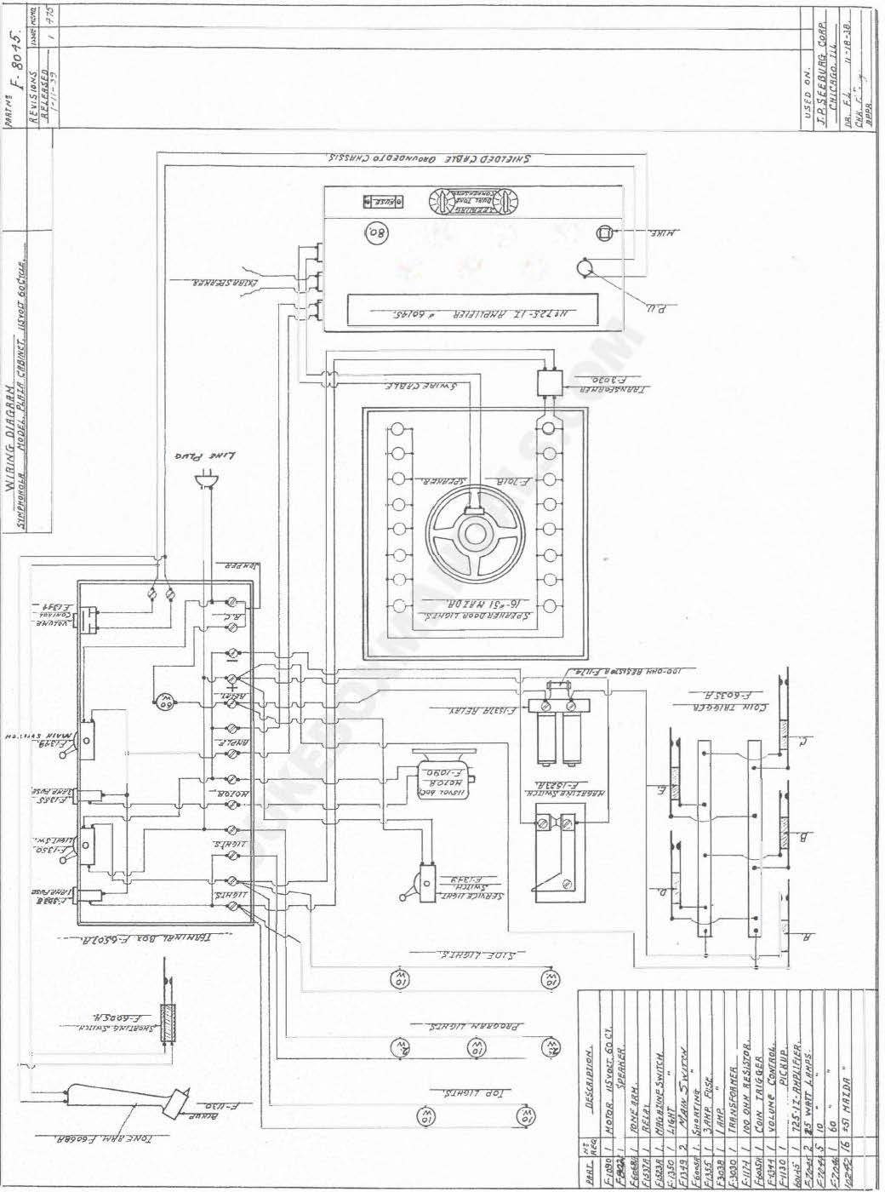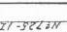

9
9
9

@ 0 9

�I

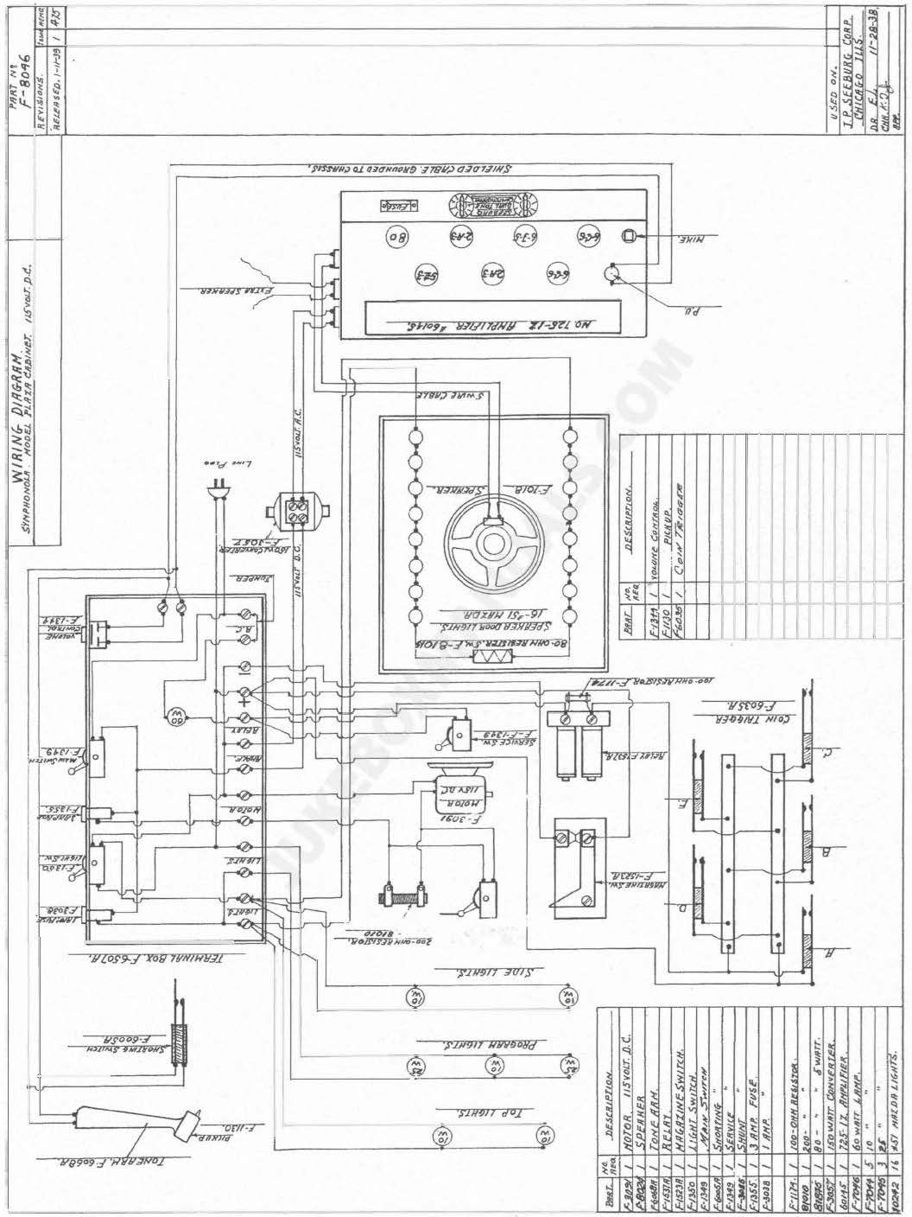

1'$'0l'-f.
·�J!Tlfl'T

42

8----­
§ qi
-===·s==l'=IO=p==='iij=/,=""='=lJ=w=U==I=l==J=t=z=,),) ==]

....

. '-?117cl N/7

')'llf9f/ JOI)'

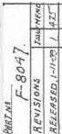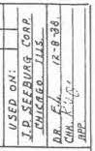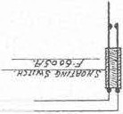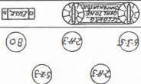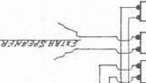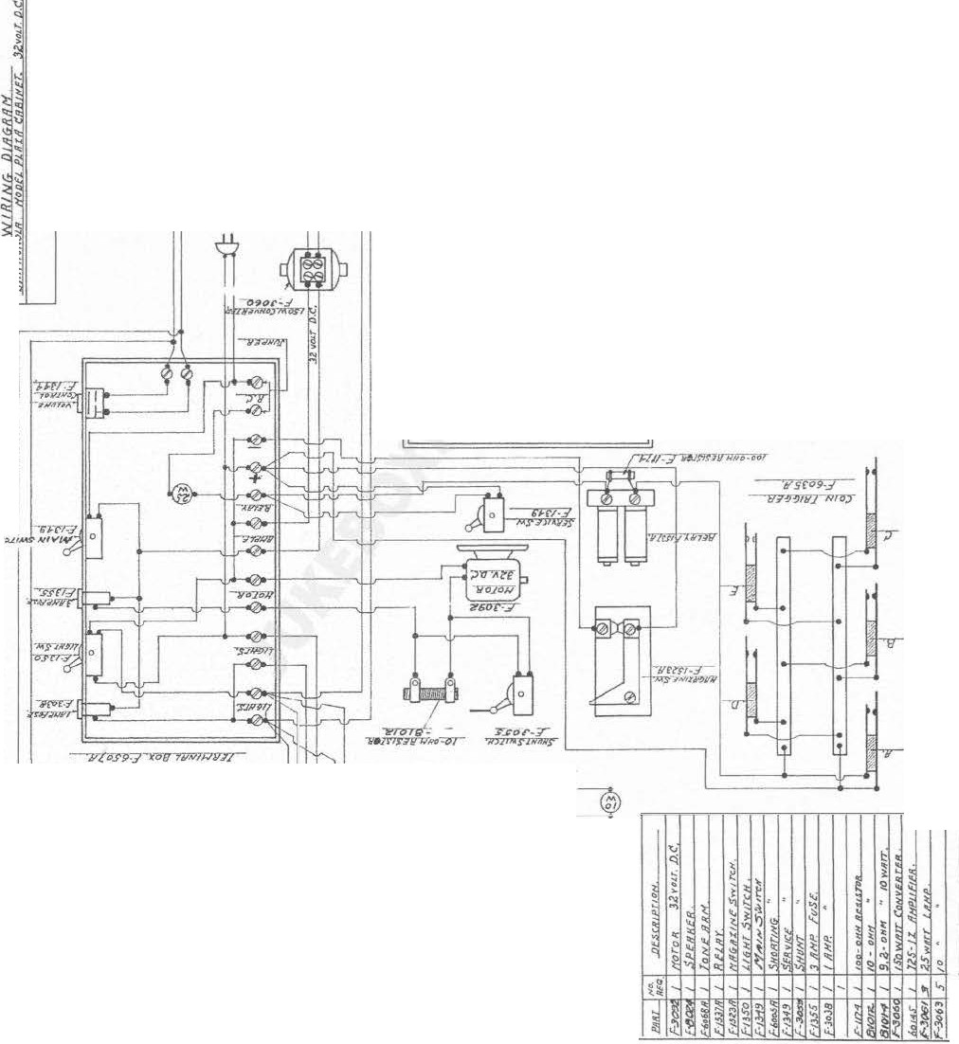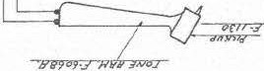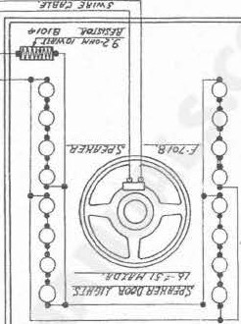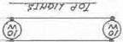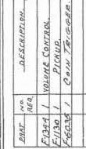
'$.'Jll'Jll lllllf90li(/

3

..,

"...'..
S..?.
"l'l'
;:;
'
.ri

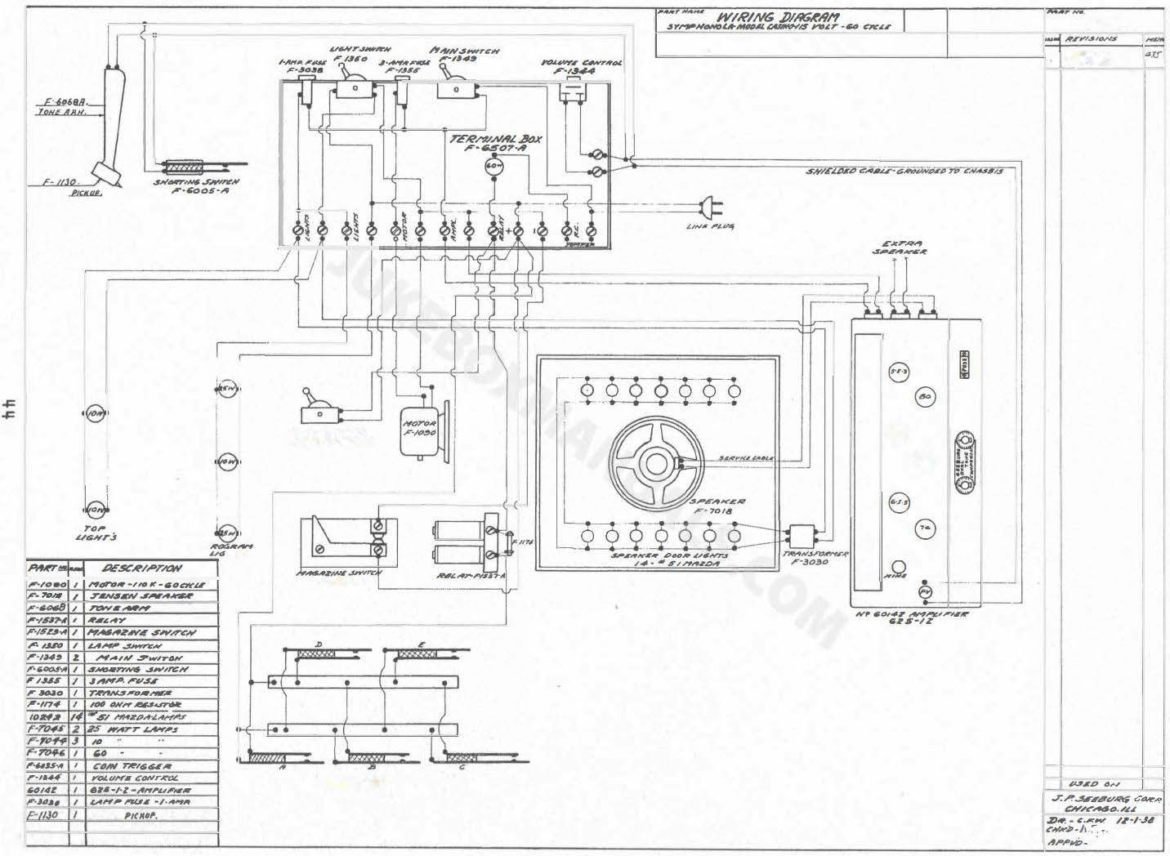

F-1010.

I "�':.���!!'

Slll"'.e./ISNT
B
.SIWTCAIJIV�

B

,.

,-../II,_,

C°'Nr;tYcJ1$1_.
,-..Id.JS-A

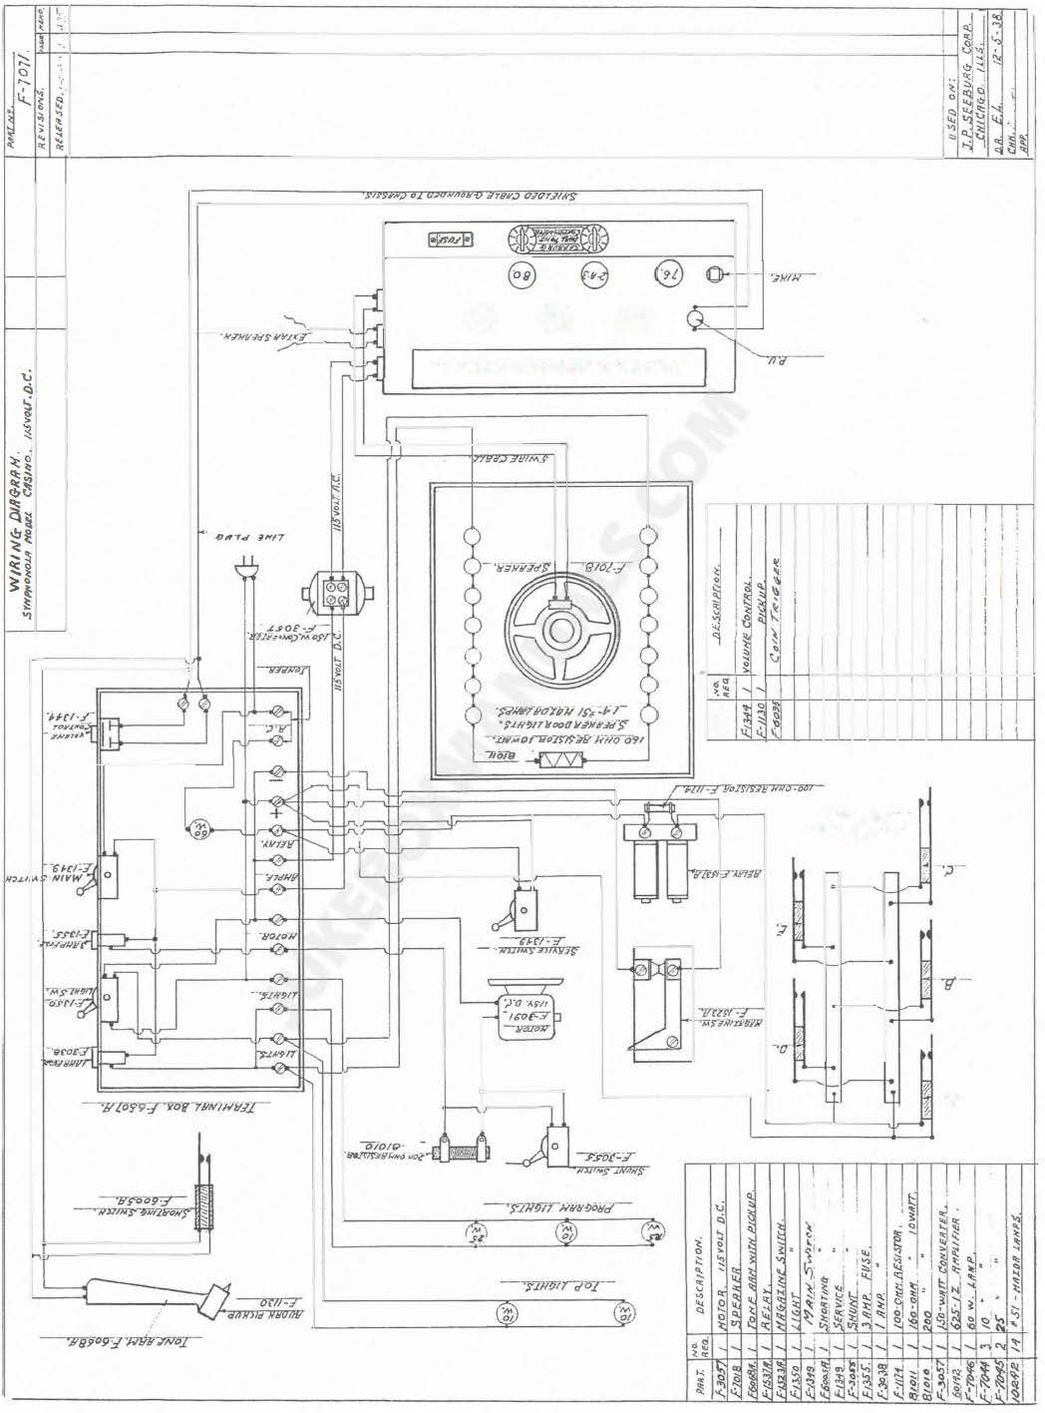

8
8
- ·

I
8
-zr-r-n nr
·l'"'°' •� ·11PilFT<iPV

'
�

"JO!J!J/11 'Nlo;J

'I

�5

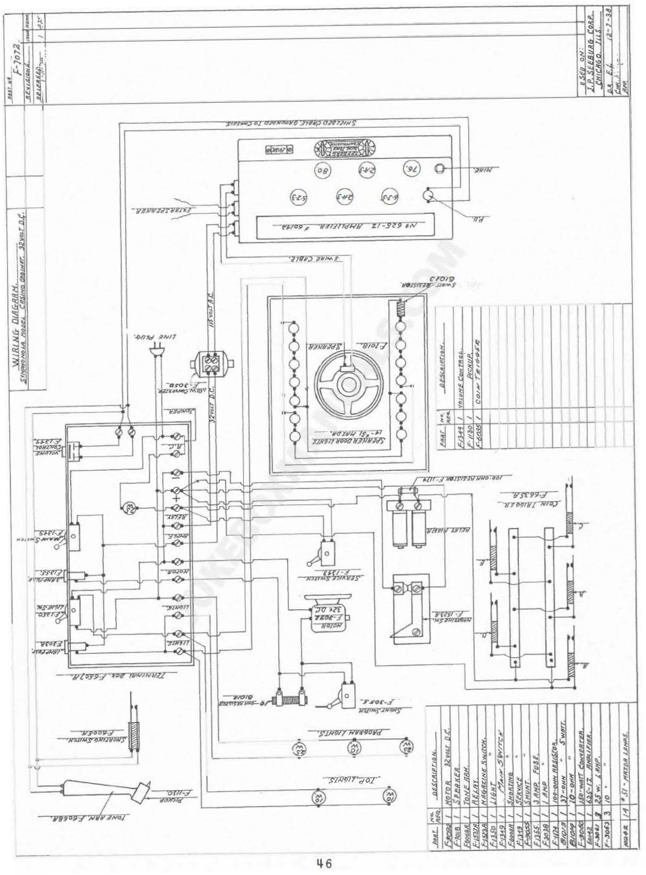

•Jtl (�

EE3 �
� ® (]) 0
\:i ® CID CD �
'
�
�

J�IY.-,) J#Y'/'f _r

�
�
� :.. �
\
II
� '
" '.a
l�
� � �

�t(" [
'!
��\� ll

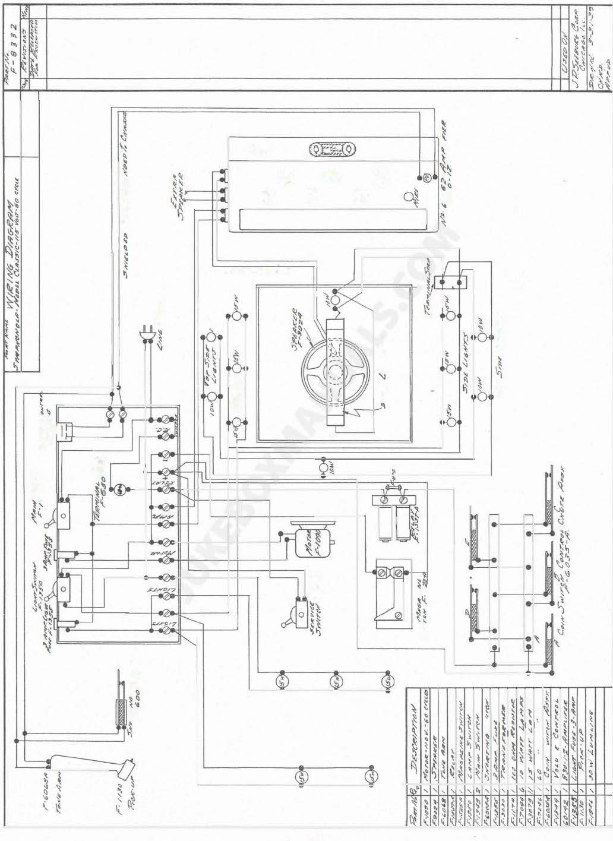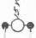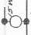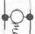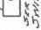
..�
��
i
��

���
::;"' �'!i

�

��
��
"\ - -
�

�\
·�
� \

i+ 7

�

® CD ®
CD CD G) �

�
.. <i

�"'

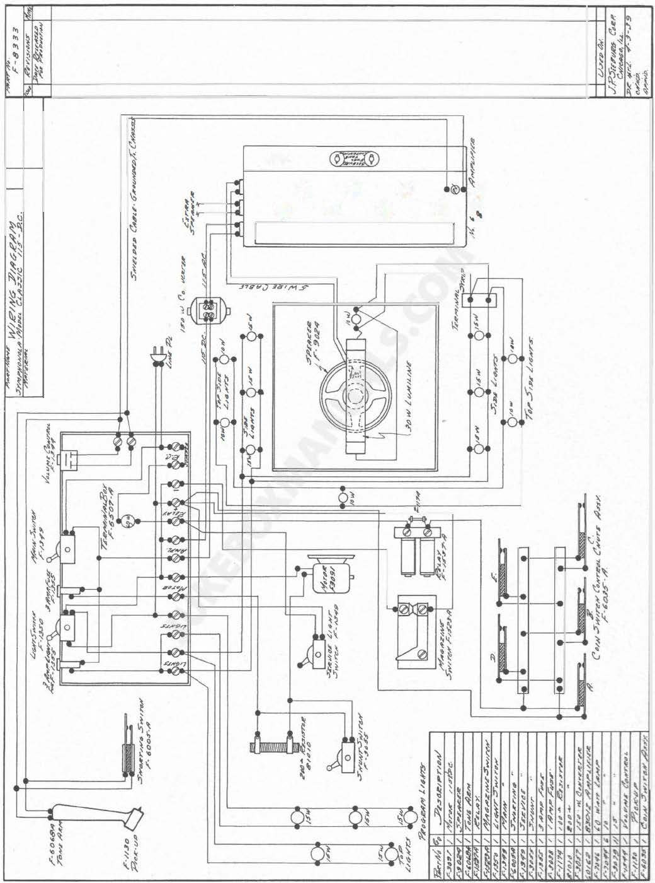

\

?

IJ

�iltl" At1rrA¥ ,.J;.,
,. ..oos ,,

;.rtJ tJ e°""""'lr,£

,,. _,

?=ir.,,.. �''""
8

8

,,.<;1

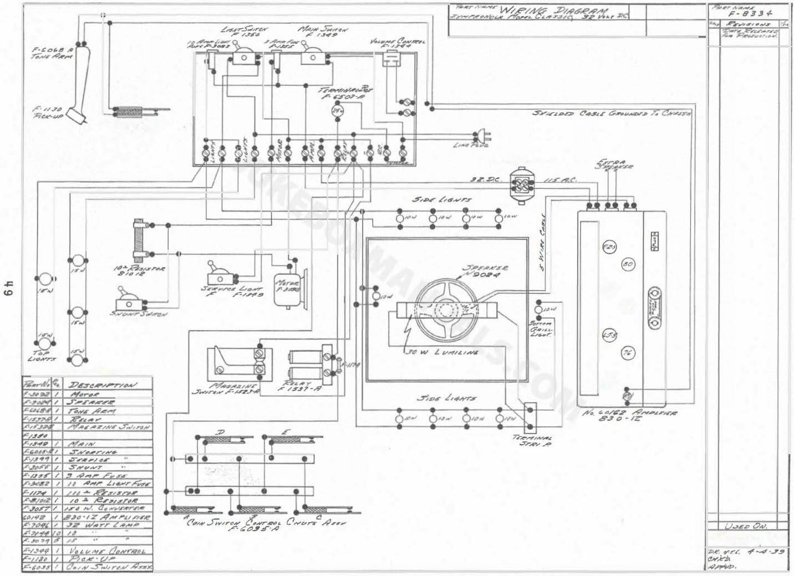

I'
' l!'l' ..r
0"

..

J.P.Jr�"°'
('.,Y/fl ,,,_ /,..

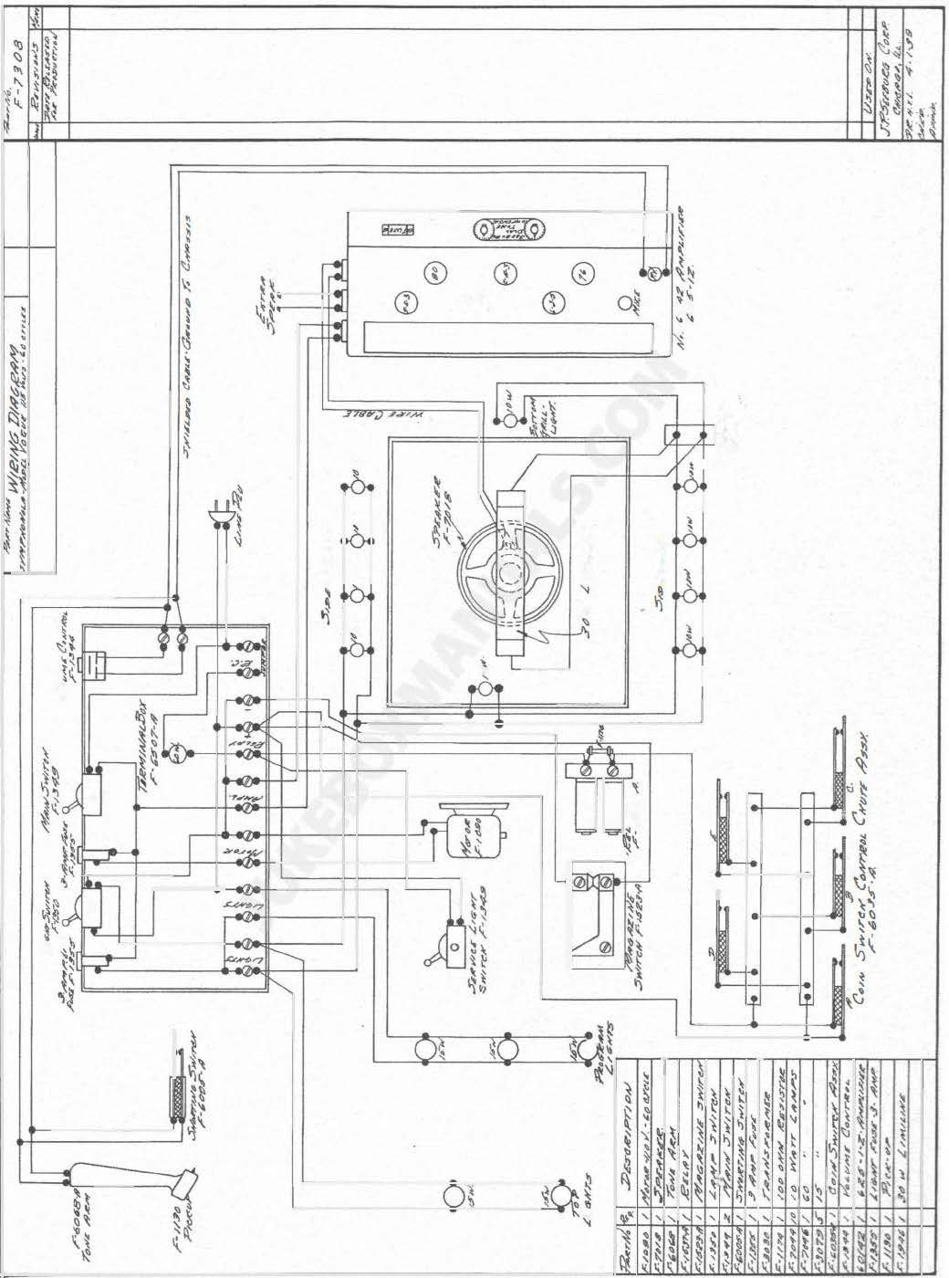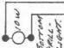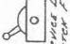

�
CD � "'

f � \:
�\ �
�
) �I)
�

't
� �\ �
� � �
� � � ..
�
�

�

.
�

0 ��
'�

0

,) �

:

\

50

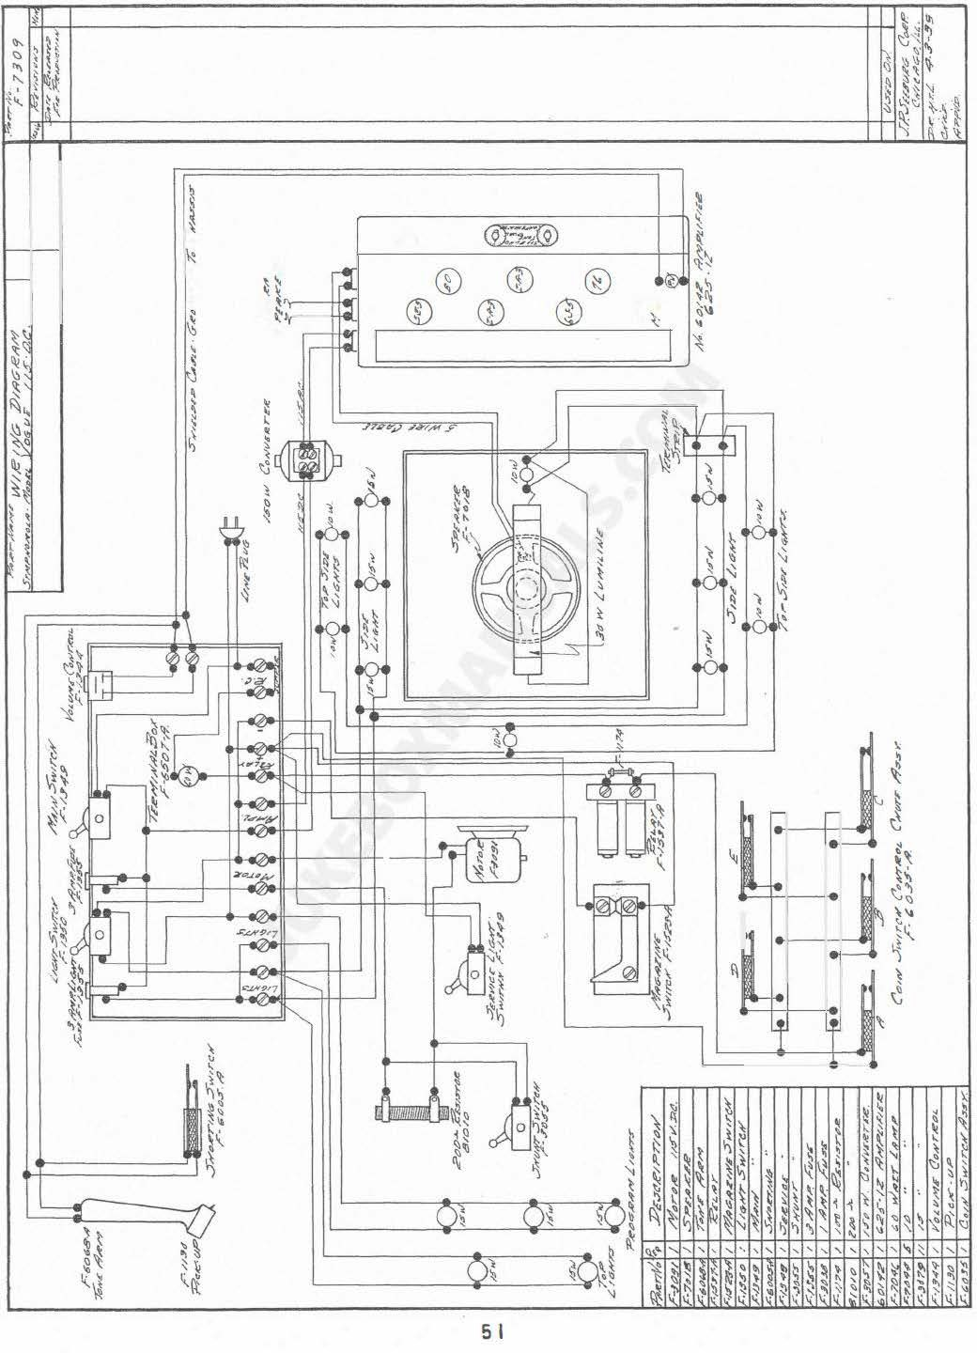

IC 8!3

� �
�
..� o�
$
� �

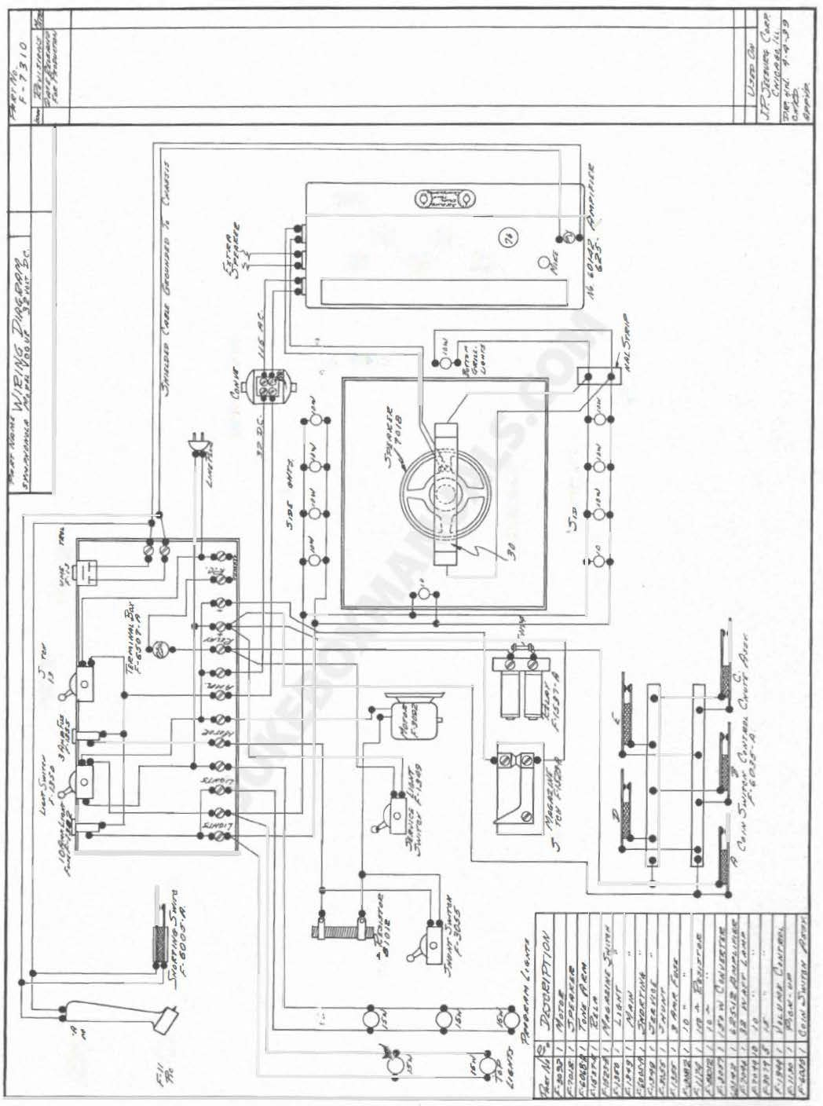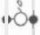

l

i�

52

�@>

Ci> ,��,,.._,.�

�-:�-

,- �
_
_
___
_ _r �-:

I /1 '
I I I
I I
: :
l I
l I I
\
:.___ _I_X'T_A&r_.1_""'1tCA_ _"'1_ _.r{_.-:_t"-TWY___'_,�..J:

A/O '-
�.1 .:t�;it,,
�'�ONI ..�

AV �&.1 J«"A;'*. �
Hl'Al'IO �..lit>

TYP£ SZJ

/1"4.A ...,.
8Z!!J ''"" .. ....
ZOQ(J A j"' IP'?.
41 i ,., 'o?.
41-#711 '°""' I "' "',.
N#Sifl '-' , ,., M -:;
UH' ,,., "'"'
Z411 /OOH , ,., .-
��·� ,,., """
'"' /0 ,.
ZOA WW

.o� 20').
.or 600 10?.
,,,,, 600 10 '7.
0/ """ 20%
.0 """ zo ii;
""" #0
·"""' 400
��,

12Y2HFO o�>'JJVlf<. 2$1'. ,,l'#�#r r.
8 _., ,or a:1 r.lf!7tf
I<. ,.,,,,.. '1751'. Po>'Yil" ,,.r
_,. �5Y.
,. "'1S;'.
All' ,Soho�
·""""' '" 7.
·""' zo ,.
.oOIJ Id _,.

rU.S.e flUtf A.S.S4n4�>'
�'" c� I Ultil A.s:I,-
,,&l �� ,, ,,�-,, r'.te*IJNI" e'4Nr1«
14016 ..,., -* �e<4'-.1-rr �'07.
.:'.rA'.fC

c-.-

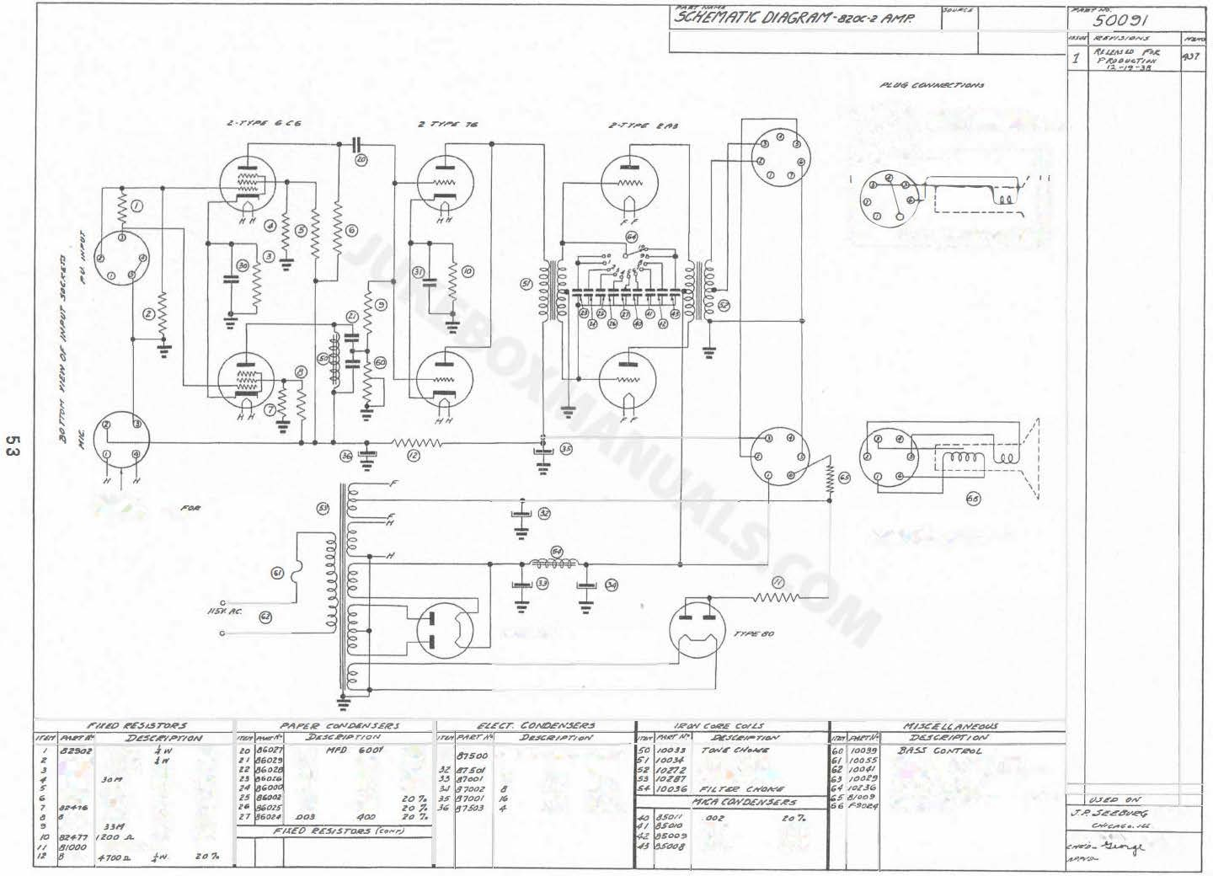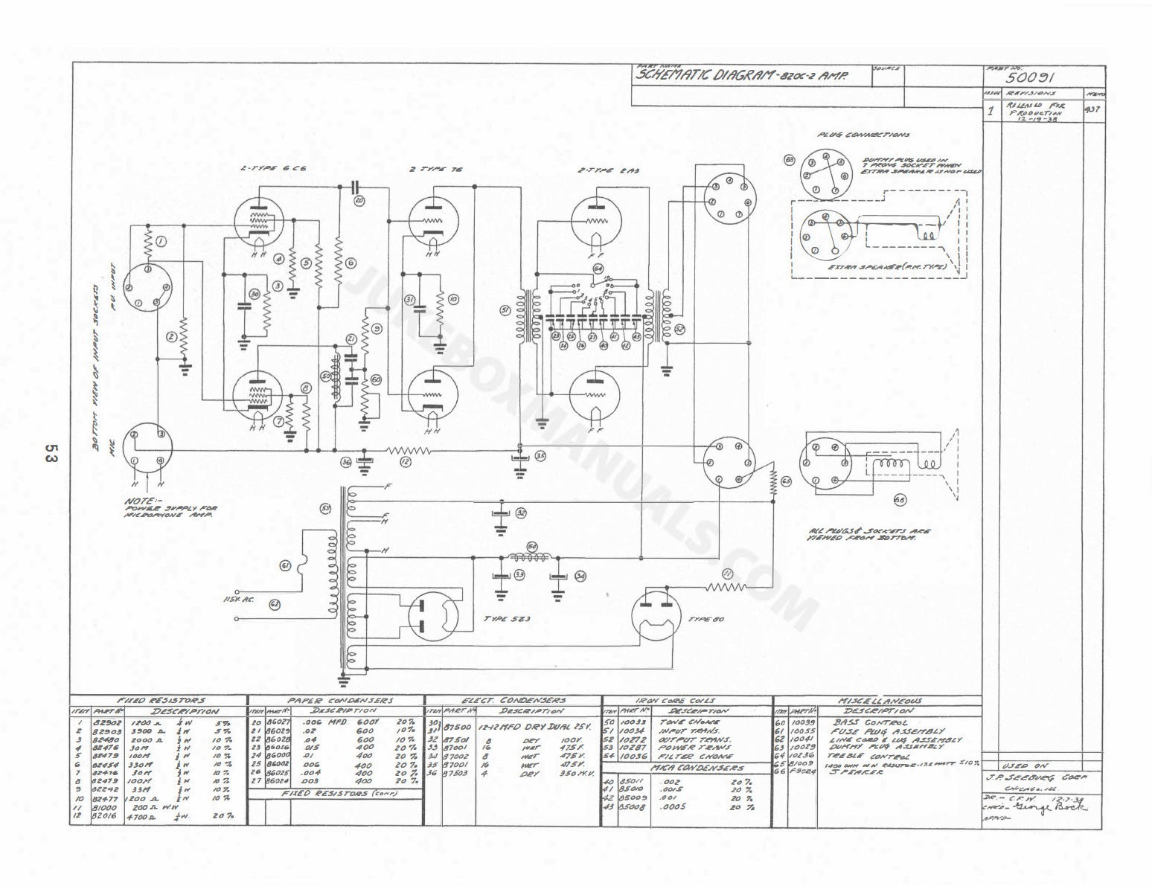Zo/6

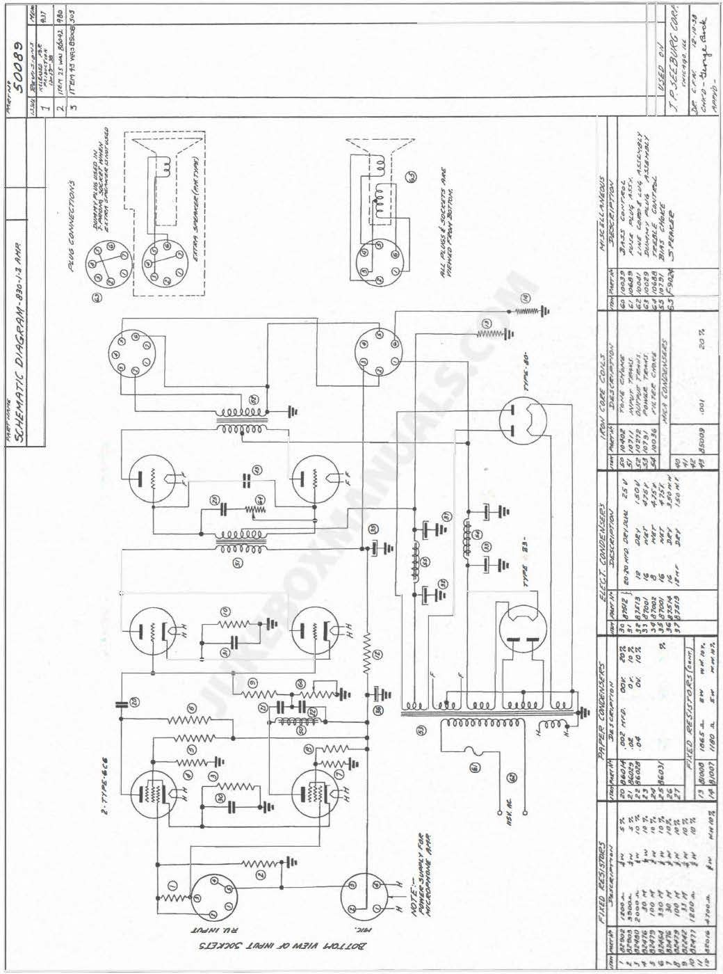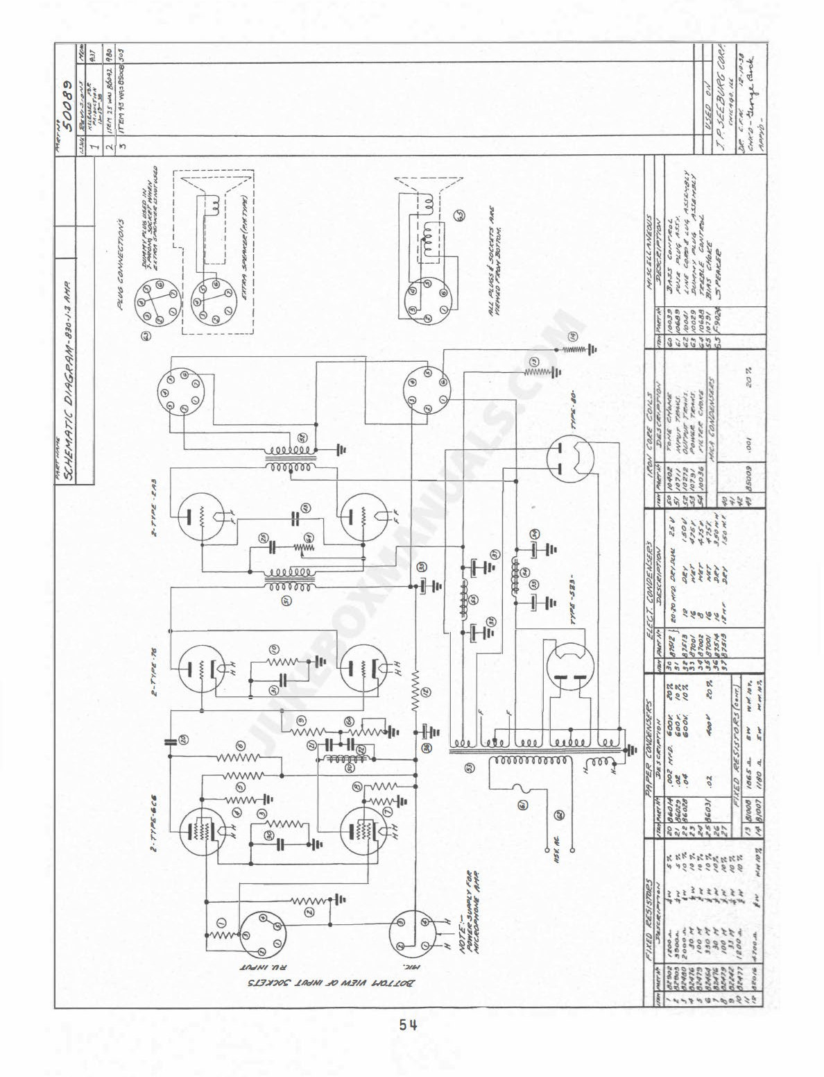

QO

"'
"

� i_

�
��
��

"' }
� �
� !. t
� � �i
"
��..

��:
"""

..

<\�'I�"

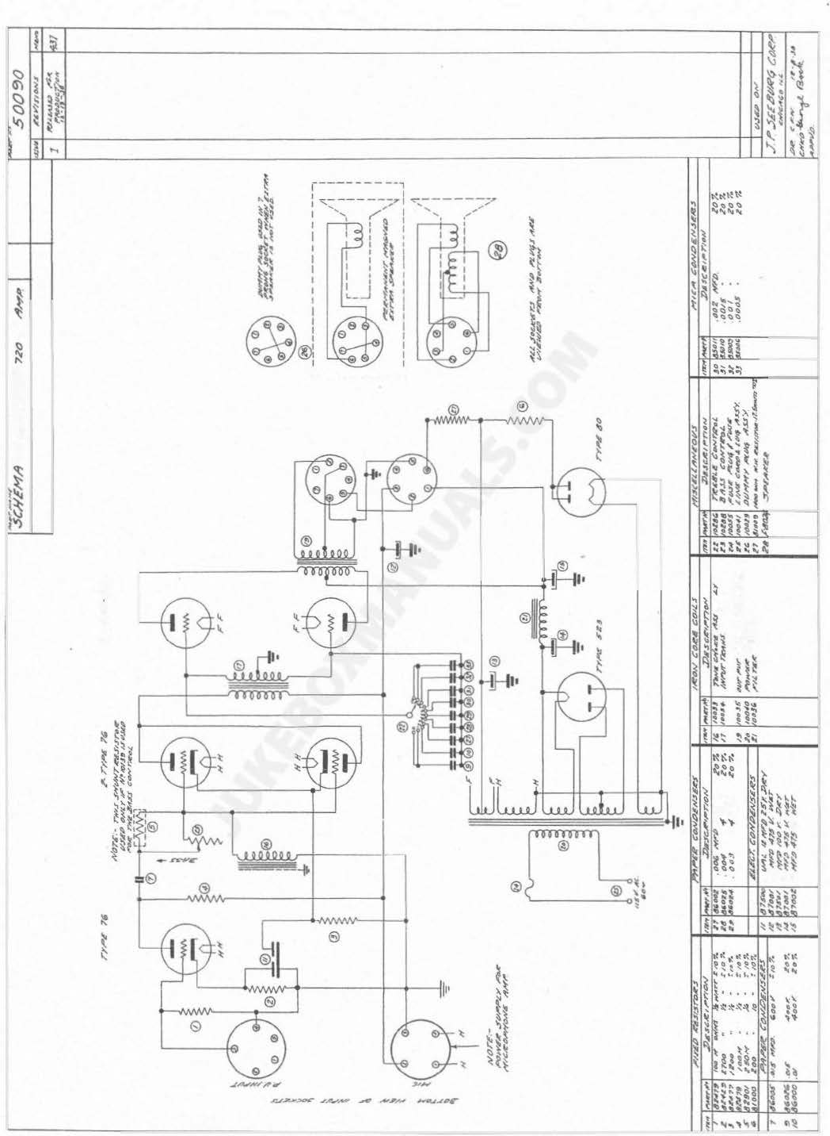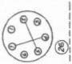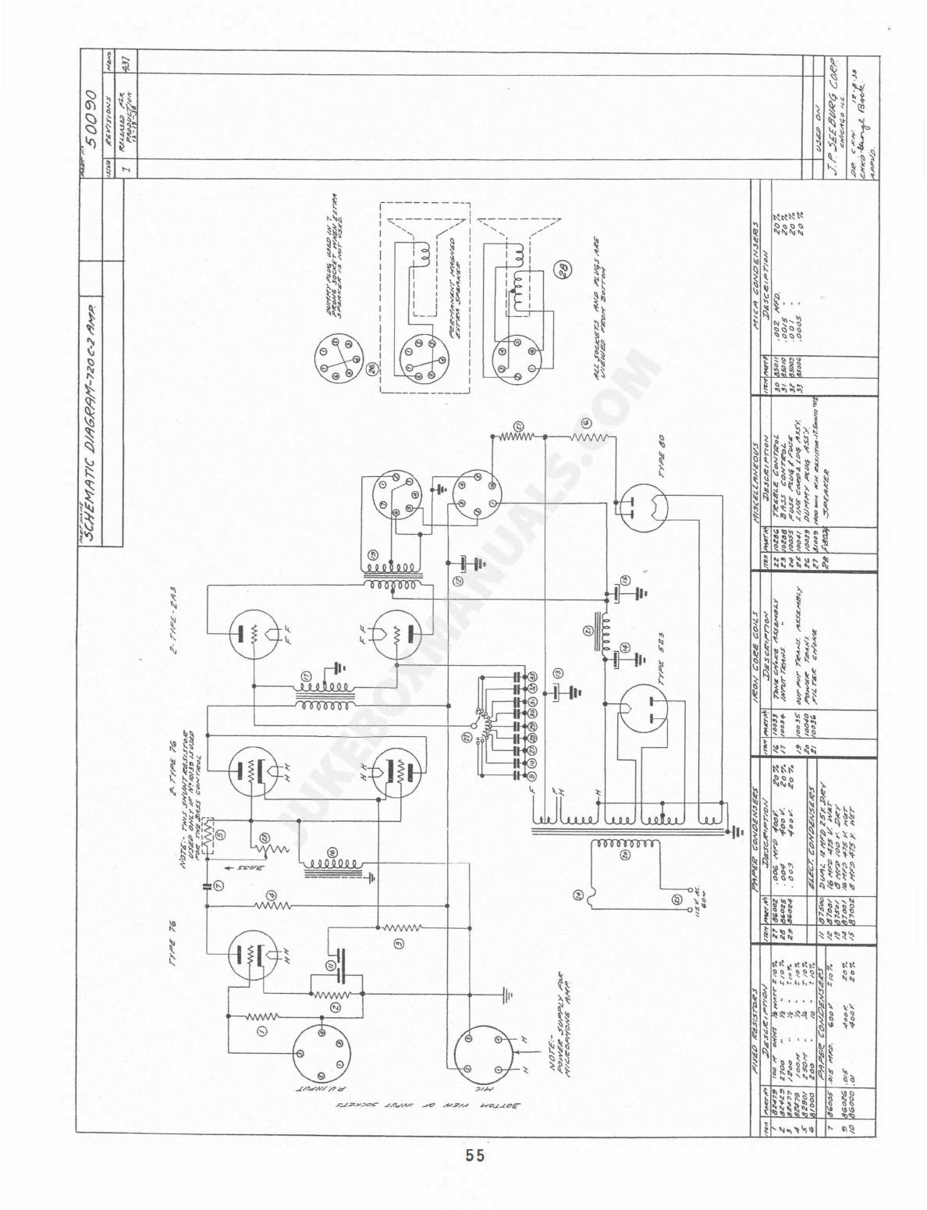

55

,r.. rr""° li

U1 O>

"' *4tV4r.I'J�r.:IA'A:i
Jl',j#"W,l,P ..,.�

J:!::!·
,_
'"""' E "'
JJoH

10 '·
,_ � 10?.
'0 .,.
.al'
, ail '"oV /I 7.

L/Ak � ti' -'.U ,,s.sl,.,Y
.J"' "�l"'f .4.r-.UT>'
TllJ!/ &_,.,.A:W

-

""'
t: ,. ?.
,. 7.
i�
!' .
St¥'Alr1Ae

,1111.. J>J
I• 7.

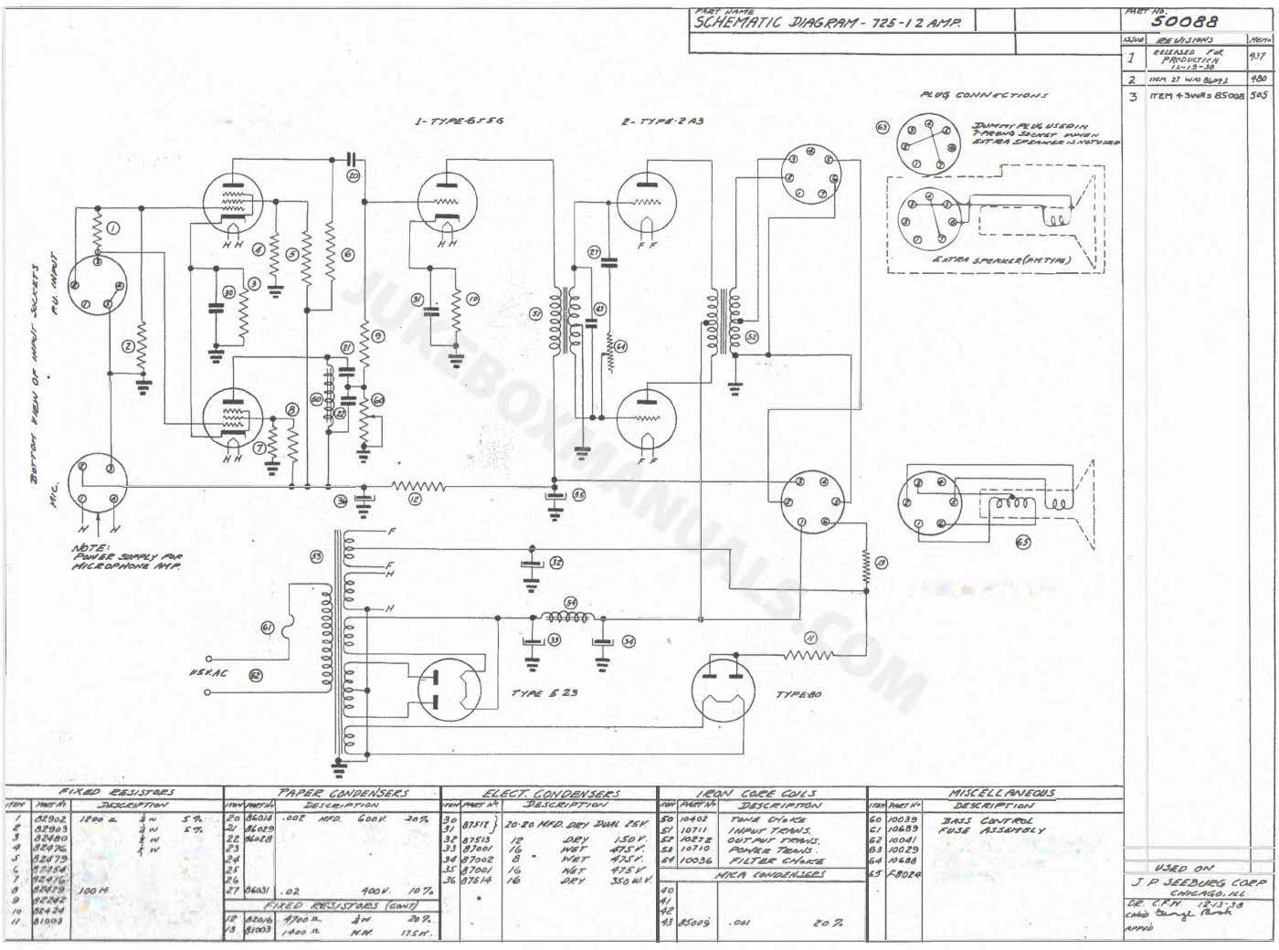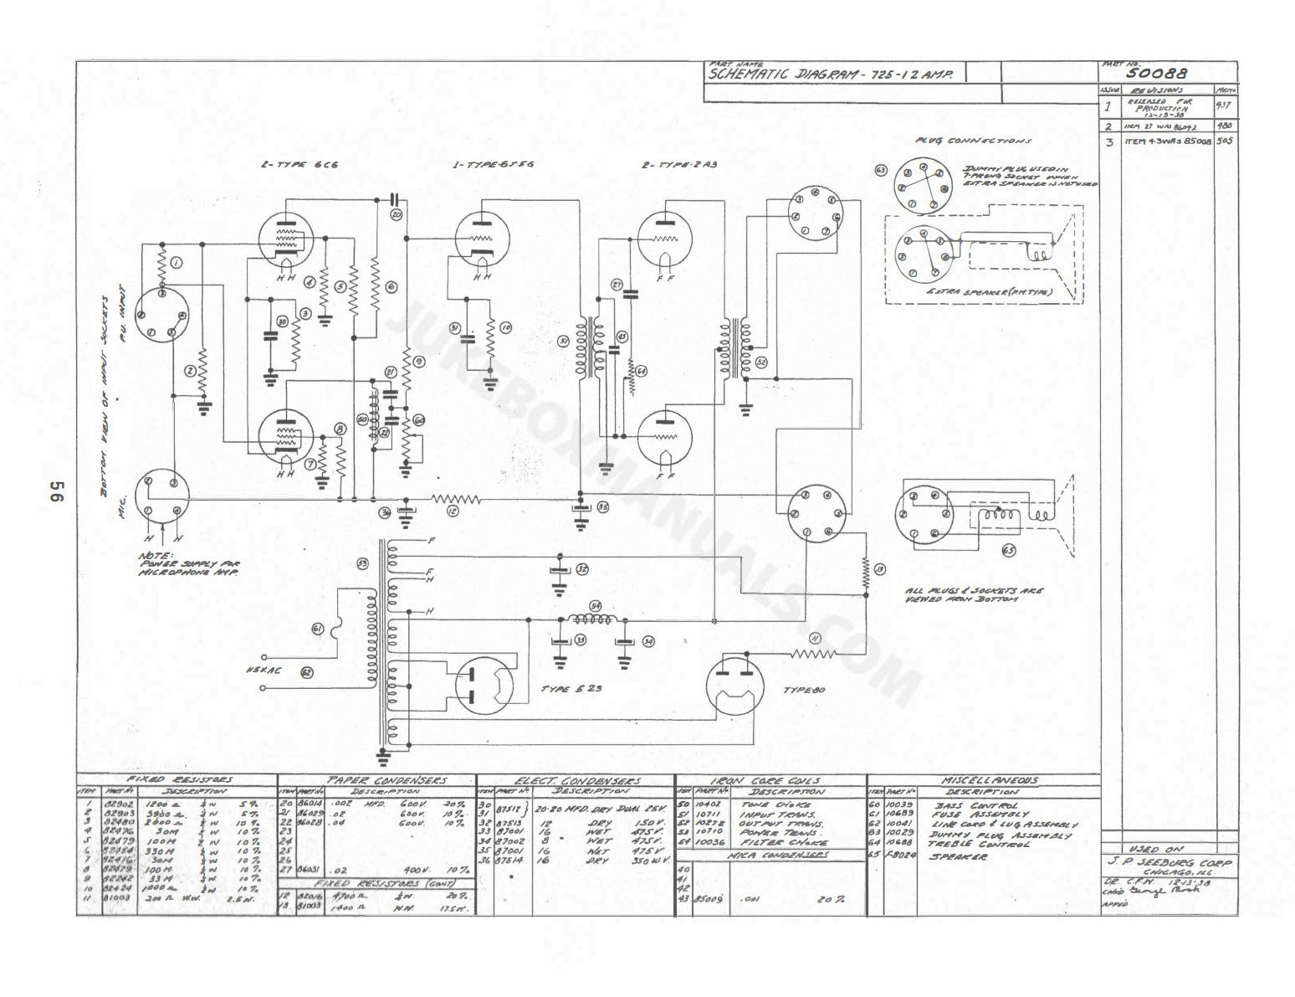�.. ,,. H(w< 1.1,,.

., 4T#V#r
�· r_flj____ 1

I
I
I
�
'- ---- I

�
U'I �
.. �
"
: ,,A•.. �
L--------- --- �
.1

.

AU J11<�r.1 .-.V.o '1:� ..1
;/IA'� ;"-"Of'4 ltJrT6¥

'' M�71 -.r,,. .,.,.4NS.AJtir ;1.:IJ>'.

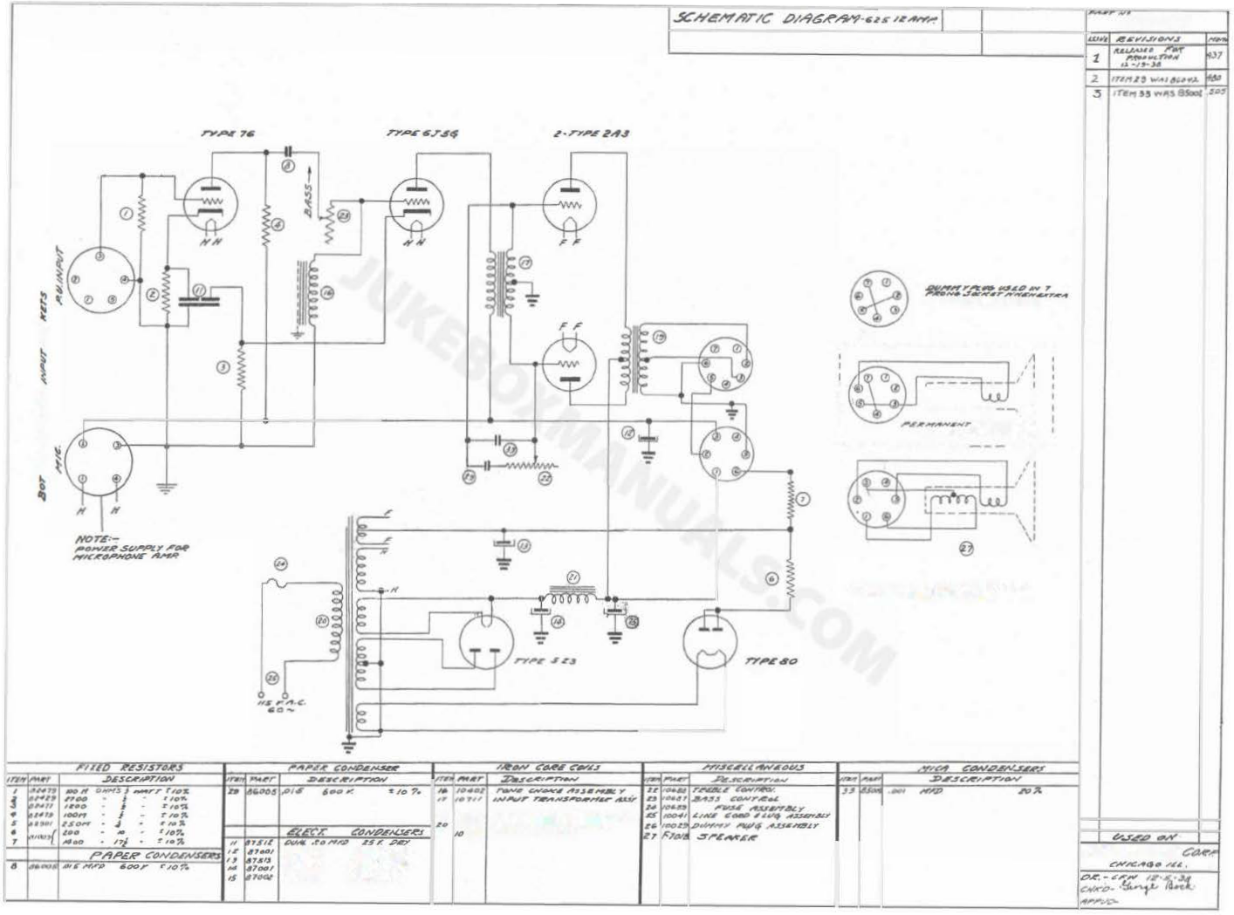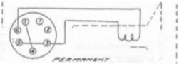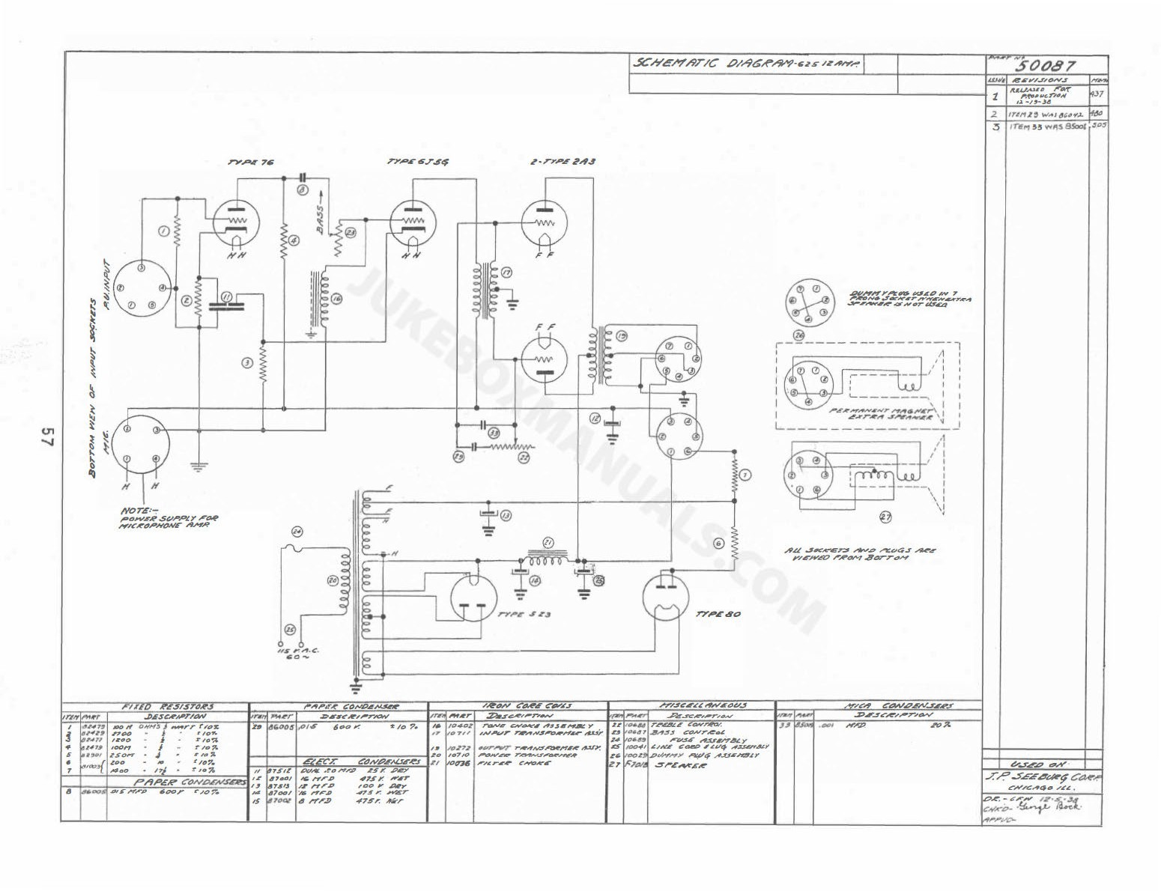

4 ,,,..I' "17.S� A'lr
/I l'Tl'"
M "'" 4? '1'! .wtsr
• ,,,, "'1 ,._ ,,.,.,,,.

,, n4 ,,rl# �""I

././.'..$.,£',

