Sears

SIMPSON 260 METER

REPAIR PROGRAM

DIVISION 92

SOURCE 260

MAY, 1976

This booklet is designed as a simple tr shooting guide to repair a Simpson 260 meter in your Service Center. Al repairs are NOT covered, only the easy repairs that do not require major recalibration. U after following the enclosed procedure the problem has not been resolved, return the meter to the authorized repair source for your Territory.

A complete schematic an parts location list is included for your convenience for Model Series 6P.

Repair parts are available from your Territorial Repair Parts Distribution Center. These par are listed on ultrafiche in Division 92, Source 260

SERVICE PROCEDURE - SIMPSON 260-3-4-5-SP-6-6P

THE FOLLOWING TESTS CAN BE
) PERF ORM ED TO DE T ERMINE DEFECT S AND D EFECTIVE
COMPONENTS:

- Set the instrument on the Rxl range, short the test leads together and adjust the zero ohms for zero indication on the meter. If the pointer falls short of zero, REPLACE THE 1.5 VOLT "D" SIZE BATTERY. This should restore normal operation.
- Next, set the 260 to the RxlOK range and adjust for zero ohms. If the pointer will not reach zero, change the

_ 9 volt transistor radio type (NEDA 160

3. If the pointer does not deflect. in Steps 1 and 2, remove the test leads from their jacks and short the "common" and "plus" jacks together with a paper clip. The 260 should still be set on a resistance range while making this check. If the pointer moves, REPLACE THE DEFECTIVE TEST LEADS.
4. If the po did not deflect in Step 3
_ re move the check the i

. fuse is accessible through the battery compartment.
5. If Steps 1 to 4 do not loc the trouble, or if the problem involves a single range only (such as Rxl or 1 MA) then an odor or visual test should be made to loc a burned resistor. The location of the components are as shown on the drawings for the ranges most likely to cause difficulty.
NOTE
1: If a resistor burns out and causes the printed circuit board to become crystalized, the entire board must be
replaced because a degree of continuity is often set up across this area. This causes inaccuracies in the instrument and usually another breakdown in a short time.
NOTE
2: With the instrument out of the case be sure to check the switch decks for smoked areas or bum marks between contacts. If there is evidence of burn or arc marks, return unit to your authorized repair center.

NOTE
Switch replacement, C OMPLE TE calibration, meter movement replacement, or repair is considered a factory repair. Send the complete unit to your Authorized Repair Station.

OVERLOAD RELAY ADJUSTME

NOTE

Field adjustments of the Overload Relay Leaf Switch causes intermittent or erratic ope of the unit. Replacement is recommended.
The mechanical adjustment of the relay is pe as follows;
- Refer to the drawing to locate the adjustment screw for the relay latching function. This can be adjusted with a small jeweler's screwdriver while the reset button is pushed in.
- With the reset button depressed, tum the screw out until it does not catch on the relay. No more than one or two turn should be required.
- Short the common and plus terminals and set the range and function switch on RxlOO and plus DC. This will provide an indication on the meter when the relay contacts are open or closed. Meter will read full scale when contacts are closed.

- Now push the reset button and turn the screw clockwise until it just catches on the relay. This is to be done in small increments while allowing the button to spring in and out until it snaps into the hole.
- The mechanism should be operated two or three times to be certain the latching an switch function is consistent. This can be accomplished by finger continuity between shunt R22 and the
This should cause the relay to release as indicated by the button "popping out".

NOTE

Finger contact at various points in the tester can cause the re to release. Do not mistake accidental finger contact with the circuitry with a defective relay or its adjustment.

positi terminal of the 15 volt battery. ANY REPAIR NOT COVEREDIN THESE
Push in the resetbutton and then connect PR OCEDURES IS CONSIDERED A
the two points together wi the fingers. FACTORY REPAIR.
TROUBLESHOO CHART, I 260-6P

SYMPTOM PO DEFE
  - Rx1 will not zero a. Defe "D" with short in- Battery
CURE
    - Replace
NOTES

put.
Ope resistor
    - Replace

    - Defe range switch
  - Rx1Ok will not a. Defe battery zero with shorted
input.

c.

    - Replace a.
260-6,6P = R16,17,19,21.
Se switch re-
placement

.
12=9v
.

    - Open resistor

    - Defective range switch SWl
  - Rx100 will not a. Open resistor zero with shorted

b. Replace b.

c.

- Replace a.
NEDA 1604

R18
See switch re- placement

R18

input
Defective switch SW-1
- Se switch re- placement

7.5 VAC range  rea approx. 1/2 | a. | Ope diode Dl or D2 | a. | Replace | a. | Se calibration proc
the actual voltage
Out-of-tolera | a. | Calibration | a. | Recall- | a. | Se calibration
indication at full sc on 2.5 VAC | b. | req  Dl or D2 de- | b. | brat• Replace |  | proced
range |  | fective
 | c. | Defe call- |  | Replace | c.
 |  | bration control
 |  |  |  |  |  | R22,25
 | d. | Defe re- | d. | Replace | d.
 |  | sistor
 |  |  |  |  |  | --- -,--- R23,24,
 |  |  |  |  |  | 26

6. | SYMPTOM  AC voltage range(s) | a. | PO DEFE  Defe re- | a. | CURE  Replace | a. | NOTES
 | defective |  | 1i1ton
--- -,-- R27
thru R30
 |  | b. | Defe range |  |  | b. | S. switch re-
 |  |  | switch SW-1 |  |  |  | placement.
7. | DC current ranges de- | a. | Ope shunt re- sistor | a. | Replace | a.
 | fec |  |  |  |  |  | Rll
 |  |  |  |  |  |  | thru R15.
 |  | b. | Defective range |  |  | b. | S. switch re-
 |  |  | switch (SW-1) |  |  |  | placement.
8. | DC voltage range(s) de- | a. | Ope multiplier re1i1ton | a. | Replace | a.
 | fec
R4
thru RI
 |  | b. | Defective range |  |  | b. | S. switch re-
 |  |  | switch (SW-1) |  |  |  | placement.

CALIBRATION CHECK
TROUBLESHOO
CHART, MODELS 260-3 THRU 260-6P
DC VOLTAGE RANGES can be checked for accuracy by usi a battery of prope voltage for the range being checked while monito the battery voltage being applied across the test leads with another 260 or equivalent meter.

RESISTANCE RANGES can be checked for accuracty by measuring a known value of resistance wi the instrument.

AC VOLTAGE CALIBRATION
When the diodes or resistors in the bridge recti have been replaced, the 250 AC and
2.5 VAC ranges must be calibrated.
250 VAC RANGE CALIBRATION
Using the line voltage from an AC outlet as a calibrating voltage source and an accurate AC monitoring voltmeter, connect the test leads an adjust or
R22 1 for the same reading as the monitoring voltmeter.
  - VAC RANGE CALIBRATION
Using an oscillator set to 1 volt RMS output at 60 hertz as read on a monitoring AC voltmeter. Set the 260 range switch to the 2.5 VAC range and connect the test leads to the
monitored 1 VAC output of the oscillator.
-
Adjust ,---- __ __ , R25 :

for the same reading as the monitoring voltmeter. This completes the AC calibr ation. SEE NOTE ON FOLLOWING PAGE.

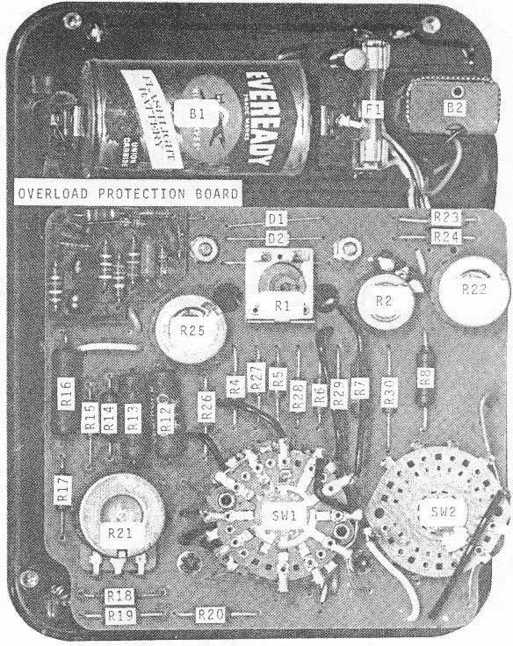

Simpson 260-6 & 6P Parts location
NOTE: 260-6 DOES NOT HAVE PROTECTION BOARD

RANGE SWlH--,--------------------,-------------------7 1
1 It 1/ I
I

1 �v.V.
I I I

2 �v. 2 2
3 a".J';.
3
2

3
121

4 lOY. 4 4
5 jl;.5V. 5
6 f.C12.,MA. 6
7 IOMA. 7
4 200l
12
5

I .10..MA.
- lMA.
- IX 1
11 Ix 10 112 11
12
I
117

12 Ix 10.0
9Y
ZERO OHMS

f I
I -D.C.. I
I 1.
I / I
I
2 +D.C. /
2

3 A.C.

+Il IODOY. + COM_MON +IOl.

- SWl IS IN 50CW10 VOLn POSITION.
� SWl IS .. +D.C.
K• 1,00 OHMS.
MI0.•\00,00 OHMS.

SCH EMATIC DIAGRAM MOD EL 260-6

I
I ns 1u
OM·l 132 D7
I :
-

l
:
I
I
c2
DI .002
1 Y2 1 i
I
I
I
I

SW·I
I.ANGE SWITCH--.----- --- -
1 = ' ..
2!�Y. 2
3 SOY. 3
JIAMl'S.
___ - -- --- - - - - - ___ _J

S UV.
ov.

- SODll
-
- IGOMA.

I 10MA..
....
    - IMA.
10 IX I
11 IX10
4

113

22.S

10
m

12
4

s

I

•
DI
117 Ill
II

mn
122

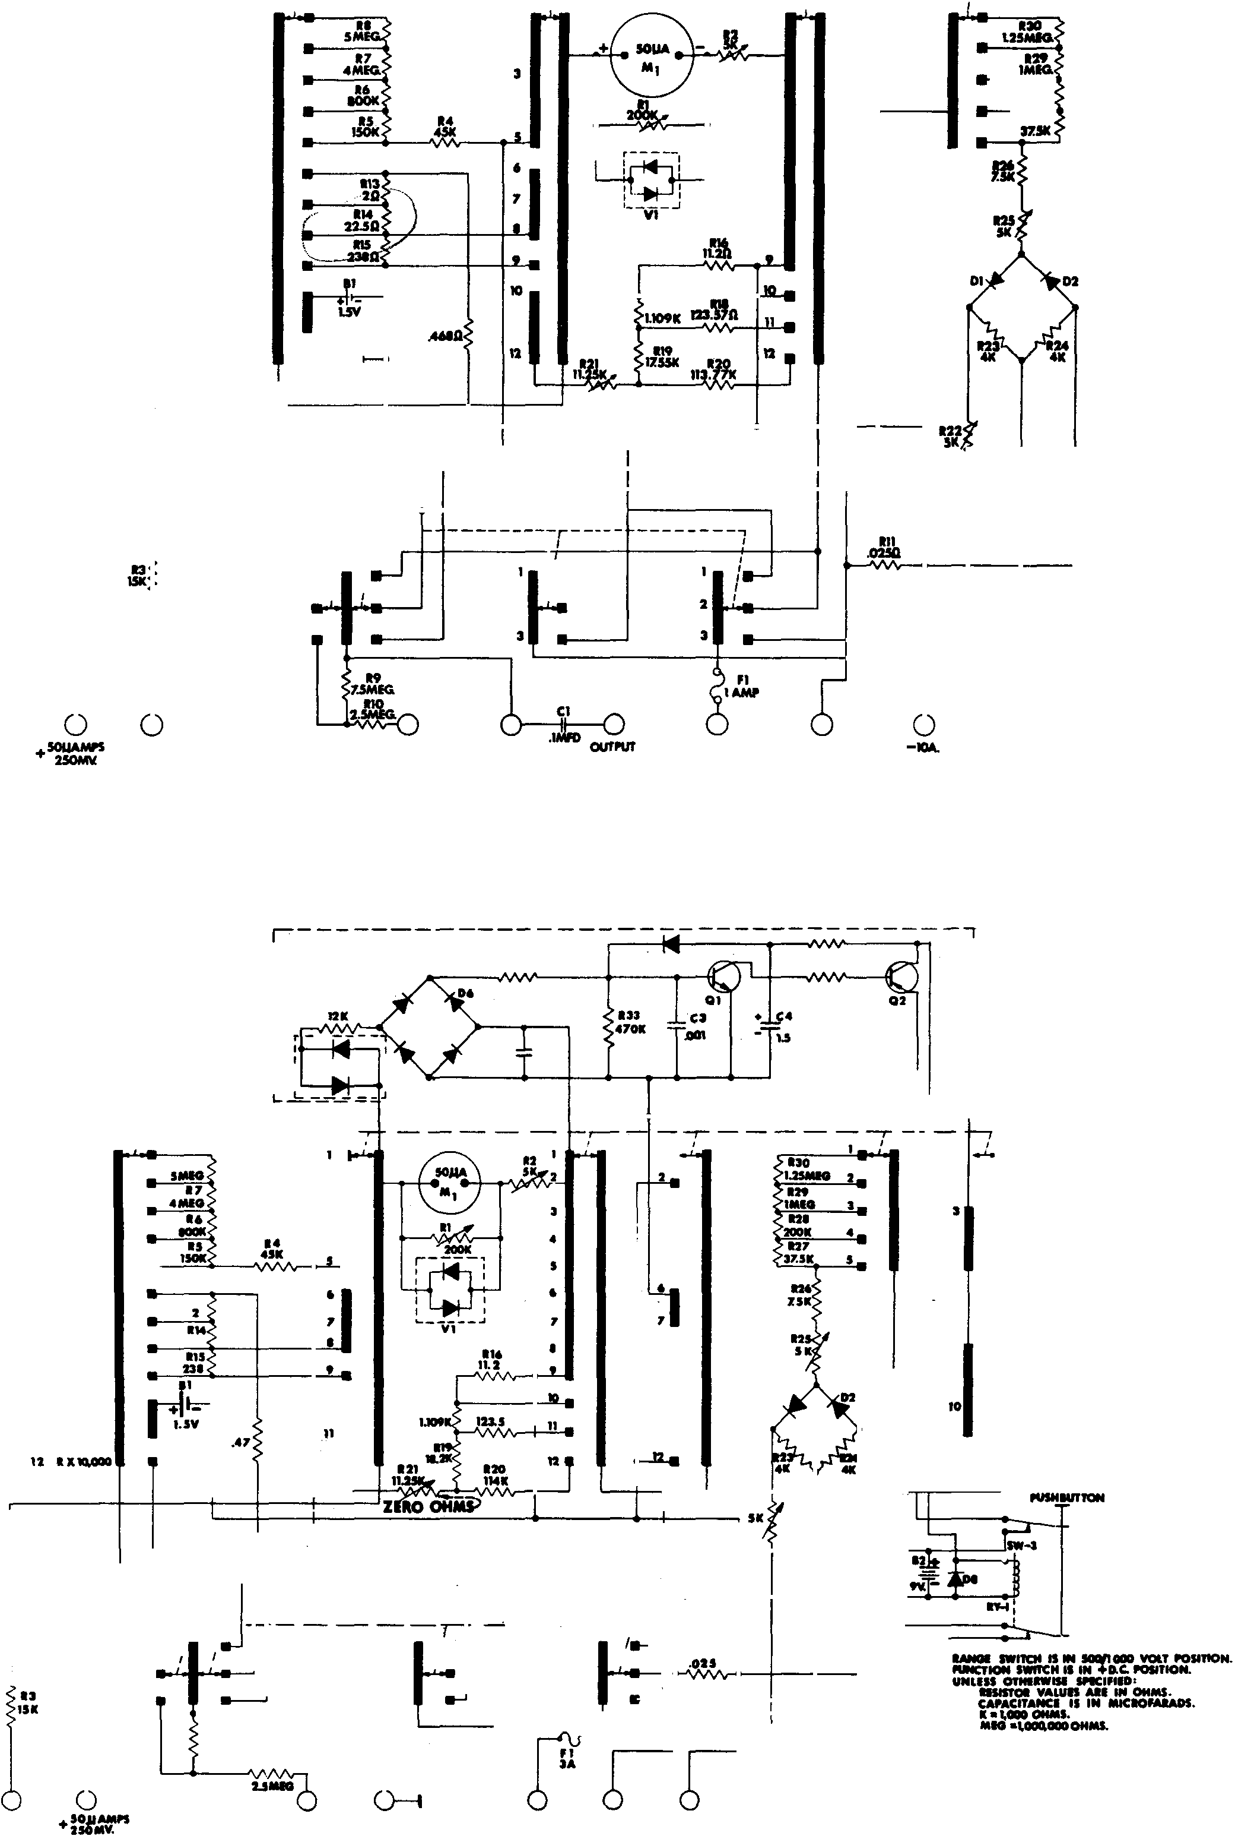

+IV
SW
FUNCTION SWl1C
I -D.C. • I I
2 + D.C.
3 A.C.
..
7.S
....

110

\Gmv.
  - ac.

I I•
--- ·
I
2
3

ch)
,I
    - OUTPUT

I
2
3

� +IOA.

Ill

-IOA.

SCHEMATIC DIAGRAM MODEL 260-6P

