

Software Box 32



Release 1.0 – June 2004

INDEX

1. MENU SOFTWARE BOX 32 3
1.1. MENU FILE 3
1.2. MENU TERMINAL 4
1.2.1. OPERATOR CODE 4
1.2.2. HOW TO SET DATE AND TIME IN THE TERMINAL 4
1.2.3. RESET 4
1.3. ABOUT MENU 4
2. TRANSFERRING DATA FROM THE TERMINAL TO THE PC 4
3. SAVING LAST AUDIT 5
4. STATISTICS 5
4.1. STATISTICS .BOX FORMAT 5
4.1.1. MAIN 7
4.1.2. KEY CREDITS 7
4.1.3. HISTORICAL DATA 8
4.1.4. SALES 8
4.1.5. CASH 8
4.1.6. USER GRUPS/DIAGNOSTICS 8
4.2. STATISTICS EXCEL FORMAT 9
4.3. COMPARISON BETWEEN BOX32 FORMAT AND EXCEL FORMAT 11
4.3.1. MACHINE 11
4.3.2. CASH 11
4.3.3. KEY/CARD 11
4.3.4. SUMMARY 11
4.3.5. USER GROUPS 12
4.3.6. CHANGEGIVER 12
4.3.7. HISTORICAL DATA 12
4.4. EXCEL SEARCH 13
4.4.1. INTRODUCTION 13
4.4.2. SEARCH BY CUSTOMER/MACHINE CODE 14
4.4.3. SEARCH BY AUDIT DATE 16
4.4.4. TOTALS PER MACHINE 17
4.4.5. NOTES ON OPERATION 17
4.4.6. HOW TO USE REPORTS IN EXCEL FORMAT TO CHECK YOUR AUDITS FOR MISTAKES 18
4.5. EXCEL EXTENDED FORMAT 19
4.6. USER GROUPS EXCEL FORMAT 22

MENU SOFTWARE BOX 32

The software Box32 is used to read, print and save data previously collected by a Terminal or a PSION Workabout.
BOX32 is structured as follows:

MENU FILE

Using this menu it is possible to save, read and print the data previously collected using the Terminal. It is also possible to set the serial port and to choose the language.
The options are:

- Read Audit : option for transferring statistics from the terminal to your PC. This option is also accessible by pressing the key .
- Save audit : option for saving statistics that have just been acquired. This option is also accessible by pressing the key .
- Open last audit : opens the last acquisition downloaded onto your PC. This option is also accessible by pressing the key. .
- Open Audit : option for opening any of the .box files. This option is also accessible by pressing the key. .
- Excel audit : option for converting all data contained in a .box file currently displayed in Box32 format into Excel format. For a detailed description, refer to section 4.2. This option is also accessible by pressing the key .
- Excel search : option for activating the Excel search features. For a detailed description, refer to section 4.4. This option is also accessible by pressing the key .
- Excel extended audit : option for viewing all data contained in a .box file in Extended Excel format. For a detailed description, refer to section 4.5. This option is also accessible by pressing the key .
- Print preview : option for viewing the print preview of all data contained in a .box file in Box32 format. This option is also accessible by pressing the key .
- Print setup : option for printing the currently selected file in Box32 format. This option is also accessible by pressing the key .
- Configuration : option for opening the Box 32 software configuration menu.
- Exit : used to exit the program

 When switching the serial port (from Com1 to Com8), close Box32 and restart the program.
Before launching the Box32 software it is necessary to close all the programs (also the KeyCard program).

MENU TERMINAL

The menu includes the options on how to use the Terminal:
- Operator Codes
- Date and Time
- Reset

OPERATOR CODE

With this option, you can enter the operator code and terminal number stored on said Terminal. The operator code is made up of 10 alphanumeric characters, whilst the terminal number consists of 3 digits. These two codes are required to identify the operator and terminal that have made the acquisition.

HOW TO SET DATE AND TIME IN THE TERMINAL

- Enter the Menu Terminal;
- Select “Date and Time” and a window with date and time of the Terminal will appear;
- Select “update” to change date and time of the Terminal and switch to the ones set in the PC.

In order to have the correct indication of the date and time of the audit it is necessary to set date and time correctly in the PC.
Select: “Settings/Control Panel/Regional Settings/Date” and choose dd/mm/yy (e.g: 28/08/03) and press “OK”.
Select: “Settings/Control Panel/Regional Settings/Time” and choose hh/mm/ss (e.g: 09/22/18) and press “OK”.

RESET

The reset function is used to cancel the data stored in the Terminal.

When the data are transferred from the Terminal and saved in the PC, reset the Terminal in order to avoid duplication of files.

ABOUT MENU

The information about the software version is included in this menu.

TRANSFERRING DATA FROM THE TERMINAL TO THE PC

All data contained in the Terminal can be transferred using the Box32 software with the following procedure:
- Connect the Terminal to the PC Interface by means of the special nine-pole connector (JACK) DB9.
- Wait for the message “TERMINAL CONNECTED” to be displayed on the status bar.
- Select the option “Read Audit” from the menu Terminal and confirm the next message. The message “READING KEY/CARD” will be displayed on the status bar and the mouse pointer will turn into an hourglass icon.
- Wait until the end of reading.

When the memory of the Terminal is full the transferring of the data could take several minutes.
When the transferring is finished, the PC will display the data of the first audit stored in the Terminal.

SAVING LAST AUDIT

Data transferred from the Terminal are stored in a temporary file named “lastaudit.tmp”.
During the next audit the Terminal will write on this file and, therefore, the data saved in the previous session are lost.
To permanently save the data transferred, select the “Save audit” from the “File” menu. In order to avoid the duplication of the archives, the option “Save audit” is not available if the saving has already been performed.
The file will be named according to the year, month, day and cumulative number of savings. The default file extension is “.box”.

Example:
20030202005.box is the fifth saving on 2nd February 2003

STATISTICS

STATISTICS .BOX FORMAT

With the “Open audit” option you can choose and view a .box file in Box32 format.
By pressing the key you can preview the printable report, as illustrated in the figure below.
To print the report, press the button

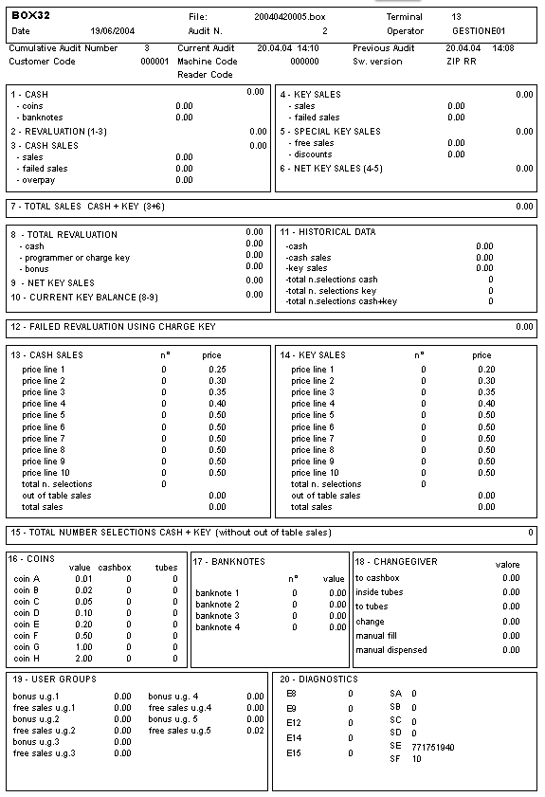
Statistics are divided in:

4.1.1 Main
4.1.2 Key Credits
4.1.3 Historical Data
4.1.4 Sales
4.1.5 Cash
4.1.6 User Groups/Diagnostics

MAIN

1) CASH: total of coins and banknotes inserted in the vending machine.

2) REVALUATION: total of coins and banknotes loaded in the keys (1-3).

3) CASH SALES:
- Sales: see 12;
- Failed sales: total of failed sales (if the parameter “refund for failed sales” is set to OFF).
- Overpay: total of coins and banknotes inserted in vending machine when the sale does not take place within three minutes (if the parameter “credit disabled” is set to ON)

4) KEY SALES:
- Sales (sales + free sales + sales with discounts at full price + bonus as token + sales using reward points + sales as promotions at full price):
- Failed sales: total of failed sales (if the parameter refund for failed sales is set to OFF).

5) SPECIAL KEY SALES: free key sales + rewards + discounts + promotions.

6) NET KEY SALES: key sales - special key sales (4-5).

7) TOTAL SALES CASH + KEY: Cash sales + Net key sales (3 + 6).

KEY CREDITS

8) TOTAL REVALUATION: the total loaded in the keys using:
- cash;
- programmer or charge key
- bonus: amount loaded in the keys when bonus is granted as credit or sales when bonus is granted as token mode.

9) NET KEY SALES: see 6.

10) CURRENT KEY BALANCE: Total loading - Net key sales (8–9).
It represents the credit stored in the keys. The value can also be negative because the credit pre-existing in the keys (before the current auditing) is not considered. In order to know the real credit stored in keys, it is necessary to sum all items10 since the first audit (provided that statistics have been retrieved starting from the first use of the system).

12) FAILED REVALUATION USING CHARGE KEY: credit that failed to be transferred in the keys using the charge key.

HISTORICAL DATA

11) HISTORICAL DATA: the following data are given for total sales/selections since the payment system was installed:
- cash;
- cash sales;
- key sales;
- total n. selections cash;
- total n. selections key;
- total n. selections cash + key.

SALES

13-14) CASH SALES – KEY SALES: number of items sold with keys or cash for each of the ten price lines and the corresponding prices. When the selections are more than ten, sales corresponding to these selections are reported in “out of table sales” (common in EXECUTIVE/MDB mode when the number of selections and corresponding prices could be more than 10).
Total sales: out of tables sales + sales for the 10 price lines.

15) TOTAL NUMBER SELECTIONS CASH + KEY (without out of table sales): number of items sold using cash and keys.

CASH

16) COINS: gives the number of coins in the cash box and in the tubes of the change-giver and their value.

17) BANKNOTES: number of banknotes and the corresponding value inserted in the bill reader.
This value is recorded only if a parallel bill reader is used.

18) CHANGEGIVER: the following data are given regarding the change-giver:

- to cashbox;
- inside tubes;
- to tubes;
- change;
- manual fill;
- manual dispensed.

USER GRUPS/DIAGNOSTICS

19) USER GROUPS

User Groups are displayed if the ZIP CPU is loaded with the software “ZIP User Groups”.
In order to see the data related to the User Groups the Box32 release 1.1.0 or higher is needed.
5 is the number of User Group that can be collected.
Within each User Group, two groups of data are collected: “Total bonus” e “Total Free Sales”:
- “Total bonus”: Bonus 1 as credit, Bonus 1 as token, Bonus 2 as token;
- “Total free sales”: sales with Free Sale Key, sales with Sales Key at price zero in the discount levels 0,1,2,3, sales using Rewards points and sales with Promotions (at price zero).
If the User Group n. 5 is set to zero, data collected for the first 4 are kept separated, while data related to the keys with a User Group code different from the first 4 are added to the data of the User Group n. 5.
It is difficult to compare data related to the User Groups with other data present in the Box32 format.
Particular care must be given when interpreting “free sales” (item 5 of the Box32 format).
The latter includes sales with Free Sales Key and Rewards, but does not include sales with Sales Key at price zero in the discount levels 0,1,2,3.
It is only possible to compare item n. 8 “Bonus” of the Box32 format with “Total Bonus” of the 5 User Groups.

20) DIAGNOSTICS: see ZIP manual.

STATISTICS EXCEL FORMAT

With the “open audit” option you can open a .box file.
By pressing the key you can convert all data contained in a .box file currently displayed in Box32 format into Excel format, as illustrated in the picture below.

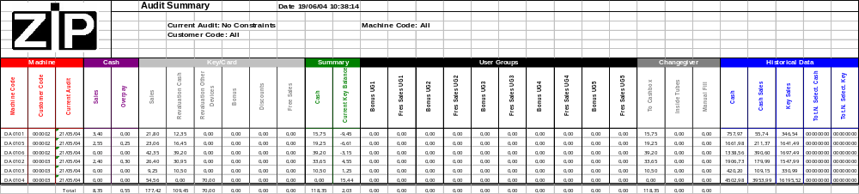

COMPARISON BETWEEN BOX32 FORMAT AND EXCEL FORMAT

The statistics displayed in Excel format are a “summarized” version of data featured in Box32 format. Whereas the Box32 format gives a detailed view of data collected by the payment system, the Excel format displays said data so that they are visible at a glance. In other words, a whole page of statistics is condensed into a single line of the Excel sheet. Below is a guide showing how data on the Excel format relate to those of the Box32 report.

MACHINE

a. Machine Code: represents the code of the machine the purchase refers to;
b. Customer Code: represents the code of the customer the purchase refers to;
c. Current Audit: represents the date the audit was made.

CASH

a. Sales = field 3 - CASH SALES → Sales
b. Overpay = field 3 - CASH SALES → Overpay

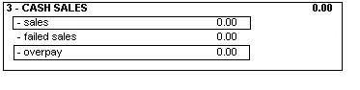

KEY/CARD

a. Sales = field 4 - KEY SALES →Sales
b. Revaluation Cash = field 8 - TOTAL REVALUATION→ Cash
c. Revaluation Other Devices = field 8 - TOTAL REVALUATION→ programmer or charge key
d. Bonus = field 8 - TOTAL REVALUATION → bonus
e. Discounts = field 5 - SPECIAL KEY SALES → discounts
f. Free sales = field 5 - SPECIAL KEY SALES → free sales

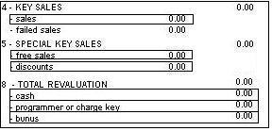

SUMMARY

a. Cash = field 1 - CASH
b. Current Key Balance= field 10 - CURRENT KEY BALANCE

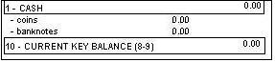

USER GROUPS

a. Bonus UG 1…5 = field 19 - USER GROUPS → bonus u.g.1…5
b. Free sales UG = field19 - USER GROUPS → free sales u.g. 1…5

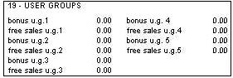

CHANGEGIVER

a. To Cashbox = field 18- CHANGEGIVER → to cashbox
b. Inside Tubes = field 18- CHANGEGIVER → inside tubes
c. Manual Fill = field 18- CHANGEGIVER → manual fill

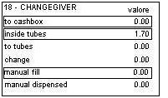

HISTORICAL DATA

a. Cash = field 11- HISTORICAL DATA → cash
b. Cash sales = field 11- HISTORICAL DATA → cash sales
c. Key sales = field 11- HISTORICAL DATA → key sales
d. Tot. N. Selections Cash = field 11- HISTORICAL DATA → Total n. selections cash
e. Tot. N. Selections Key = field 11- HISTORICAL DATA → Total n. selections key

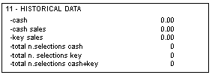

EXCEL SEARCH

INTRODUCTION

The 1.4.0 (or higher) version of the Box32 software lets you search its .box files and view the result in Excel format.
You can call up this function by selecting the icon
The following window appears:

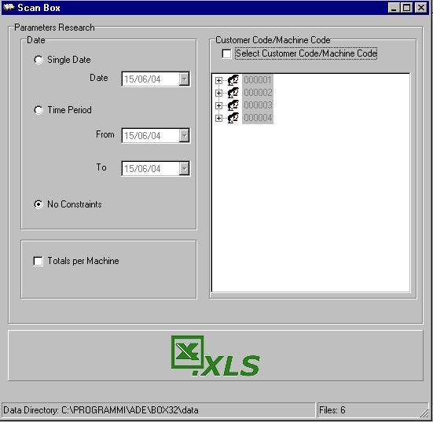

Using this window, you can set all the parameters to base the search on. Once these parameters are set, you can start the search by pressing the key with the Excel symbol . If you press this key but you have not selected any search parameter, you can view all audits ordered by machine code, customer code, date of audit.

At the bottom of the window is the folder where all .box files have been saved to. The path of this folder is Ade/Box32/data. You will also see the number of files contained in said folder.
To add or delete other files to or from the database, simply copy or delete the desired files in this folder.

SEARCH BY CUSTOMER/MACHINE CODE

When the search window is opened, Box32 searches all the .box files in its database, extracting the customer and machine codes in said files and entering them in a tree-view. This kind of view gives you quick, immediate access to your customer pool/fleet of machines.
To activate this view, you must tick on the “Select Customer Code/Machine Code” box.
If you select just the customer code and start the search, you can view all audits of machines belonging to the given customer.

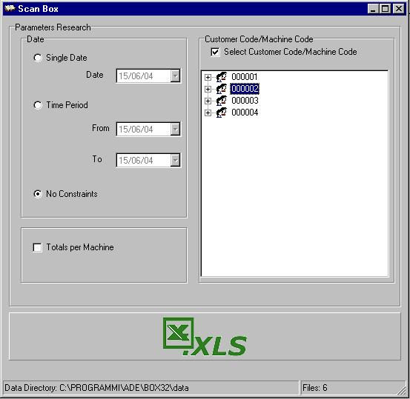

By double-clicking a customer code, you can call up a list of all machines belonging to said customer code, as shown in the following picture.

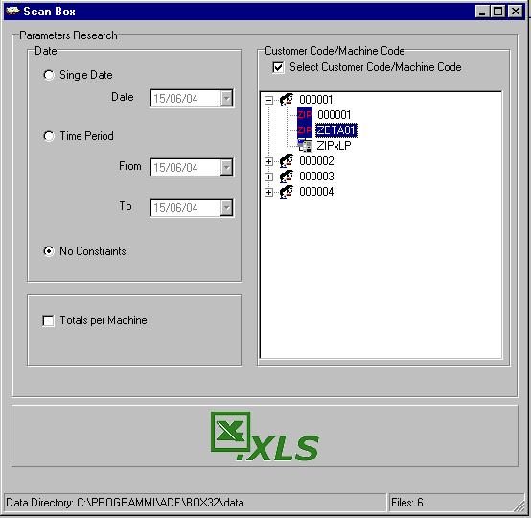

Each machine is identified by its own code and and icon indicating whether the system is a Zip (), ZIP Loader(), ZIP Loader Plus (), Caterpay () or Caterlink ().

If you select a machine and start the search, you can view all audits relating to said machine belonging to the given customer code.

Example: if search parameters are set as illustrated in the previous picture, you can view all audits relating to the machine called “ZETA01” belonging to customer code “000001”.

The Excel sheet header features all the parameters that have been used for searching.
You can select just one customer code or machine code at a time.

SEARCH BY AUDIT DATE

In addition to the search by customer/machine code, you can search by Audit Date.

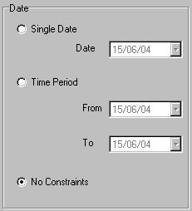

- Single date: Only those audits made on the date specified in the Date field are displayed;
- Period: Only those audits falling within the period specified by the From/To fields are displayed;
- No restriction: No filter is applied on the date.

Example:
When search parameters are set as illustrated in the below picture, you can view all audits between 03/05/2004 and 15/05/2004.

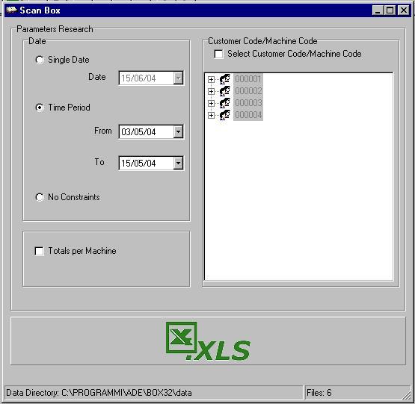

Searches by period of time and customer code can be combined.
Example:
When parameters are set as illustrated in the below picture, you can view audits relating to machine DA0101 belonging to customer 000002 between 01/04/2004 and 14/05/2004

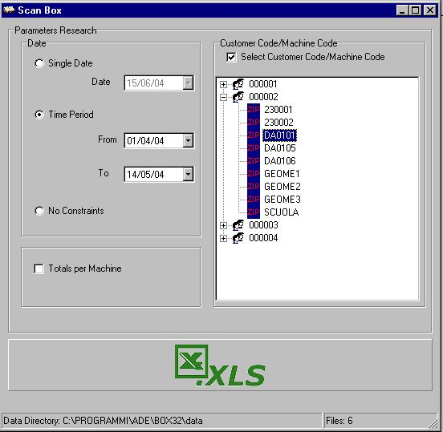

TOTALS PER MACHINE

By selecting the “Totals per Machine” option, a single line will be displayed for each machine, where the value of the fields is given by the sum of the values present in the audits relating to those machines.
The fields relating to date, historical data, coins in the tubes and coins filled manually feature the data referring to the last available audit.

NOTES ON OPERATION

- To be able to use the functions described in the above sections, you must use Excel 2000 or a later version.
- For the Excel report to be printed properly, your computer must have a printer installed. If it doesn’t, the report print settings might not be correct.
- Once you have pressed the “Read audit” key, you must save the audit by pressing the “save audit” button on Box32 window before you can enter the audit in its database. This is to avoid any of the audits appearing twice.

HOW TO USE REPORTS IN EXCEL FORMAT TO CHECK YOUR AUDITS FOR MISTAKES
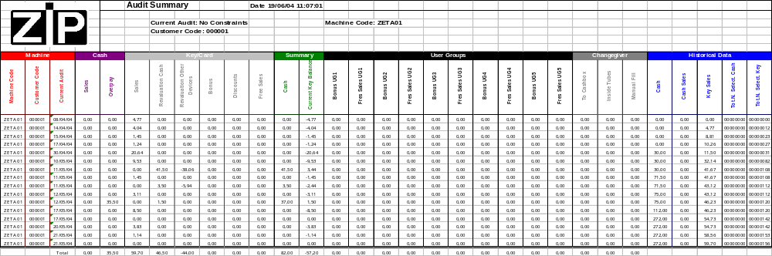

- The total “Sales Key/Card” matches the last value “Key Sales” in the Historical Data (there will be a match only if the “historical value” of the first audit is zero. If this is not the case, you must process the difference between the “initial” and “final historical value”).
- We can see how the total “Cash” in the field Summary does not match the last value “Cash” in the Historical Data.
- Data analysis: discrepancies can be seen between the Historical Data between 17/4 and 30/4. In fact, the value “Cash” in the Historical Data must equal the sum of the “Cash” in the Historical Data + “Cash” in the Summary of the previous audit.
- If we analyse the detailed printed reports of the audits, we can see that some are missing.

EXCEL EXTENDED FORMAT

To collect the data with Excel Extended format update the EPROM of the Terminal or check the production batch of the Terminal (after September 2003).
Program the menu OTHER PARAMETERS / AUDIT MODE / EXTENDED.
The data collected in Excel Extended format can only be visualised choosing the option .

If you try to open the data collected in the Excel Extended format with Box32 format, you will be warned by a message: “Excel Extended”.
If despite this message you try to open the data with Box32 format, the field “software version” will indicate “Excel Extended” and all the data will be set to “0”.

If the data have been collected in Excel Extended format and you try to open the file with Excel format, the data are not displayed.

When using the option Excel Search , the software ignores the statistics in Excel Extended format.

Procedure on how to use Excel Extended:

- Connect the Terminal to the Caterpay or ZIP Loader Plus in order to retrieve the data (the possibility to use this tool in the ZIP has not been developed yet).
- Connect the Terminal to the PC Interface.
- Launch the “Box 32” program.
- Select “Read Audit”.
- Select “save audit” and the data are automatically saved in the directory “Box32\data”.
- Press the button and the following window will appear:

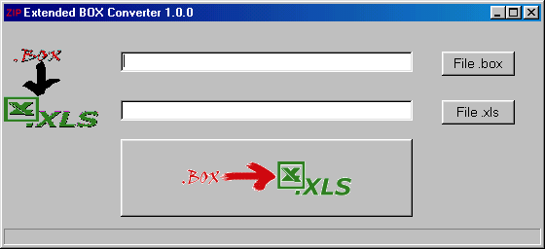

- Press the button and select within the directory “B0x32/data” the file to be converted. Press the button “Apri” (Open).

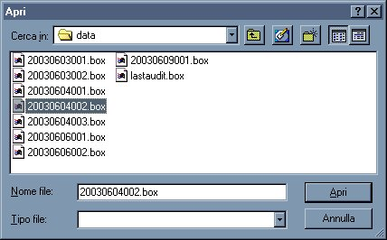

- Press the button and select “Stat117_EN.xls” for the Caterpay or select “Stat60_EN.xls” for the ZIP Loader Plus or a different file if the data have to be added to an existing file with the same number of statistics (117 or 60). Press the button “Save”.

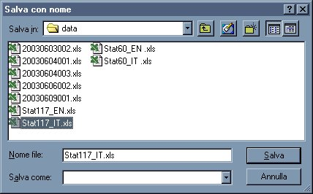

Press the button  to create the Excel spreadsheet:

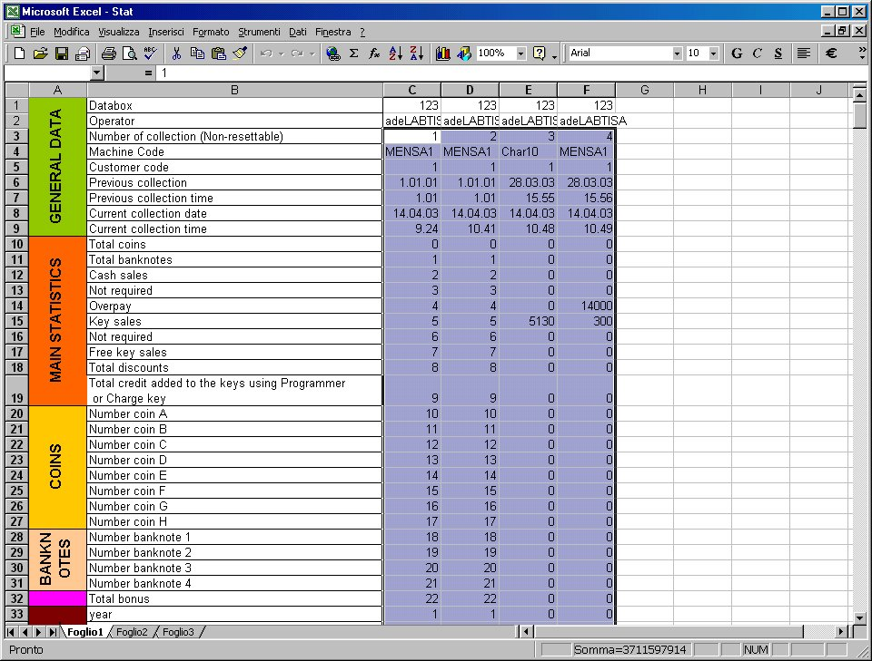

- Save the spreadsheet by pressing or “Save audit as” when the file has to be saved in a different folder.
In order to add the last audit to an existing one, choose the destination file with the button . The software will automatically add the new data to the existing ones:

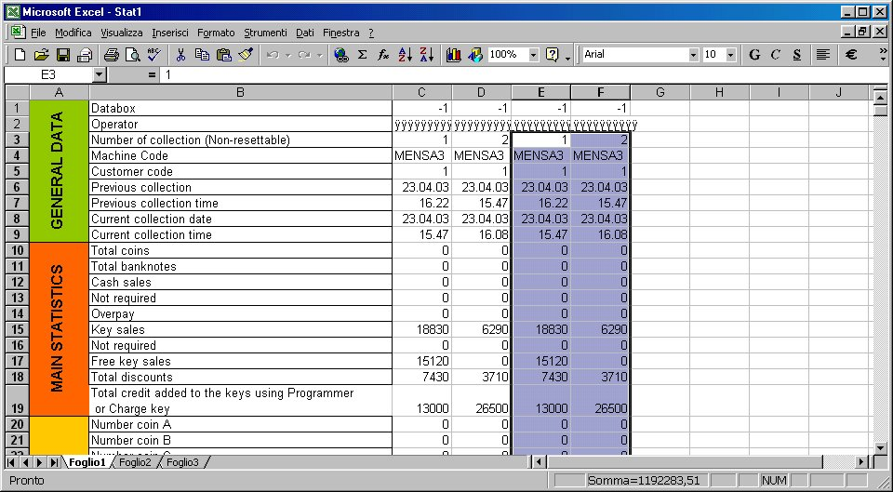

The destination file must not be in use while transferring the data.

USER GROUPS EXCEL FORMAT

Read chapter 4.1.6 User Groups/ Diagnostic.

The number of User Groups displayed in the Excel spreadsheet depends on the Excel format:
- Excel summary:
ZIP 5 User Groups
Caterpay 5 User Groups
- Excel extended:
ZIP 5 User Groups
Caterpay 10 User Groups

