LAYOUT L15.
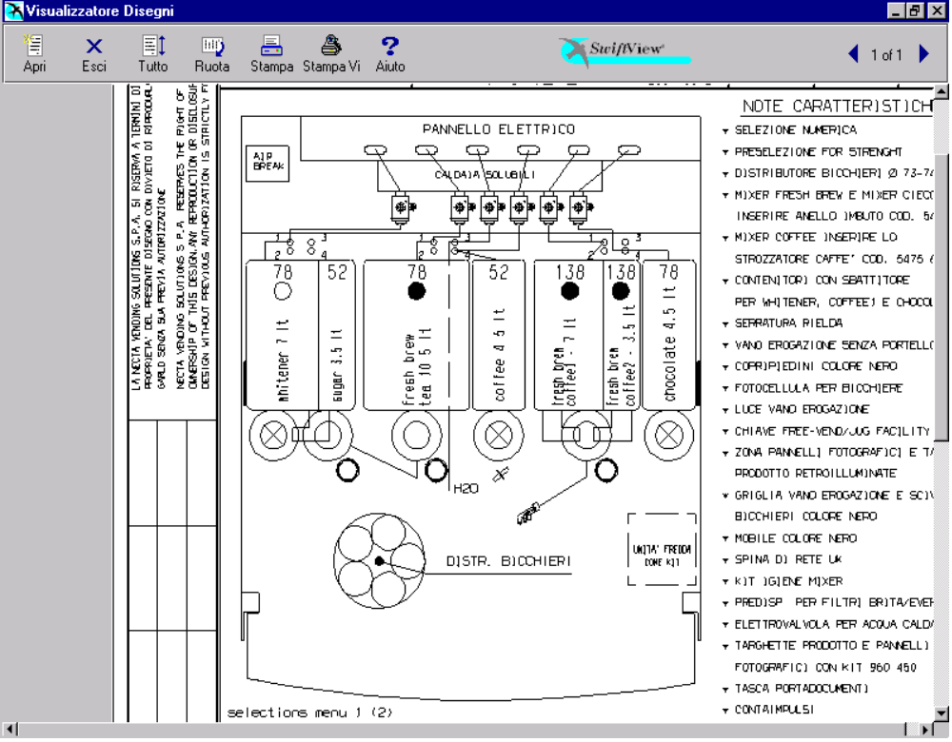

PRODUCT TABLE.

POSIT. | PRODUCT | N° DOSING | SETT. DOS.  (gram./sec.) | N° ELECTRO. | SETT. EV  (cc/sec.)
1 | Whitener / Milk | 1 | 1,5 | 1 | 9
2 | Sugar | 2 | 2,3 | 1 | 9
3 | Fresh Brew 1 | 3 | 1,7 | 2 | 16
4 | Fresh Brew 1
5 | Coffee Ins. / Soup * | 4 | 0,6 / 2,5 * | 4 | 10 / 15 *
6 | Fresh Brew 2 | 6 | 1,7 | 5 | 14
7 | Fresh Brew 2 (C2) | 8 | 1,7 | 5 | 14
8 | Chocolate | 7 | 3,0 | 6 | 9
/ | Hot Water | / | / | 3 | 20
/ | Carbonated Water | / | / | 7 | 17
/ | Still Water | / | / | 8 | 16
KEYBOARD SELECTION L15.

Strength - | ¤ | Strength + | ¤

SELECTION | SUGAR  N. | EX. SUGAR  N. | NO SUGAR  N.
Coffee Fresh Brew Black | 17 | 18 | 19
Coffee Fresh Brew White | 21 | 22 | 23
Coffee Fresh Brew Ex. White | 24 | 25 | 26
Chocolate | -- | -- | 27
Soup * | -- | -- | 28 *
Hot Water | -- | -- | 29
Coffee2 Fresh Brew White | 31 | 32 | 33
Coffee2 Fresh Brew Ex. White | 34 | 35 | 36
Coffee Instant Black | 37 | 38 | 39
Coffee Instant White | 41 | 42 | 43
Coffee Instant Extra White | 44 | 45 | 46
Coffee2 Fresh Brew Black | 47 | 48 | 49
FB Tea White | 51 | 52 | 53
FB Tea Extra White | 54 | 55 | 56
Fresh Brew Tea Black | 57 | 58 | 59
Coffee Fresh Brew Cappuccino | 61 | -- | 62
Coffee Fresh Brew Espresso | 63 | -- | 64
Coffee Fresh Brew EspressoChoc | 65 | -- | 66
ChocoMilk | -- | -- | 67
Instant Cappuccino | 71 | -- | 72
Instant EspressoChoc | 73 | -- | 74
 | STILL |  | CARBONATED
Chilled Water | 81 |  | 84
Orange ( Syrop 1 ) | 82 |  | 85
Lemon (Syrop 2 ) | 83 |  | 86

* When it takes the place of the Coffee Instant with the Soup, and vice versa, is necessary disable the selections of the powder to replace and train those of the new, therefore modify of the value of setting of the doseur and electrovalve. correspondent like suitable in the table product.
* Quando si sostituisce il Coffee Instant con il Soup, e viceversa, e’ necessario disabilitare le selezioni della polvere da sostituire ed abilitare quelle della nuova, quindi modificare del valori di taratura del dosatore ed elettrov. corrispondente come indicato nella tabella prodotti.

PRESELECTION L15.

PRESELECTION  (N.) | DOSE VARIAT. | DESCRIPTION
Strength - | -10 % | Reduces the powder of Coffee/Tea (3 step).
Strength + | +10 % | Increase the powder of Coffee/Tea (3 step).
Extra Sugar | + 66% | Increase the dose of sugar to 66%
No Sugar | - 100% | Reset the dose of sugar of the selection

SELECTION L15.

SELECTION  (N.) | WATER DOSES | SUGAR  (to door) | POWDER DOSES
Fresh Brew Black  ( 17 – 18 – 19 ) | Coffee FB  110 cc |  | Coff. FB  9,0 gr.
 | Sugar  60 cc (tot. 170 cc) |  | Sugar  5,3 gr.
Fresh Brew White  ( 21 – 22 – 23 ) | Coffee FB  110 cc |  | Coff. FB  9,0 gr.
 | Milk  60 cc (tot. 170 cc) |  | Milk  1,5 gr. | Sugar  5,3 gr.
Fr. Br. Ex.White  ( 24 – 25 – 26 ) | Coffee FB  110 cc |  | Coff. FB  9,0 gr.
 | Milk  60 cc (tot. 170 cc) |  | Milk  2,1 gr. | Sugar  5,3 gr.
Chocolate  ( 27 ) | Chocolate  80 cc |  | Chocolate  19,0 gr.
Hot Water
60 cc (tot. 140 cc)
Soup *  ( 28 ) | Soup  150 cc |  | Soup  8,0 gr.
Hot Water  ( 29 ) | Hot Water  150 cc
Fresh Brew White  ( 31 – 32 – 33 ) | Coffee2 FB  110 cc |  | Coff.2 FB  9,0 gr.
 | Milk  60 cc (tot. 170 cc) |  | Milk  1,5 gr. | Sugar  5,3 gr.
Fr. Br. Ex.White  ( 34 – 35 – 36 ) | Coffee2 FB  110 cc |  | Coff.2 FB  9,0 gr.
 | Milk  60 cc (tot. 170 cc) |  | Milk  2,1 gr. | Sugar  5,3 gr.
Coffee Black  ( 37 – 38 – 39 ) | Coffee Instant  40 cc |  | Coffee  1,4 gr.
 | Sugar  45 cc |  | Sugar  5,3 gr.
Hot Water
55 cc (tot. 140 cc)

SELECTION  (N.) | WATER DOSES | SUGAR  (to door) | POWDER DOSES
Coffee White  ( 41 – 42 – 43 ) | Coffee Instant  40 cc |  | Coffee  1,4 gr.
 | Milk  60 cc |  | Milk  1,8 gr. | Sugar  5,3 gr.
Hot Water
50 cc (tot. 150 cc)
Coffee Ex. White  ( 44 – 45 – 46 ) | Coffee Instant  40 cc |  | Coffee  1,4 gr.
 | Milk  60 cc |  | Milk  3,0 gr. | Sugar  5,3 gr.
Hot Water
50 cc (tot. 150 cc)
Fresh Brew Black  ( 47 – 48 – 49 ) | Coffee2 FB  110 cc |  | Coff.2 FB  9,0 gr.
 | Sugar  60 cc (tot. 170 cc) |  | Sugar  5,3 gr.
Fresh Brew White  ( 51 – 52 – 53 ) | Tea FB  110 cc |  | Tea FB  3,0 gr.
 | Milk  60 cc (tot. 170 cc) |  | Milk  1,5 gr. | Sugar  5,3 gr.
Fr. Br. Ex.White  ( 54 – 55 – 56 ) | Tea FB  110 cc |  | Tea FB  3,0 gr.
 | Milk  60 cc (tot. 170 cc) |  | Milk  2,1 gr. | Sugar  5,3 gr.
Fresh Brew Black  ( 57 – 58 – 59 ) | Tea FB  110 cc |  | Tea FB  3,0 gr.
 | Sugar  60 cc (tot. 170 cc) |  | Sugar  5,3 gr.
FB Cappuccino  ( 61 – 62 ) | Coffee FB  80 cc |  | Coff. FB  6,5 gr.
 | Milk  55 cc |  | Milk  8,0 gr. | Sugar  5,3 gr.
 | Chocolate  30 cc (tot. 165 cc) |  | Chocolate  3,5 gr.

SELECTION  (N.) | WATER DOSES | SUGAR  (to door) | POWDER DOSES
FB Espresso  ( 63 – 64 ) | Coffee FB  50 cc |  | Coff. FB  3,3 gr.
 | Sugar  60 cc (tot. 110 cc) |  | Sugar  5,3 gr.
EspressoChoc  ( 65 – 66 ) | Coffee FB  55 cc |  | Coff. FB  3,8 gr.
 | Milk  35 cc |  | Milk  1,8 gr. | Sugar  5,3 gr.
 | Chocolate  50 cc (tot. 140 cc) |  | Chocolate  13,0 gr.
Chocomilk  ( 67 ) | Chocolate  70 cc |  | Chocolate  16,0 gr.
 | Milk  60 cc (tot. 130 cc) |  | Milk  1,4 gr.
Inst. Cappuccino  ( 71 – 72 ) | Coffee Instant  40 cc |  | Coffee  1,6 gr.
 | Milk  60 cc |  | Milk  8,0 gr. | Sugar  5,3 gr.
 | Chocolate  40 cc (tot. 140 cc) |  | Chocolate  9,6 gr.
Ins.EspressoChoc  ( 73 – 74 ) | Coffee Instant  40 cc |  | Coffee  1,4 gr.
 | Milk  35 cc |  | Milk  1,8 gr. | Sugar  5,3 gr.
 | Chocolate  50 cc (tot. 125 cc) |  | Chocolate  13 gr.
Chilled Water  ( 81 ) | Still  160 cc
Chilled Water  ( 84 ) | Carbonated  140 cc
Still
20 cc (tot. 160)
SELECTION  (N.) | WATER DOSES | SUGAR  (to door) | POWDER DOSES
Orange  ( 82 ) | Still  150 cc |  | Syrop 1  32 ds
Orange  ( 85 ) | Still  35 cc |  | Syrop 1  0 ds
 | Carbonated  95 cc |  | Syrop 1  32 ds
Still
20 cc (tot. 150)
Lemon  ( 83 ) | Still  150 cc |  | Syrop 2  32 ds
Lemon  ( 86 ) | Still  35 cc |  | Syrop 2  0 ds
 | Carbonated  95 cc |  | Syrop 2  32 ds
Still
20 cc (tot. 150)

INFORMAZIONI GENERALI.

TABELLA PESI VALIDATORE:
Linea | A | B | C | D | E | F
Peso | 1 | 2 | 10 | 20 | 50 | 5

PREZZO SELEZIONI: Tutte le selezioni a 10.00.
NPREZZO SELEZIONI: Tutte le selezioni puntano al prezzo 1.

POSIZIONE PUNTO DECIMALE: 2.
TEMPERATURA CALDAIA EXP: ---- °C.
TEMPERATURA CALDAIA SOLUBILI: 86.0 °C.

RITARDI ACQUE / POLVERI: Ritardo polvere rispetto all’acqua 0.6 sec.

TIPO DI TASTIERA: Tastiera numerica.

LINGUE: Italiano, Francaise, Espanol, English, Deutsch, Danska, Ungaria, Nederlands, Svenska, Czech, Polski e Finnish.

GENERAL INFORMATION.

PAYMENT SYSTEMS DETAILS:
Line | A | B | C | D | E | F
Weight | 1 | 2 | 10 | 20 | 50 | 5

SELECTION PRICE: All the selections to 10.00.
SELECTION NPRICE: All selections are set price line 1.

DECIMAL POINT POSITION: 2.
TEMPERATURE BOILER EXP: ---- °C.
TEMPERATURE BOILER INSTANT: 86.0 °C.

WATER/POWDER DELAYS: Powder delays to water 0.6 sec.

TYPE OF KEYBOARD: Numerical keyboard.

LANGUAGE: Italiano, Francaise, Espanol, English, Deutsch, Danska, Ungaria, Nederlands, Svenska, Czech, Polski and Finnish.

MODIFICHE.

SW CPU / SCHEDA ATTUAZIONI REV. 1.1:
Modifica alla struttura del database (l’upgrade necessita l’inizializzazione del d.a.).
SW CPU / SCHEDA ATTUAZIONI REV. 1.1 UK:
Introdotta una modifica della gestione del guasto air-break.
Aggiornamento stringhe in inglese.
Modifica del valore minimo del tempo di uscita ugelli per freddo e caldo (80).
Modifica delle attuazioni generate dal pulsante utility “SPOUTS” (uscita e rientro degli ugelli senza arresto)
SW CPU / SCHEDA ATTUAZIONI REV. 1.2:
Aggiunta delle lingue polacca e finlandese.
Modifica delle lingue svedese e danese.
Modifica della gestione delle statistiche (azzeramento) via GSM.
Programmazione tramite l’utilizzo di UP-KEY.
Modifica della gestione dei lavaggi e degli schizzi su distributori con acque fredde.
SW CPU / SCHEDA ATTUAZIONI REV. 1.3:
Eliminazione del controllo della presenza della caraffa in modalità Jug Facilities.
Gestione VENDITA LIBERA con solo sistemi CASHLESS e protocollo MDB.

CHANGES.
SW CPU - I/O BOARD REV. 1.1:
Modification of database structure (upgrade needs the d.a. initialisation)
SW CPU - I/O BOARD REV. 1.1 UK:
Introduction of air-break failure management modification.
Updating of english display messages.
Modification of minimal value for hot and cold spouts movement times (80).
Modification of movements caused by SPOUTS utility button (spouts outgoing and incoming without stop)
SW CPU - I/O BOARD REV. 1.2:
Insertion of Finnish and Polski languages.
Modified Swedish and Danska languages.
Modified of statistical management by GSM.
D.A. programmation by use of UP-KEY.
Modified washing and spurt management in d.a. with cold water.
SW CPU - I/O BOARD REV. 1.3:
Eliminated jug check during Jug Facilities operation.
Management of free-vend operation with only cashless systems and MDB protocol.

